Economics Notes – Chapter 4 – The private firm as producer and employer

Part A – Types of Businesses
- Describe the type of business organisation in the public and private sectors: sole proprietors, partnerships, private companies, public companies, multi-nationals, co-operatives, public corporations
- Describe and evaluate the effects of changes in structure of business organisations.

Part B
- Describe what determines the demand for factors of production.
- Distinguish between labour-intensive and capital-intensive production.
- Define productivity and recognise the difference between productivity and production.
- Describe and evaluate integration, economies and diseconomies of scale.
- Describe the main reasons for the different sizes of firms (size of market; capital; organisation)

Part C – Cost of Production
- Define total and average cost, fixed and variable cost and perform simple calculations.
- Analyse particular situations to show changes in total and average cost as output changes.
- Define total and average revenue and perform simple calculations.

Part D – Market Structure
- Describe the principle of profit maximisation as a goal and recognise that business organisations may have different goals.
- Describe the characteristics of perfect competition and monopoly.
- Describe pricing and output policies in perfect competition and monopoly.
- Discuss the advantages and disadvantages of monopoly.

Part A
5.1 Types of Business Organization in the Public and Private Sectors
5.1.1 Sole Proprietorship
- Definition: Sole proprietor is a business entity that is managed and owned by one person
- Roles of a sole proprietor:
- Carries out functions of an entrepreneur
- Organizes the factors of production (i.e. land, labour, capital and entrepreneurship)
- Characteristics of a sole proprietorship
- One person
- Small scale business
- Unlimited liability
- Profits and losses go right to the owner
- ‘Liability’ refers to a company’s legal debts that arise during the course of business operations
- Most common type of business organization
- Easy to set up
- Advantages of sole proprietorship
- Adaptable to any changes in the market
- Promotion of sales through direct interaction with consumers
- Low start up cost
- Better control of business administration
- Minimum government regulation
- Disadvantages of sole proprietorship
- Difficult to raise capital
- Lack of access to expertise
- Effectiveness of business depends on the individual
- Uncertain lifespan of business

5.1.2 Partnership
- Definition: A partnership is a business organization in which two or more individuals are personally responsible for its debts and profits
- The owners are equally and personally liable for the business debts
- Characteristics of partnership
- Two or more partners
- Unlimited liability
- Advantages of partnership
- Shared financial commitment
- Increased ability to raise capital
- Easy to set up
- Disadvantages of partnership
- Limited capital
- Uncertain lifespan
- Shares are non-transferable

5.1.3 Private Limited Companies (Ltd)
- Definition: A private limited company is a business organization with limited liability which can only sell its shares with the approval of existing shareholders
- Characteristics of a private limited company
- A form of joint stock company – a number of people can jointly own the business
- Shareholders run the business
- Does not release information to the public
- Stocks are not sold to the public
- Small in size
- Advantages of a private limited company
- Owned and controlled by members
- Limited liability
- Profit distribution to members in form of shares or cash
- Disadvantages of a private limited company
- Longer decision-making process
- Require participation of members for success
- Less incentive to invest additional capital

5.1.4 Public Limited Companies (plc)
- Definition: A public limited company is a business organization with limited liability and sells its shares to the general public
- Characteristics of a public limited company
- Limited liability
- Can sell shares to the public
- Releases information to the public for potential buyers
- Distinction between ownership and control of company – Shareholders may not necessarily run the company
- Advantages of a of a public limited company
- Able to raise more capital through sale of shares
- Bank loans at lower interest rates
- Disadvantages of a public limited company
- Vulnerable to takeovers by predator companies (or competitors) as shares are available on stock exchanges
- Costly to launch business on stock market
- Costly to update shareholders

5.1.5 Multinational Company
- Definition: A multinational company is a public limited company which produces in more than one country
- Advantages of MNCs
- Reduce transportation cost
- Direct access with markets
- Cheaper labour
- Cheaper raw materials
- Access to financial incentives from hosting countries (governments)
- Beneficial impacts of MNCs on host countries
- Brings revenue into host country
- Increase employment, output and tax revenue
- Transfer of technology and skills
- Adverse impacts of MNCs on host countries
- Rise of interest rates- due to demand for capital locally
- Uneven distribution of income
- Inflation – due to demand for resources
- Brain drain – deprive local businesses of local professionals
- Closure of domestic firms
- Profits reaped by MNCs paid to shareholders in other countries than host country
- Environmental pollution

5.1.6 Co-operatives
- Definition: A co-operative is a firm that exists for the benefit of its members
- Characteristics of co-operatives
- Owned jointly and managed by members
- Profits split among members
- Lower cost of production due to bulk purchase

5.1.7 Public Corporations
- Definition: A public corporation is a business organization owned by the government which is designed to act in the public interest
- Characteristics of public corporations
- Owned by government
- No shareholders
- Funds from government
- Not profit-driven, work in public interest
- Advantages of public corporations
- Affordable price setting – e.g. natural monopoly (PUB, SMRT)
- Efficient coordination and planning – through direct government regulation
- Disadvantages of public corporations
- Lack of competition promotes complacency
- Opportunity cost of funds spent – could be diverted to public infrastructural development

5.2. Privatisation
- Definition: The transfer of ownership of property or businesses from a government to a privately-owned entity
- Also known as the sale of public sector assets to the private sector
- Advantages of privatisation
- Lower prices
- Higher quality of goods and services
- Greater variety of goods and services
- Lower administration costs
- Absence of government regulation
- More adaptable to changes in market conditions
- Disadvantages of privatisation
- Consumer exploitation
- Charge higher price
- Produce lower quality goods
- Reap higher profit
- Rise of monopoly
- The transition from a publicly traded and owned company to a company which is privately owned and no longer trades publicly on a stock exchange. When a publicly traded company becomes private, investors can no longer purchase a stake in that company

Part B
5.3. Factors of Production
Resources used for production, which can be classified as:
- Land (rent)
- Labour (wage)
- Capital (interest)
- entrepreneurship (profit)

5.3.1 Factors contributing to Demand for Factors of Production
- Demand for and price of final product
- Also known as derived demand
- E.g. If demand furniture increases, demand for timber will also increase
- Price of input
- Inverse relationship between price and quantity demanded of an input
- Price of other inputs
- Substitutes
- Complements
- Technological advancement
- Productivity
- Timeframe
- Short run
- Long run

5.3.2 Distinguish between labour-intensive and capital-intensive production
- Labour Intensive production
- Definition – A production process that requires a relatively high level of labour compared to capital investment
- Nature of Production – To produce individual or personalized products
- E.g. Apparels, shoes
- Costs – Wages, other employment benefits such as medical benefits
- Manpower allocation – Ease of replacement of workers (e.g. temporary staffs)
- Examples – Agriculture, mining, F&B, hospitality

- Capital Intensive production
- Definition – A production process that require a relatively high level of capital investment compared to the labour cost
- Capital refers to equipment, machinery, vehicles for the production of goods and services.
- Nature of Production – Highly automated and produced on large-scale
- Costs – Long term investment for most businesses, cost of financing, maintaining and depreciating equipments
- Manpower allocation – Needs a pool of skilled labour that is difficult to replace
- Examples – Petroleum, steel, automobile industries

5.3.3 Distinguish between Productivity and Production
- Productivity
- Definition – Productivity measures the amount of output that can be produced from a given amount of input, such as land, labour and capital
- Measurement – Measures how efficiently resources are used in production
- Rise in productivity – More output or revenue is produced with the same amount of resources
- Fall in productivity – Less output or revenue is produced with the same amount of resources
- Example – Labour productivity refers to output per worker

- Production
- Definition – Production refers to the physical output in the production process
- Measurement – Measures the level of output

5.3.4 Integration
- The growth of a firm either through merger or acquisition with another firm
- Merger – Combination of two or more firms
- Takeover/Acquisition – One firm takes over another firm

5.3.4.1 Advantages of Integration
- Higher profit
- Greater market share
- Promotes innovation through the exchange of ideas
- Lower risk and competition level
- Reaps economies of scale

5.3.4.2 Disadvantages of Integration
- Consumer exploitation due to the development of market power
- Rise of social problems due to retrenchment
- Unable to attain EOS due to complexity of organization and differences in the production and distribution channel
- Experience DEOS when firm expands beyond the optimum level of production.
- Possibility of business failures due to over-stretch of resource capacity

5.3.4.3 Types of Integration
- Horizontal integration – same product; at same stage of production
- Vertical integration – forward/backward vertical integration
- Lateral integration – same industry; different product
- Conglomerate integration – merge with unrelated products

5.3.4.4 Reasons for Integration
- Reap internal EOS (business which are of the same nature)
- Increase market share by taking over the share of the market of the competitors when there is horizontal integration
- Risk diversification – to spread risk over products, market and sources of supply to cut down loss due to the instability of the market
- To raise the profile of the organization when a firm takes over the brand name of another company – Lenovo buy over IBM
- To provide greater control over the consumer market when there is vertical forward integration
- To provide greater control of the supplier of goods and resources for backward integration
- To create greater stability for the company when it is more diversified

5.3.5.1 Distinguish between Internal and External Economies of Scale (EOS)
- Definition – Economies of scale are cost savings and gains in production accrued to a firm in the production of output resulting in returns to scale
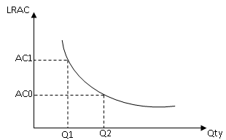

Internal EOS
- Definition – Internal economies of scale are cost savings that are accrued from large scale production of the firm which will contribute to the fall of the long-run average cost (LRAC) as result of the firm’s expansion of its output
- Calculation – The cost saving is attained by the spread of the total cost of production over a larger number of output or the cost saving gained by lowering the rate of increase in the total cost due to lower cost of inputs
- Examples – Technical economies of scale, managerial economies of scale, financial economies of scale, commercial economies of scale and risk-bearing economies of scale
- Diagram – As seen from the diagram, the average cost will fall from AC₀ to AC₁ as the output increases from Q₀ to Q₁

External EOS
- Definition – External economies of scale are sources of cost reductions, which are accrued to the firm from the growth in the size of the industry
- Calculation – The firm’s cost per unit of output decreases as the size of the whole industry grows
- Firms, regardless of size, benefit from expansion of the industry
- Examples – Concentration of facilities and resources, concentration of information and disintegration of industries.
- Diagram – As seen from the diagram, the LRAC will lower down from LRAC1 to LRAC2 as output remains at Q1
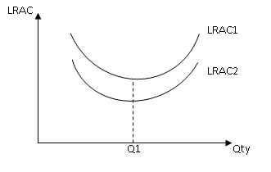
External economies of scale

Sources of Internal Economies of Scale

- Technical Economies of Scale
    - Can be attained as a result of technical improvement achieved in the production process due to the increase in plant size. The cost saving can be seen in these areas:
    - Greater specialization of work to reap the advantage of division of labour, increasing the productivity of the workers and hence, increase in production
    - Better process of production by linking processes so as to reduce wastage of goods and cut down the time period and increase production with the given resources
    - Enhance the capacity of machinery production to allow greater production
    - Allow the use of bigger machinery overcoming the problem of indivisibility of machinery
    - Recycling of waste product to cut down cost

Managerial Economies of Scale
    - Attained by the employment of specialized workers to raise the efficiency of the firm without increasing the unit cost of production. This is achieved when the specialized staffs manage to increase the production scale allowing the spread of the total cost of production over a large quantity of output.

Commercial Economies of Scale
    - Attained when the firm manages to reduce the cost of inputs by buying in bulk at favourable rates and through cost saving of advertising cost due to large scale production.

Financial Economies of Scale
    - Attained when the firm is able to have cheaper source of fund to finance their business due to the size of their operation, enabling them to obtain lower interest rate in their borrowing or the issue of shares to obtain more fund.

Risk Bearing Economies of Scale

Attained when the large firm spread risks, eliminates them though diversification in production, making the firm less vulnerable to changes in market conditions.

Sources of External Economies of Scale

Economies of Concentration (Network system – CTE,PIE)
    - When an industry is concentrated, firms benefit from the concentration resources, facilities and infrastructures. All these facilities will help the firm increases its efficiency and lower cost of production for the whole industry.

Economies of Information (R&D)
    - Derived from the publication of trade and technical journals, central research institutions. These efforts will help the firm gain greater knowledge to raise its efficiency and improves its productivity in many aspects, lowering cost of production.

Economies of Disintegration (Outsourcing - handphones)

Allows the firms to split certain parts of production and source for inputs, which can be produced by the common suppliers. The supplier of these inputs can gather the total production and concentrate the production to bring down the cost of these inputs.
5.3.5.2 Internal Diseconomies of Scale (DEOS)
Sources of Internal Diseconomies of Scale
Internal DEOS – When the firm exceeds a certain production level, internal diseconomies of scale will set in

Administrative Diseconomies of Scale
    - Occur due to weak coordination as there are too many departments in the firm. This will create weak control and coordination in the organization, leading the rise of inefficiency and average cost of production too.
    - Too many operational procedure – waste time and incur more manpower cost

Managerial Diseconomies of Scale
    - Conflicts due to different organization cultures
    - Occur due to the complexity of decision-making and frictions among the various departments due to the size of the firm. The various departments have different perspectives, and conflicting aims and thus this undermines the efficiency of the organization. This will lead to the rise of the average cost of production.

Low labour morale
- As the firm grows too big, hierarchy alienation is seen as the lower level workers feel a sense of loss. The absence of a sense of belonging undermines the morale of the workers and interest in their work. Consequently, the productivity of the organization will decrease. Workers trapped in a repetitive, mundane job with limited interests in success of firm, decrease quality and increased cost in quality control.
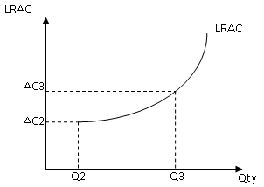

Sources of External Diseconomies of Scale
External DEOS – External diseconomies of scale will set in when the industry’s resources capacity is over-stretched and thus contributes to inefficiency
- Excessive use of resources
    - Increasing demand for factors of production creates stress on the availability of resources, demanding the cost of resources to rise, such as labour cost as the issue of scarcity arises
- Rise of externalities
    - Third party effects
    - Stress on facilities will lead to the rise of externalities, raising the cost of production for the society and the industries For example, pollution and traffic congestion
- Excessive Competition
    - Increase wage cost of workers
    - Greater competition will mean the there will be greater wastage in the form of excessive advertising which will only increase the cost of production but no increase in the demand

5.3.6.1 Reasons for the Survival of Small Firms

8.1 Nature of Product (niche market)
    - Some services require personal attention, such as a haircut, tailoring, shops selling accessories, etc. Individual attention is required to cater to the needs of the customers. In most cases, such services cannot be handled by machines as the goods cannot be standardized, i.e. mass production is not possible. Craftsmanship is vital, e.g. ladies' fashion, costume, watches and jewellery, hand-printed batik, etc.

8.2 Skills of the Entrepreneur
    - If the entrepreneur is highly educated, knowledgeable and skilful, he would be able to improve the productivity of the organization. He will ensure the survival of the small firm.

8.3 Geographical Location
    - The small firm will be able to provide the consumer convenience as it will locate itself near to the consumer.

8.4 Adaptability and Flexibility
    - The adaptability and flexibility of small firms make it attractive for small firms to remain small. The firm can adapt easily to changing economic conditions. Their factors of production are not specialized as in the case of the larger firms, like the blast furnace of an iron and steel mill which cannot be used for other purpose.

However, firms can still be big despite the need of personal servicescan standardize services – can conduct mass sales

5.3.6.2 Reasons for the Existence of Large Firms (Reasons for merger)
a) Benefits to the Firm
- Firms can reap Economies of Scale to lower average cost of production, enabling the firm to raise profitability
- Expand the size of market as a result of a larger market share
- provide sizeable market demand which will provide the incentive for the firm to engage in research and development to raise product innovation and productivity
- enable the firm to control the market share to raise market power by decreasing price or controls the administrative process
- The firm can reduce the risks of their business as it has a greater market share to diversify their sources of market demand
- They can create greater fund and gather more resources to compete more effectively against foreign firms and to compete in the international market

b) Detriments to the firm
- Development of a bureaucratic organization
- Extensive division of labour (will lead to lower productivity)
- High wages for professionals
- Intense and hence expensive competition
- increasing risks (unwillingness to undertake risks can also deter expansion)
- May stretch out the resources of the firm (cash-stripped/lack of staff) as the size of the production expands too extensively
- May experience diseconomies of scale which leads to rise in average cost of production
- May incite regulation from the government as firm may gain excessive market power such as the violation of the anti-trust law or the regulation in the aspect of retrenchment from mergers

Part C
5.4 Cost of Production
    - Short run – The firm is constrained by a fixed maximum capacity, which means that it can only increase the variable factors of production to increase its production while one of its factors of production is held fixed
    - Long run – All the factors of production used by the firms can be changed to increase production
    - Fixed cost – Cost of production that is incurred due to the use of fixed factors and they do not vary with the level of output of the firm
- E.g. Salaries, interest payment on loans
    - Variable Cost – Cost that incurred due to the use of variable factors and the cost will vary with the level of output
- E.g. Wages
    - Total cost – The total cost of producing all output, calculated by the addition of fixed cost and variable costs
- TC = FC + VC
    - Average cost – Cost per unit of output. It is equal to total cost divided by output
- AC= TC/Q
    - Marginal cost – Addition to total costs from the next unit of output
- MC = TC/Q
    - Total Revenue – The total receipts of a firm from the sale of any given quantity of a product. It can be calculated as the selling price of the firm’s product times the quantity sold
- TR = P x Q
    - Average Revenue – The amount earned per unit sold, price per unit, P
- AR = TR/Q
    - Marginal Revenue – Addition to total revenue from selling an extra unit of output
- MR = TR/Q

How the Two Types of Cost of Production will Vary on the Basis of Average Value

AFC will decrease as output increases but at a steeper level at the initial stage since the total fixed cost is dived by a smaller level of output and less gentle at a larger level of output as the total fixed cost is divided by a larger number of output. It steepness of the slopes varies with the change in total product. As for the AVC, it will decrease at the initial stage before diminishing returns set in since marginal product will increase but it will increase as total production increases since the marginal product decreases as diminishing returns set in.
Qty
AFC
AVC
Costs
ATC
MC

Average fixed cost (AFC) will decrease as output increases but at a steeper level at the initial stage since the total fixed cost is dived by a smaller level of output and less gentle at a larger level of output as the total fixed cost is divided by a larger number of output. It steepness of the slopes varies with the change in total product.

As for the average variable cost (AVC), it will decrease at the initial stage before diminishing returns set in since marginal product will increase but it will increase as total production increases since the marginal product decreases as diminishing returns set in.

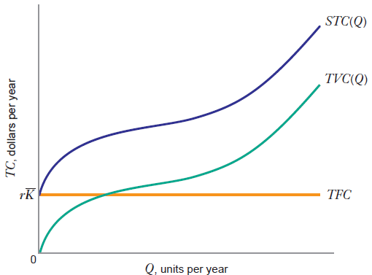
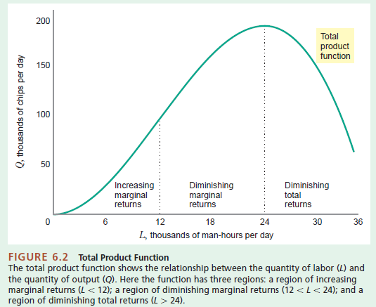

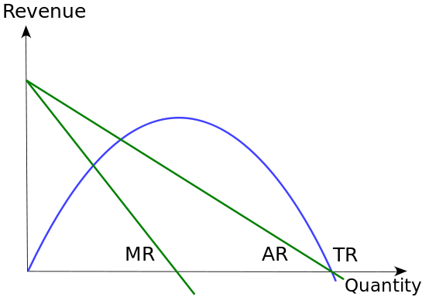
Part D – Market Structures – Perfect Competition & Monopoly
5.5 Aims of Firms
    - Profit Maximization – Firms seek to attain the highest net profit and produces at the level of production where MC=MR
- Profit = Total Revenue – Total Costs
- Types of profits
- Supernormal profit
- Normal profit
- Subnormal profit
    - Allocative and production efficiency – Firms seek to produce at the level of production where P+MC as there will be no deadweight loss, implying maximization of welfare while production efficiency is at the level where production is at minimum AC.

Perfect Competition

5.6.1 Characteristics of Perfect Competition
- Many firms
- Perfect market information
- Mobile of factors of production
- No barriers to entry
- Homogeneous product
- Firms are price-takers
- No firms can control the production level and thus cannot set the price level

5.6.2. Price and output setting for Perfect Competition
- Under this market structure, the marginal and average revenue is under this market structure, and constant as output increases, which means that the demand curve (AR) is perfectly elastic implying that the firms in this market structure are price-takers, abiding to the price level set by the industry as there is prefect information about the price level while the marginal cost will rise as there is over-utilization of fixed capacity of production in short run
- As a profit-maximizing firm, the production level is at the level where the marginal cost is equal to the marginal revenue
- As the marginal revenue is perfectly elastic, the firm is able to attain production efficiency and allocative efficiency in the long run
- Since the average cost can be at the lowest level and P = MC

Characteristics of production equilibrium in the PC market
- Price is set by the industry
- through the market forces of DD/SS
- Profit-maximising condition is where MC=MR
- MC must cut the MR from below (MC is rising and then further rise beyond MC=MR, means additional loss will occur)
Allocative and production efficiency can be attained at production equilibrium based on profit maximisation

Diagrams for Perfect Market Condition
S₀
D₀
Qty
Q₀
P₀
Price
D₁
MC
ATC
P
Q₀
0
A
Price
Qty
DD = AR =MR

P₁
Q₁
Q₁
D₁=AR₁=MR₁
Firms
Production EquilibriumMC=MR
Industry
-Market Equilibriumdd/ss
Supernormal profits
= TR – TC
= OPAQ – OCBQ
= CPAB
Subnormal profits
= TR – TC
= OPAQ – OCBQ
= CPAB (losses)
MC
ATC
P
Q
0
A
C
B
DD = AR =MR

Qty
Price
SR – Profit condition – sub-normal$π$, normal$π$, supernormal $π$
LR – normal $π$

Monopoly

5.6.3 Characteristics of Monopoly
- One firm
- Imperfect market information
- Immobility of factors of production
- Strong barriers to entry
- Homogeneous product
- Single firm is price-setter

5.6.4. Price and output setting for Monopoly
- Under this market structure, the marginal revenue and average revenue is downward sloping from left to the right due to the market power and thus, allowing it to exercise as a price setter while the marginal cost will rise as there is over-utilization of fixed capacity of production
- As a profit maximizing firm, it will produce at the level of output where the marginal revenue is equal to the marginal curve
- However, the firm is unable to attain production efficiency and allocative efficiency since the market equilibrium level of production at MC = MR does not equal the production efficiency level where output level is at min AC or P = MC, as the firm is producing at excess capacity of production (SR).
P₀
Price
Qty
Q₀
MR
AR
MC
AC

Profit-maximising condition where MC=MR supernormal $π$

Advantages and Disadvantages of Monopoly

Advantages
- Lower price
- Higher product quality
- More resistant to economic downturns
- Higher level of economic growth and living standard

Disadvantages
- Consumer exploitation
- Higher price
- Deadweight loss
- Lack of competition due to complacency
- Reduce quality and variety of products

Aims of Firms
- Sales volume maximisation – sell as many products as possible, without making a loss
- Sales revenue maximisation – gaining the maximum possible revenue from selling a product
- Increase market share – firms with larger market share can increase market power to influence market price
- Survival – usually new firms and those in highly competitive markets will focus on survival, even if there is zero profit gained
- Increase shareholder value – increase the asset value of the business
- Ethical goals – firms may focus on environmental sustainability and fair trade
- Satisficing – Refers to the attempt to take into account a number of different and competing objectives, without attempting to ‘maxmise’ any single goal.

