JC Economics CSQ

Emerging Economies as Engines of Growth in the Global Economy

Extract 5: BRIC Economics as Future Powerhouses

Following the global economic slowdown in 2009, emerging economies are leading the recovery with high rates of economic growth and increasing consumer demand. It is predicted that emerging markets will account for more than half of world GDP, according to the International Monetary Fund (IMF).

Among them, the four BRIC countries — Brazil, Russia India and China — are identified as the future economic powerhouses. These countries are propelling the global recovery as their economic growth rates exceed global averages. With the 42% of the global population that reside within them becoming more affluent and seeking higher living standards, the rise of the BRIC consumer will only become more marked over the next decade.

A new trend which has influenced the flow of goods and services is that of intra-BRIC trade. Previously, the BRIC countries were seen as the factories and commodity supplies to the world, but now they are working together as consumers and producers and trading with one another. Should we see a slowdown in the developed world, the BRIC countries are well-positioned to ride out the storm.
Adapted Source: The Telegraph, 11 Nov 2011

Figure 2: Emerging Market Share of World GDP

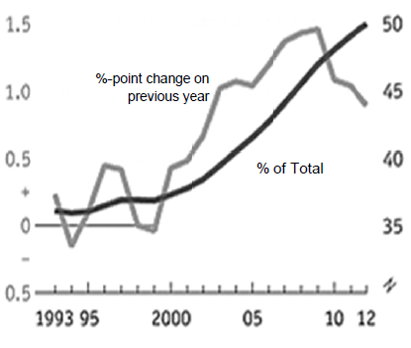
Source: IMF Website

Table 2: Real Economic Growth (Annual %)
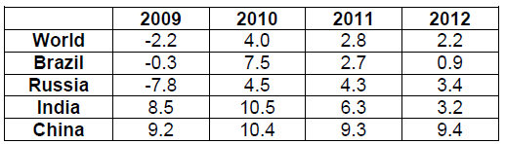

Source: World Trade Organisation Website, accessed on 7 August 2013

Table 3: Selected Economic Statistics, 2011

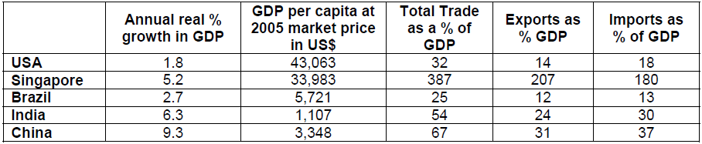

Source: The World Bank Website

Extract 6: BRIC Nations Rocked by Aftershocks of Eurozone Crisis
The devastating slowdown in the European economies has shown that 'decoupling' – the idea that emerging countries would go on growing despite problems in the west -- is a myth. Plunging demand from the markets of Europe, many of which remain deep in recession, and collapsing global confidence in politicians' ability to stop the rot, has ruthlessly exposed the weaknesses of emerging markets.

The rupee plunged as investors take flight and head for the safety of the US dollar. China slowed most alarmingly. If the slowdown in its manufacturing output is serious enough to hit China's demand for imported oil, iron ore and industrial components, it could create problems for Brazil too.

Most analysts expect the radical shift of economic power from the west to the emerging markets to continue but as Europe and the US turn inwards to tackle their own crises, it could be a tough couple of years for the BRICs.

Adapted Source: The Observer, 24 June 2012

Extract 7: New-wave Economies Going for Growth
Economists say there are a number of key factors that will allow emerging countries to grow more quickly than the mature markets of the west. Firstly, they must have sound macroeconomic policies, including control of inflation and budget deficits. Secondly, they must invest in human capital and improve their educational standards. Thirdly, they must be able to import new technologies from the west. Finally, they must have young and growing populations.
Source: The Guardian, 18 December 2012
Questions
(a) (i) Compare the growth rates of the BRIC countries between 2009 and 2011 in Table 2. [2]

(ii) Using Extract 5, explain how the growth rates in the BRIC countries affect the global world economy. [4]

(b) Comment on whether Table 3 and Figure 2 support the view that emerging economies will be the ‘Engines of Growth in the Global Economy’. [6]

(c) (i) With reference to Table 3, which indicator would you use to assess the standard of living in a country? Justify your answer. [2]

(ii) Explain two other pieces of information that would be useful in assessing the standard of living in a country. [4]

(e) Discuss the extent to which the factors highlighted in Extract 7 can help emerging countries sustain their economic growth. [8]

