The impact of trade and automation on jobs Extract 5: Trade in the balance
Economists tend to argue that trade does far more good than harm. Yet new research reveals that for many, the short-term costs and benefits are more finely balanced than textbooks assume.

David Autor of MIT, David Dorn of the University of Zurich and Gordon Hanson of the University of California, San Diego, provide convincing evidence that workers in the rich world suffered much more from the rise of China than economists thought was possible. In their most recent paper, published in January, they write that sudden exposure to foreign competition can depress wages and employment for at least a decade.

Trade is beneficial in all sorts of ways. It boosts variety: Americans can shop for Volvos and Subarus in addition to Fords. Yet its biggest boon, economists have argued, is that it makes countries richer. Trade creates larger markets, which allows for greater specialisation, lower costs and higher incomes.

Economists have long accepted that this overall boost to prosperity might not be evenly spread. Some research papers pointed out that trade between an economy in which labour was relatively scarce (like America) and one in which labour was relatively abundant (like China) could cause wages to fall in the place that was short of workers. Yet many were sceptical that such losses would crop up much in practice. Workers in industries affected by trade, they assumed, would find new jobs in other fields.

For a long time, they appeared to be right. In the decades following the second world war, rich countries mostly traded with each other, and workers prospered. Even after emerging economies began playing a larger role in global trade, in the 1980s, most research concluded that trade’s effects on workers were benign. But China’s subsequent incorporation into the global economy was of a different magnitude. From 1991 to 2013 its share of global exports of manufactured goods rocketed from 2.3% to 18.8%. For some categories of goods in America, Chinese import penetration – the share of domestic consumption met through Chinese imports – was near total.

The gain to China from this opening up has been enormous. Hundreds of millions of Chinese have moved out of poverty thanks to trade. A recent NBER working paper suggests Americans will benefit too: over the long run trade with China is projected to raise American incomes. In parts of the economy less susceptible to competition from cheap Chinese imports, the authors argue, firms profit from a larger global market and reduced supply costs, and should also gain – eventually – from the reallocation of labour away from shrinking manufacturing to more productive industries.

But those benefits are only visible after decades. In the short run, the same study found, America’s gains from trade with China are extremely small. The heavy costs to those dependent on industries exposed to Chinese imports offset most of the benefits to consumers and to firms in less vulnerable industries. Competition from Chinese imports accounted for a significant of the decline in employment in manufacturing in America between 1990 and 2007.

The costs of Chinese trade seem to have been exacerbated by China’s large current account surpluses: China’s imports from other countries did not grow by nearly as much as its exports to other countries. China’s trade with America was especially unbalanced. Between 1992 and 2008, trade with China accounted for 20-40% of America’s massive current-account deficit; China imported fewer goods from America than vice versa.
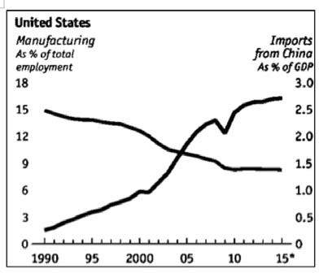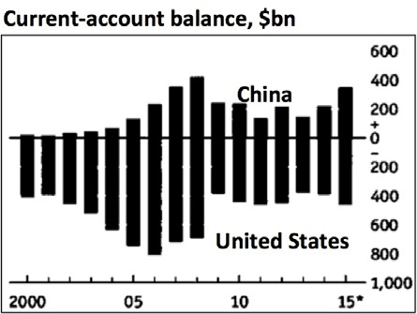

Figure 2 Figure 3

Source: The Economist, 06 Feb 2016

Extract 6: Most US manufacturing jobs lost to technology, not trade

A focal point of president-elect Donald Trump’s campaign, that manufacturing jobs have left the US in droves as a result of bad trade deals, could be based on a faulty premise.

The US did indeed lose about 5.6m manufacturing jobs between 2000 and 2010. But according to a study by the Center for Business and Economic Research at Ball State University, 85 per cent of these jobs losses are actually attributable to technological change — largely automation — rather than international trade. The think-tank found that although there has been a steep decline in factory jobs, the manufacturing sector has become more productive and industrial output has been growing.

The Americans are producing more with fewer people. US factories have been achieving this by gradually replacing human labour with robots. Automation has transformed the American factory, rendering millions of low-skilled jobs redundant. Fast-spreading technologies like robotics and 3D printing will exacerbate this trend. The Boston Consulting Group has estimated that while “a human welder today earns around $25 per hour, including benefits, the equivalent operating cost per hour for a robot is around $8. The extra cost of maintaining a robotics system — installation, maintenance and the operating costs — should be amortised, according to the group, over a five- year period.
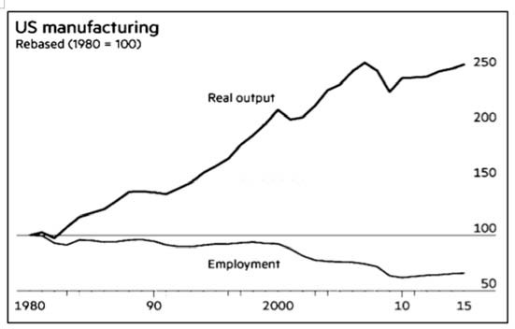

Figure 4

Nevertheless, trade with China and other countries did contribute to job losses to some extent. Research by the Ball State University found that 13 per cent of the overall job losses in
manufacturing had resulted from trade. Another, more recent, MIT study estimated that rising Chinese imports from 1999 to 2011 cost up to 2.4m American jobs. Overall though, what this suggests is that one of the new administration’s main policy aims, increasing trade protectionism, is unlikely to override the larger forces of automation and the transition to a digital economy.

Source: FT.com, December 03, 2016

Extract 7: In Japan, the rise of machines solves labor shortage
The rise of the machines in the workplace has U.S. and European experts predicting massive unemployment and tumbling wages. Not in Japan, where robots are welcomed by the Government as a way to handle the country’s aging populace, shrinking workforce and public aversion to immigration. Japan is already a robotics powerhouse. The Government launched a five-year push to deepen the use of intelligent machines in manufacturing, supply chains, construction and health care, while expanding the robotics markets from ¥660 billion to ¥2.4 trillion by 2020. The labour shortage is such an acute issue that companies have no choice but to boost efficiency. By 2025, robots could shave 25 percent off of factory labour costs in Japan, says the consulting firm.

Source: Bloomberg, 14 September 2015

Extract 8: Automation the future of Singapore economy

With automation, Singapore's economy can maintain a Singaporean core in the face of a local workforce on the verge of shrinking, while not relying on foreign labour for growth. Automation provides crucial interim alleviation for the negative effects of the manpower crunch. Automation can also help to raise productivity in the long run. But, it is still crucial for workers to upgrade their skills to keep up with this automation in industries. Singaporean workers increasingly need to learn to be able to handle automated technology, so that automation can serve its purpose – to benefit productivity.

Source: The Straits Times, 30 April 2016

Extract 9: Singapore Budget 2016: Robots and start-ups - to transform Singapore Inc

Finance Minister Heng Swee Keat announced a slew of measures under the Industry Transformation Programme that will help companies and industries automate, innovate, expand overseas and procure financing. Some of these measures are:

- Support for automation: A new Automation Support Package will be introduced for a period of three years. It will cover (i) Grant support for the roll-out or scaling up of automation projects at up to 50 per cent of project cost, with a maximum grant of $1 million (ii) Investment allowance of 100 per cent for automation equipment, in addition to the existing capital allowance.

- More robots at work: The National Robotics programme - more than $450 million has been set aside in the next three years for the development and adoption of robots. These robots will be used in sectors such as healthcare, construction, manufacturing and logistics.

- Help workers ‘adapt and grow’: will help Singaporeans adapt to changing job demands and grow their skills. Separately, the Government will set up TechSkills Accelerator, a new skills development and job placement hub, to help workers in the information and communications technology sector learn new skills quickly.

- Deepening innovation capabilities: Up to $4 billion under the Research, Innovation and Enterprise 2020 Plan will be directed to industry-research collaboration. The Government will provide a top-up of $1.5 billion to the National Research Fund in 2016 to support these initiatives.
Source: The Straits Times, March 24 2016
Questions:

(a) (i) State the relationship between manufacturing employment (as a % of total employment) and imports from China (as a % of GDP). [1]

(ii) Explain how changes in imports from China have contributed to the change in manufacturing employment. [3]

(b) Compare the change in China’s current balance between 2010 and 2015 with that of the US over the same period. [2]

(c) Explain whether an increase in trade between China and the US would result in higher standard of living in the US. [6]

(d) Assess the extent to which automation is the main cause of unemployment in an economy.
[8]

(e) Discuss the most appropriate policies that the US and Singapore should adopt to tackle unemployment. [10]

[Total: 30]

