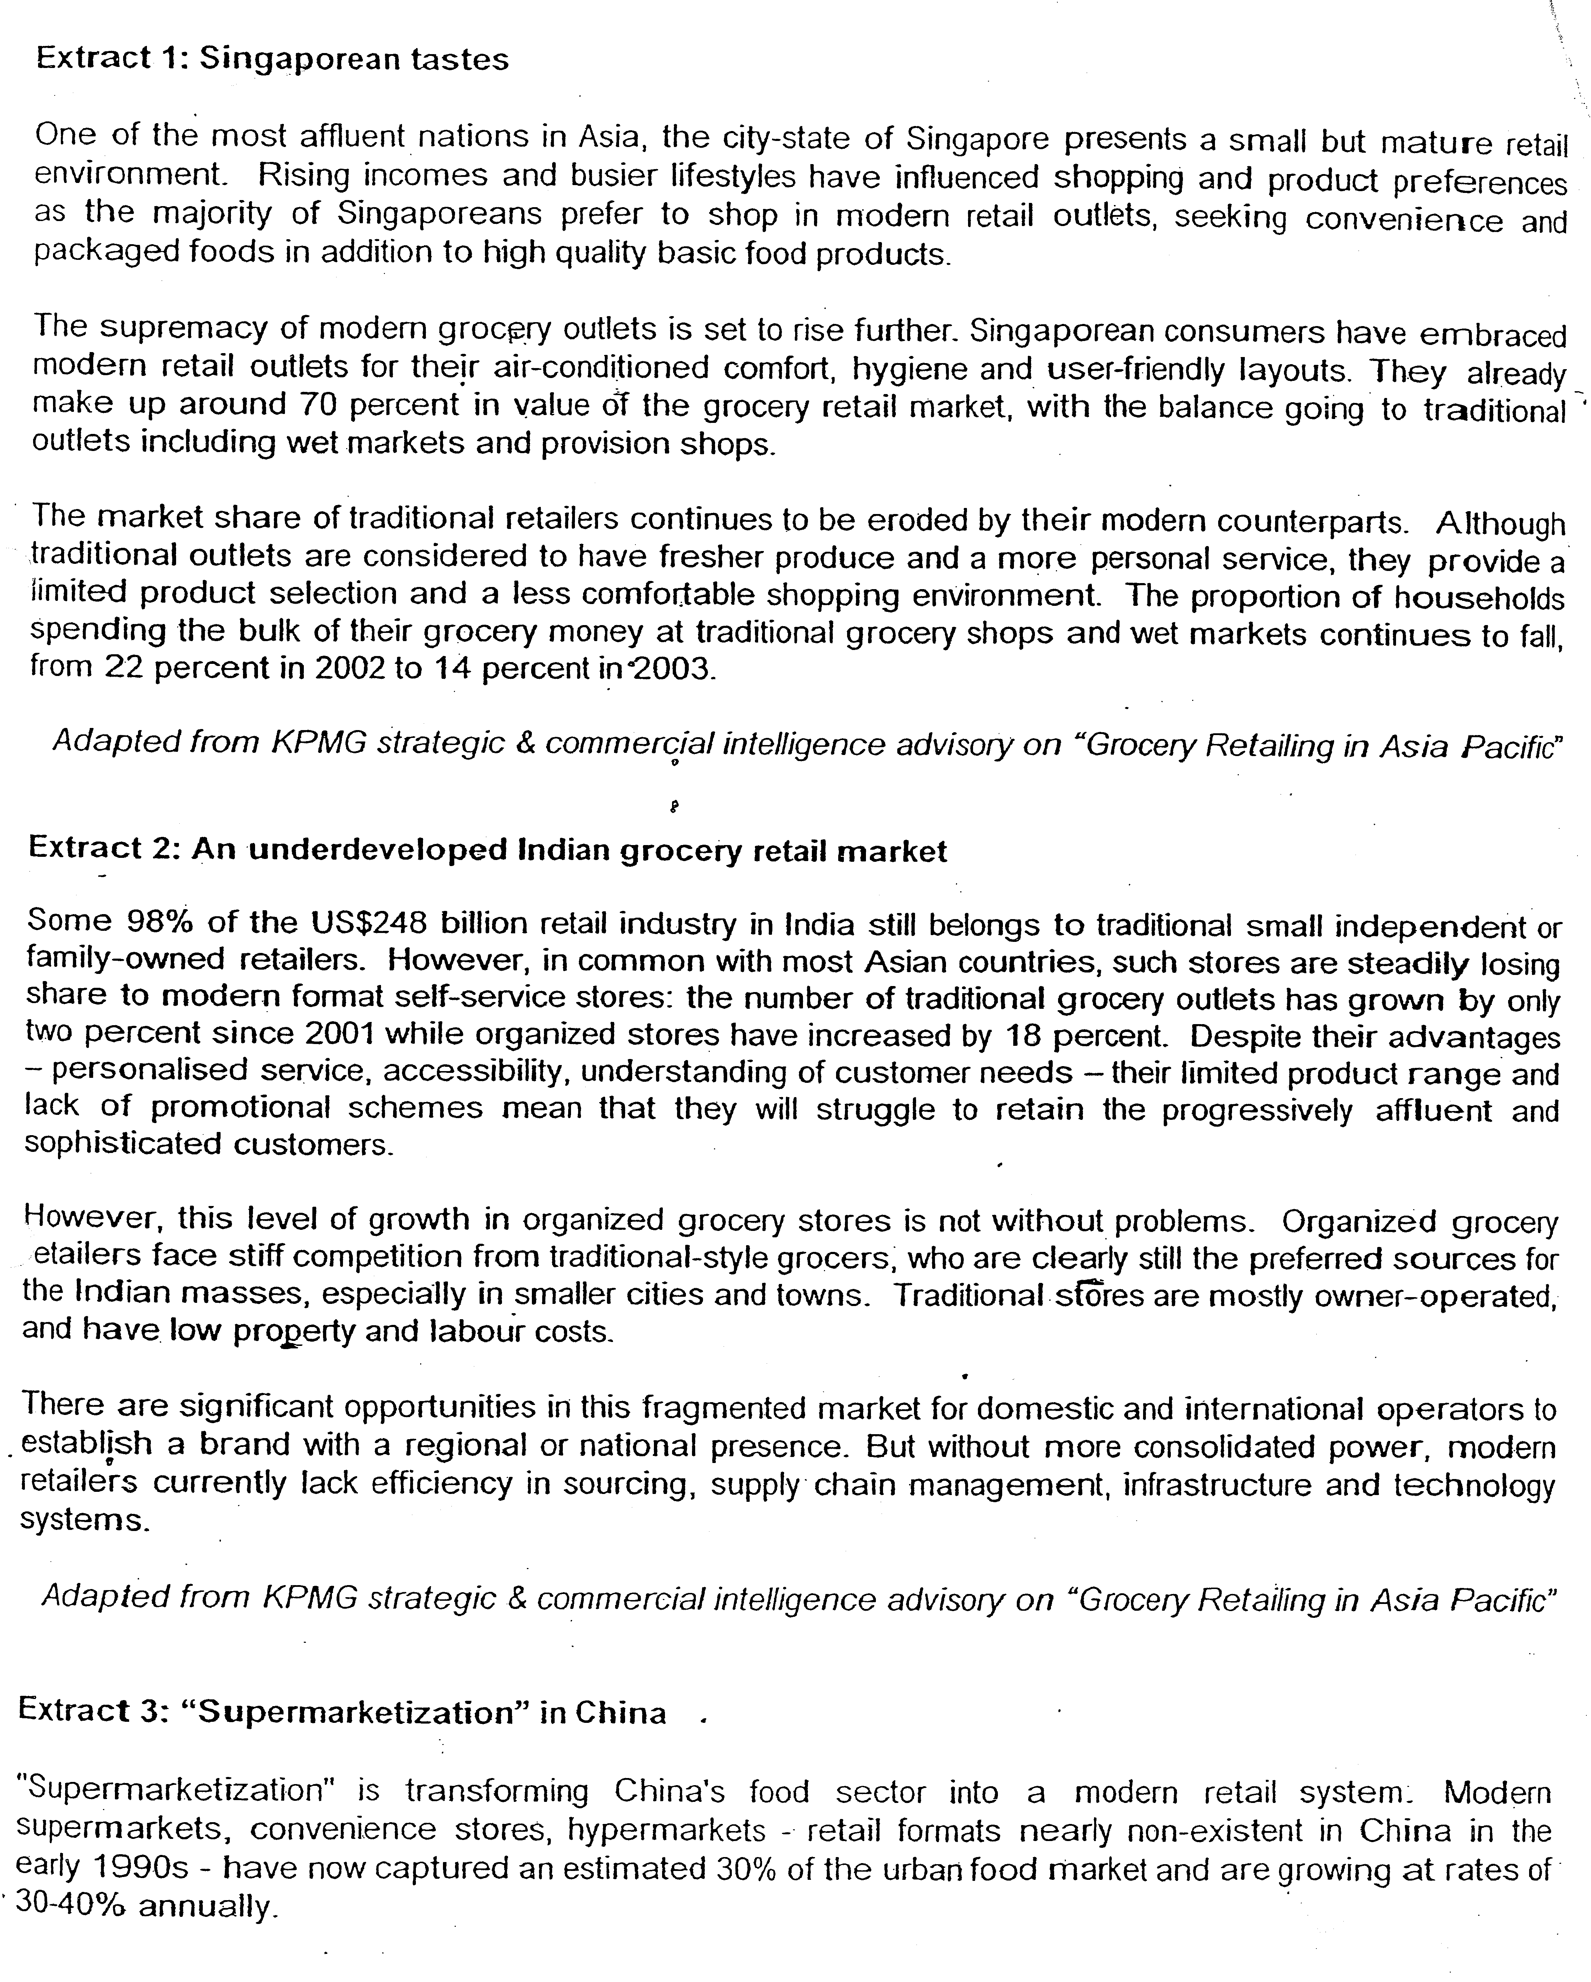$

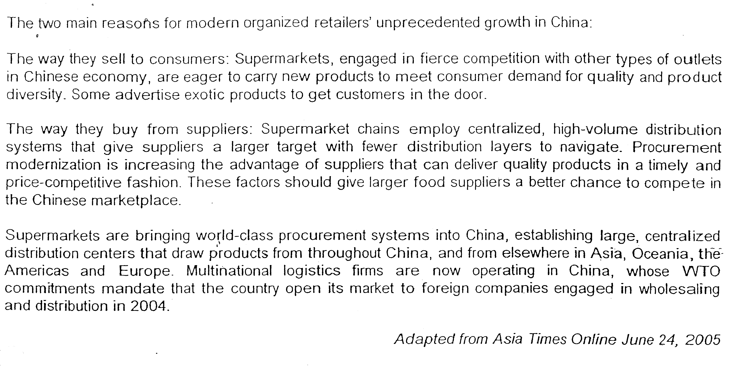

Source: IGD, 2005; KPMG analysis

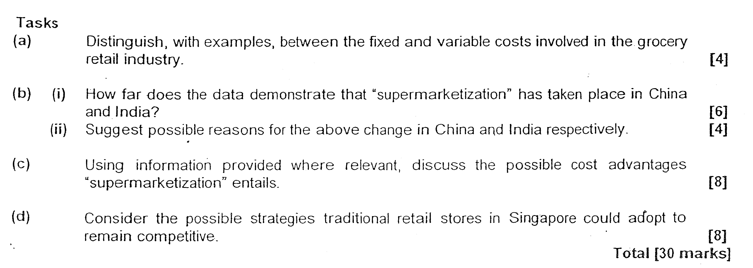

CSQ 2
Case study Answer - Topic 2 - Theory of firms (Cost and Production)
Title : Supermarketization

- Distinguish, with examples, between the fixed and variable cost involved in the grocery retail industry. (4) (idntify

Fixed costs are costs incurred by the firm on fixed factors of production that do not vary with any change in the level of output such as the expenditures on the insurance premium, cost of equipment and renovation cost. As for variable costs, the firm incurred this cost when the firms increases the usage of variable factors of production that will vary with the change in the level of output such as the expenditures on wages, utility charges and inventory cost.
This fixed cost is still incurred by the firm even when the production is zero and remains the same as the production level increases. As for the variable costs, it will only be incurred when the production increases and it can change at different rate as the production increases, depending on the law of diminishing returns which will depict the efficiency of utilization of fixed factors by variable factors.
When the cost is measured in average basis, the average fixed cost will falls sharply at the initial stage and more gently at the later stage as the total fixed cost is only dividable by a smaller output level at the initial stage and a larger output level at the later stage of production. As for average variable costs, it will decrease at the initial stage as marginal product is increasing due to more efficient rate of utilization of fixed factors by the variable factors but it will increase when there is over-utilization of the fixed factors by the variable factors.

    - How far does the data demonstrate that ‘supermarketization’ has taken place in China and India? (6)
(quote from the extraction to support/ extent (how far) – criticizes the inadequacy of the data)
As seen from extract 2, 'supermarketization' has indeed taken place as India's 'organized stores have increased by 18%' while 'the number of traditionally grocery outlets has grown only by 2%'. While in China, the growth of the supermarkets, convenience stores and hypermarkets have attained a remarkable 30-40% growth rate in 2004.
However, the pie chart by KPMG analysis has indicated that the traditional retailers still dominates 68% of the market share in the grocery retail sales in China. As for India, it is also known that '98% of the US$248 billion retail industry still belongs to traditional small independent or family-owned retailers. This implies that both countries have not embraced the modern retailing structures yet despite the growth rates.
Furthermore, the data is limited in depicting the trend development as the information only reflects the growth of the market in 2004 only. A greater understanding of the trend of growth is needed to provide a more supportive analysis as the trend development will not reflect the extent of growth over a period.
The data does not provide the geographical distribution of the concentration of stores with no comparison of the distribution among the rural and urban areas. Thus, it can be concluded that the data is limited in the evaluation whether 'supermarketization has taken place.

    - Suggests possible reasons for the above changes in China and India respectively?
(determinants of demand and supply of supermarket in China and india)
For China, the open-door policy to welcome foreign investment has induced the inflow of foreign direct investment by major international retailers which are organized in their business management. This will prompt the development of modern retailing structures.
Besides this, the Chinese consumers have changed their tastes and preference which induces the growth of mega retailing stores which offer a greater variety of goods and services.
As for India, there is lesser growth for the megastores as the Indian consumers still prefer personalized services which the traditional stores can offer, thus allowing the traditional stores to continue to operate. Furthermore, the lack of infrastructural support for the development of supermarket also undermines the growth and development of modern supermarket retailing. Intensified competition among the traditional stores has also prompted these stores to improve their services and management, leading to the survival of these stores.

- Using information provided where relevant, discuss the possible cost advantages supermarketization entails. (8)
(source of EOS and DEOS)
This development will enable the firms to reap economies of scale in many ways. Firstly, the firm can enjoy commercial economies of scale through bulk buying of raw materials and supplies at lower cost, it can also lower the cost of advertising and promotion since the cost can be spread over a large level of output. The firm can also reap technical economies of scale through the usage of better warehouse facilities, storage system and the application of the principles of multiples. Lastly, the firm can also enjoy risk hearing economies of scale by diversifying the sources of supply to attain cheapest source of the supply and reduce possibility of loss by having a move diversified market.
The firm can also enjoy external economies of scale when the retailing industry expands as there will be improvement in the logistics and distribution support with the set up of a centralized trading centre.
However, it the expansion exceeds the level where there is diseconomies of scale of production, the firm will experience higher average cost of production. This will happen when the firm experiences administrative and managerial diseconomies of scale where there is excessive duplication of work and delay indecision-making. Bureaucratic red-tape will undermine the production process as there is delay in decision-mating due to complexity in the organization. This will decrease productivity which will increase the unit cost of production.

- Consider the possible strategies traditional retailer Stores in Singapore could adopt to remain competitive. (8)
(reasons for the survival of small firms)
To stay competitive, the traditional retailers can improve their services by offering products that are preferred by the customers. This will mean that there retailers must have a good understanding of their customers. They also can extend their operating hour and personalized sales by doing special delivery to nearby customers, making it more convenient for their customers. The retailers can also improve their sales by doing bundle sales and other advertisings and promotions which are less costly with distribution of flyers.
It is also imperative for the traditional retailers to organize themselves to allow them to gain the advantages of EOS through joint ventures with other smaller retailers is bulk buying which will help them to lower average cost of purchase. They can group the other similar retailers in the neighbourhood to set up joint promotion to expand their sales volume and cultivate consumer loyalty.
The traditional retailers can also appeal to the government to provide grants for the upgrading of the various purchases of equipments like Point of Sales system to help them to upgrade their retail management. They can also participate in retail management training and development subsidized by the government to improve their services. These training programmes will raise their knowledge on how to improve their management in cost control and sales management which will enable the small retailers to attain profit maximization.
However, the solutions are not easily implemented. This is because the traditional relaters are handicapped with lesser resources and manpower to execute these solutions. The attitude of the traditional retailer is another determinant as they may not be willing to change their business models to adapt to the changes in the retailing market.
Nonetheless, it the solutions are well implemented it will be possible for the traditional retailers to co-exist with the mega retailers.

