Q1. Partnerships in the United States of America (US) can now issue tradable shares and can limit the amount of money that shareholders may lose. To which type of business organisation do these changes make US partnerships similar?
- co-operatives
- public corporations
- public limited companies
- sole traders
( )

Q2. Partnerships in the United States of America (US) can now issue tradable shares and can limit the amount of money that shareholders may lose. To which type of business organisation do these changes make US partnerships similar?
- co-operatives
- public corporations
- public limited companies
- sole traders
( )

Q3. What is an external economy of scale for a firm?
- agreeing to produce large quantities exclusively for a major retailer
- bulk buying of raw materials
- obtaining discount rates from suppliers
- sharing research from other firms
( )

Q4. In 2011, the UK-based Rio Tinto, the world’s second largest mining company, decided to bid for Australian Coal and Allied Industries, another mining company. Which economic concepts could be involved in this decision?
- amalgamation and external economies
- international finance and forward vertical integration
- monopoly power and horizontal integration
- multinational company and a more competitive market
( )

Q5. A firm opens new branches in four different cities. As a result, it can negotiate a better deal from its foreign suppliers because it purchases larger quantities. However, it finds the distance between branches causes organisational problems. What describes the result for the firm?
- an external economy of scale and an external diseconomy of scale
- an external economy of scale and an internal diseconomy of scale
- an internal economy of scale and an external diseconomy of scale
- an internal economy of scale and an internal diseconomy of scale
( )

Q6. In 2008, XL, the UK’s third largest tour operator went out of business. What would have been the effect of this on the level of competition in the industry, the external economies of scale experienced by the remaining firms and the level of business confidence in the UK?
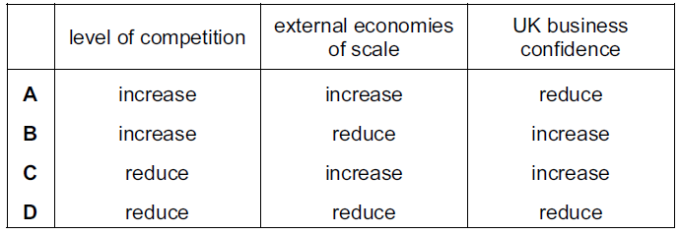
( )

Q7. When a firm produces 500 units its total variable cost is $1000. Its total fixed cost is $1500. What is the average cost of 500 units?
- $2
- $3
- $5
- $2500
( )

Q8. As a firm increases its weekly output from 10 units to 20 units, its average cost falls from $15 to $10. Which of its costs have risen?
- fixed costs and variable costs only
- fixed costs, variable costs and total costs
- total costs only
- variable costs and total costs only
( )

Q9. The table shows how a firm’s total cost rises with changes in output.
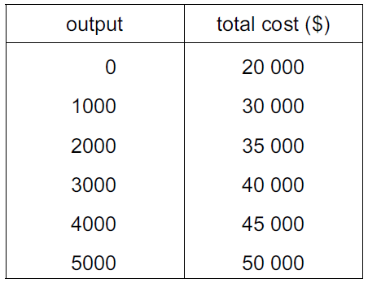

What is the average fixed cost of producing 5000 units?
- $4
- $5
- $6
- $10
( )

Q10. How does a firm guarantee that it makes the maximum profit?
- by maximising the difference between its total revenue and total cost
- by maximising the number of goods that it sells
- by minimising the amount of goods that it keeps in stock
- by minimising the difference between average revenue and average cost
( )

Q11. A Japanese company which has spare capacity has agreed to refine 20 000 barrels of oil a day for a Chinese company. What is likely to happen in the Japanese firm to fixed cost, to variable cost and to total cost?
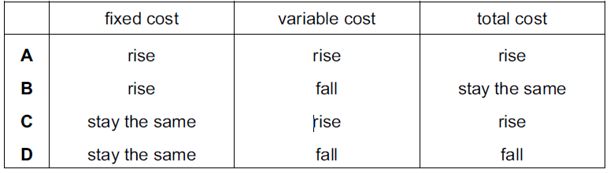
( )

Q12. Why might a government encourage a monopoly?
- It can have high average costs.
- It can compete against foreign firms.
- It can prevent innovation.
- It can make excessive profits.
( )

Q13. Which change would make the supply of a product more price elastic?
- an increase in the number of close substitutes for the product
- an increase in the proportion of firms working at full capacity
- a reduction in the time taken to make the product
- a reduction in the time that the product can be stored
( )

Q14. Many people are life-long, devoted fans of the Los Angeles Lakers basketball team in the United States. The team’s stadium can seat 19 000 spectators and tickets are always sold out.

What does this suggest about the price elasticity of demand and the price elasticity of supply of tickets to watch the Lakers play?
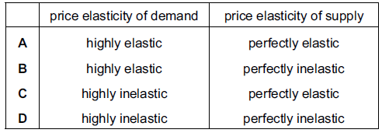
( )

Q6. The table illustrates the demand and supply for rice in a market in Africa.
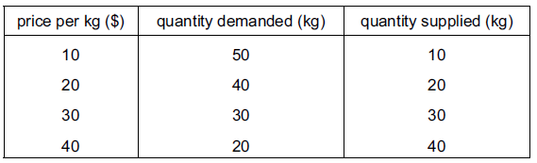

When the price rises from $20 to $30 per kg, what is the approximate price elasticity of demand for rice?
- 0.25
- 0.5
- 1.0
- 2.0
( )

Q15. The table illustrates the demand and supply for rice in a market in Africa.

When the price rises from $20 to $30 per kg, what is the approximate price elasticity of demand for rice?
- 0.25
- 0.5
- 1.0
- 2.0
( )

Q16. It was estimated that bread has an income elasticity of demand of 0.5. What can be concluded about bread from this information?

- It is a necessity.
- It is an inferior good.
- It has very few substitutes.
- It takes up a small proportion of household expenditure.
( )

Q17. It was estimated that bread has an income elasticity of demand of 0.5. What can be concluded about bread from this information?

- It is a necessity.
- It is an inferior good.
- It has very few substitutes.
- It takes up a small proportion of household expenditure.
( )

Q18. In which of the following circumstances will consumer surplus be zero?
- PED is perfectly inelastic
- PED is perfectly elastic
- PED is 1
- PES is perfectly inelastic
( )

Q19. It was reported that a company producing designer clothes had increased its revenue by 20 % at a time when it decreased its prices. What does this suggest about the demand for these goods at that time?
- It was perfectly price elastic.
- It was perfectly price inelastic.
- It was price elastic.
- It was price inelastic.
( )

Q20. It was reported that a company producing designer clothes had increased its revenue by 20 % at a time when it decreased its prices. What does this suggest about the demand for these goods at that time?
- It was perfectly price elastic.
- It was perfectly price inelastic.
- It was price elastic.
- It was price inelastic.
( )

