Market Structures (Type I) – Q1

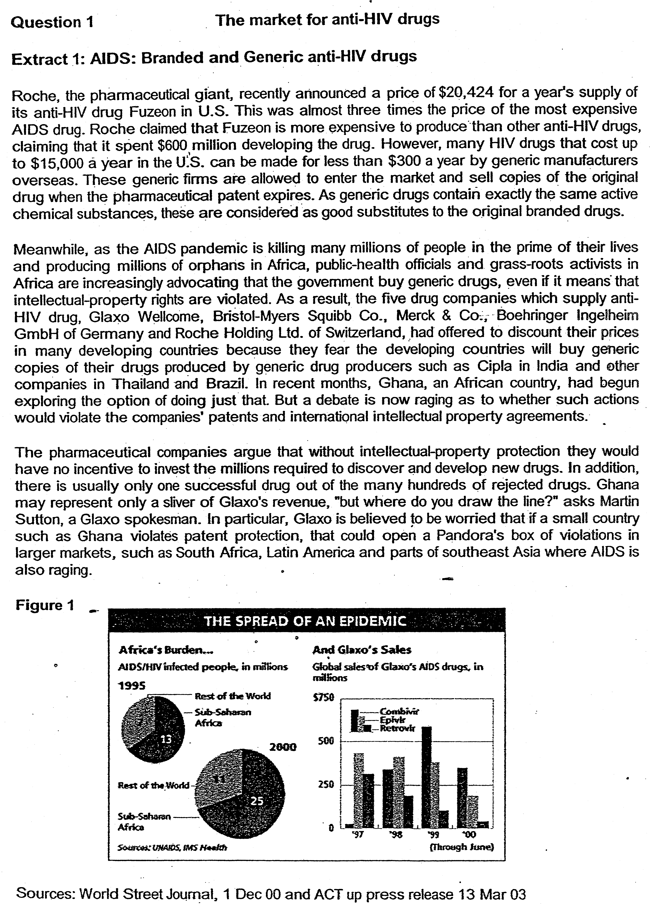

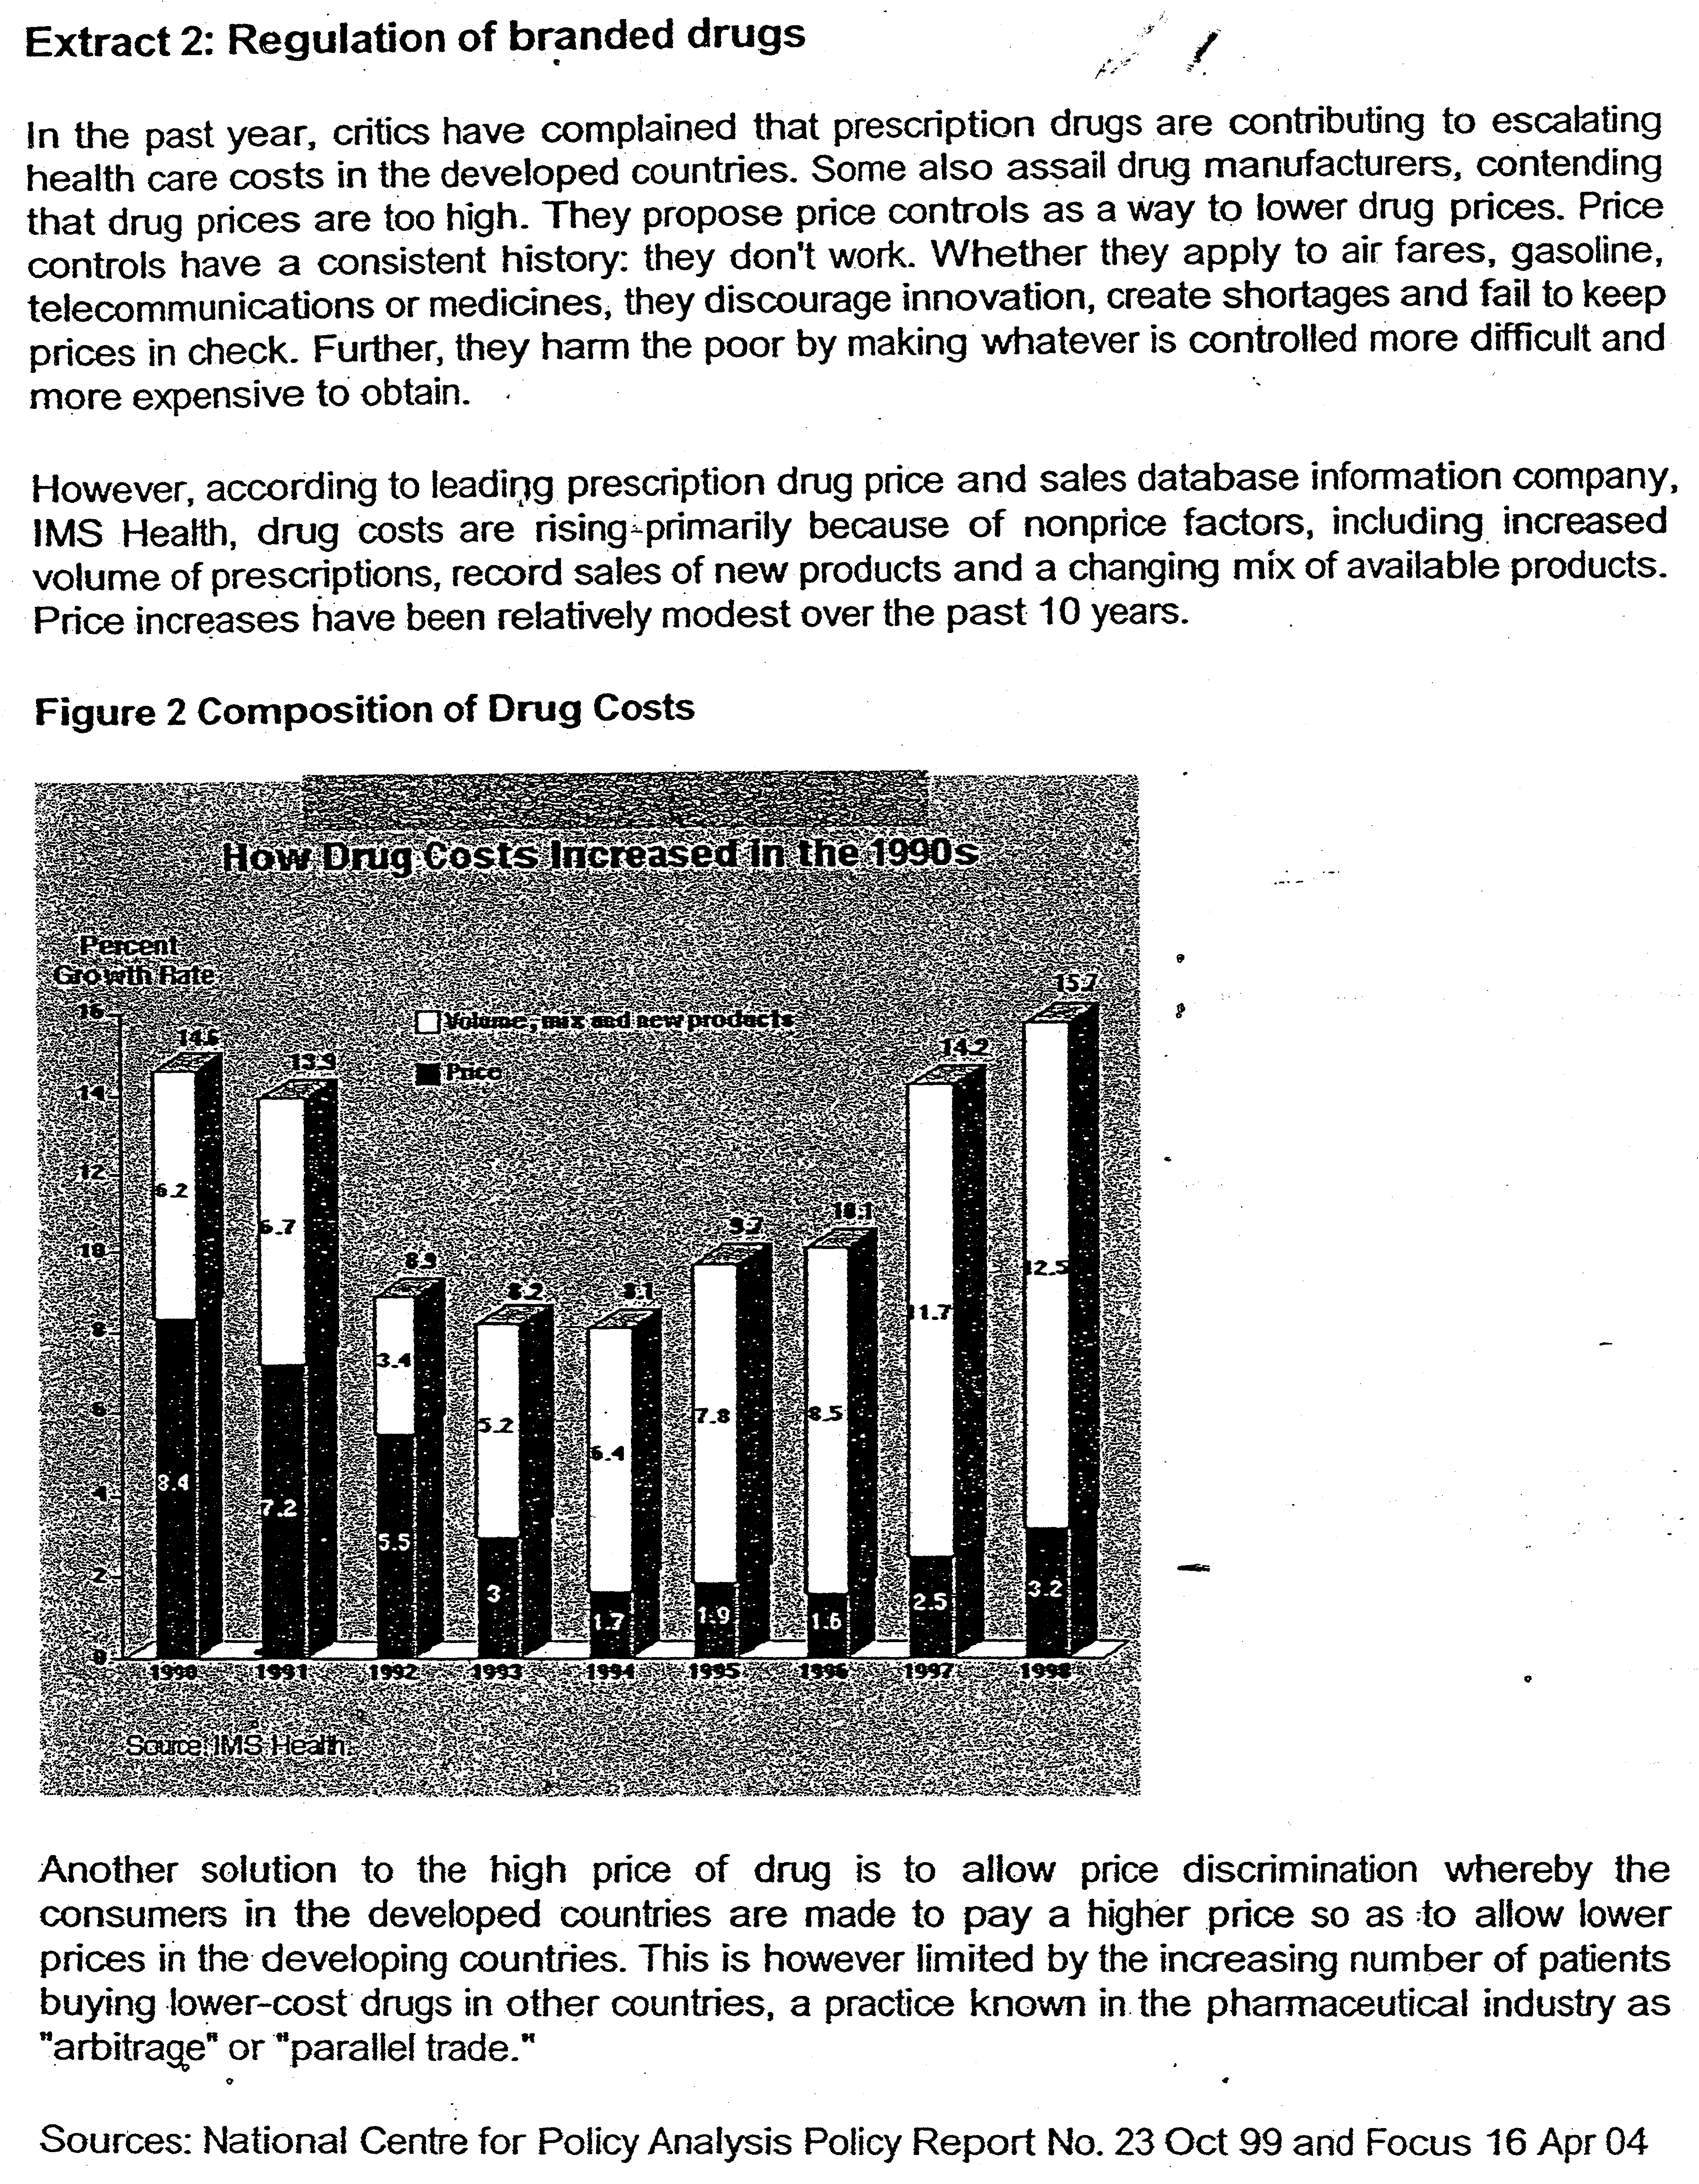

Questions
(a) (i)Drawing evidence from the data, identify and explain the type of market structure that the AIDS drugs producers operate in. [4]

(ii) With the use of data, assess whether government should implement price controls on AIDS drugs. [6]

(iii) Explain how price discrimination works in the market for AIDS drugs and analyse whether price discrimination can be effectively carried out in this market. [6]

bi.) Explain if the price discrimination would beneficial to the society. (8)

Suggested Answers

(a)(i) Drawing evidence from the data, identify and explain the type of market structure AIDS drugs producers operate in. [4]

AIDS drugs producers are likely to operate in a monopolistic or oligopolistic market [1] This is because of substantial barriers to entry to this market due to high cost of R&D and patents for new AIDS drugs. Thus, there are only few (five) branded AIDS drugs producers with substantial market power to set high price when they introduce new drugs (e.g. high price set by Roche) and large market share of the new branded drugs (e.g. rising sales revenue of Glaxo's Combivir to more than $500m in 1999).

However, with the violation of property rights by developing countries to buy generic drugs, the market may become more monopolistic competitive as the market share of branded anti-AlDS drugs fall.

Evidence of mutual interdependence as branded drugs come together to offer lower prices for their branded drugs in response to low price of generic drugs and to drive out generic drug producers.

Price is not as rigid as it should be suggesting that it may not be oligopolistic but monopolistic competitive. There is inadequate concrete evidence provided such as market concentration to prove that it is oligopolistic.

(ii) With the use of data, assess whether government should implement price control on AIDS drugs. [6]

In this case, the price control takes the form of a maximum price or price ceiling.
It is set below the equilibrium price.

Price ceiling is recommended because it lowers the current price of the costly drug and make it readily available to the lower-income AIDS patients, thus leading to a better distribution of income. This is especially true for rising number of patients in the developing countries. Furthermore, the market for AIDS drugs is imperfect because the demand for AIDS drugs is inelastic and patients may be exploited by the large drug producers due to lack of information- The market power of the AIDS drugs producers may enable them to reduce output to raise price beyond the marginal cost leading to allocative inefficiency and market failure. Thus, price control may be justified to reduce the market power of the large AIDS drugs producers.

On the other hand, a maximum price on AIDS drugs may not be desirable as it reduces the incentive of firms to produce and invest in costly innovation. As a result few new and effective drugs are discovered and there may be a shortage of AIDS drugs in the market as demand exceeds supply. A black market may result causing the price of AIDS drugs to be even higher and to be out of reach for the poor. Furthermore, according to Figure 2, the increase in drug cost is only due marginally to the increase in price of drugs but largely to cost of innovation. This shows that price control may cause the drug producers to incur losses resulting in fewer drugs introduced in the market.

(iii) Explain how price discrimination works in the market for AIDS drugs and analyse whether it can be effectively carried out in this market. [10]

Price discrimination refers to the practice of charging different prices for the same good in different markets for reasons not due to cost differences but due to different price elasticity of demand. In this case, higher price is charged in the developed country where the demand is more inelastic and lower price in the developing country where the demand is more elastic. In this way, the drug producer is able to maximize his total revenue.

For price discrimination to work, the producer must be able to control the supply of the good and separate the two markets to prevent resale of the good.

However, in this case, due to parallel sale of the drug from developing to developed country, the markets are not separated and thus price discrimination cannot work. Also, the drug producer may not have market power to control the supply of this drug as the generic drug producers have not complied with the patent and the governments of developing countries allow it to happen.

The falling sales of Glaxo's drug seem to suggest that the branded drug producers are not able to stop the generic drug producers from penetrating the market and thus preventing them from controlling the supply and practice price discrimination. Price discrimination will be more effective if the branded drug producers such as Glaxo can be successful in defending the patent rights and stopping the generic drug producers from penetrating the market.

bi.) Explain if the price discrimination would beneficial to the society. (8)

Price Discrimination: Definition & Characteristic

Conditions for Price Discrimination
- Two or more prices being charged
- The good in all situation must be exactly the same good
- Price differences must not arise out of cost differences
- The seller must be able to control the supply of the good and thus prevent the resale of the good from one market to another
- Ability of the monopolist to separate markets:
  - Geographically
  - Type of demand
  - Time
  - Nature of product (Different value of PED)
- Basis of assessment for discussion on whether price-setting is an act of price-discrimination
  - Examples – Weekend/Weekdays
    - Cinema tickets
    - Cruise tickets
  - Other examples
    - Photocopying
    - Auction

Price Discrimination: Definition & Characteristic

Conditions for Price Discrimination
- Two or more prices being charged
- The good in all situation must be exactly the same good
- Price differences must not arise out of cost differences
- The seller must be able to control the supply of the good and thus prevent the resale of the good from one market to another
- Ability of the monopolist to separate markets:
  - Geographically
  - Type of demand
  - Time
  - Nature of product (Different value of PED)
- Basis of assessment for discussion on whether price-setting is an act of price-discrimination
  - Examples – Weekend/Weekdays
    - Cinema tickets
    - Cruise tickets
  - Other examples
    - Photocopying
    - Auction

Advantages of Price Discrimination (Justification for price discrimination)
- Price discrimination makes it possible to supply a good which otherwise could not have been produced. For example, the services of a surgeon
  - Allow the surgeon to charge high price to sustain the provision of services – ensure that the loss from the lower price market is covered by the high price market
- Price discrimination makes it possible for a greater number of consumers to benefit from the product/services.
- May be used to cultivate customer loyalty
  - Encourage greater consumption
- Can allow the firm to produce above a larger quantity so as to reap EOS
  - Lower AC – raise profitability

Disadvantages of Price Discrimination
- It may be a form of consumer exploitation
  - Some consumers will pay at a higher price and there is allocative inefficiency
- It may also increase the cost of production
  - Cost of separation of market
- Cost in engaging in the change of product imagery
  - Inform the consumers about the change

