2013 T4 J2 CSQ Q5 – Unemployment, FP,MP
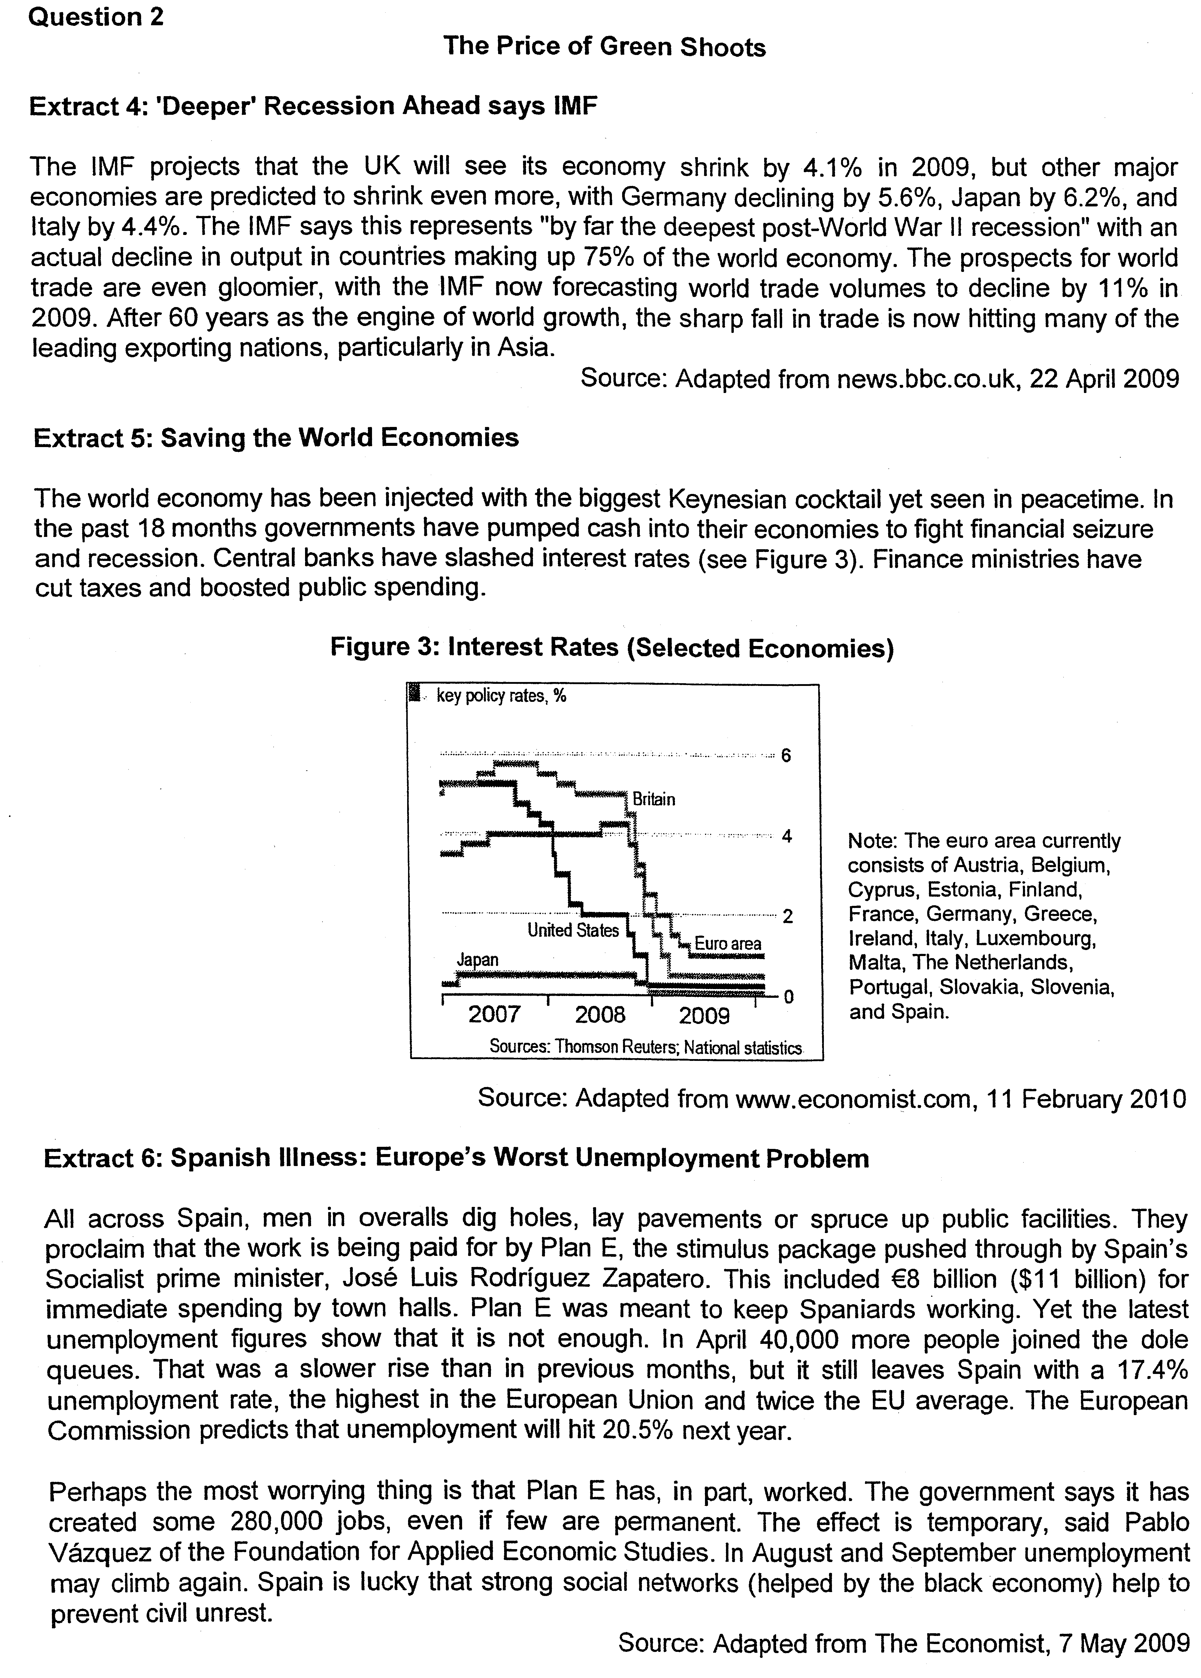

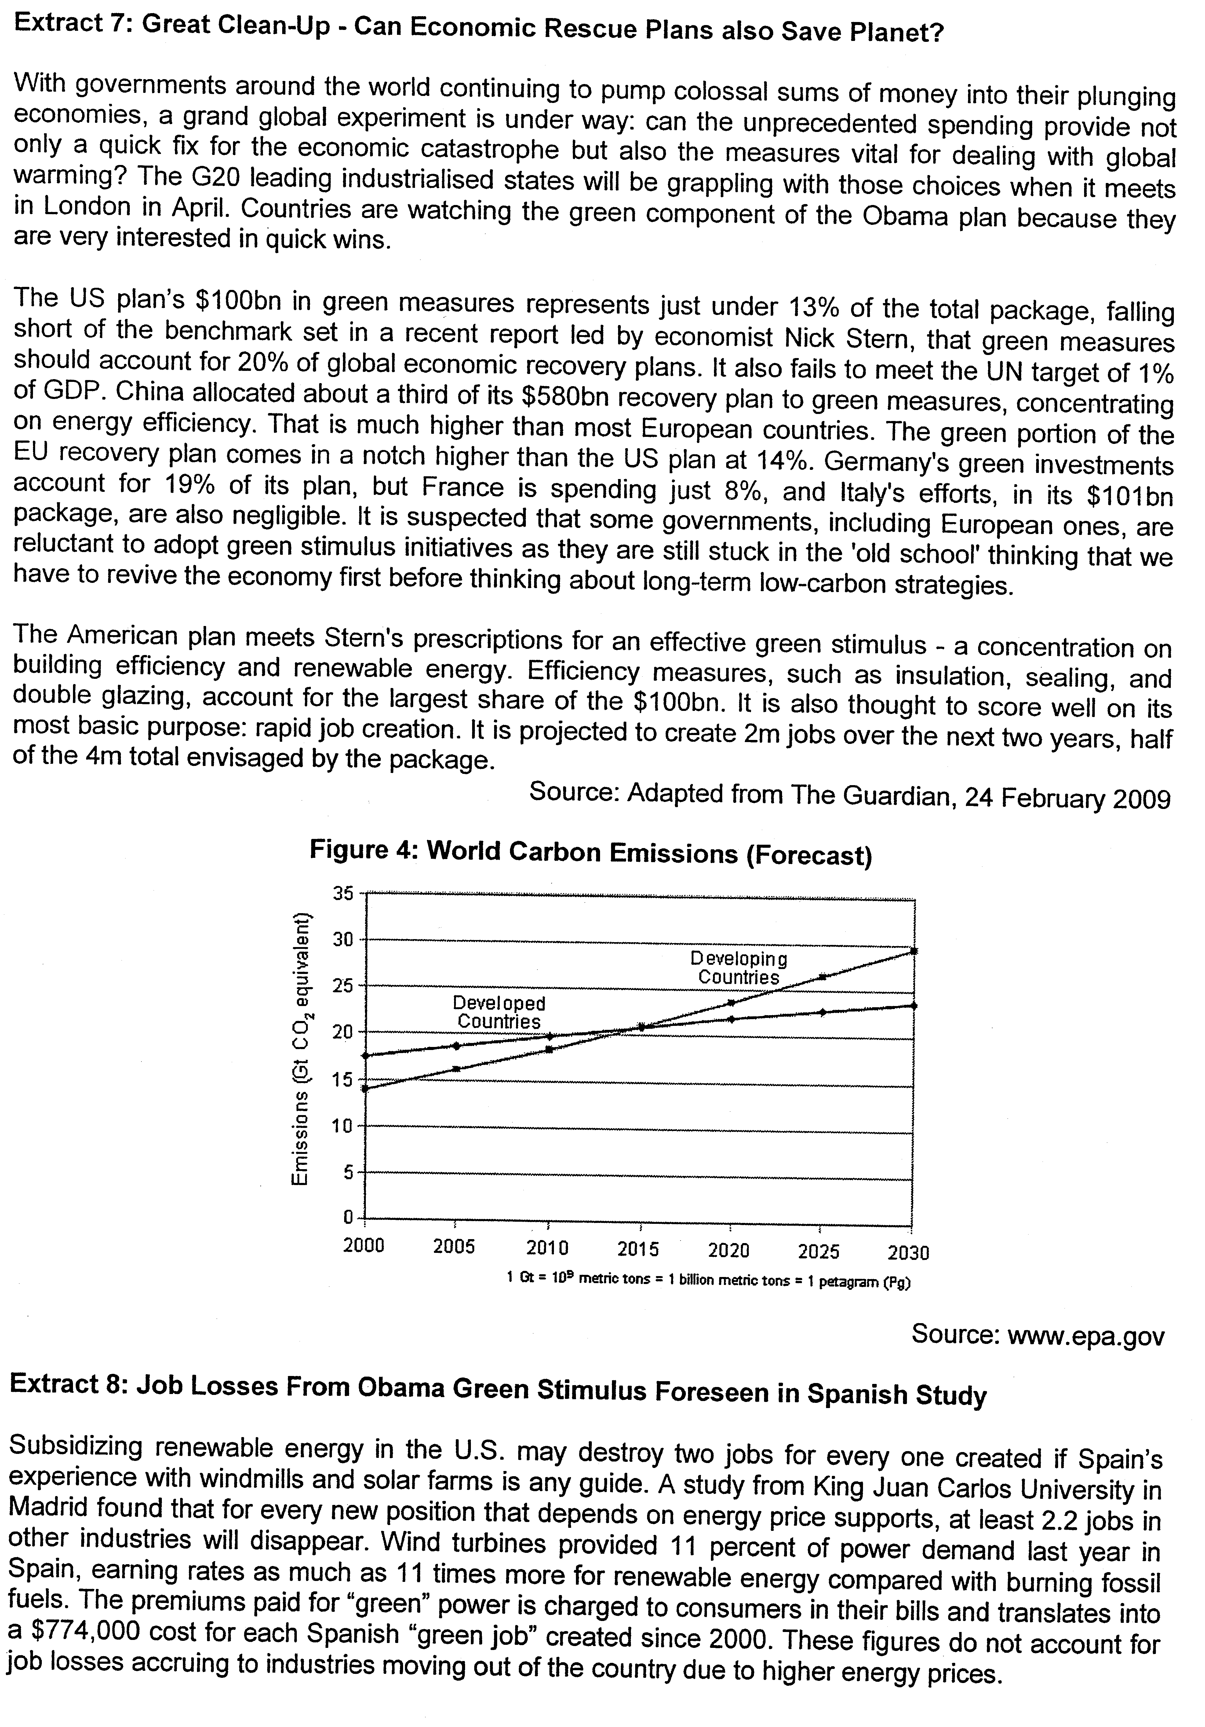

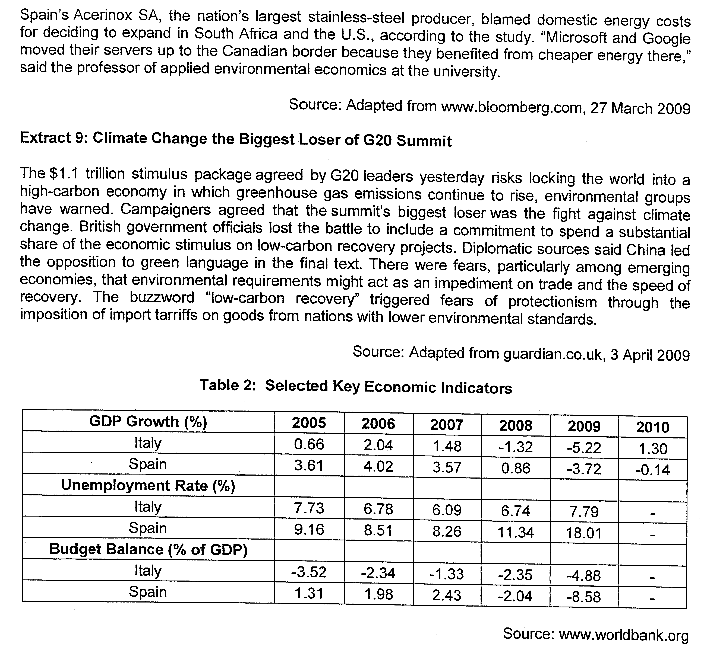
Questions
(a) Compare the trends in unemployment between Spain and Italy. [2]

(b) Account for the high rates of unemployment in Spain. [4]

(c) Explain how the existence of a black economy in Spain affects the accuracy of reported unemployment rates. [2]

(d) Explain why countries' budget balances will worsen in a recession. [4]

(e) Evaluate the use of demand management policies in reviving the economies of Spain and Italy. [8]

(f) Assess the view that a "low carbon recovery" would be beneficial to the global economy. [10]
[Total: 30]

Suggested Answers
(a) Compare the trends in unemployment between Spain and Italy. [2]

Unemployment rate in Italy and Spain both exhibited a rising trend. However, the unemployment rate in Spain rose by a greater extent.

Other acceptable points:
1. Unemployment in both Spain and Italy fell from 2005 to 2007 before rising again.
2. Generally, unemployment rate in Spain was higher than that of Italy

(b) Account for the high rates of unemployment in Spain. [4]

Demand side factor: The global recession has led to falling income levels worldwide. As import spending is income induced expenditure, the worldwide spending on Spain's exports hence falls. As exports is a component of Spain's aggregate demand, her AD falls and this leads to a fall in real GDP and output. This causes the derived demand for labour to fall and hence leads to cyclical unemployment in Spain.

Supply side factor: Secondly, dependence relatively expensive green energy has caused the cost of production for many firms in Spain to rise. As key manufacturing industries (Steel) shift production to other countries with a lower COP (South Africa / USA), these workers would lose their jobs and do not have the skills to take up jobs in other sectors, resulting in high structural unemployment.

(c) Explain how the existence of a black economy in Spain affects the accuracy of reported unemployment rates. [2]

The black economy refers to economic activities that are not reported and hence unrecorded by the government. People engaged in economic activities in the black economy are therefore considered to be unemployed even though that may be earning an income. This causes reported unemployment rates to be overstated.

(d) Explain why countries' budget balances will worsen in a recession. [4]

Define budget balance:
The budget balance is determined by the level of government spending and government revenue.

Effect of recession on G:
In a recession, the fall in national income and rising unemployment means that government spending will rise due to more unemployment benefits being paid out to the increased number of people on the dole (unemployed).

OR
In a period of recession, governments tend to increase government spending to boost AD and revive their economies. Such discretionary fiscal policies can be on subsidies, infrastructure or merit / public goods.
Effect of recession on T:
During a period of recession, rising unemployment and falling profit margins for firms will lead to lower tax revenue being collected from individuals (falling income) and firms (lower profits) even if tax rates remain the same.

OR
Governments tend to adopt expansionary fiscal policies by lowering income and corporate tax rates to stimulate C and I so as to boost AD and hence growth. Lower tax rates hence reduce government tax revenue.

Conclusion:
With higher government spending and lower government tax revenues, budget balances hence tend to worsen during a recession.

(e) Evaluate the use of demand management policies in reviving the economies of Spain and Italy. [8]

Introduction
The use of demand management policies focus on the use of expansionary fiscal policy and monetary policies which will raise economic activities to raise aggregate demand and thus, real GDP via the multiplier effect. This will help to solve the recession and the detrimental effects of unemployment.

Main Body
1. Explain how expansionary monetary policy works
    - When expansionary monetary policy is conducted, the government will increase the money supply through the buying of government bonds which will lower interest rate. This will lower the cost of credit consumption and reduces the reward for saving which will encourage more consumption and reduce willingness to save. Also, the level of investment will be raised as the level of profitability is raised since the cost of investment is lowered as lowering interest rates lowered the cost of borrowing. Consequently, there will be a rise in consumption and investment which will raise the aggregate demand, via the multiplier effect and thus raises the real GDP, production and employment.

2. Explain how expansionary fiscal policy works
    - Increase in government expenditure → increase aggregate expenditure directly through infrastructural development and provision of public services
    - Tax reduction → increase disposable income → raise consumption and increase return on investment, (lower tax on corporate earnings) contributing the rise in investment expenditure → rise in aggregate expenditure/national income (multiplier effect)
    - This will close up the deflationary gap and thus curb recession.

3. Evaluation of the effectiveness of expansionary monetary policy
- Interest-inelastic MEI due to market pessimism
- Impact on capital inflowoutflow of fund
- Lack of market demand to induce investment

4. Evaluation of effectiveness of expansionary fiscal policy
- Crowding out effect
- Temporary effect of government expenditure on employment Provision of employment is temporary. e.g. infrastructural development will stop employment when work is complete.
Conclusion
Italy and Spain faces high degree of hindrances in implementing expansionary fiscal policy/monetary policy under these circumstances. These two policies can only be introduced with the consideration of these limitations so as to ensure that they can achieve its aims.

f) Assess the view that a "low carbon recovery" would be beneficial to the global economy. [10]

Introduction
- Meaning of ‘low carbon recovery’
- Its impact on global economy can be both beneficial and detrimental

Main Body
1. Explain the benefits of ‘low carbon recovery’
- Achieve socially efficient allocation of resources (utilization affected by carbon emission)
- It will also raise the qualitative aspect of standard of living
- Using these new areas of development to create more economic activities to induce more production and employment, which will raise national income

2. Assess why the ‘low carbon recovery’ would not be beneficial
- Half-hearted implementation – uneven injection of fund by EU markets – may not be create the intended effects
- May not be able to create employment opportunities – Why?
- Spillover effect from the industry is limited and the impact on the economy is limited
- Size of unemployment is too large ↑ in government expenditure is unable to create enough production or services to create huge demand for labour as the unemployment rate is highest among EU members at 17.4%
- Time lag – production with massive employment needs planning by the government to implement
- High cost of financing – may raise public debt under current circumstances – Consequently, Italy and Spain may need to raise tax which will cut down disposable income and incentive to induce investment. Hence, this will lower aggregate demand components like consumption and investment and thus, dampening the expansionary effects of the fiscal policy

