GCE A Level H1 Economics 2019 Question 1

Tourism in the world economy

Extract 1: Travel and tourism – the global economic impact

Despite the increasing and unpredictable shocks from terrorist attacks, political instability, health pandemics and natural disasters, the travel and tourism sector continued to show resilience in 2016. Also, for the longer term, growth in the sector is expected to continue to be strong, so long as governments continue to invest in the necessary infrastructure.

The travel and tourism industry creates jobs, drives exports and generates prosperity across the world. Indeed, the sector currently supports 292 million jobs, roughly 10% of the world total, and this is forecast to rise to 380 million by 2027. This means that travel and tourism is forecast to provide at least 23% of global net job creation during the next decade.

Figure 1: Annual growth rates in global GDP and the travel and tourism sector, 2011-2016
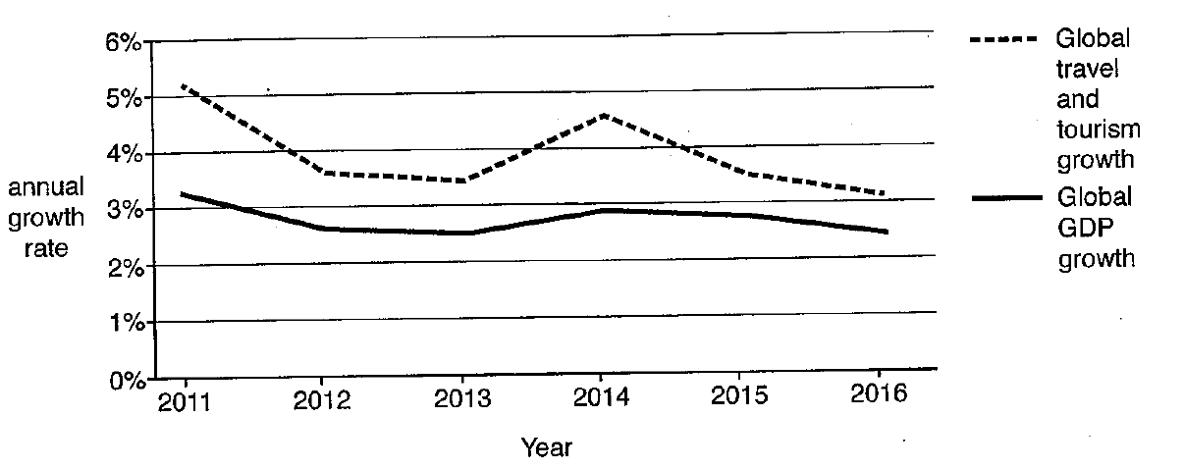
Figure 2: Global growth of selected industrial sectors, 2016
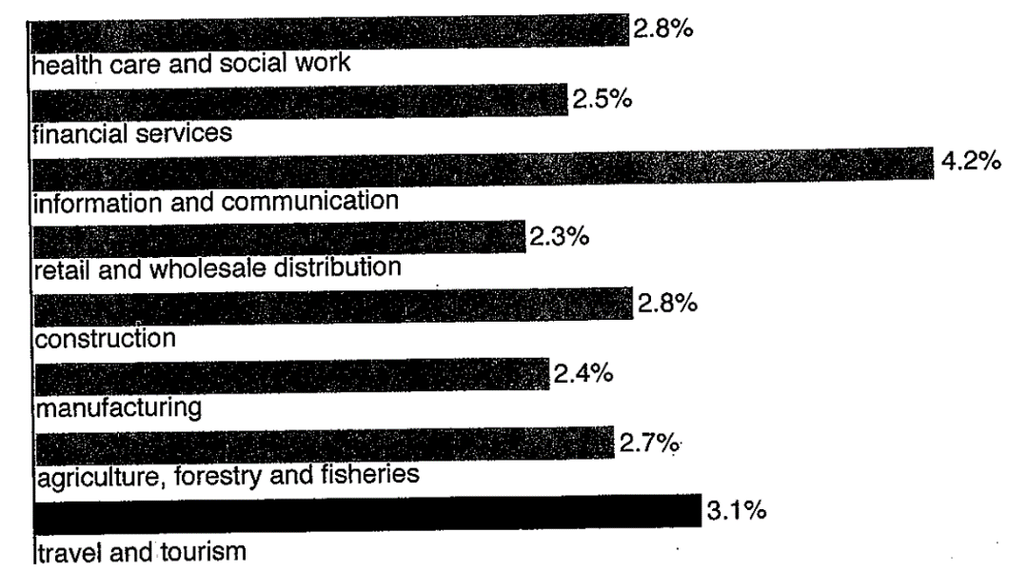
Source: Travel and Tourism, Global Economic Impact and Issues, World Travel and Tourism Council (WTTC), 2017.
Extract 2: Some individual cases

2.1 Singapore

Figures just realised by the Singapore Tourism Board (STB) showed both visitor arrivals and tourism receipts exceeding forecasts and hitting historical height in 2016, in spite of challenging economic conditions. Visitor arrivals grew 7.7% to 16.4 million, driven by growth in key markets where STB had been advertising heavily; for example, there were 36% more visitors from China. Meanwhile tourism receipts rose by 13.9% to S$24.9 billion, on the back of spending on food and beverages, shopping and accommodation. ‘Despite challenges such as a weaker economic performance in some countries that provide many of Singapore’s tourists, and a Zika virus outbreak in 2016, Singapore has managed to attract more high-spending visitors to contribute to economic growth’, said STB’s chief executive. The organisation had implemented a range of measures in 2015-2016 aimed at raising tourist members, including a S$20 million global advertising campaign to attract more visitors, as well as restructuring to improve the productivity of the hotel and travel agent industries.

Source: Channel News Asia, 14 February 2017
2.2 France

France is the world’s most popular tourist destination, but 2016 was a disaster for the French tourist industry; visits fell by over 8% compared with 2015. The number of nights spent in hotels in Paris in 2016 was as much as 21% lower.

The decision by the United Kingdom (UK) to leave the European Union (EU) has not helped, since it is France’s second biggest source of foreign visitors, and the fall in the value of the pound sterling (£) after the UK vote to leave has meant visits to France have become much more expensive for UK citizens. But terrorism is the main reason for the falling visitor numbers. Several recent atrocities, that claimed hundreds of innocent lives, have made Asians in particular wary of visiting France. Thus, while arrivals from the UK are down by 4%, arrivals from Japan and China are down by 40% and 23% respectively.

Interestingly, a recent study by the World Travel and Tourism Council (WTTC) showed that tourist numbers are actually quite resilient to terrorist attacks. The study showed that the length of time for tourist figures to recover to their pre-existing level were shown, on average, to be as follows:

After political unrest 27 months
After an environmental disaster 24 months
After a disease outbreak 21 months
After a terrorist attack 13 months

The French government is spending money on measures to reduce the likelihood of terrorist attacks so that France is seen as a safe place to visit, work and invest. The hope in France is that its government’s efforts to prevent future terrorist attacks will be successful.

Source: adapted from The Economist, 8 November 2016
2.3 Egypt

The country experienced a political revolution in early 2011, popularly-backed military coup in 2013 and then a series of high-profile airline disasters. The result has been disastrous for the country’s tourist industry. Tourist numbers recovered considerably after the shocks of 2011 and 2013, but by 2016 were 60% below their peak 2008 level. The impact on the whole economy ,including in particular foreign currency earnings and employment, has been devastating, and the government’s promises to take effective action to repair the economic damage have been ineffective.

Source: The Guardian, 21 October 2016

2.4 The UK

Record numbers of overseas visitors came to the UK in April 2017, and spent record amounts of money in ships, hotels and restaurants, giving fresh evidence of a boost to tourism from the recent steep fall in the value of the £. But the decline in the value of the £ has left potential British visitors overseas very much worse off.

Source: The Guardian, 16 June 2017

Extract 3: Effects of tourism

Tourists can bring many benefits, particularly in rural areas and developing countries, but mass tourism is also associated with downsides. The effects can be considered under three categories:

ECONOMIC

Tourism creates employment, both directly, within the tourism industry, and indirectly, in sectors such as retail and transportation. It is estimated that the multiplier effect of increased tourist expenditure in the UK is 2.8. Small-scale local firms, particularly those in rural districts, also stand to gain from tourism. In addition, tourism generates extra tax revenues, which in turn can be used for such things as schools and hospitals. For the UK, it is forecast that in 2023, for the first time in forty years, spending from inbound tourism will exceed that from outbound tourism.

There are economic downsides. The cost of providing relevant infrastructure – roads, visitor centres, etc. – usually falls on the government, which means spending out of limited tax revenues. Jobs in tourism are often low-paid and seasonal, yet tourism can push up local property prices and the cost of living. And money generated by tourism sometimes leaks away to huge multi-national companies.

SOCIAL

The local community benefits from tourist-related spending infrastructure, and possibly from the preservation of local traditions and landmarks that otherwise might have been allowed to decline. Interchanges between local and visitors can help cultural understanding, too.

On the other hand, visitor behaviour can have a harmful effect on local people, for example through congestion or increased levels of crime, and traditional culture and values can be eroded.

ENVIRONMENTAL

Tourism that focuses on nature in particular helps promote conservation of natural resources and can help to generate funding for environmental improvement schemes. Employment opportunities in eco-tourism can also help to prevent harmful actions such as over-fishing and deforestation.

However, tourism also poses threats to the environment in the areas of clean water supply, coral reefs and heritage sites, due to the overuse and overcrowding of these resources. Increased pollution through traffic emissions, litter and noise is also an obvious problem.

Sources: Positive and Negative Effects of Tourism, usatoday.com, and visitbritain.org/visitor-economy-facts

Questions

(a) With reference to Figure 1, compare the growth of travel and tourism to the growth of total world output from 2011 to 2016. [3]

(b) Assess whether or not the statement in Extract 2.3 that the Egyptian ‘government’s promises to take effective action to repair the economic damage have been ineffective’ is a normative one. [4]

(c) Using a supply and demand diagram, explain the likely effects on Singapore’s tourism market of increased advertising expenditure by the STB and the initiatives to improve productivity of the hotel industry. [6]

(d) Explain what is meant by the statement in Extract 3 that ‘it is estimated that the multiplier effect of increased tourist expenditure in the UK is 2.8’, and comment briefly on how reliable this estimate might be. [5]

(e) Explain how UK hotel owners might use the concept of price elasticity of demand to estimate the effect on their revenue of a fall in the value of the pound sterling (£). [8]

(f) Discuss the likely impact on the macro-economy in a country such as France of significant additional government expenditure on measures aimed to reduce the likelihood of terrorist incidents. [9]

(g) Discuss the view that the best way for governments to minimise the effects of the negative externalities arising from increased inbound tourism is to impose an indirect tax on all tourist expenditure. [10]

[Total: 45]

