CSQ 2010- Cost of Production – Q2
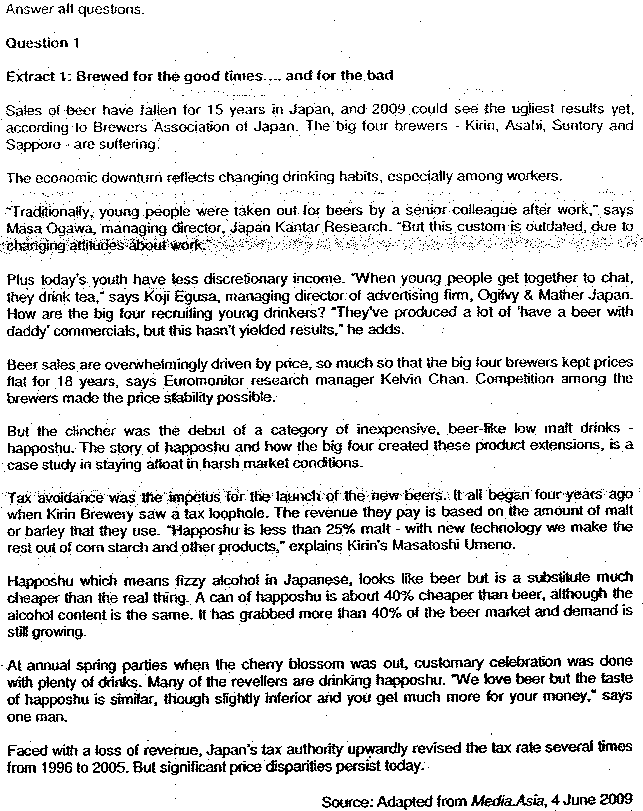

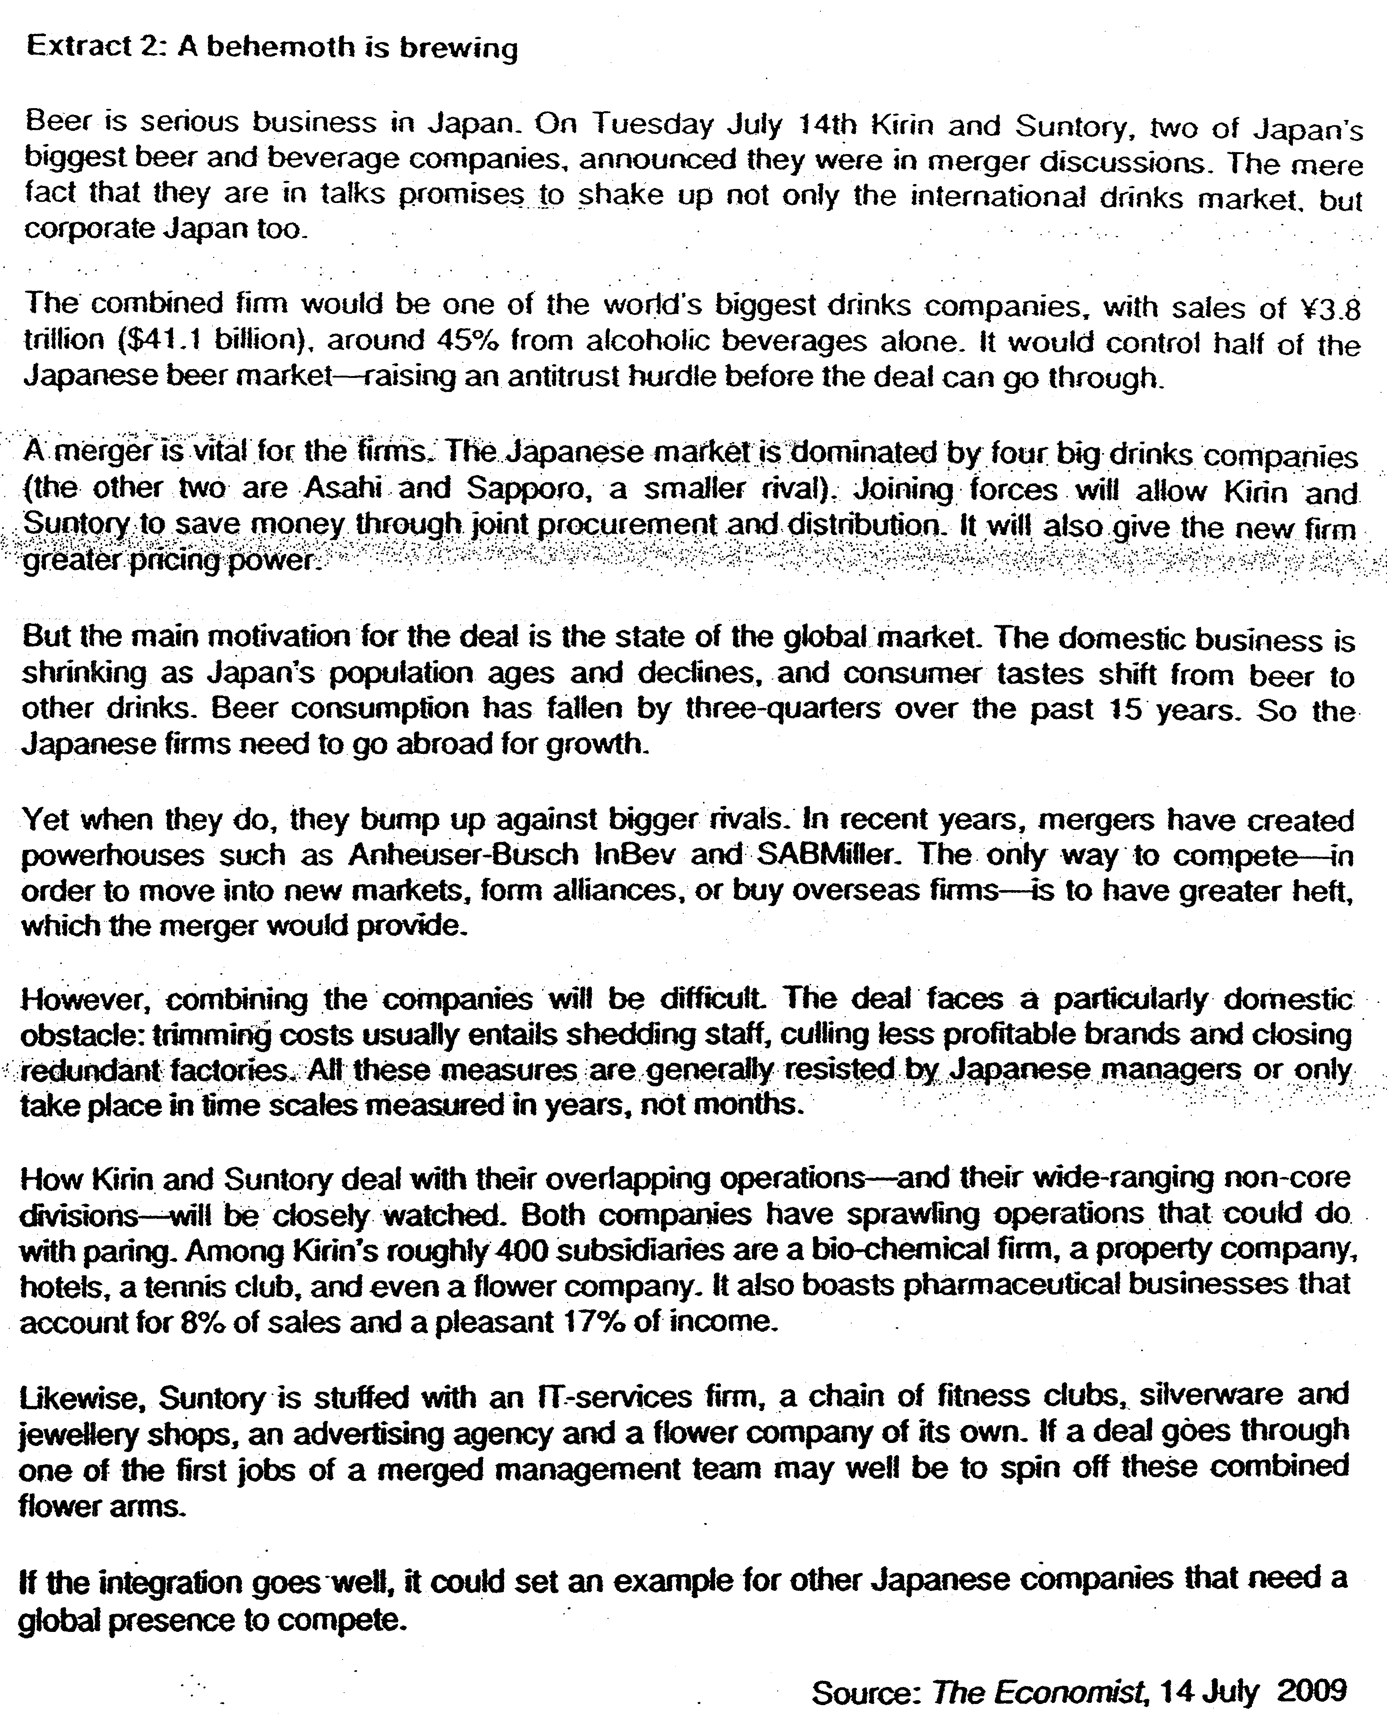
Sx 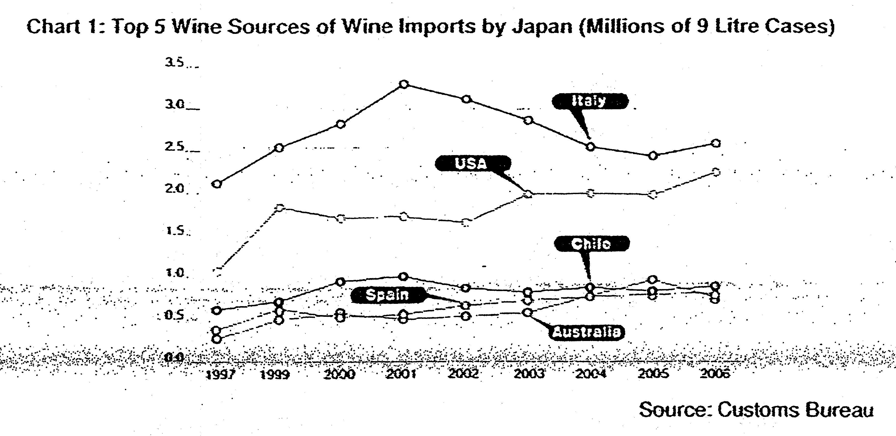

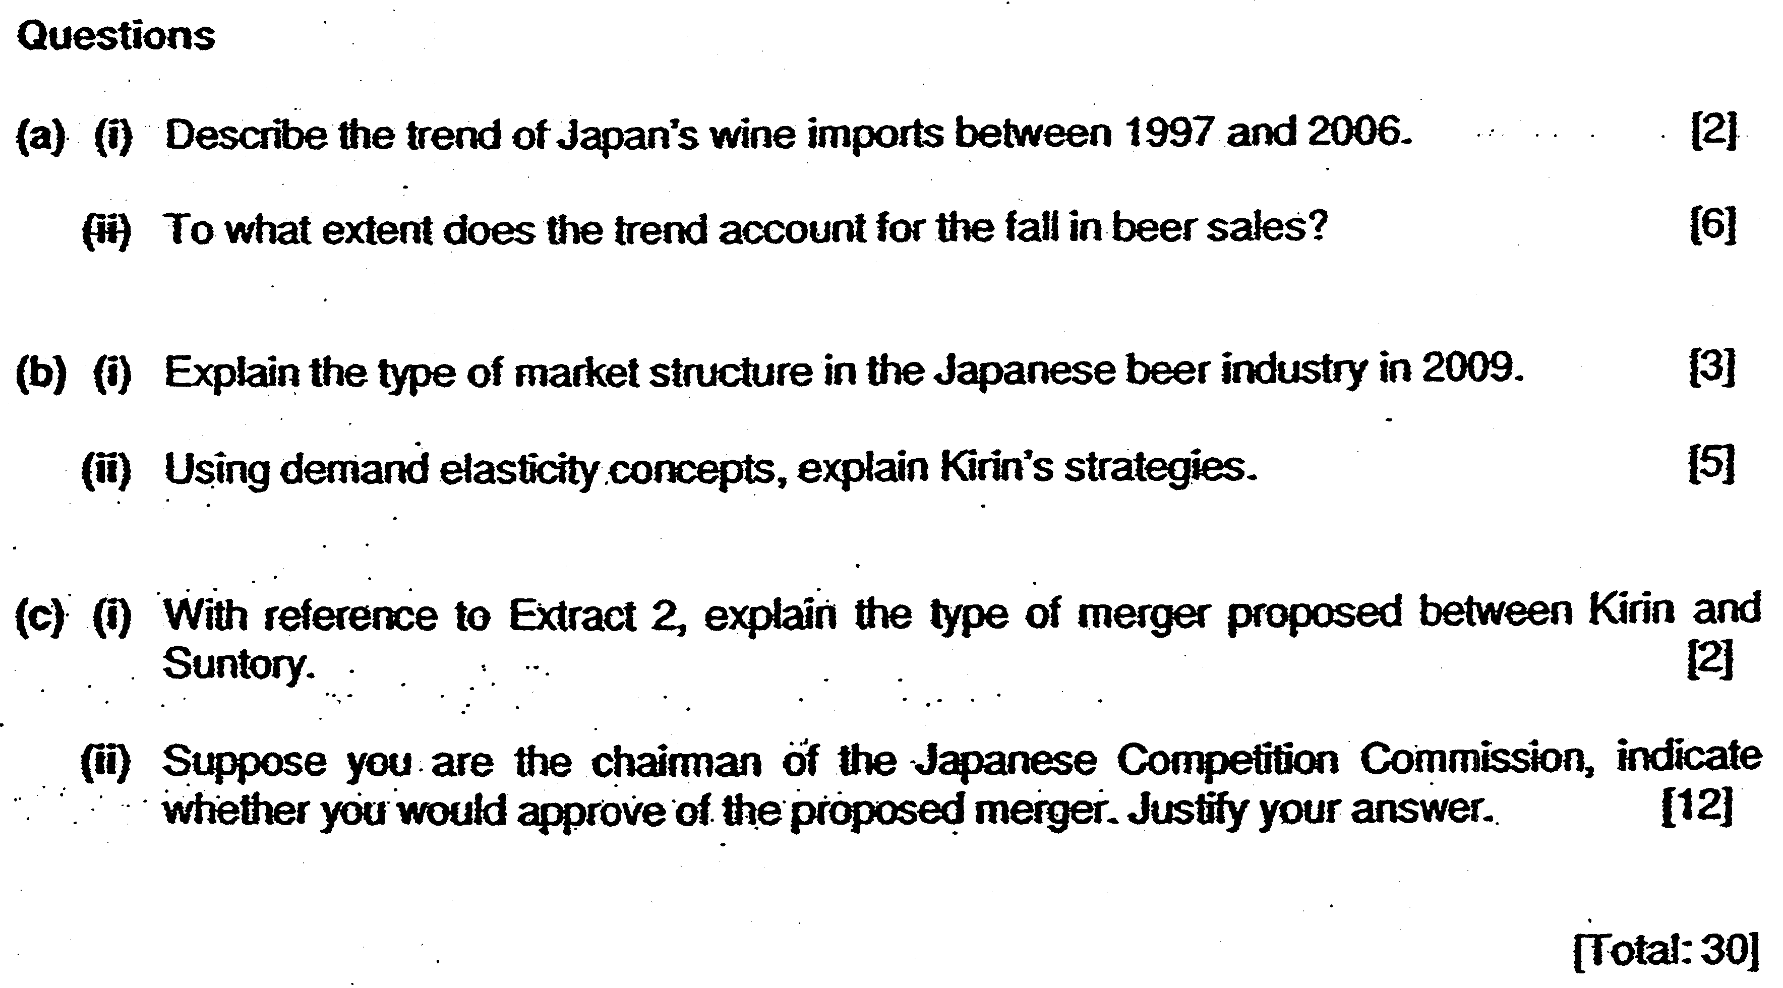

RJC Paper 1: Case Study
Case Study Question 1
(a) (i) Describe the trend of Japan's wine imports between 1997 and 2006. [2]

It is an increasing trend (1m) with the largest source of imports being from Italy OR with the largest increase (1.2 million) coming from USA (1m),

(ii) To what extent does the trend account for the fall in beer sales [6]

Thesis:
Beer and wine are close substitutes: Therefore, if the demand for wine has increased, it is likely that the demand for beer has fallen since they are both alcoholic drinks and serve the same needs of the consumers and satisfy similar wants. (2m)

Anti-thesis: (Any two reasons-4m)
•Changing tastes and preferences. Japan's youth today have changing attitudes about work - having a drink after work with colleagues seems to be out-dated, thus impacting on their reduced consumption of beer.
•Fall in income. 'Economic downturn* results in a fall in disposable income and thus a fall in ability to purchase beer which is a normal good.
•Population ages. The ageing population results in a change In demographics and Japan's older generation, who are the main consumers of beer ages, thus resulting the fall in demand for beer.

(b) (i) Explain the type of market structure in the Japanese beer industry in 2009. [3]

It is oligopoly. (1m)

Characteristics of Oligopoly | Evidence
Presence of dominant firms in the industry | Chart 2 shows a 4-firm concentration ratio of about 99%.
Price rigidity due to mutual interdependence | Mutual interdependence between the various firms as implied by the line 'Competition among chain retailers made the price stability possible,thus if anyone of the four firms raises it price, the others will not follow, but if they decrease the price, competitors will follow. So price has remained stable for 18 years.

Note: Full marks are awarded if for an answer that link evidence to the characteristic.

(ii) Using demand elasticity concepts, explain Kirin's strategies. [5]
Elasticity Concepts | Strategies
Cross-elasticity of demand | - Define CED  - Explain that CED between Kirin beer and other brands is positive and high, likely greater than 1.  - When the price of rival beers fall, demand for Kirin's beer wilt fall more than proportionate.  - Reason: There are many close substitutes of different brands.  - Strategy:  - If a close competitor lowers price, Kirin has to follow suit so as to prevent a huge fall in demand.  - At the same time, to prevent price war, Kirin has to reduce the degree of substitutability between its beer and other beers through advertising e.g. 'a beer with daddy7commercials' (extract 1) which will build brand loyalty. This will prevent Kirin's revenue from decreasing drastically due to a fall in demand should other beer companies lower their prices.
Income elasticity ofdemand | - Define YED.  - •Explain that YED for Kirin beer is high, likely greater than 1as it is a normal good.  - When Income falls, demand for beer falls by more than proportionate and TR falls  - Reason: Beer takes up a relatively large portion of the income of the youth and workers (extract 1 para 3 and 4).  - Strategy:  - By introducing an inferior good, happoshu which has a negative income elasticity of demand. Demand for happoshu will increase when income falls and this will lead to an increase in revenue from happoshu. This will make up for the loss of revenue from beer sales due to falling consumers' income. Kirinrs TR may therefore increase.  - OR  - Introduce a less luxurious product which has a smaller income elasticity value, i.e. Happoshu which is cheaper and the taste of which is 'slightly inferior*. Any further economic downturn will not see fall in sales of happoshu to any large extent because of the low income elasticity. Therefore, TR may not fall to a large extent

• A maximum of 4 marks for answers that do not link to effect on TR.
- A maximum of 3 marks if the one/both strategies discussed in the answer do not come from the case material

(c) (i) With reference to Extract 2, explain the type of merger proposed between Kirin and Suntory. [2]
Type of Merger:
Horizontal Merger

Definition:
This occurs when firm takes over a similar firm at the same stage of production in the same industry

Evidence:
Two of Japan's biggest beer and beverage companies' with overlapping operations

Type of Merger:
Conglomerate Merger

Definition:
Conglomerates have been defined as those mergers, which are neither substantially vertical nor horizontal. They are generally understood to be combination of firms which are not directly related to one another.

Evidence:
Among Kirin's roughly 400 subsidiaries are a bio-chemical firm, a property company, hotels, a tennis club, and even a flower company and Suntory has an IT-services firm, a chain of fitness clubs, silverware and jewellery shops, an advertising agency and a flower company of its own.

Either answer with explanation is acceptable for 2 full marks.

(ii) Suppose you are the chairman of the Japanese Competition Commission, indicate whether you would approve of the proposed merger. Justify your answer. [12]

Introduction:
State objectives of the Japanese Competition Commission:
•Promote greater competition
•Address anti-competitive practices by firms in the Japanese market

From Extract 2 paragraph 1, firms such as Kirin and Suntory, which are two of the largest beer and beverage companies are having plans to merge their operations.

Body:
Thesis: Merger should be approved.

Reasons:
•Cost savings can be passed on to consumers through lower prices.
By merging to achieve greater scale of production, companies such as Kirin and Suntory are able to enjoy greater internal economies of scale through marketing economies such as bulk purchase of key inputs like the ingredients, aluminum, lower unit costs of advertising as well as distribution costs (Extract 2 para 3), Such cost savings can be passed on to consumers in terms of lower prices, enhancing consumer welfare.

•Increased global cost competitiveness to increase sales overseas
With the lower unit cost of production, the enlarged merged firm is able to price their product more competitively in the global market. This is especially crucial as in the global beer market,
Japanese firms like Suntory and Kirin need to achieve 'greater heft' by merging to compete better in terms of pricing against the likes of major producers like Anheuser-Busch InBev and
SABMiller which are likely to already enjoy substantial internal EOS given their large market share (Extract 2 para 5).

•Ability to enjoy greater economies of scope.
As both Kirin and Suntory do have existing products and services other than beer production,
(Extract 2 para 7-8) through a conglomerate merger, it can perhaps achieve spin-offs among selected product lines by tapping on the synergies between products and services. For instance the merged firm can attempt to bundle its hotel services, silverware and jewellery and fitness club services together to offer a more complete range of products to customers, thus benefiting the consumer.

• Ability to earn and retain sufficient supernormal profits for product innovation.
With the merger of Kirin and Suntory, the merged firm is able to enjoy greater market power in the form of “greater pricing power” through its enlarged market share. With the ability to earn and retain sufficient high level of supernormal profits, Kirin and Suntory have greater ability and incentive to product innovate their beer products to compete more effectively against major beer companies in the global market. Product innovation can also benefit consumers through improved product quality and variety.

Anti-Thesis:
• Worsens ailocative Inefficiency
The beer industry in Japan is an oligopoly as explained in b(i). With the merger, the degree of competition in the beer industry is further reduced. The newly merged firm enjoys greater market power and with its increased pricing power, it has the ability to set higher prices and reduces output. The difference between price and marginal cost is now even greater and hence allocative inefficiency is worsened.

•Results in productive Inefficiency,
With the merge in the beer industry may result in the enlarged firm being cost inefficient and not adopting production processes that are productive efficient

•Gains internal EOS that acts as barrier to entry that limits competition in the beer industry.
With increased market dominance, newly merged firms have the advantage of its substantial internal EOS in the domestic market which acts as a barrier to entry to deter competition.

• Inequity.
With greater degree of market dominance, the merged firm can raise prices and restrict output therefore being able to raise their level of supernormal profits. Such profits are now concentrated in the hands of the merged entities at the expense of consumers who have to bear with the higher prices charged by the dominant merged firms. This results in greater inequity.

• Higher incidence of unemployment in the beer industry due to rationalisation.
Merger of the two firms involves "shedding staff, culling less profitable brands and closing redundant factories/ Due to the need to streamline operations in the merged firm to avoid duplication of operations and functions and reduce costs, workers which are deemed to be surplus to requirements may be retrenched.

Conclusion:
Given the potential benefits and drawbacks of the merger, decision on whether to approve of the merger need to be made by weighing the benefits against the costs of the merger. A case can be made to approve of the merger in view of the high degree of need to allow the Japanese beer companies to be able to compete better globally (Extract 2 para 4 :T3eer consumption has fallen by three-quarters over the past 15 years. So the Japanese firms need to go abroad for growth.")

In addition, the Competition Commission may recommend alternative measures such as:

Opening up the Japanese market to foreign competition through liberalization and deregulation so as to inject greater competition in the domestic market. This will give added impetus for
Japanese firms to seek product innovation and undertake essential restructuring of their production processes to achieve greater cost efficiencies.

