\

JC Economics CSQ – Term 3 2014
Inflation/Unemployment Q2

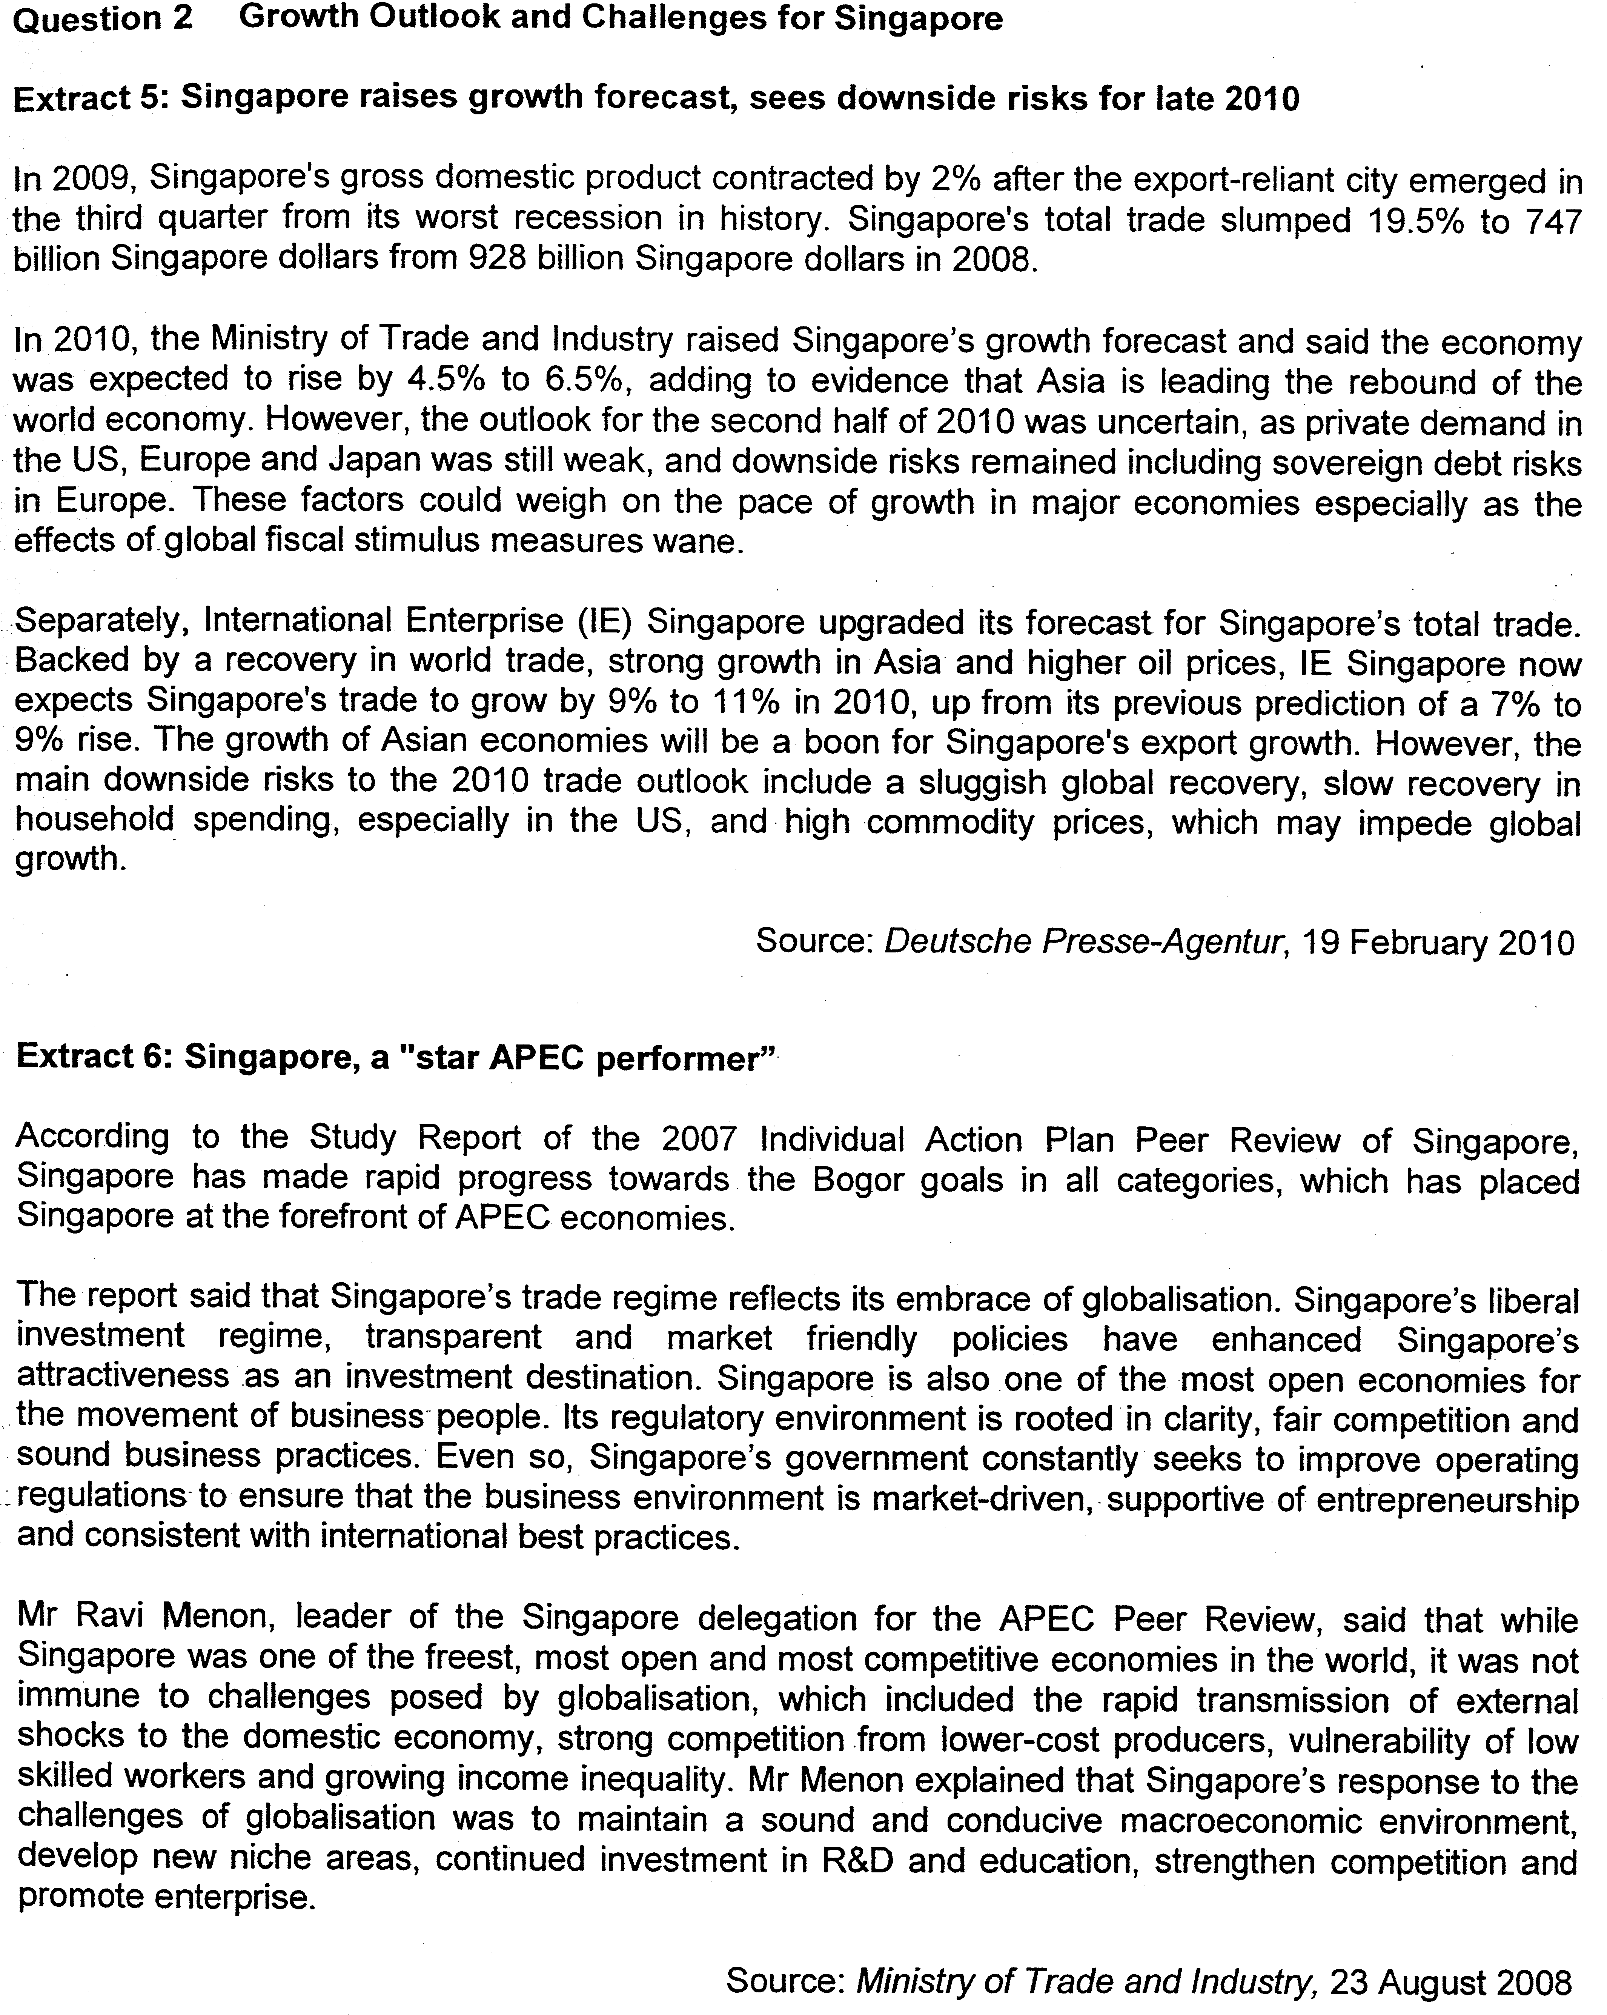

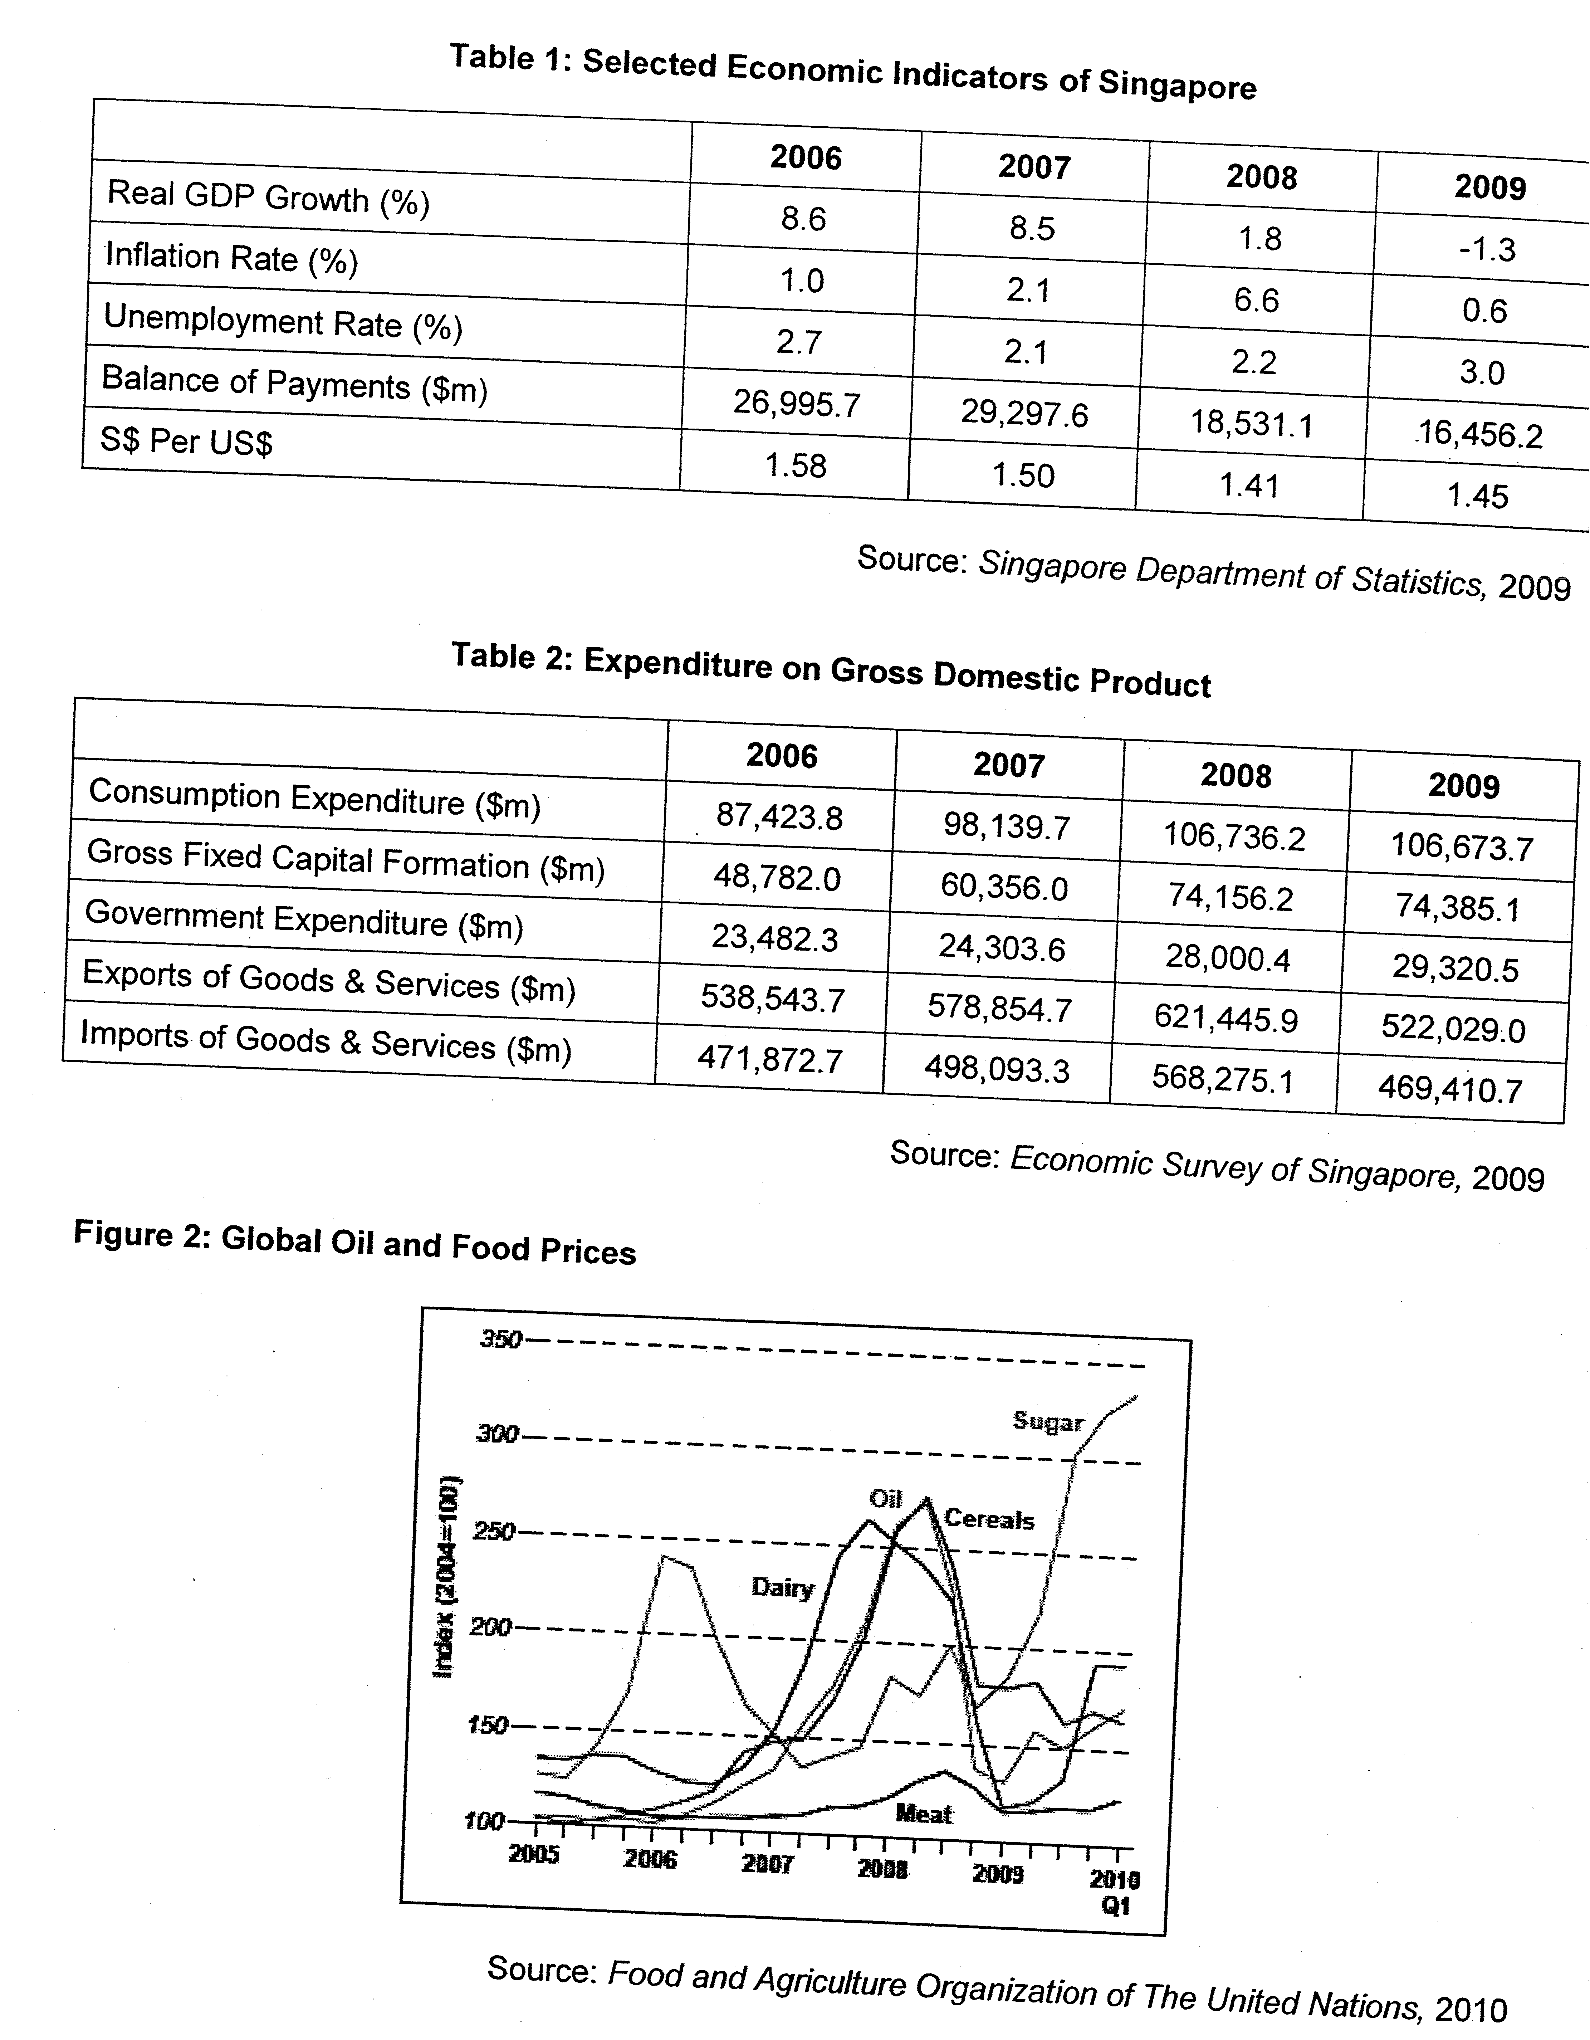

Questions
(a) Summarise Singapore's economic performance from 2006 to 2009. [2]

(b) With reference to the data provided, account for the high inflation rate in Singapore between 2007 and 2008. [5]

(c) To what extent does the inflation rate affect the balance of payments of Singapore between 2007 and 2009? [5]

(d) Assess the relative importance of factors that could slow down economic growth in Singapore in the second half of 2010. [8]

(e) Discuss whether Singapore is willing to embrace globalisation despite the challenges posed by it. [10]

[Total: 30 marks]

Suggested Answers
(a) Summarise Singapore's economic performance from 2006 to 2009. [2]

Overall Trend: Singapore economy generally performed above expectations before 2008 with
- real GDP rising as shown by the positive real GDP growth rate
- unemployment rate maintaining around 2.5%, and
- gradual appreciation of S$ against US$ over the period 2006-2009

Specific Trend: However,
- Between 2008-2009, the economy slows down and then recession kicks in with higher unemployment rate at 3%
- High inflation rate of 6.6% in year 2008
- Although balance of payments is still a surplus, it has worsen over the period with a 11 % drop from year 2008-2009

(b) With reference to the data provided, account for the high inflation rate in Singapore between 2007 and 2008. [5]

According to table 1, Singapore registered a 2.1% and 6.6% inflation rate in year 2007 and 2008 respectively. The causes of inflation in Singapore are due to demand-pull and cost-push inflation.

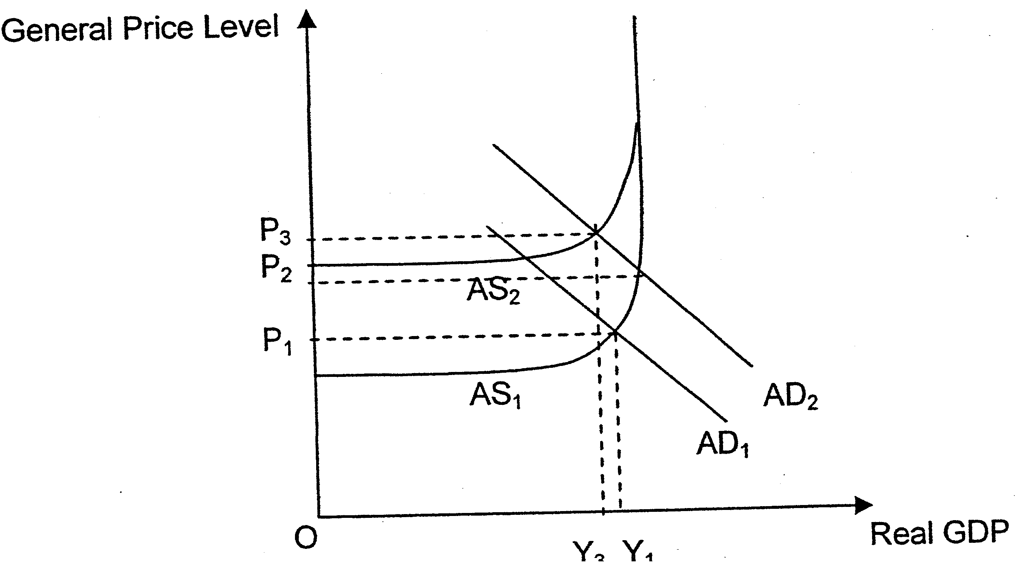

Explain demand-pull inflation
Referring to table 1, Singapore registered a high positive real GDP growth rate of around 8.6% for 2 years since 2006. This indicates that Singapore is enjoying robust growth in the economy which raised the income of the average Singaporean, hence boosting consumption. The optimistic economic outlook also boosted firm's confidence and stimulated investment expenditure. In fact, as seen in table 2, all components of aggregate demand (AD) namely consumption, investment and government expenditure and net export earnings all rose in a near full employment situation, leading to demand-pull inflation in Singapore. An increase in AD will shift the AD curve rightwards from AD₁ to AD₂ leading to higher general price level to from OP₁ to OP₂.

Explain imported and cost-push inflation
Further, as seen from figure 2, there is a sharp increase in global oil prices and food prices (dairy, sugar, cereals and meat) from year 2007 to 2008. As Singapore does not possess any natural resources and rely heavily on imports for domestic consumption, a rise in the prices of imported finished goods, intermediate goods or raw materials, increases the costs of production substantially, leading to cost-push inflation. The diagram below shows that the aggregate supply (AS) curve shifts to the left from AS₁ to AS₂ when the cost of production increases. This results in a rise in general price level from OP₂ to OP₃.

(c) To what extent does the inflation rate affect balance of payments of Singapore between 2007 and 2009? [5]

According to table 1, inflation rate rose and BOP surplus worsen.

Explain how changes in inflation rate affects BOP
This is supported by economic theory, where if a country's inflation rate is relatively higher than its trading partners, her exports will be more expensive and therefore less competitive. If the demand for the country's exports is price elastic which is likely in the case of Singapore, it will lead to a more than proportionate fall in quantity demanded for her exports and a subsequent fall in export earnings. On the other hand, her imports will be relatively cheaper than home-produced goods and thus demand for imports increases and her import expenditure will rise. This will worsen BOP.

Explain the other factors that affects BOP
When inflation rate fell for the period 2008 to 2009, BOP surplus did not improve according to the theory explained above, instead BOP surplus still worsen. This is due to other factors that will also affect BOP. Taking the 2009 global financial crisis as an example, it led to a fall in demand for Singapore's exports when her major trading partners suffered from a recession. This fall in export earnings led to the worsening of Singapore's BOP as shown in table 1.

(d) Assess the relative importance of factors that could slow down economic growth in Singapore in the second half of 2010. [8]

Explain factors that could slow down economic growth
As evident in Extract 5, in 2010 the global economic recovery is described as sluggish especially in countries like the US, Europe and Japan. These economies are still suffering from weak private demand. Being Singapore's major trading partners, the repercussion on the Singapore economy would be a lack of export growth which will impede Singapore's growth.

Furthermore, the withdrawal of global fiscal stimulus measures previously implemented by various countries to stimulate their economy will now cause contractionary effects in these economies. The lack of growth and national income in these economies would mean a lack of demand for foreign imports. The consequences on Singapore, being an export oriented economy, may be detrimental as she is reliant on the world demand for her growth.

Referring to table 2, trade is a very important source of growth for a small and open economy like Singapore. Thus, if trade is hindered, it will affect Singapore's growth tremendously.

As mentioned in the same extract in paragraph 2, the Europe sovereign debt crisis has also gloomed over the global economic recovery. It sent a wave of pessimism and conjecture over the possibility of another global economic downturn just as the economy seems to be picking up. These negative sentiments shook investors' confidence, caused the postponement and termination of long investment plans. Singapore being a small country heavily dependent of foreign direct investments (FDI) for growth and employment would inadvertently be hit. The fall in FDI would also hinder potential growth for Singapore. This lack of optimism also deter household from spending as they would prefer to save more in anticipation of a slowdown in the economy.

However, despite the negative global business sentiments due to the Europe sovereign debt crisis, foreign MNCs which seeks long terms returns are likely to still venture into Asia which is described as leading the rebound of the world economy. The positive growth forecast made by the Ministry of Trade and Industry in quarter 2010, is expected to further boost investor's confidence.

Lastly, high commodity prices would also impede Singapore's growth. As Singapore is an import dependent country, high cost of raw materials and intermediate goods would increase the costs of production substantially. This would deter investments as it would erode firm's profitability. Higher prices would also erode price competitiveness of Singapore's exports, causing a fall in export earnings. Higher prices of imported finished goods would also deter consumption and household cuts back on spending. The fall in components of AD and a fall in AS explained above would cause real GDP to fall from OY₁ to OY₂ as shown in diagram 1 and a slow down economic growth in Singapore.

Fortunately, in managing cost pressures, the Singapore government has effectively maintained a gradual and modest appreciation of S$ to ward off imported inflation while maintaining the price competitiveness of her exports. Further, supply-side policies are in place in Singapore to increase productive capacity to lower domestic inflationary pressures.

Conclusion
Due to the nature of-Singapore's small and open economy, it is the slow global economic recovery and the contractionary effects of the withdrawal of fiscal stimulus that would more likely hamper Singapore's economic growth in the second half of 2010.

(e) Discuss whether Singapore is willing to embrace globalisation despite the challenges posed by it. [10]

Define Globalisation

Explain the challenges posed by globalisation
Since economies are more closely integrated with one another as a result of increased globalisation, they are also more, vulnerable to the various risks from its trading partners. These detrimental effects are shown in both extract 5 and 6 where Singapore was not spared and in fact badly affected by the recent global financial crisis.

With globalisation and the increased competition, firms which are unable to restructure fast enough would lose out, especially to countries like China which poses "strong competition as a low cost producer". As mentioned in extract 6, this resulted in lost of jobs especially those belonging to the low skilled workers and caused growing income inequality. Workers who lose their jobs due to relocation of low-end manufacturing firms may not be unable to acquire new skills quick enough to find employment in other sunrise industries, hence contributing to the structural unemployment in Singapore.

Explain the benefits of globalisation
Despite the challenges posed by globalisation as explained above, Singapore is willing to embrace globalisation as we are able to reap the net benefits that served us well.

Singapore is a small and open economy that is import-dependent and export-oriented, one of the main benefits that Singapore gets from globalisation is the increased availability of export markets. With an increased in market size, Singapore firms can reap greater economies of scale which will help lower their costs of production. This would improve her export competitiveness in the international market. The increase in export earnings will increase the aggregate demand, bringing about a multiple increase in real national income via the multiplier process and higher employment.

Furthermore, the Singapore government is able to maximise the opportunities presented by globalisation, through restructuring the economy and "developing new niche areas" that she has a comparative advantage in. This strategy brought about the development of several sunrise industries like life sciences, biotechnology, water technology, tourism and tertiary services in Singapore. Government policies are also designed to convert the challenges of globalisation into opportunities. The Singapore government devoted much of her budget to investing in research and development, higher education and skills upgrading. A substantial amount of funding was set aside to retrain and equip the workforce with the necessary skills required by the sunrise industries. The workforce will thus benefit as they move from unskilled to skilled sectors earning higher income.

The increased competition from foreign firms will also spur local firms to improve their efficiency in order to better compete and to retain their market share. Local firms will also invest more into research and development to improve the quality of their products. This may result in lower prices, better quality and more innovative products which will benefit consumers. Firms may even relocate or outsource stages of production to lower cost country to take advantage of their comparative advantage. For example, manufacturing activities are relocated to China, Indonesia and Vietnam, while the R&D activities are still in Singapore.

Conclusion
Singapore is willing to embrace globalisation despite the challenges posed by it. This is because being a small and open economy which relies on export-driven growth, it is vital for her to expand her export markets. Though there may be challenges such as the vulnerability to external shocks, structural unemployment, worsening income inequality brought about by globalisation, Singapore has been able to adopt suitable policies to manage such problems. Thus, Singapore is willing to embrace globalisation despite the challenges posed by it

