Economics Term 3 2017
CSQ – Lesson 5 – Inflation, Unemployment Q1

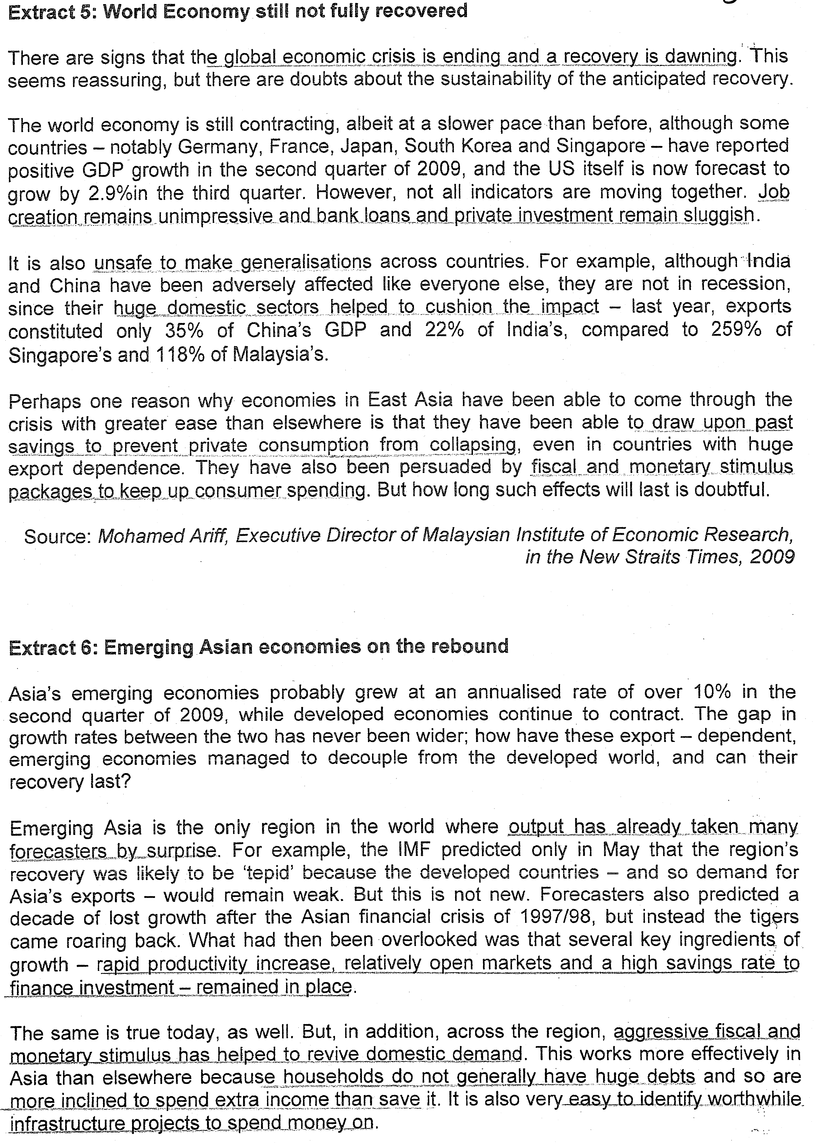
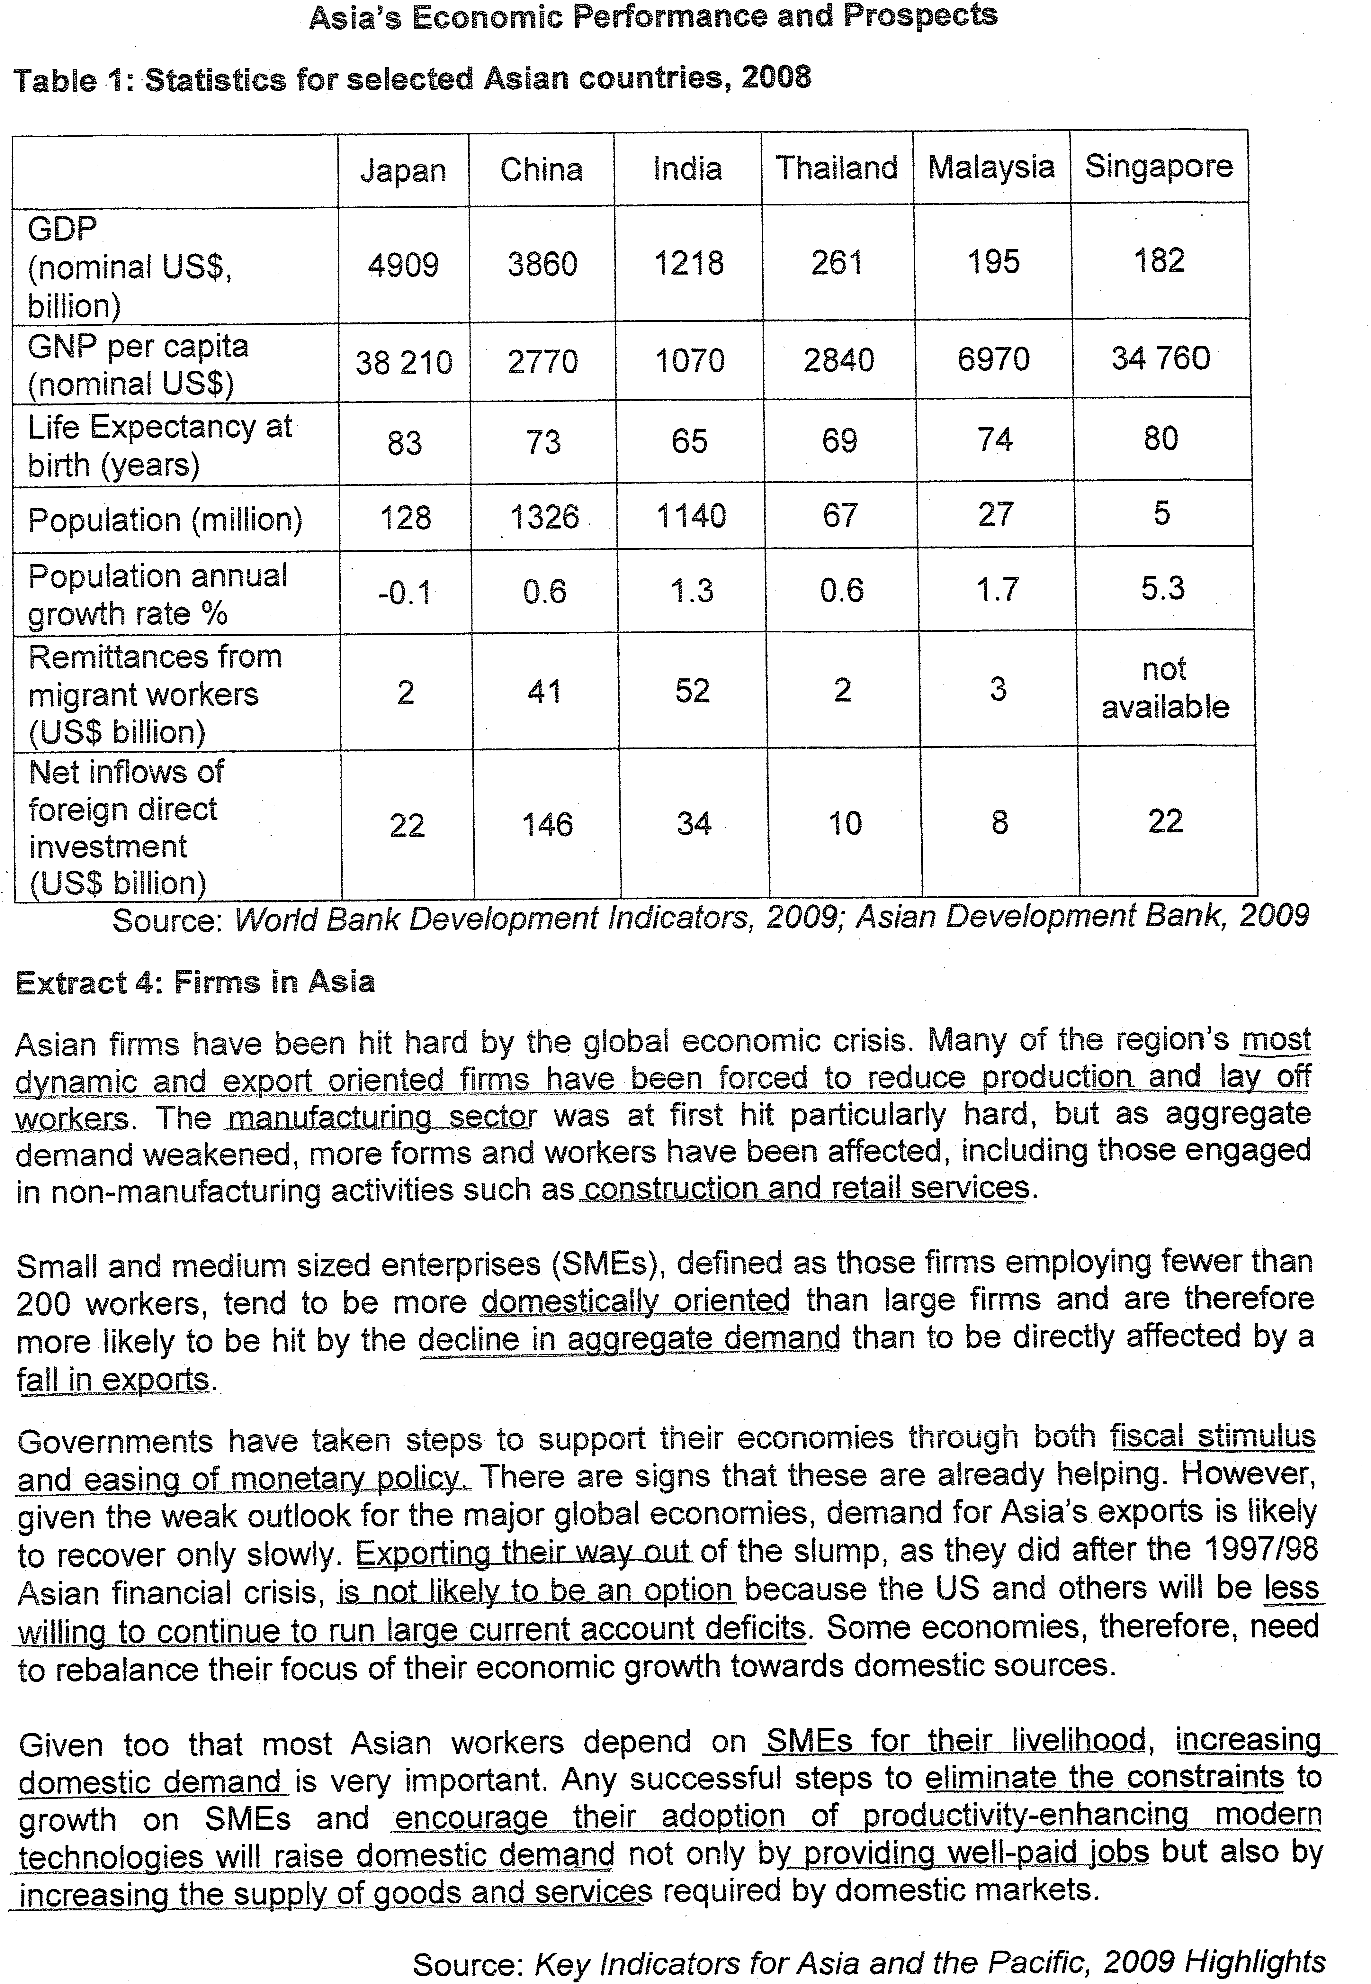
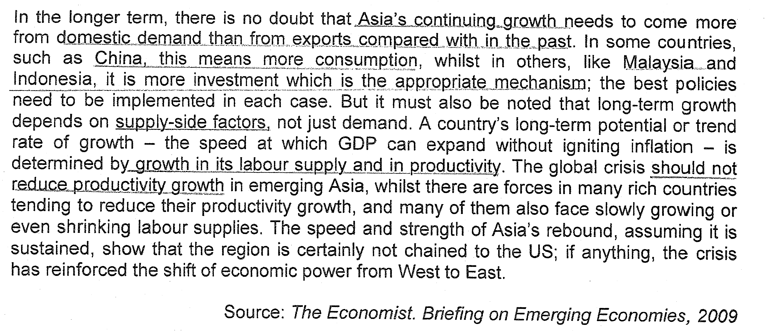
Questions

(a)(i) Using Table 1, identify which of the countries shown has the highest and which the lowest GNP per capita [1]
(ii) Explain two other pieces of information, one from table 1 and one not in Table 1 that would be useful in assessing living standards in a country such as Malaysia. [4]

(b) Using AD/AS analysis, explain how Foreign Direct Investment would benefit a country such as China. [4]

(c) Explain how 'adoption of productivity-enhancing modern technologies' will help Asia 'rebalance the focus of their economic growth towards domestic sources'. (Extract 4) [5]

(d) Explain the claim that 'aggressive fiscal and monetary stimulus...works more effectively in Asia than elsewhere'. (Extract 6) [6]

(e) Extract 6 explains how export-dependent, emerging Asian economies have recovered from recession faster than Western economies. To what extent do you agree with the conclusion that the 'crisis has reinforced the shift of economic power from West to East'? [10]

[Total: 30 marks]

Suggested Answers
(a)(i) Using Table 1, identify which of the countries shown has the highest and which the lowest GNP per capita [1]

Skill Development: Trend comparison / Concept Application
Focus: Economic indicators about standard of living

Out of the six countries, India has the lowest GNP per capita at US$1070 while Japan has the highest GNP per capita at US$38210.

(ii) Explain two other pieces of information, one from table 1 and one not in Table 1 that would be useful in assessing living standards in a country such as Malaysia. [4]

From table 1, the economic indicator that can be used to measure standard of living would be life expectancy at birth. This indicator can reflect standard of living as the longer time period an individual can live, the longer the time period a person can enjoy the well-being of his life and attain higher level of income and wealth in his life. It also reflects the medical and healthcare the individual can enjoy is prolonging his lifespan, implying that he is having a more qualitative aspect of life.

As for another economic indicator not reflected on the table, it would be the level of consumption the country has conducted. A higher level of consumption per capita would mean that there is a higher level of material comfort the individuals can enjoy which is made possible when the citizens have higher disposable income due to higher wage rate.

(b) Using AD/AS analysis, explain how Foreign Direct Investment would benefit a country such as China. [4]

Skill Development: Application of AS-AD concept
Focus: Explanation on how FDI as a component of AD and determinant of LRAS will lead to sustainable economic growth and other aspects of benefit

i) Definition
Foreign Direct Investment are expenditure on capital goods made by foreign multi-national corporations in the local economy to manufacture goods and services for local and international market.

Foreign Direct Investment is part of the investment which is one of the components of aggregate demand that will lead to growth of real GDP via the multiplier effect. This rise in aggregate demand will induce more economic activities that will lead to greater consumption and production which will expand the circular flow of income and thus raises economic growth.

The inflow of foreign direct investment will also lead to the expansion of the availability of resources as the inflow of foreign direct investment will lead to a higher level of infrastructural development that will enhance the mobility of resources and the efficient utilization of resources.

As seen from the diagram, the rise in aggregate demand from AD₀ to AD₁ and the outward shift of the LRAS from LRAS₀ to LRAS₁ will lead to a rise in real GDP from Y₀ to Y₂ while the full employment level will shift from Y_{F0} to Y_{F1}. This will enable the economy to raise real GDP without contributing to rising price level as the price level remains at P₂ which is equal to P₀, achieving sustainable economic growth.
Y₁=Yf₀
Y₂
Y_{F1}
LRAS₀
LRAS₁
P₁
P₂ = P₀
GPL
Real GDP
AD₁
Y₀
AD_{o}
The growth of Foreign Direct Investment (FDI) will accelerate the growth of the economy as it will provide China greater scope of market demand as the market demand of the multinational corporations (MNCs) is from the international market. As for the extent of impact on potential growth, the transfer of technology and expertise from multinational corporations (MNCs) will raise the efficiency of the economy in expansion of the resources.

Besides this, China will also benefit in terms of higher level of employment as the multinational corporations’ (MNCs) production comes from the manufacturing sector which is quite labour-intensive. This will be beneficial for China as it has large urbanized population and it is in need of Foreign Direct Investment (FDI) to provide massive employment opportunities.

The inflow of Foreign Direct Investment (FDI) will also help to improve the balance of trade for China as Foreign Direct Investment (FDI) will promote the growth of export demand which will raise production. It will also enable the economy to gain higher real GDP per capita when the growth of real GDP is greater than the percentage change in price level and population growth rate.
(c) Explain how 'adoption of productivity-enhancing modern technologies' will help Asia 'rebalance the focus of their economic growth towards domestic sources'. (Extract 4) [5]

Skill Development: Concept explanation and application to the context
Focus: Apply the measures proposed in the context to apply to the requirement of the question
meaning of the phrase – implication of economic acitivities
The ‘adoption of productively-enhancing modern technologies’ refers to the development of more capital equipment and higher level of technology to raise local production and create more domestic demand

In doing so, the Asian economies will seek to raise their technological development to increase their efficiency of production to lower the cost of production which will enable the local firms to replace import demand and thus, induces more local production which will raise economic growth and employment. The development of ‘productively-enhancing modern technologies’ will also raise the quality of locally-produced goods which will raise the degree of import substitutability by local firms.

This strategy would be effective in helping to enhance the growth of local economy as there is a higher level of expenditure power in the local economy, given a higher level of saving and lower personal debt. The provision of the development in the technological advanced development will also create more employment opportunities ‘with well-paid salary and also, increasing the supply of goods and services’ required by domestic demand.

The advancement of technology will also lead to better utilization of resources and development of more infrastructures to support the growth of the industries to enable more domestic production. This strategy will induce greater local production to provide more employment which will lead to real GDP to enable greater level of consumption. Consequently, through the multiplier and accelerator effects, there will be perpetual economic growth that focuses on domestic growth.

(d) Explain the claim that 'aggressive fiscal and monetary stimulus...works more effectively in Asia than elsewhere'. (Extract 6) [6]

Skill Development: Application and Evaluation of policies based on the context
Focus: Explanation on the expansionary monetary policy and fiscal policy
Evaluation: Assess whether it can be more effective in Asia than developed nations

1) Definition and Mechanism of Monetary Policy and Fiscal Policy
2) evaluate why the policies works more for Asia than developed countries
3) evaluate why it will not work so effectively
4) Analysis – the main determinants of this issue

i) Definition and Mechanism of Monetary Policy and Fiscal Policy
Expansionary Monetary Policy
When expansionary monetary policy is conducted, the government will increase the money supply through the buying of government bonds which will lower interest rate. This will lower the cost of credit consumption and reduces the reward for saving which will encourage more consumption and reduce willingness to save. Also, the level of investment will be raised as the level of profitability is raised since the cost of investment is lowered as lowering interest rates lowered the cost of borrowing. Consequently, there will be a rise in consumption and investment which will raise the aggregate demand, via the multiplier effect and thus raises the real GDP, production and employment.

Expansionary Fiscal Policy
- It is used to solve recession or curb unemployment by raising aggregate demand
- Increase in government expenditure → increase aggregate expenditure directly through infrastructural development and provision of public services
- Tax reduction → increase disposable income → raise consumption and increase return on investment, (lower tax on corporate earnings) contributing the rise in investment expenditure → rise in aggregate expenditure/national income (multiplier effect)
- This will close up the deflationary gap and thus curb recession.

ii) Evaluate the effectiveness of Monetary Policy and Fiscal Policy
Fiscal policy is more effective in Asia than elsewhere as Asian economies have a lower public debt ratio and thus, it is easier to finance the development of the expansionary fiscal policy through borrowing from the bond market. The low level of infrastructural development in term of transport and communication network and other public facilities will imply that the expansionary fiscal policy will be able to meet the need of the economy and help to promote the growth of the economy more efficiently and effectively. Consequently, the introduction of the expansionary fiscal policy will be creating effective impact on the growth of the economy.

As for monetary policy, the lower personal debt ratio of the consumers in the Asian economies will mean that the expansionary monetary policy will enable to raise consumption as individuals are more willing to borrow and it will not create debt problem for the people. This introduction of fund for borrowing will enable the economy to raise more funds to finance the local investment which helps to create domestic economic activities to compensate the loss of external demand and inflow of Foreign Direct Investment (FDI) during the economic downturn.
However, these two policies may be less effective in Asian economies as these economies tend to have a high marginal propensity to import (MPM) than the foreign counterparts in Europe or other economies. This will contribute to a small multiplier effect which will undermine the effects of the expansionary monetary and fiscal policy. In addition, the economies are very in need of foreign demand as the local domestic expenditures occupying a much lower percentage of GDP than the external demand as a percentage of GDP as in countries like Singapore, Malaysia and Thailand. The need for foreign demand will undermine the effectiveness of the ‘aggressive fiscal and monetary stimulus’.

(e) Extract 6 explains how export-dependent, emerging Asian economies have recovered from recession faster than Western economies. To what extent do you agree with the conclusion that the 'crisis has reinforced the shift of economic power from West to East'? [10]

Skill Development: Application of context based on economic concepts
Focus: Derive information concepts from the extract or data to make assessment on whether the Asian economies are more significant
source of info: economic indicators, aggregate demand components that reflect economic activities – extract from the passage and understanding of the nature of the economies

Introduction
To assess whether there is a shift of economic significance from West to East, there is a need to assess the economic activities and economic indicators provided by the extract.

Based on the extract, there is an adverse impact on the economy when there is a global economic downturn in 97/98 and in recent years when the downturn in US will affect Asian economies like China and India as these Asian economies rely extensively on the Western economies for the growth of their export demand. As seen from extract 4, the manufacturing sector of the Asian economies will shrink and experience layoff due to reduction in the export demand, especially for the Small Medium Enterprises (SMEs) which rely indirectly on the demand of the multi-national corporations (MNCs).

The call for more investment in ‘productively-enhancing technology’ also suggests that the Asian economies lack the capacity to generate higher level of domestic growth to reduce the reliance on external demand. Furthermore, some of these economies have a higher reliance on the Foreign Direct Investment (FDI) as seen from the Foreign Direct Investment’s (FDI) percentage of GDP for countries like Singapore (12%) or China (3.7%) and the significant beneficial effect of Foreign Direct Investment (FDI) on these Asian economies.

The cut down of import due to the economic downturn in these Western economies will mean that it is less effective for Asian to use export as a means to recover from recession, implying that the Western economies ‘demand is of great significance to these economies. The export demand of some Asian economies is still of great significance to Asian economies as seen from the export demand as a percentage of GDP for countries like Singapore (259%) and Malaysia (118%). For large economies like India and China, the export demand as a percentage of GDP may not be that high but the export demand for the countries are for their key industries and significant in influencing their local economic activities as they provide intensive and urbanized employment opportunities, critical to the growth of the local industries.

However, Asian economies are raising their economic independence as the domestic economies become more influential and significant to reduce the vulnerability on the reliance of Western economies. Albeit a slower global growth, countries in Asia like China, India, Japan and South Korea are registering growth to indicate that they are on track for growth. These nations have shown their resilience against global economic influences despite reliance on infrastructural market demand due to their strong fundamentals.

These economies in Asia have also huge reserves and a low debt ratio to allow them to conduct fiscal monetary stimulus during downturns, depicting their economic capacity. This will enable the nations to push up their local consumption, reducing reliance on external demand.

As stated, the “Asian emerging economies grew at an annualized rate over 10% in the 2nd quarter of 2009, implying that these economies are more capable to accelerate growth despite their reliance on the faltering Western economies.

The prospect of higher growth is also evidential in stating that there is decoupling from the developed world to the Asian economies. There is a possibility of higher market demand, given a higher growth in GDP and more borrowing capacity as households do not have huge debts. Furthermore, the need for infrastructural development will mean that there will be higher level of government expenditure. Thus, it can be observed that the market demand for growth in Asia is likely to be greater and it will generate growth at a higher rate than the Western counterparts.

In sum, the decoupling of Western economies towards Asian economies is noted with concern as there are evidences to suggest that there is decoupling but such development is still controversial as economies are now more integrated and are closely-related.

