H1 Economics 2018 – CSQ – Demand and Supply & Market Failures – Q1

Future of Public Libraries
DWL for merit good – seen from the external benefit that society fails to reap
Extract 5: The economic value of public libraries (external benefit)
The economic contributions of public libraries are twofold – direct and indirect. The direct economic contribution that public libraries can make includes educational benefits and improved wellbeing for individuals from reading. On the other hand, there are wider educational and social impact of libraries. Public libraries can contribute to long term processes of human capital formation and social cohesion of communities.
Source: Information Today,
Europe, 5 June 2014
Extract 6: Libraries are changing
As technology advances into every aspect of modern life, traditional public libraries are experiencing a major shift, from being housed strictly in buildings and having physical books, to moving onto the internet. There are four main ways by which libraries are changing:
Problems in providing free merit good
Libraries are being shaped by fiscal budget cuts - Public libraries have continued to struggle in many countries, like in US, particularly since the 2008 Global Financial Crisis. In many cases, governments have scaled back on the opening of new branches and library services so that the money could be used for alternative purposes. And yet, during the recession, more people rely on libraries for entertainment, employment opportunities, and as a resource for internet access.

In fact, the public library saw a rise in the loans for the books about technical knowledge to upgrade and how to better write resumes to find jobs. Computer terminals were constantly used to search for jobs available.

Libraries are becoming technological hub - As the internet becomes the main means to obtain information, public libraries are transforming themselves from mere physical buildings into technological spaces. When looking at technology use in public libraries, researchers have found that patrons are increasingly thinking of libraries as community spaces that allow access to technology and as a source of digital literacy for various demographics.

Expanded access through information sharing - Digital Libraries provide useful interactions between information and users - easing the global dissemination of information. Information sharing has the power to bolster educational equality across the world. For instance, the United Nations Educational, Scientific and Cultural Organization’s (UNESCO) “Information for All Programme” (IFAP) is providing access to over 25,000 titles and is equipped with on-line connections to a worldwide network of libraries.( demand and supply factors)
Printed books still dominate reading despite the growth of e-books - The popularity of electronic books (e-books) is rising, but printed books remain the foundation of many people’s reading habits. The number of e-book users is growing, but, surprisingly, not to the extent that e- books have replaced printed versions. This trend is expected to change as e-reader ownership expands, but the love affair with an actual book is not expected to vanish completely. Nothing quite compares to the smell of a book.
Source: The Global Citizen Organization, 15 January 2015
Figure 1: Government Subsidy for Public Libraries in Singapore (SGD)
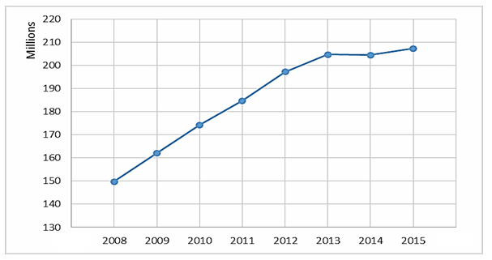

Source: National Library Board, Singapore

Extract 7: Singapore redesigning library spaces
National Library Board (NLB) of Singapore had been redesigning library spaces where books, programmes and cafés co-existed to create a seamless learning environment for library users. NLB also introduced a digital library to make learning borderless. At Pixel Labs at Jurong Regional Library, a “tinkering lab”, visitors use the facilities for free and are allowed to take home the 3D models they make. Launched last year by NLB and Infocomm Media Development Authority (IMDA), the lab is the first such dedicated venue in a library for exploring new technologies.

At Woodlands Regional Library and Bedok Library, seniors aged 50 and above can sign up for digital media courses run by librarians from the library board. The courses teach basic computing skills, as well as how to access the board's e-resources and e-books. Seniors also learn the functions of mobile devices such as iPads and popular apps such as Facebook. The affordable course fee ranges from $4 to $10. For early childhood educator Tavana Zulliani-Ramachandra, 60, who signed up for several digital media courses at the Woodlands Regional Library and Bedok Library, from an e-entertainment course, she was really happy to learn to book air tickets and overseas accommodation online and learn how to connect with her grandchildren with WhatsApp.
In 2014, smart work centres or flexible mobile workstations were launched at Jurong Regional Library, Toa Payoh Library and Geylang East Library. Next year, another centre will come up at the revamped Tampines Regional Library. These come with a whole suite of business functions and resources such as Wi-Fi, meeting rooms and high-definition video-conferencing services. Ms Catherine Lau, assistant chief executive of public library services, says the library board has been moving away from a cookie-cutter approach to make sure each library caters to its community.
Source: The Straits Times, 20 November 2016
Questions
(a)(i) Explain the two characteristics of a public good. [2]

(a)(ii) Explain why public library is not a public good. [2]

(b) Extract 6 mentions that “the number of e-book users is growing, but, surprisingly, not to the extent that e-books have replaced printed versions”.

With the help of a demand and supply diagram, explain the extent of change in the equilibrium quantity of the printed books in these circumstances. [4]

(c)(i) With reference to Extract 5, use a PPC diagram to explain how public libraries can affect long-term economic growth of a country. [2]

(c)(ii) With reference to the extracts, explain how more public libraries can improve a country’s current standard of living. [4]

(d) With reference to Extract 6, explain and comment whether public libraries can help to deal with the main causes of unemployment in the US. [6]

(e)(i) With reference to Figure 1, summarise the trend of subsidies for public libraries in Singapore over the period 2008-2015. [2]

(e)(ii) Discuss the view that a government should allocate more resources to public libraries to bring about a more efficient allocation of resources. [8]

[Total: 30]

