GP Comprehension – Loneliness 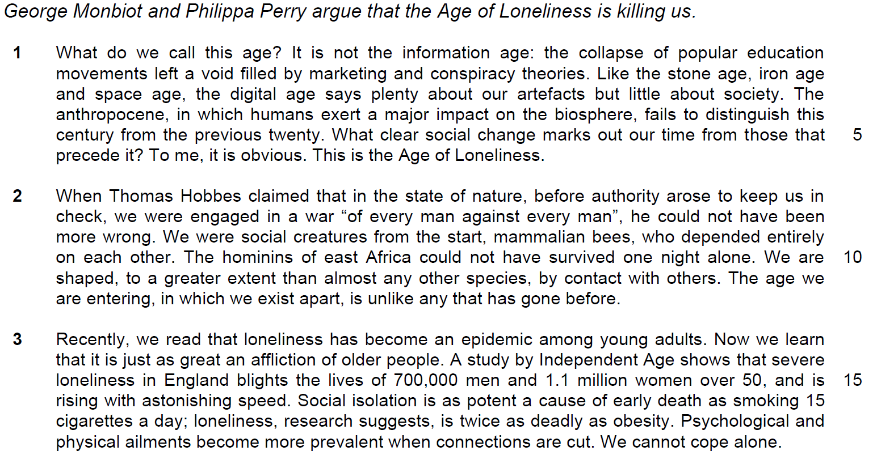

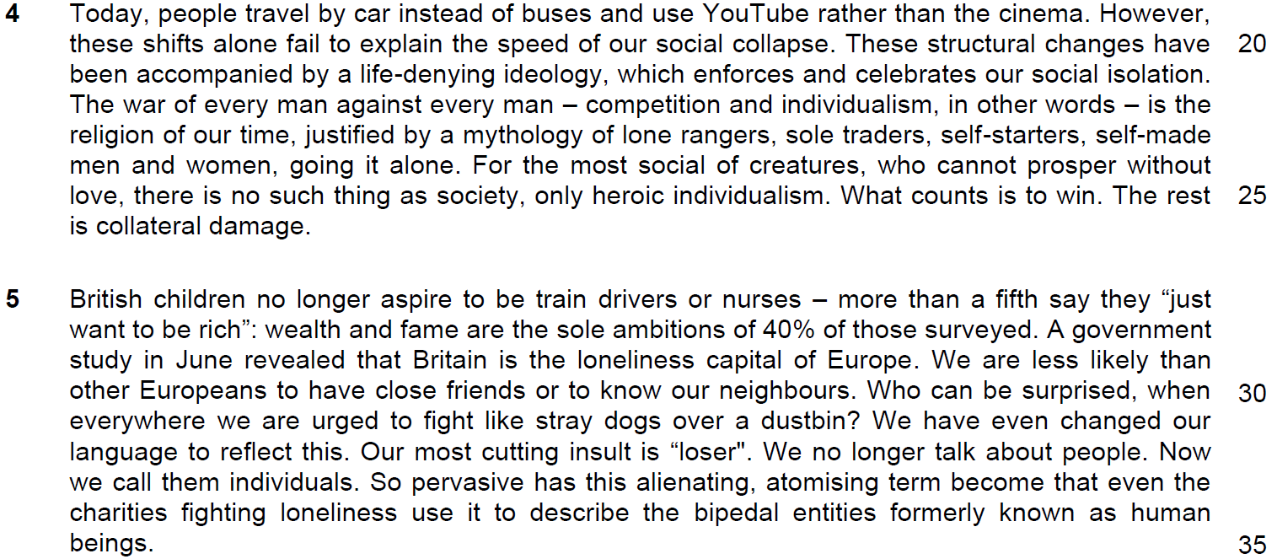

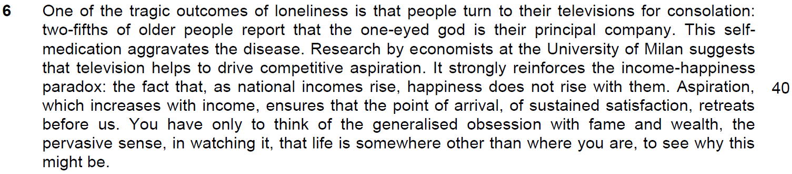

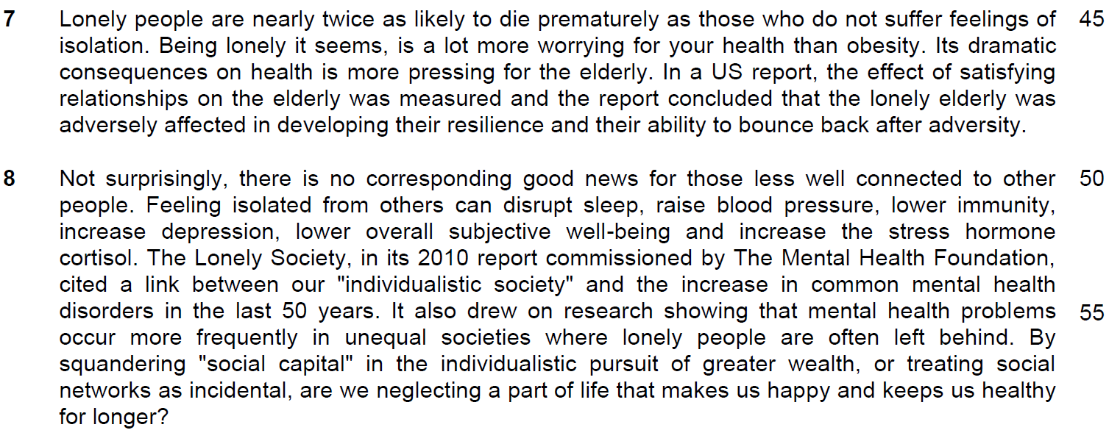

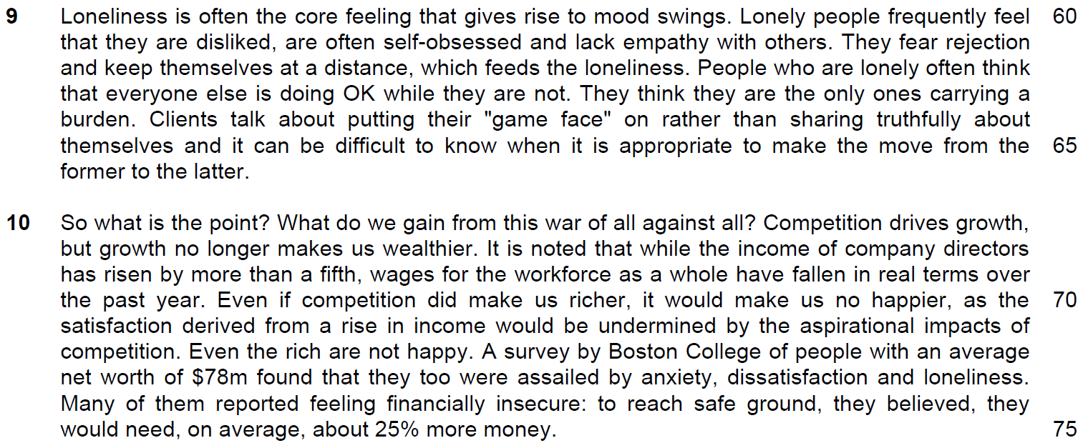

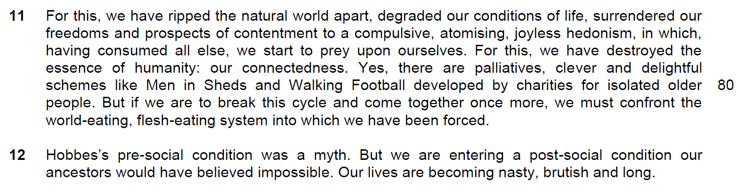

Suggested Answers
1. In lines 2-3, what similarity do the authors see between the Age of Loneliness and the ages that precede it? Use your own words as far as possible. [2]

From the passage
Like the stone age, iron age and space age, the digital age says plenty about our artefacts but little about society. (line 3)

Answer
The authors see that there are lots of things/articles/objects that belong to a particular time in the past but not much about the people/ourselves.

2. What is the claim made by Thomas Hobbes in lines 7-8 and why do the authors disagree with it? Use your own words as far as possible. [3]

From the passage
claimed that in the state of nature, before authority arose to keep us in check, we were engaged in a war “of every man against every man” (line 7-8)

he could not have been more wrong. We were social creatures from the start, mammalian bees, who depended entirely on each other. (lines 8-10)

We are shaped, to a greater extent than almost any other species, by contact with others. (line 10-11)

Answer
Each man for himself is an innate tendency. However, we are people who relied on others. Also, we are moulded/influenced by our interactions with others.

3. In paragraph 3, what do the words ‘just as’ tell you about the effect of the epidemic on older people? [1]

From the passage
Loneliness…just as great an affliction of older people (line 14)

Answer
Loneliness is as much a source of misery/ hardship/ suffering for the elderly/ same extent.

4. What is implied by the ‘shifts’ (line 21) described in the sentence ‘Today people travel by car instead of buses and use YouTube rather than the cinema’ in line 20? [2]

From the passage
People travel by car instead of buses

use YouTube rather than the cinema (line 20)

Answer
Choices that people make in their daily lives have shifted from a group setting to an individual setting / become more individualistic/ increasing social isolation.

5. Explain the phrase ‘to fight like stray dogs over a dustbin’ (line 32). [2]
metaphors – 1) explain the metaphor and relate to the context.
From the passage
to fight like stray dogs over a dustbin (line 32)

Answer
Just as stray dogs compete for food in their fight for survival, so do people regard others as competitors and compete for gains.

6. Explain the ‘income-happiness paradox’ in lines 40-41. Use your own words as far as possible. [2]
two truths which contradict each other.
From the passage
As national incomes rise, happiness does not rise with them. Aspiration, which increases with income, ensures that the point of arrival, of sustained satisfaction, retreats before us. (line 40-41)

Answer
It seems contradictory that happiness does not increase with salary/wages. (focus is on the contradiction)

Yet, the truth is that as our salary increases, the increased ambitions that come along with it cannot be fulfilled leading to happiness becoming elusive. (focus is on the reasoning)

As income increases, we are able to raise our material comfort. However, the happiness income index shows that our level of happiness decreases as our income rises.
7. What does the word ‘assailed’ in line 74 tell us about how loneliness affects the rich? [1]

Answer
The word tells us that the rich is affected deeply or undermined by loneliness.

8(a) What does ‘this’ in line 77 refer to? [1]

Answer
It refers to the competition to gain wealth.

8(b) Why does the author repeat the phrase ‘for this’ in lines 77 and 79? [1]

Answer
He wants to emphasize our foolishness in being willing to sacrifice what makes us human, for the trivial.

9) What are the authors’ opinion about schemes like ‘Men in Sheds’ and ‘Walking Football’ in line 82? [1]

From the Passage
Yes, there are palliatives, clever and delightful

Answer
They do not think that they are the correct solution.

10) Why is Hobbes mentioned again in the first line of paragraph 12? [1]

From the passage
(Para 2) When Thomas Hobbes claimed that in the state of nature, before authority arose to keep us in check, we were engaged in a war “of every man against every man”, he could not have been more wrong.

(Last Paragraph) Hobbes’s pre-social condition was a myth. But we are entering a post-social condition our ancestors would have believed impossible. Our lives are becoming nasty, brutish and long.

Answer
While the authors disagreed with Hobbes’ claim, Hobbes is mentioned again to show that the claim was untrue in the past but seems to be valid now.

Summary Writing
11. Using material from paragraphs 7 to 9, summarise what the authors have to say about the harmful effects of loneliness on people.

Write your summary in no more than 120 words, not counting the opening words which are printed below. Use your own words as far as possible. [8]

Loneliness leads to …
S/No | From the passage | Paraphrased equivalent
1 | nearly twice as likely to die prematurely as those who do not suffer feelings of isolation. | Cause of early death/ more prone to early death.
2 | a lot more worrying for your health than obesity. | Medically, is more troubling / a greater cause for concern than other illnesses/ ailments
3 | more pressing for the elderly | More serious for the elderly
4 | the lonely elderly was adversely affected in developing their resilience  OR  and their ability to bounce back after adversity | As they were less able to recover from hardship / difficulty
5 | can disrupt sleep, raise blood pressure, lower immunity, increase depression, lower overall subjective well-being and increase the stress hormone cortisol. | Leads to physical health issues / complications
6 | increase in common mental health disorders in the last 50 years. | We see more cases of psychological ailments/illness

S/No | Points/Ideas from the passage (Essence of the point/idea in bold) | Paraphrased equivalent
7 | unequal societies | Unfair / non-inclusive societies
8 | where lonely people are often left behind. | as lonely people are not given the chance to go forward / marginalised/ sidelined
9 | neglecting a part of life that makes us happy and keeps us healthy for longer? | Disregarding/ ignoring / forsaking the very things that ensure our well-being.  Note: health and happiness come together
10 | gives rise to mood swings | Leads to volatile/ unstable/ unpredictable emotions / temperamental
11 | feel that they are disliked | Think people detest them
12 | self-obsessed | Place too much focus on themselves / narcissistic
13 | lack empathy with others. | Do not show understanding/ compassion / apathy towards others
14 | fear rejection | Are afraid / scared /frightened about not being accepted by others
15 | keep themselves at a distance | Isolate themselves / cut themselves off from the community / alienate them
16 | feeds the loneliness. | Reinforces / adds to/ compounds the loneliness
17 | often think that everyone else is doing OK while they are not.  OR  they are the only ones carrying a burden. | Think they are the only ones suffering / facing difficulties
18 | putting their "game face" on | Put on a brave front / pretending to be brave
19 | rather than sharing truthfully about themselves | Instead of being open/ honest with others
20 | difficult to know when it is appropriate to make the move from the former to the latter. | Unsure of when to confide in others
12. Application Question
George Monbiot and Philippa Perry argue that the age of loneliness is killing us.
How applicable are their observations to yourself and your own society? [10]

- Quote
- explanation of the quote
- explain why it is applicable to your country
- give example

# | Point | Agree/ Disagree/Explanation/Eg
 | “Lonely people are nearly twice as likely to die prematurely as those who do not suffer feelings of isolation.”  "Being lonely it seems, is a lot more worrying for your health than obesity."  “Feeling isolated from others can disrupt sleep, raise blood pressure, lower immunity, increase depression, lower subjective well-being and increase the stress hormone cortisol.” | Agree  Explanation  Loneliness is becoming a major cause for mental health concerns in highly urban or developed societies, potentially leading to disorders or even premature deaths.  E.g.  A 2009 - 2011 NUS study commissioned by the Ministry of Social and Family Development found that loneliness shortens the lifespan of the elderly, with data showing that those who professed to be lonely were found to have died within 2 years of the initial interview. Also, according to Singhealth, social isolation leads to lowered immunity and increased possibility of medical conditions such as cancer and heart disease.

# | Point | Agree/ Disagree/Explanation/Eg
 | "(there is)...a link between our "individualistic society" and the increase in common mental health disorders...”  “(Mental health disorders)…occur more frequently in unequal societies where lonely people are often left behind." | Agree  Explanation  Feelings of loneliness are elicited from social isolation common in competitive and individualistic societies, leading to mental illnesses such as depression and even suicide.  E.g.  As one of the most competitive nation in Asia, Singapore makes for a highly individualistic, self-centred society which prizes getting ahead of others over empathy and camaraderie today. This is evident in our 'kiasu' culture, which sees the young and old inadvertently forgo the creation of genuine or deep emotional bonds with family, peers and community in their pursuit of success in academics, career and life. For example, the Samaritans of Singapore reported in July 2013 that there was an 80% increase in suicide rates in the age group 20 – 29 years old from 2012 and this is attributed to struggles with stressful studies or work, social interactions and feelings of loneliness.  Disagree  Explanation  Altruism is still present in individualistic societies with the government and community organizations pitching in to create opportunities for interaction, reducing the likelihood of loneliness and mental illnesses.  E.g.  Estates with a high percentage of elderly residents often see Senior Activity Centres set up at the foot of their HDB blocks, such as that of the Lions Befrienders Senior Activity Centre in Toa Payoh and Bendeemer. The elderly residents can chat with friends, take part in mass exercise sessions and handicraft classes or help prepare meals for each other once in a while.  Other Eg: The Silver Ribbon Project raises awareness of the stigma of mental illnesses

# | Point | Agree/ Disagree/Explanation/Eg
 | By squandering 'social capital' in the individualistic pursuit of greater wealth or treating social networks as incidental, are we neglecting a part of life that makes us happy and keeps us healthy for longer?" | Diasgree  Explanation  Recent times have shown that there is an increased inclination towards building a greater work-life balance amongst Singaporeans, especially amongst adults with young children and/or elderly parents. We are increasingly aware that we should not neglect what makes us happy and healthy.  E.g.  Public campaigns such as Eat with Your Family Day, which fell on 29 May this year saw a day set aside for all workers as well as students to get off work or school early and spend quality evening time with their families.
 | life-denying ideology, which enforces and celebrates our social isolation. The war of every man against every man – competition and individualism | Disagree  Explanation  Competition and individualism do not necessarily enforce and celebrate social isolation. The authors simply assume that all forms of competition are unhealthy when in fact competitions can come in various forms and manners with desirable consequences. Competition can promote collaborative effort where people work with one another. Competing against other groups also engenders bonding rather than isolation.  E.g. Unilever Future Leaders’ League (UFLL) is a dynamic global competition that brings together students from all over the world to experience what tomorrow's leadership is all about through collaboration.

# | Point | Agree/ Disagree/Explanation/Eg
 | For this (accumulation of wealth), we have ripped the natural world apart, degraded our conditions of life, surrendered our freedoms and prospects of contentment to a compulsive, atomising, joyless hedonism, in which, having consumed all else, we start to prey upon ourselves. For this, we have destroyed the essence of humanity: our connectedness. | Disagree  Explanation  The efforts made towards the accumulation of wealth do not necessarily destroy our connectedness. In fact, we can use this to help people.  E.g. social entrepreneurships in Singapore (KerbsideGourmet, 18Chefs)  KerbsideGourmet is modelled on a BAMGAM (Buy A Meal Give A Meal) basis. For every main meal sold, one is given to needy families. The organisation works with Volunteer Welfare Organisations like Prison Fellowship Singapore (PFS) and South Central Community Family Service Centre and also collaborates with Grand Hyatt Singapore to deliver food to beneficiary families. Thus far, it has received great support.
 | Yes, there are palliatives, clever and delightful schemes like Men in Sheds and Walking Football developed by charities for isolated older people. | The author is mocking the schemes and indicating their ineffectiveness. However, this may not be true in Singapore.  Explanation  In fact, the Government may have pre-empted that isolation is divisive and have thus implemented sustainable policies or activities that help make our society more inclusive.  E.g. Care Corner Senior Activity Centre.  Schools with tie-up programmes with eldercare associations that are on a long-term basis.

# | Point | Agree/ Disagree/Explanation/Eg
 | TV aggravates the disease of loneliness by  People turn to their TVs for consolation (especially old people) | Agree  Explanation  People turn to television to curb their loneliness. This is especially so in Singapore for the Pioneer Generation living on their own. For this particular group, the television is arguably more ubiquitous than the internet. Furthermore, this is user-friendly to the tech-illiterate.  E.g. The TV is also able to entice since MediaCorp is rather established in its programmes for the Chinese speaking community.

Review of the Holiday programme
Part A Review on Comprehension

- Reading Process
  - Category of discussion
  - Nature of discussion
  - Extraction of ideas

- Extraction of information
  - How to extract
  - Derivation of the points

- Phrasing of the answer
  - Root sentence
  - Phrasing based on the types of question
- Summary Question
  - Points in total
  - Techniques on phrasing
- Application question
  - Structure of writing
  - Elaboration
  - Examples
- Major Errors in Comprehension
  - Phrasing
  - Extraction of information
  - How to explain better
  - Other Errors

Part B – Review on Essay Writing

- Analysis of the question
1.1 How to generate the points
- Structure of discussion
  - DYA
  - EOA
- Paragraph Development
  - Relevancy
  - Sign posting
  - Example development
- Introduction
  - Structure
  - Generation of ideas
- Conclusion
  - Structure

- Major Errors in Essay Writing
  - generation of ideas
  - Relevancy
  - Sign posting
  - Order of explanation
  - Example derivation

