J2 H2 Economics CSQ – AS-AD Analysis & National Income Determination

The Global Economy Pre and Post Crisis: Heading for another recession?

Figure 3: Labour and unemployment statistics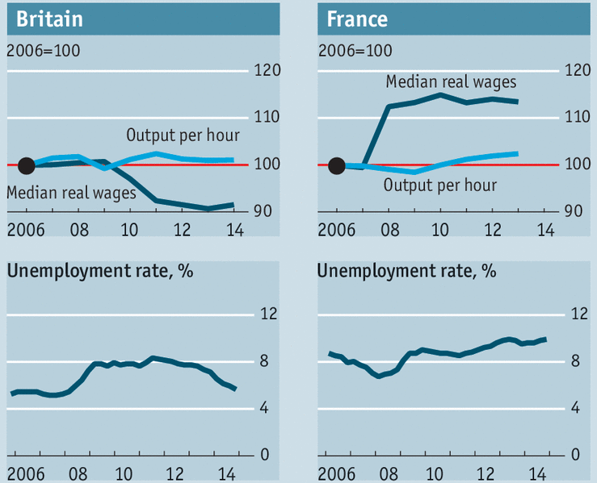
Source: The Economist, 2 May 2015

Extract 5: The economics of low wages
In most places, the recession that followed the 2009 financial crisis had dire effects on wages. In America, workers have been demonstrating for higher pay and stronger union rights in the profitable but poorly paying food industry. Britain’s Labour Party has plans to punish “predatory” capitalists that exploit the low-paid. In Japan Shinzo Abe has sworn to lift salaries.

Across rich countries, household consumption ranges from 55% (France) to 68% (America) of GDP. While it makes sense for an individual boss to hold down pay, low pay across the economy as a whole threatens to put a lid on the growth that one would otherwise expect after a recession.

Meanwhile, scholars seek to explain this decline in the labour share. One is that the income from capital has been increasing more than the income from labour. Another is that, in many industries, capital goods have become a lot cheaper and/or better. Bosses can choose whether to spend money on machinery or people, and declines in the price of the capital goods required for a given amount of output reduce demand for labour.

Globalisation can also reduce the demand for less skilled toward more skilled labour, driving income inequality between them. Competition from imports alter the profit opportunities facing firms. Firms respond by shifting resources toward industries in which profitability has risen and away from those in which it has fallen. And the decline of trade unions reduces labour’s bargaining power. In addition, rapid technology change seems to have led to relative price declines in skill- intensive industries as well.
Source: Adapted from The Economist, 2 May 2015
& www.imf.org, accessed July 2016
Table 1: Economic data of selected countries, 2014
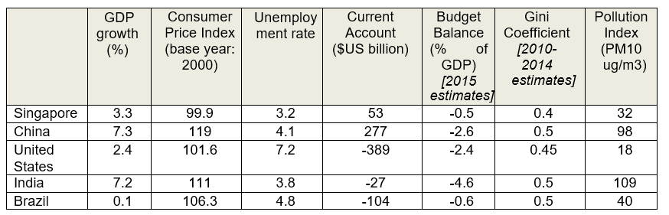

Source: World Bank Data, www.tradingeconomics.com, IMF website

Extract 6: Global economy faces low growth

The world economy appears to be suffering a slowdown in growth that will stretch through 2016, according to a report by the Organisation for Economic Cooperation & Development (OECD).

Despite a secular stagnation that is associated with higher health and pension costs of an ageing population that impedes other investment and improved productivity in western countries, stimulus efforts appear to have had an impact with the US economy showing signs of recovery of late. That has seen the Federal Reserve, US’ central bank, scale back its key stimulus measure of increasing money supply. However in its latest policy decision, the Federal Reserve said it would look at multiple factors before approving any rise in its interest rates. It has previously hinted at doing so once jobless rate fell to 6.5%.

The OECD said in its interim economic forecast that the prospect of higher interest rates in the US and UK had exposed the vulnerability of emerging market economies to higher borrowing costs. It urged the US Federal Reserve to maintain its course for higher interest rates, but called on its officials to signal that the pace of increases will be slow, allowing those countries that have borrowed heavily in dollars to adjust to the jump in costs. Brazil is expected to be one of the hardest hit by the slowdown in China and by its exposure to higher borrowing costs following a US interest rate rise.

The World Bank has cut its forecasts for growth across emerging economies, warning that they face a double whammy from rising US interest rates and lower commodity prices in the oil and energy markets. The World Bank said that emerging economies should prepare themselves for a future beyond cheap money and the commodities boom by investing in infrastructure. “We believe that countries that invest in people’s education and health, improve the business environment, and create jobs through upgrades in infrastructure will emerge much stronger in the years ahead,” it said. “These kinds of investments will help hundreds of millions of people lift themselves out of poverty.”

Source: Adapted from The Guardian, 16 September 2015
& www.bbc.com, March 2014

Extract 7: The economics of infrastructure development
The development of highways, ports, bridges, public transport, railways, telecommunications, fisheries, harbours and irrigation are important for an economy’s rapid development. These constitute essential economic infrastructure whose development is vital as the efficiency of investment is determined by the state of infrastructure.

Nevertheless the economics of infrastructure development, especially the methods of financing, priorities and returns to investment require serious evaluation. Infrastructure investments are large, could put a strain on balance of payments, and their economic returns take a long period of time. However beneficial investments in infrastructure are, if they lead to large fiscal deficits these would lead to inflationary pressures. Furthermore, there is a large import content in many infrastructure investment projects. In many cases it is even difficult to determine precise benefits of infrastructure investment. One current misconception is that all infrastructure investments are beneficial to the country’s economic and social development. Several large infrastructure projects can only be described as White Elephants, while others will bring in only small benefits.

Future infrastructure designs will need to be anticipatory and proactive to be truly sustainable. One examples of this type of next-generation monitoring is in Songdo, South Korea where everything from traffic flow to household waste is highly responsive and networked. These smart-grid networks will become increasingly responsive to allocating electricity in response to demand, or public transport systems that respond to congestion by allocating buses where people are congregating or changing lights automatically based on traffic patterns.
Source: www.sundaytimes.lk, 27 July 2014 & www.bbc.com, 23 November 2013
Questions
(a)(i) What is meant by real wages? [1]
(ii) Based on Figure 3, compare the changes in output per hour and median real wages for Britain and France between 2009 and 2014. [2]
(iii) With reference to the data, explain a factor that could have contributed to the change in UK’s real wages after 2009. [2]

(b)(i) Explain why a rise in a country’s wages is not evidence of a narrowing income gap in the country. [2]
(ii) Extract 5 suggests that low pay across an economy as a whole threatens to put a lid on its growth. Using economic analysis and a relevant diagram, explain and comment whether this threat is valid. [6]

(c) Explain why maintaining a rise in the US interest rate is good news for the US but bad news for countries like Brazil. [4]

(d)(i) Analyse how infrastructure investment by emerging economies will ‘put a strain’ on their balance of payments (extract 7). [3]
(ii) Extract 6 states that “these kinds of investments will help hundreds of millions of people lift themselves out of poverty”.
Based on the data and your own relevant knowledge, assess whether a country should then focus on infrastructure investment to achieve growth or pursue other economic goals as its priority. [10] [Total: 30]
Suggested Answers
(a)(i) What is meant by real wages? [1]

Nominal wages / earning of workers adjusted for inflation.

(a)(ii) Based on Figure 3, compare the changes in output per hour and median real wages for Britain and France between 2009 and 2014. [2]

Output per hour rose slightly whilst the median real wages fell significantly for UK. In contrast, in France, both output hour and real wages rose continuously with its rate of output rising faster than UK.

(a)(iii) With reference to the data, explain a factor that could have contributed to the change in UK’s real wages after 2009. [2]

World economy slowing down with slow growth in China, the second largest economy that drives the world economy, including UK (ext 4). As a result, UK investors and firms have a pessimistic economic outlook and cutback production as they anticipate that its trading partners will buy less imports from them.

This will cause a fall in the derived demand for labour as less production is required. Assume price of goods and services unchanged, real wages thus fell.

(b)(i) Explain why a rise in a country’s wages is not evidence of a narrowing income gap in the country. [2]

A narrowing income gap means there is less uneven distribution of earnings amongst the various groups of people.

Wages are a major source of household income in both developed and developing economies but a rise in the country’s wages does not mean that all workers benefit equally. The rise in wages could have been significant and benefitted only certain industries/sectors, especially those in the trade sectors spurred by globalisation export opportunities. At the same time, a fall in demand for less skilled workers reduces their income.

In addition, it has also been observed that globalisation presents vast opportunities for capitalists and entrepreneurs which means that their profits could also have improved greatly.

(b)(ii) Extract 5 suggests that low pay across an economy as a whole threatens to put a lid on its growth. Using economic analysis and a relevant diagram, explain and comment whether this threat is valid. [6]

Growth may be actual or potential rise in real GDP. Using the expenditure method, GDP is the sum of spending by households, firms, government and the foreign sector, ie: C+I+G+X-M.

It may be achieved by either increasing aggregate demand (AD) for locally produced goods and services and/or a rise in aggregate supply (AS).

Low pay results in low C by households due to firstly their low income and purchasing power and secondly, households’ pessimistic outlook at the same time. Therefore, in figure 1, at the same price OP, AD will fall. This is illustrated by a left shift of AD.

This fall may be to a large extent for countries like USA and rich countries, where consumption comprise a large percentage of their GDP (68%) and especially at this current period of slow growth where consumption is required to boost production.

In addition, this fall in consumption would at the same time cause a fall in investment by firms due to pessimistic outlook. This fall in investments means that the potential growth will also be reduced, meaning that the productive capacity will increase at a slower rate.

However, if low pay is a result of technology advancements where workers are replaced by machinery or business firms switch production approaches to more capital and automation and demand less labour (ext 1), it could mean that growth might be assisted by more efficient methods of production. This could also result in export competitiveness and rise in real GDP.

(c) Explain why maintaining a rise in the US interest rate is good news for the US but bad news for countries like Brazil. [4]

A rise in interest rates is good news for United States because of the current state of the economy.

It signals that US is beginning to show signs of economy recovery as suggested by successful “stimulus efforts” in ext 6. This means that the job market is improving and there is some turn around in economic growth. Hence, raising interest rate suggests that United States has already reached its targeted job creation and inflation rate. This is in spite of the problem of secular stagnation where it is gripped by higher health and pension costs associated with ageing population. Hence a rise in interest is a good contractionary tool to curb possible demand pull inflation.

However, rising US interest rates is bad news for Brazil because firstly, if Brazil is a big borrower from US banks, it incurs higher interest payment on its debt. In addition, this will prevent some government investments in Brazil due to the higher cost of borrowing from US banks. As a result, this fall in government spending will reduce the aggregate demand and output and income. Hence this further curtails economic growth and job creation in the country. Secondly, a high public debt ridden with high interest payment may dampen investors’ confidence in the country, further crippling the economy.

(d)(i) Analyse how infrastructure investment by emerging economies will ‘put a strain’ on their balance of payments (extract 7). [3]

Balance of payments is a record of receipts and payments from exports and imports of goods, services and assets. A strain suggests the country is paying more than it is receiving from its international transactions.

Infrastructural development could mean capital/government spending on roads, ports etc. These require imports of capital goods, trains, oil and construction equipment, thus demand for imports and import expenditure will rise. Such investments are “large” and therefore could result in huge import expenditure and hence a severe current account deficit, assuming export revenue unchanged. This will put a strain on achieving a healthy balance of payments, assuming capital account unchanged.

Furthermore, extract mentions the possibility of inflation with infrastructure investment. This could result because of a rise in government spending on infrastructure that stimulates the economy to near full employment level. This resulting demand pull price instability could reduce foreign direct investment as foreign firms could be discouraged from setting up business in the country as they have challenges estimating cost, revenue and profits. Assuming local firms investment overseas remain unchanged, this puts a strain on the capital account as a net outflow of currency would result.

(d)(ii) Extract 6 states that “these kinds of investments will help hundreds of millions of people lift themselves out of poverty”.

Based on the data and your own relevant knowledge, assess whether a country should then focus on infrastructure investment to achieve growth or pursue other economic goals as its priority. [10]

There are a few fundamental macro-goals a country should seek to achieve, such as growth, external healthy balance of payments, low inflation stability and full employment. Microeconomic goals include equity in income distribution amongst various groups of people and efficiency in resource allocation.

TS1a: The data (ext 6) suggests the importance of developing physical infrastructure such as ports and highways to stimulate economic growth.
Infrastructure investment can be seen as an expansionary fiscal tool with long run sustainable rise in real GDP. Firstly, this rise in government spending will initially raise the aggregate demand for locally produced goods and services, stimulate production and bring about a rise in real GDP. Secondly, once this infrastructure is completed, it improves the productive capacity of and attracts further investments in the economy bringing about an increase of the country’s aggregate supply. This enables sustainable economic growth into the long run.

TS1b: At first glance, it appears that this focus on government spending to improve infrastructure is therefore necessary if growth is the priority.
This would be the case especially if a country experiencing slow growth or recession or severe poverty. This will especially lift emerging economies out of poverty, bring about a higher standard of living for everyone as a rise in income would now mean a higher purchasing power for the average citizen, assuming the inflation rate remain constant or rise less than the rise in national income. In addition, through growth, it is hoped that strong job creation and equity goals can also be achieved through a redistribution of income that a rise in government tax revenue makes possible with economic growth.

Hence, under such conditions, growth would be a reasonable priority to pursue for countries like Brazil with only a growth rate of 0.1% (Table 1) with the danger of sliding into recession. If this happens, investors’ confidence will further be shaken with serious repercussions on reviving the economy. In addition, the strength of choosing this priority is that it is not likely to be in conflict with other goals, but achieves other important goals such as employment and equity simultaneously as explained above.

TS2: Some countries such as India and China also appear to suffer from serious pollution issues with an unhealthy pollution index of close to 100 (Table 1) and may need to prioritise micro economic goals instead.
Such countries should seriously also look into environmentally sustainable growth with measures to manage growth and efficient use of resources at an optimal level. This is because environmental pollution will undermine citizens’ non material well-being and quality of life due to negative externalities arising from economic activity. Such externalities could affect both the living and the unborn as water and air pollution cause serious medical concerns and deaths where research has already shown to have happened in countries like China. Hence instead of pursuing growth at all cost, it should prioritise cutting on environmental damage.

TS3: However, the data also suggests that countries such as Brazil and United States suffer from a huge deficit in their current account balance.
This means that the country’s export earnings are less than its import expenditure arising from trade in goods and services. This means the country suffers from an external debt where it is living beyond its means. The opportunity cost of interest paid on debt would mean less funds available for other competing needs of the economy. The more immediate concern is that a massive current account deficit suggests a continuing loss of export competitiveness and a possible loss of investors’ confidence and credit rating with long term consequences. Hence, the severity of the deficit suggests this could be the priority area for such countries. Instead of concentrating on growth alone fuelled by domestic factors, these countries could look into measures to improve, for example training and productivity of their workers to reduce their cost of production in the respective sectors to ensure a healthy external performance.

Conclusion
In conclusion, there are many economic goals a government wishes to pursue. With a limited budget, it should consider carefully how serious or how far short its country is currently at in achieving these goals and whether they wish to solve the short term challenges with long term solutions. This requires an expedient mix of policies to achieve as many goals simultaneously.

