JC Economics
CSQ – Lesson 4 – AD-AS Model & National Income Accounting – Q1

Tale of Two Economies

Extract 4: Indonesia aims for FDI growth
Indonesia is aiming to increase foreign direct investment by 23 percent this year, after record inflows in 2012 helped insulate Southeast Asia's largest economy from a slowdown in exports. Strong investment was driven by the mining, transport and chemicals sectors, showing firms shrugged off worries over policy uncertainty, corruption and weak infrastructure to seek returns in an economy growing at more than 6 percent.

It was also reported that investors at home and abroad have responded positively to efforts to improve the investment climate. Foreign inflows to the G20 economy have increased significantly since Indonesia regained investment grade status from two rating agencies a year ago. Investment makes up around 30 percent of the G20 economy. Although it’s FDI is less than that attracted by China in 2012, Indonesia remained attractive to foreign investors compared with its Southeast Asian neighbours. Vietnam, for example, estimated its FDI fell by 5 percent to $10.46 billion in 2012.

Foreign investors are not expected to stop coming into Indonesia, especially noting the fact that infrastructure upgrades are ongoing in the country over the next three to five years. There is a need to continue enhancing workers’ productivity, especially in the manufacturing sector, which has been a laggard relative to the region."
Adapted from Reuters, 22 June 2013

Extract 5: Abenomics and the Japanese Economy
Just weeks after taking office in December 2012, Japanese Prime Minister Shinzo Abe, who had also led the country from 2006 to 2007, announced plans for a new suite of policies geared toward jolting the stagnating economy out of its deflationary malaise. Japan, having fought deflation for more than two decades, remains mired in weak growth despite repeated attempts to revitalize the economy.

Abenomics refers to an aggressive set of monetary and fiscal policies, combined with structural reforms, geared toward pulling Japan out of its decades-long deflationary slump.

Fiscal stimulus began with economic recovery measures totaling 20.2 trillion yen ($210 billion), of which 10.3 trillion ($116 billion) was direct government spending. Abe ordered a hefty stimulus package focused on critical infrastructure projects, such as building bridges, tunnels, and earthquake-resistant roads. This was earmarked to stimulate private investment

The Bank of Japan (BOJ) simultaneously pursued an unorthodox injection of liquidity into the economy, a policy known as quantitative easing, seeking to push inflation to 2 percent to spur spending. The goal of easy monetary policy is to reduce real interest rates. In Japan’s case, it has a significant side effect of weakening the yen.

Finally, structural reform—including slashing business regulations, liberalizing the labor market, cutting corporate taxes, and increasing workforce diversity—aims to revive Japan’s long-term competitiveness.
Adapted from Business Insider, 16 March 2013

Extract 6: Abenomics needs an overhaul

Japanese Prime Minister Shinzo Abe must rethink his Abenomics program in its entirety. So far, only Abenomics' third and final arrow, reform, has come in for widespread criticism. But arrows one and two – monetary and fiscal stimulus – are also flagging in their efforts to pull Japan out of its economic funk. Annualized GDP growth fell to 1 percent in the second half of 2013 from more than 4 percent in the first half. If Abe does not refocus his reform program, the country risks a dangerous reliance on the Bank of Japan and its ultra-loose monetary policy.

Barring substantial reforms elsewhere in the Japanese economy, using the 'first arrow' to repeatedly weaken the yen is an unsustainable source for growth in the long-run. Under Abenomics, growth in Japanese exports has failed to keep pace with the rising cost of imports.

In a country with an aging and shrinking population, real long-term growth can only be realized through improved productivity. To stimulate productive investment, Japan must revamp the second arrow of Abenomics and focus on tax incentives rather than government spending. The new tax breaks tied to capital investment are surely too small to encourage significant new domestic investment, and only apply if companies can meet a 15 percent return on investment hurdle, a level which may be unrealistic in such a stagnant economy. These kinds of measures should prove more effective, and safer, than fiscal stimulus. Japan's government debts are already more than twice its GDP and further increasing it would prove problematic.

The third arrow of Abenomics, reform, also requires redirection. First, Japan needs to ensure its businesses use its people properly. To do this it will need to address a rigidity that has led to the development of a 'dual' labor market. Around 40 percent of workers are now deemed 'temporary,' in jobs which provide low pay, a lack of social insurance, and little opportunity to develop skills. There is scope to increase the use of foreign labor. There is also a need to use more flexible labor contracts so you can bring people into the labor force
Adapted from CNBC News, 27 March 2014

Using the given data, compare and evaluate the economic performance of Indonesia and Japan the period 2009 to 2013.(10)

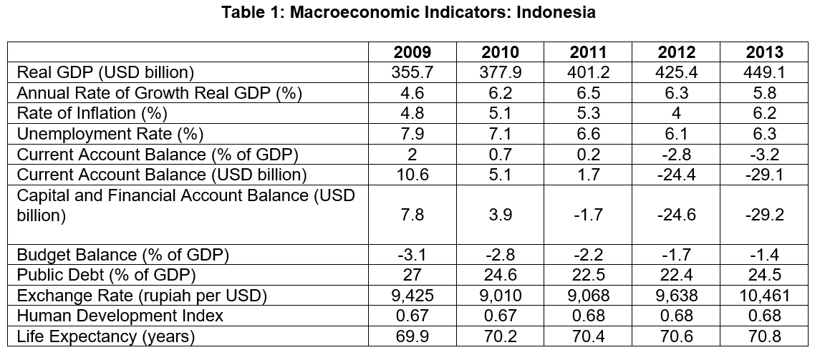
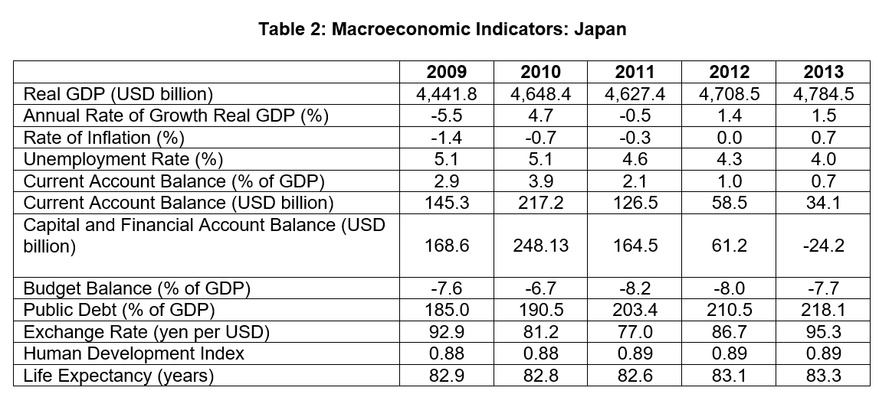
Source: Organisation for Economic Co-operation and Development
Questions
(a) (i) With reference to Table 1, describe the trend in the government budget balance as a percentage of GDP of Indonesia between 2009 and 2013. [2]

(ii) Explain how the government budget could have affected GDP growth rate in Indonesia. [2]

(b) (i) How far does the data support the changes in the capital and financial
in Indonesia from 2009 to 2013? [4]

(ii) Explain the rationale for Indonesia’s aim “to increase foreign direct investment by 23 percent this year”. [4]

(c) Comment on the view that residents in Japan enjoyed a higher standard of living compared to those in Indonesia in 2013. [8]

(d) Discuss the view expressed in Extract 6, which suggests that “Japanese Prime Minister Shinzo Abe must rethink his Abenomics program in its entirety.” [10]
[Total: 30 marks]

