JC Economics CSQ – Term 3 2014
Market Failures Q1
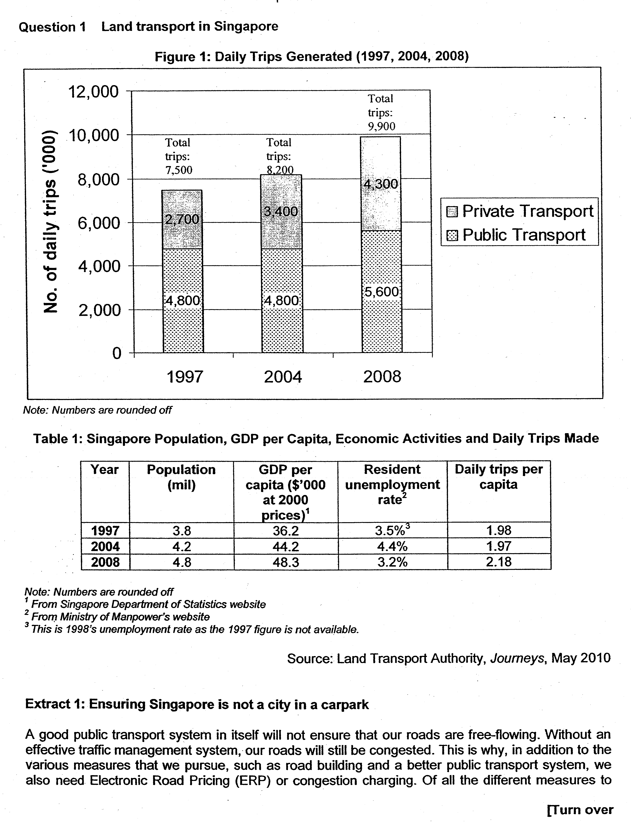

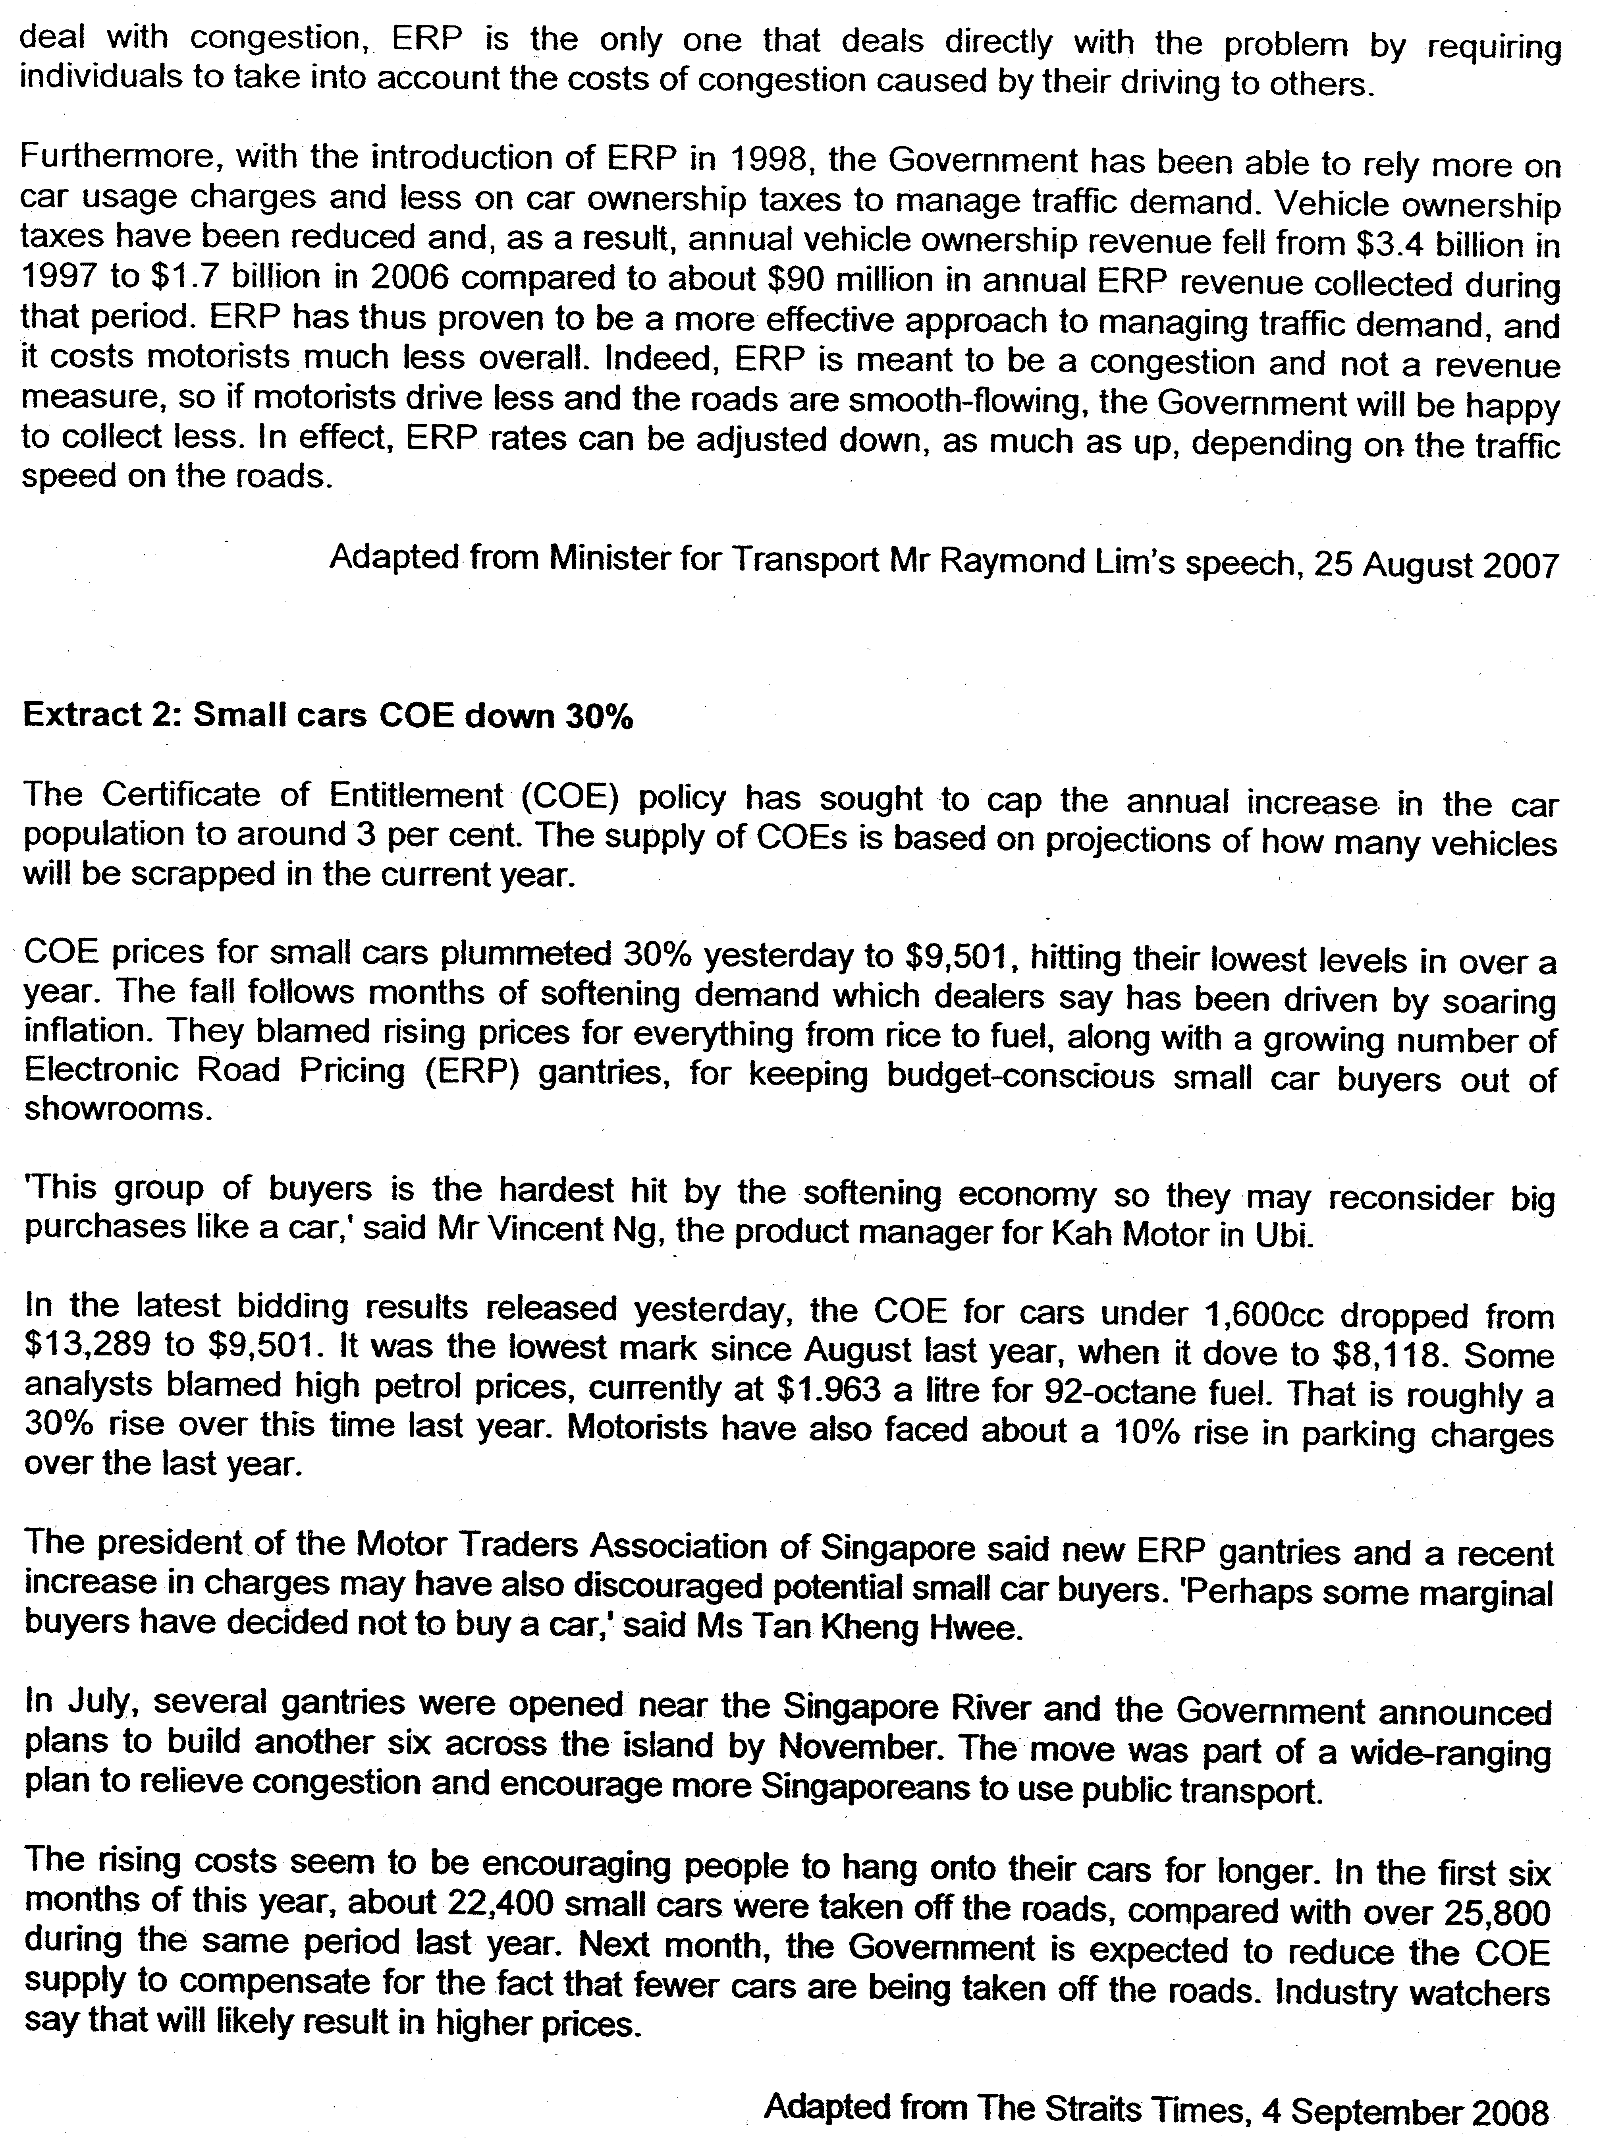

Suggested Answers

(a)(i) With reference to Figure 1, describe the main features in the generation of trips between 1997 and 2008. [2]
The number of trips grew rapidly with private transport trips growing faster than public transport trips.

(ii) Using Table 1, suggest possible reasons for the features observed. [4]

•Increase in population
According to Table 1, Singapore's population had grown from 3.8 million to 4.8 million between 1997 and 2008, a 26 percent increase. This has led to increase in total ridership.
•Economic growth
Real GDP per capita grew by 33 percent between 1997 and 2008. Private transport is perceived to be more of a luxury good than public transport. With higher income, the increase in demand for private transport is greater than the increase in demand for public transport. Hence, this explains why private transport trips grow faster than public transport. (increase in income leads to an increase in demand for normal goods)

Note: 1 reason for the general rising trend, 1 reason for the more rapid increase in private transport trips.

(b) With the help of a demand and supply diagram, account for the change in the price of Certificate of Entitlement (COE) in Extract 2. [6]

Price of COE fell. In particular it fell by 30% for small cars (Extract 2, para 2).

Demand for COEs falls
•Fall in demand for cars due to soaring inflation, rise in cost of car usage(fuel, parking charges, ERP) (Extract 2 para 2) → demand for COEs also falls.

Supply of COE is perfectly price inelastic and unchanged
•Supply is perfectly price inelastic. The total number of COEs allotted is based on projections of how many vehicles will be scrapped in the current year (Extract 3 para 1) of which a certain number would be released every month for bidding
•It is unchanged at the moment because it would only be next month that the supply of COE be adjusted by the Government (Extract 2 para 7)

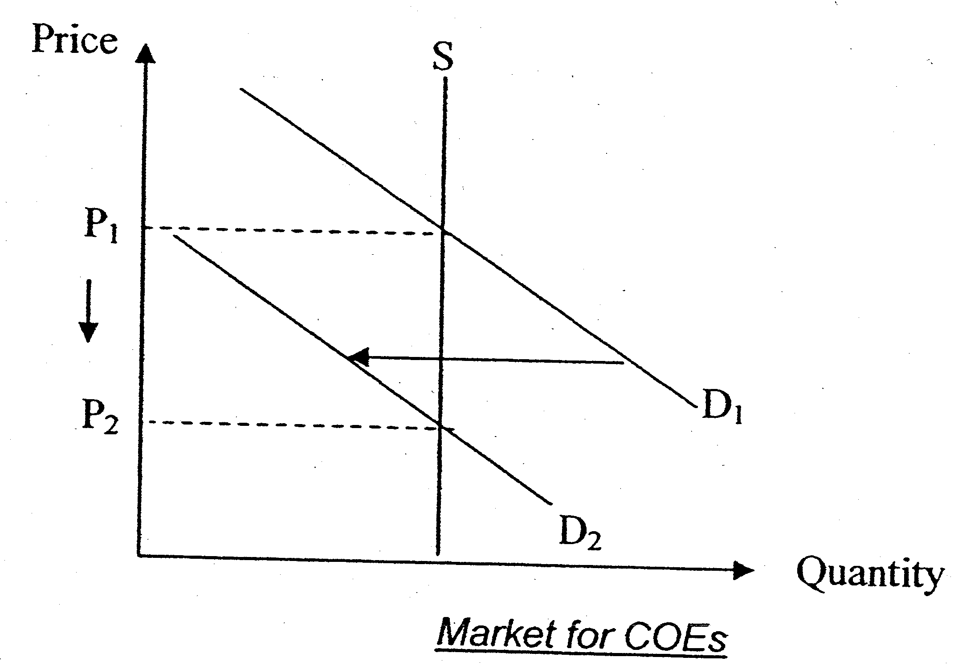
As seen from the diagram, the fall in demand for cars from Do to D1 will contribute to a fall in the price of car from Po to P1 due to the excess supply at Po for this car market.

Note: Supply curve needs to be vertical to reflect the fixed amount of COEs supplied (0m for the diagram if the supply curve is upward sloping)

(c) (i) What is meant by price elasticity of demand? [2]

Price elasticity of demand measures the degree of responsiveness of quantity demanded of a good to a change in its own price, ceteris paribus.

It is measured by taking the ratio of the percentage change in quantity demanded of the good to the percentage change in the price of the good itself.

(ii) To what extent is the car sellers' revenue affected by the new COE quota? [6]

Thesis: The new COE quota would affect the car sellers' revenue based on the price elasticity of demand of cars

In Extract 3, the new COE quota would be nearly 30 per cent smaller. This translates to higher prices of cars.

For motor traders of smaller cars, a rise in the price of cars is likely to reduce their total revenue. Demand for smaller cars (less than 1600cc) tends to be price elastic. This is because buyers of smaller cars are likely to be less affluent. As such, the cost of buying a car takes up a much larger proportion of their income. Hence, with a rise in the price of cars, the quantity demanded for smaller cars will fall more than proportionately leading to a fall in total revenue for the motor traders.

For motor traders of larger cars, a rise in the price of cars is likely to increase their total revenue. Demand for larger cars (1600cc and above) tends to be price inelastic. As buyers of such cars are richer, the cost of buying a car takes up a relatively smaller proportion of their income. Hence, with a rise in the price of cars, the quantity demanded for larger cars will fall less than proportionately, leading to a rise in total revenue for the motor traders instead.

Anti-thesis: Car sellers' revenue can also be impacted by other factors
However, there can be other factors, besides the new COE quota (hence higher car prices) that can affect car sellers' revenue. These are factors that shift the demand curve and are due to changes in tastes and preferences and income levels.

With a softening economy (Extract 2 para 3), the level of income falls. This would cause the demand curve to shift to the left hence reducing total revenue for all the motor traders. However, motor traders of smaller cars are likely to be impacted more as demand from buyers of smaller cars is likely to fall relatively more since this group of buyers are the hardest hit. Moreover, there can be changes in tastes and preferences towards driving.
With more new ERP gantries and a recent increase in parking charges (Extract 2, para 5), people may have shifted their preferences towards public transport instead. This would reduce the demand for cars and subsequently total revenue
for all the motor traders.

Evaluation
In conclusion, the impact on car sellers’ revenue has to be analysed from many factors, not just the new COE quota.

(d) Evaluate the relative effectiveness of the COE system and Electronic Road Pricing in managing traffic congestion in Singapore. [10]

- how the road congestion will contribute to market failures (presence of negative externalities)
- state that ERP and COE can solve the market failures
- Explain how COE works
- Explain how ERP works
- Evaluate why COE is more effective than ERP
- Evaluate why ERP is more effective than COE
- Your judgement
Why manage traffic congestion in Singapore? [Brief] (1)
- How traffic competition leads to market failure in road industry
- Road usage negative externalities (road congestion)
- ↑rise of external costoverproduction rise of DWL
- Correct market failure due to congestion

Explain how COE and ERP work (3)
i) COE:
- Quota system which limits the growth of the car population based on the number of vehicles taken off the road in the preceding six-month period (Extract 3)
- Targets at car ownership to reduce traffic congestionreduce Qty of road usage from Q_{m} to Q_{s} (↓size of car population)
- It is a lump-sum payment to increase the fixed cost of driving. It does not vary with number of trips made.

ii) ERP
- ERP raises the cost of road usage↓SS of road usage↑P ↓Qty dd from Q_{m} to Q_{s}
- Works by charging drivers an amount when they enter congested areas/roads during peak hours
- Targets at car usage as it allows people to own cars but only penalises those who enter congested roads
- It is a pay-per-use principle to increase the private marginal cost of driving
- Illustrate with externalities diagram how ERP works to bring the level of road usage closer to the socially optimal level

COE is more effective than ERP in managing traffic congestion
- COE directly controls the car population in Singapore which will manage the number of cars using the road and enabling the government to control road usage while ERP merely directs the traffic congestion to alternative routes
- Setting the size of car population will make it easier for the government to see the output of road usage at social optimal level while the ERP is unable to ensure that road usage is at social optimal level since the tax duty may not adjust to internalize the external cost as the governments can estimate the extent of external marginal cost
- COE can be a strong deterrence to car ownership and thus reduces the size of car population which will lower demand for road usage especially after the introduction of huge percentage upfront cash payment which will raise the financial cost for car ownership. On the other hand, ERP may not be effective to reduce demand for road usage as ERP charge occupies only a small percentage of proportion of consumers’ income (demand for road usage is price-inelastic)

ERP is more effective than COE in managing traffic congestion
- ERP can conduct allocation of road usage based on time and route allocation but COE cannot control the allocation. ERP is more effective as it tackles the root cause of traffic congestion
- ERP can be adjusted to the external marginal cost as it is a variable cost that adjusts to the nature of demand. However, COE will only encourage me road usage as it is a fixed charge whereby drivers will drive more to reduce the average COE charge per trip

Evaluation
- Both methods have their strengths and weaknesses. But in controlling congestion, it would be more effective if we were to target car usage and to reduce the incentive for commuters to travel by car or if they still wish to travel by car, to choose to go by a different route instead. Moreover, as mentioned in Minister's speech, ERP is the only one that deals directly with the problem by requiring individuals to take account the costs of congestions.
- However, this does not mean that these are the only methods to manage traffic congestions. The government needs to supplement these with road building/widening and better public transport system.

COE is more effective than ERP in managing traffic congestion
•COE directly controls the car population in Singapore. On the other hand, ERP does not control the car population in Singapore. It merely reduces traffic congestion in areas with ERP and diverts the problem to other roads along alternative routes not covered by ERP, hence causing traffic congestions elsewhere.
•It is easier to determine the allotment of COEs as there is a "formula" to follow. On the other hand, it is difficult to estimate the extent of external marginal cost for ERP and thus the tax rate may not be accurately determined.
•Relatively lower cost of implementing COE system as opposed to high costs of setting up the gantries

• As price of the COE is of a much larger amount, people are more likely to be deterred from buying a car. On the other hand, once a car is bought the amount deducted by ERP may seem relatively "insignificant" and people may not feel the pinch. Hence, demand for travel on affected roads becomes price inelastic after a while as the convenience outweighs the ERP charge. This result in a less than proportionate fall in quantity demanded for road usage given a rise in ERP charges.

ERP is more effective than COE in managing traffic congestion
•COE does not control the usage of cars (which is the main cause of congestion) as car owners may view COE as a fixed cost and may wish to spread out the cost over more trips. It may encourage more usage. On the other hand, ERP is more effective as it tackles the root of the problem which is excessive usage of some roads.
•Moreover, the determination of allotment of COE can be flawed. The previous system of allotting COE had led to an almost 25% increase instead of the target annual 3% increase in vehicle population in the past five years. On the other hand, ERP is a more flexible and responsive instrument which can be periodically adjusted down or up depending on the traffic speed on the roads (Extract 1)

Evaluation
Both methods have their strengths and weaknesses. But in controlling congestion, it would be more effective if we were to target car usage and to reduce the incentive for commuters to travel by car or if they still wish to travel by car, to choose to go by a different route instead. Moreover, as mentioned in Minister's speech, ERP is the only one that deals directly with the problem by requiring individuals to take account the costs of congestions.

However, this does not mean that these are the only methods to manage traffic congestions. The government need to supplement these with road building/widening and better public transport system.

(a)(i) With reference to Figure 1, describe the main features in the generation of trips between 1997 and 2008. [2]

(ii) Using Table 1, suggest possible reasons for the features observed. [4]

(b) With the help of a demand and supply diagram, account for the change in the price of Certificate of Entitlement (COE) in Extract 2. [6]

(c) (i) What is meant by price elasticity of demand? [2]

(ii) To what extent is the car sellers' revenue affected by the new COE quota? [6]

(d) Evaluate the relative effectiveness of the COE system and Electronic Road Pricing in managing traffic congestion in Singapore. [10]

(a)(i) With reference to Figure 1, describe the main features in the generation of trips between 1997 and 2008. [2]
The number of trips grew rapidly with private transport trips growing faster than public transport trips.

(ii) Using Table 1, suggest possible reasons for the features observed. [4]

•Increase in population
According to Table 1, Singapore's population had grown from 3.8 million to 4.8 million between 1997 and 2008, a 26 percent increase. This has led to increase in total ridership.
•Economic growth
Real GDP per capita grew by 33 percent between 1997 and 2008. Private transport is perceived to be more of a luxury good than public transport. With higher income, the increase in demand for private transport is greater than the increase in demand for public transport. Hence, this explains why private transport trips grow faster than public transport.

Note: 1 reason for the general rising trend, 1 reason for the more rapid increase in private transport trips.

(b) With the help of a demand and supply diagram, account for the change in the price of Certificate of Entitlement (COE) in Extract 2. [6]

Price of COE fell. In particular it fell by 30% for small cars (Extract 2, para 2).

Demand for COEs falls
•Fall in demand for cars due to soaring inflation, rise in cost of car usage(fuel, parking charges, ERP) (Extract 2 para 2) → demand for COEs also falls.

Supply of COE is perfectly price inelastic and unchanged
•Supply is perfectly price inelastic. The total number of COEs allotted is based on projections of how many vehicles will be scrapped in the current year (Extract 3 para 1) of which a certain number would be released every month for bidding
•It is unchanged at the moment because it would only be next month that the supply of COE be adjusted by the Government (Extract 2 para 7)

Note: Supply curve needs to be vertical to reflect the fixed amount of COEs supplied (0m for the diagram if the supply curve is upward sloping)

(c) (i) What is meant by price elasticity of demand? [2]

Price elasticity of demand measures the degree of responsiveness of quantity demanded of a good to a change in its own price, ceteris paribus.

It is measured by taking the ratio of the percentage change in quantity demanded of the good to the percentage change in the price of the good itself.

(ii) To what extent is the car sellers' revenue affected by the new COE quota? [6]

Thesis: The new COE quota would affect the car sellers' revenue based on the price elasticity of demand of cars

In Extract 3, the new COE quota would be nearly 30 per cent smaller. This translates to higher prices of cars.

For motor traders of smaller cars, a rise in the price of cars is likely to reduce their total revenue. Demand for smaller cars (less than 1600cc) tends to be price elastic. This is because buyers of smaller cars are likely to be less affluent. As such, the cost of buying a car takes up a much larger proportion of their income. Hence, with a rise in the price of cars, the quantity demanded for smaller cars will fall more than proportionately leading to a fall in total revenue for the motor traders.

For motor traders of larger cars, a rise in the price of cars is likely to increase their total revenue. Demand for larger cars (1600cc and above) tends to be price inelastic. As buyers of such cars are richer, the cost of buying a car takes up a relatively smaller proportion of their income. Hence, with a rise in the price of cars, the quantity demanded for larger cars will fall less than proportionately, leading to a rise in total revenue for the motor traders instead.

Anti-thesis: Car sellers' revenue can also be impacted by other factors
However, there can be other factors, besides the new COE quota (hence higher car prices) that can affect car sellers' revenue. These are factors that shift the demand curve and are due to changes in tastes and preferences and income levels.

With a softening economy (Extract 2 para 3), the level of income falls. This would cause the demand curve to shift to the left hence reducing total revenue for all the motor traders. However, motor traders of smaller cars are likely to be impacted more as demand from buyers of smaller cars is likely to fall relatively more since this group of buyers are the hardest hit. Moreover, there can be changes in tastes and preferences towards driving.
With more new ERP gantries and a recent increase in parking charges (Extract 2, para 5), people may have shifted their preferences towards public transport instead. This would reduce the demand for cars and subsequently total revenue
for all the motor traders.

Evaluation
In conclusion, the impact on car sellers’ revenue has to be analysed from many factors, not just the new COE quota.

(d) Evaluate the relative effectiveness of the COE system and Electronic Road Pricing in managing traffic congestion in Singapore. [10]

Why manage traffic congestion in Singapore? [Brief]
- How traffic competition leads to market failure in road industry
- Road competition negative externalities
- ↑rise of external costoverproduction rise of DWL
- Correct market failure due to congestion

Explain how COE and ERP work
i) COE:
- Quota system which limits the growth of the car population based on the number of vehicles taken off the road in the preceding six-month period (Extract 3)
- Targets at car ownership to reduce traffic congestionreduce Qty of road usage from Q_{m} to Q_{s} (↓size of car population)
- It is a lump-sum payment to increase the fixed cost of driving. It does not vary with number of trips made.

ii) ERP
- ERP raises the cost of road usage↓SS of road usage↑P ↓Qty dd from Q_{m} to Q_{s}
- Works by charging drivers an amount when they enter congested areas/roads during peak hours
- Targets at car usage as it allow people to own cars but only penalises those who enter congested roads
- It is a pay-per-use principle to increase the private marginal cost of driving
- Illustrate with externalities diagram how ERP works to bring the level of road usage closer to the socially optimal level

COE is more effective than ERP in managing traffic congestion
- COE directly controls the car population in Singapore which will manage the number of cars using the road and enabling the government to control road usage while ERP merely directs the traffic congestion to alternative routes
- Setting the size of car population will make it easier for the government to see the output of road usage at social optimal level while the ERP is unable to ensure that road usage is at social optimal level since the tax duty may not adjust to internalize the external cost as the government can estimate the extent of external marginal cost
- COE can be a strong deterrence to car ownership and thus reduces the size of car population which will lower demand for road usage especially after the introduction of huge percentage upfront cash payment which will raise the financial cost for car ownership. On the other hand, ERP may not be effective to reduce demand for road usage as ERP charge occupies only a small percentage of proportion of consumers’ income (demand for road usage is price-inelastic)

ERP is more effective than COE in managing traffic congestion
- ERP can conduct allocation of road usage based on time and route allocation but COE cannot control the allocation. ERP is more effective as it tackles the root cause of traffic congestion
- ERP can be adjusted to the external marginal cost as it is a variable cost that adjusts to the nature of demand. However, COE will only encourage me road usage as it is a fixed charge whereby drivers will drive more to reduce the average COE charge per trip

Evaluation
- Both methods have their strengths and weaknesses. But in controlling congestion, it would be more effective if we were to target car usage and to reduce the incentive for commuters to travel by car or if they still wish to travel by car, to choose to go by a different route instead. Moreover, as mentioned in Minister's speech, ERP is the only one that deals directly with the problem by requiring individuals to take account the costs of congestions.
- However, this does not mean that these are the only methods to manage traffic congestions. The government needs to supplement these with road building/widening and better public transport system.

COE is more effective than ERP in managing traffic congestion
•COE directly controls the car population in Singapore. On the other hand, ERP does not control the car population in Singapore. It merely reduces traffic congestion in areas with ERP and diverts the problem to other roads along alternative routes not covered by ERP, hence causing traffic congestions elsewhere.
•It is easier to determine the allotment of COEs as there is a "formula" to follow. On the other hand, it is difficult to estimate the extent of external marginal cost for ERP and thus the tax rate may not be accurately determined.
•Relatively lower cost of implementing COE system as opposed to high costs of setting up the gantries

• As price of the COE is of a much larger amount, people are more likely to be deterred from buying a car. On the other hand, once a car is bought the amount deducted by ERP may seem relatively "insignificant" and people may not feel the pinch. Hence, demand for travel on affected roads becomes price inelastic after a while as the convenience outweighs the ERP charge. This result in a less than proportionate fall in quantity demanded for road usage given a rise in ERP charges.

ERP is more effective than COE in managing traffic congestion
•COE does not control the usage of cars (which is the main cause of congestion) as car owners may view COE as a fixed cost and may wish to spread out the cost over more trips. It may encourage more usage. On the other hand, ERP is more effective as it tackles the root of the problem which is excessive usage of some roads.
•Moreover, the determination of allotment of COE can be flawed. The previous system of allotting COE had led to an almost 25% increase instead of the target annual 3% increase in vehicle population in the past five years. On the other hand, ERP is a more flexible and responsive instrument which can be periodically adjusted down or up depending on the traffic speed on the roads (Extract 1)

Evaluation
Both methods have their strengths and weaknesses. But in controlling congestion, it would be more effective if we were to target car usage and to reduce the incentive for commuters to travel by car or if they still wish to travel by car, to choose to go by a different route instead. Moreover, as mentioned in Minister's speech, ERP is the only one that deals directly with the problem by requiring individuals to take account the costs of congestions.

However, this does not mean that these are the only methods to manage traffic congestions. The government need to supplement these with road building/widening and better public transport system.

