J2 H1 Economics CSQ Q4

Issues of Falling Oil Prices

Figure 1: Supply and Price of Brent Oil

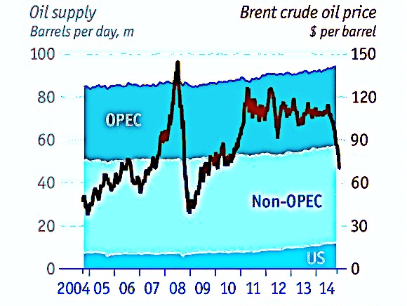

Source: IEA, Bloomberg

Extract 1: The falling oil price

The oil price has fallen by more than 40% since June, when it was $115 a barrel. It is now below $70. This comes after nearly five years of stability. At a meeting in Vienna on November 27th the Organisation of Petroleum Exporting Countries (OPEC), which controls nearly 40% of the world market, failed to reach agreement on production curbs, sending the price tumbling.

The oil price is partly determined by actual supply and demand, and partly by expectation. Demand for energy is closely related to economic activity. It also spikes in the winter in the northern hemisphere, and during summers in countries which use air conditioning. Supply can be affected by weather (which prevents tankers loading) and by geopolitical upsets. If producers think the price is staying high, they invest, which after a lag boosts supply. Similarly, low prices lead to an investment drought. OPEC’s decisions shape expectations: if it curbs supply sharply, it can send prices spiking. Saudi Arabia produces nearly 10m barrels a day - a third of the OPEC total.

Demand is low because of weak economic activity, increased efficiency, and a growing switch away from oil to other fuels. Second, turmoil in Iraq and Libya—two big oil producers with nearly 4m barrels a day combined—has not affected their output. Thirdly, America has become the world’s largest oil producer. Though it does not export crude oil, it now imports much less, creating a lot of spare supply. Finally, the Saudis and their Gulf allies have decided not to sacrifice their own market share to restore the price.

Source: The Economist, 8 December 2014

Extract 2: Falling oil price on Russia economy

Russia is one of the world's largest oil producers, and its dramatic interest rate hike to 17% in support of its troubled Russian currency, the Rouble, underscores how heavily its economy depends on energy revenues, with oil and gas accounting for 70% of export incomes.

Russia loses about $2bn in revenues for every dollar fall in the oil price, and the World Bank has warned that Russia's economy would shrink by at least 0.7% in 2015 if oil prices do not recover. Despite this, Russia has confirmed it will not cut production to shore up oil prices. "If we cut, the importer countries will increase their production and this will mean a loss of our niche market," said Energy Minister Alexander Novak.

Falling oil prices, coupled with western sanctions over Russia's support for separatists in eastern Ukraine have hit the country hard. The government has cut its growth forecast for 2015, predicting that the economy will sink into recession. Because of the twin impact of falling oil prices and sanctions, Prime Minister Dmitry Medvedev said the government had had to cut spending. "We had to abandon a number of programmes and make certain sacrifices." Russia's interest rate rise may also bring its own problems, as high rates can choke economic growth by making it harder for businesses to borrow and spend.

Source: BBC News, 19 January 2015

Extract 3: Fossil-fuel subsidies

Most economists agree that fossil-fuel subsidies are a bad idea. They promote a misallocation of resources in the economy, namely, the over-consumption of fossil fuels. They can be a burden on the public finances. What’s more, this waste increases global carbon emissions.

Some countries have already wised up to the foolhardy nature of energy subsidies and have sought to trim them back. Over the past year or so, Jordan, Morocco, Indonesia and Malaysia have all cut subsidies and raised fuel prices. Globally, the cost of government subsidies for fossil fuels increased from $311 billion in 2009 to $544 billion in 2012, the IEA estimates. Much of this spending is wasted; overconsumption of energy does not lead to higher levels of economic output but instead lower levels of efficiency.

Other research suggests that most of this spending leads to big “deadweight losses”, meaning lost economic efficiency as a result of government intervention. In the case of fuel subsidies for road transport, worth $110 billion globally in 2012, these losses reached $44 billion, reckons Lucas Davis at the University of California, Berkeley, in a new paper. This waste is a shame. For scrapping fossil-fuel subsidies can provide part of the answer to a question gripping much of the developed world: how to reduce global carbon emissions without damaging economic growth or living standards. But, unfortunately, subsidy policies cannot be abolished entirely overnight. Public opinion across the world is hostile to higher energy prices, however highly taxed or subsidised they may already be.
Source: The Economist, 10 January 2014
Extract 4: How low oil prices may impact greenhouse gas emissions

Low crude oil and gasoline prices have a direct effect on greenhouse gas emissions and climate change. The cheaper gasoline is, the more people drive and use fuel, leading to more and more greenhouse gas emissions. There are economic benefits to that, especially if it means, for example, that it costs less to transport goods across the country. But with the increased oil consumption, the climate suffers.

But as for how that impacts greenhouse gas emissions, a few months of low gasoline prices aren’t likely to inspire people to rush out to buy gas guzzling cars right away. Low oil prices that remain stable are what drive increased demand for oil — and which in turn could then have a bigger role in emissions, said Peter Erickson, senior scientist at the Stockholm Environment Institute in Seattle. “If it really is a short-term effect, it may not be that significant,” he said. “It’s when the oil price stays stable for a long time and when gasoline prices stay stable for a long time when investors and especially consumers notice and make decisions based on that.”

Source: Climate Central, 25 October 2014

Questions
(a) (i) With reference to Figure 1 and Extract 1, explain how changes in demand and supply have affected the price of oil in recent years. [4]

(ii) With reference to Extract 1, explain the likely value of price elasticity of supply of oil. [2]

(b) (i) With reference to Extract 2, explain the relationship between the change in oil price and exchange rate of Russia currency. [3]

(ii) Using AD/AS analysis, explain how the change in oil price has affected the economic growth of Russia. [4]

(c) (i) Explain what determines the impact of a fuel subsidy on government expenditure. [4]

(ii) Comment on the factors that government may consider in the removal of energy subsidies. [5]

(d) Low crude oil and gasoline prices have a direct effect on greenhouse gas emissions and climate change. The cheaper gasoline is, the more people drive and use fuel. Discuss whether falling oil price will lead to a more inefficient allocation of resources. [8]

[Total: 30]

Suggested Answers
(a) (i) With reference to Figure 1 and Extract 1, explain how changes in demand and supply have affected the price of oil in recent years. [4]

The equilibrium price of oil is determined by the interaction of the demand and supply of oil. The demand for oil has been low due to reasons such as weak economic activity. As oil is a derived demand where its demand is dependent on the demand of other production activity, a fall in production activity will cause a fall in demand for oil. This would cause a leftward shift of the demand curve.

On the other hand, there is a steady increase in the supply of oil as shown by Figure 1. This might be due to the reluctance of OPEC to cut down on their production. This would cause a rightward shift of the supply curve from S0 to S1.

Overall, due to the simultaneous fall in demand and rise in supply, the equilibrium price of oil would fall.

Other demand factors:
i) increased efficiency in production
ii) switch to usage of other fuels
iii)fall in demand of oil from the US

Other supply factors:
i) increase in oil production by the US

(a) (ii) With reference to Extract 1, explain the likely value of price elasticity of supply of oil. [2]

The PES of oil is likely to be less than 1, meaning SS is price inelastic. Thus, even though the price of oil rise, oil suppliers need a long time to explore and extract oil, hence the quantity of oil supplied will rise less than proportionate.

(c) (i) Explain what determines the impact of a fuel subsidy on government expenditure. [4]

When fuel subsidy is given by the government to the producer, it will lower the cost of production and hence higher profitability and incentive for the producers to increase the supply of fuel. [1] The impact of a fuel subsidy on government expenditure will depend on the price elasticity of demand for fuel. If demand for fuel is price elastic (PED>1),a fall in price of fuel will lead to a more than proportionate increase in quantity demanded for fuel, and hence resulting in a larger amount of government expenditure on fuel subsidy (area ABE0Pe) as shown in Figure 1. On the other hand, if the demand for fuel is price inelastic, a fall in price of fuel will result in a less than proportionate increase in quantity demanded, resulting in a smaller amount of government expenditure on fuel subsidy (area FGEoPi) as shown in Figure 2.

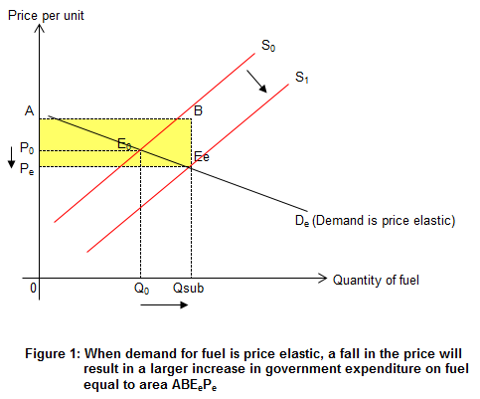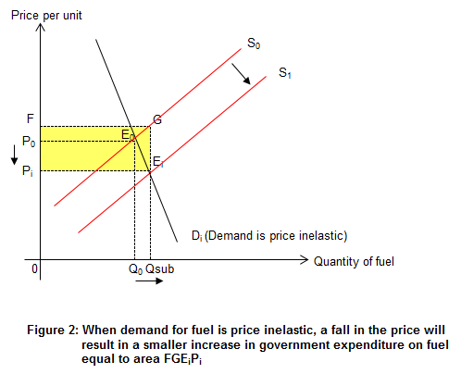

(c) (ii) Comment on the factors that government may consider in the removal of energy subsidies. [5]

The government may consider the removal of energy subsidies in order to correct the market failure that arises from the overconsumption of fuel due to the lower subsidized prices of fuel. In the consumption of fuel, the consumers will only take into consideration their marginal private benefits (MPB) and marginal private costs (MPC) which is the price of the subsidized fuel ignore any marginal negative externalities such as carbon emissions and the costs it imposed on the environment and the health of the people. In addition, with the removal of energy subsidies, the government would have more funds available for other more important areas of economic development, reducing the opportunity cost that arises from subsidizing fuel consumption.

On the other hand, removal of energy subsidies would result in higher energy prices which would impact both the consumers and producers in terms of higher cost of living and the higher cost of production. This will in turn affect the competitiveness of the country exports and economic development. Hence, the government will have to take into consideration the political, social and economic implications when considering whether or not to remove energy subsidies.

However, with the falling oil prices, it may be an appropriate opportunity for the government to consider reducing or removing the energy subsidies as the effect of higher prices without subsidies would be offset by falling oil prices and the impact on the cost of living on consumers and cost of production on producers would not be sharply felt (evaluation).

(d) Low crude oil and gasoline prices have a direct effect on greenhouse gas emissions and climate change. The cheaper gasoline is, the more people drive and use fuel. Discuss whether falling oil price will lead to a more inefficient allocation of resources. [8]

The falling oil price will lead to a more inefficient allocation of resources.

This is because as the oil price drop, car users will find it cheaper to drive their car and hence their usage of car increases. This will lead to an even greater consumption of car leading to greater greenhouse gas emission and hence worsening the negative externality problem. The larger over-consumption of cars will lead to an even greater welfare loss and hence a more inefficient allocation of resources. This can be explained using Figure 1 below.

When a driver uses his car, he will only consider the marginal private benefit, MPB (e.g. the convenience and time saved from the additional trip) and marginal private cost, MPC (e.g. the cost of petrol for the additional trip) and will consume his car up to Qe where MPB=MPC. However, when the driver uses his car, he ignores the external cost that could be incurred by third party, e.g. the pollution caused by his car which could cause the passer-by to incur higher medical cost as he inhale the polluted gas and fall sick. The presence of the external cost causes the marginal social cost (MSC) to diverge from the MPC. Hence, the socially optimal car usage is where MSC = Marginal Social Benefit (MSB) at Qs. The over-usage of cars in the market caused a welfare loss indicated by the shaded area.
As the price of oil drop, the MPC faced by the drivers in using the car drop to MPC1 and hence the new equilibrium amount of car used is at Q1 where MPB = MPC1. Thus, the over-consumption of cars increased to QsQ1 and there is a greater welfare loss shown by area EsE1A, thus indicating that there is a more inefficient allocation of resources when oil price fell.

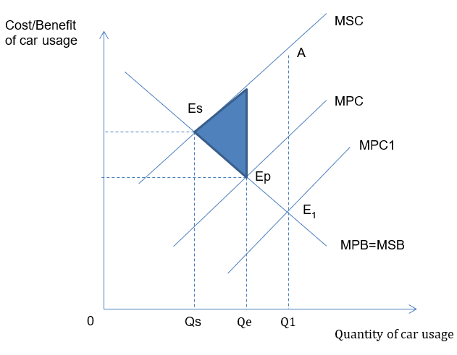

Figure 1

However, the fall in oil price will lead to a more inefficient allocation of resources depends on whether the fall in oil price is temporary or permanent? As mentioned in Extract 4, “a few months of low gasoline prices aren’t likely to inspire people to rush out to buy gas guzzling cars right away”. Thus, if car users believe that the fall in oil price is temporary, they will not change their consumption behavior and use their car more frequently or switch to bigger and less oil efficient cars. However, if car users believe that the fall in oil price is permanent or long term, then the effect on inefficiency of allocation of resources is greater.

Furthermore, the fall in oil price has prompted many government to cut back on fuel subsidies. This freed up the government budget which can be reallocated to other more productive uses such as subsidizing expenditure on healthcare and education which could improve the efficient allocation of resources. At the same time, the reduction of subsidies which improve the government’s finance will enable it to lower the tax rate which will lead to greater incentive to work efforts and higher investment, both of which will increase the efficiency of the economy.

Conclusion
Hence, whether the fall in oil price will lead to a more inefficient allocation of resources depends on whether the fall in oil price is temporary or permanent and how the government uses the fund that was previously used to subsidise fuel. If the fall in oil price is temporary and the government reallocates the fuel subsidies to areas which will improve the efficiency of the economy, the fall in oil price need not lead to a more inefficient allocation of resources.

