Notes 2012 Topic 4A – Foreign Exchange

List of Definitions

1.1.Exchange Rate (ER)
    - The foreign exchange rate is the price of a currency in terms of another currency. It is the external value or price of a country’s currency. [S$1 – US$0.82/ US$1 –S$1.22; (1/0.82))

Demand of S $
-(Xd/capital inflow)

supply of S $
-(Md/capital outflow)
S₀
D₀
Qty of S$
US$/S$
$0.82
Q₀

1.2.Demand for Currency (Change in Xd/ Capital inflow)
    - Downward sloping on ER to quantity of currency axis

Currency is demanded by:
- Foreigners who wants to buy goods produced domestically (Export dd)
- Foreign firms or individual looking to invest domestically (FDI)
- Currency traders who believe that future value of domestic current will appreciate/ take advantage of interest rate differentiation (affected inflow of hot money)/equity transaction

1.3.Supply of Currency (Change in import demand/ Capital outflow)
    - Upward sloping on ER to quantity of currency axis
    - Currency is supplied by: (Increase in Capital outflow – Increase of S$)
- Local firms and individuals who are buying foreign goods (import dd)
- Local firms and individuals who are looking to invest in foreign nations (FDI outflow)
- Currency traders who believe that the local currency will depreciate in future/ take advantage of interest rate differentiation (affected inflow of hot money)/equity transaction)

1.4.Market Equilibrium for FOREX
    - Refers the level of exchange rate which is at equilibrium when the demand of FOREX is met with the supply

1.5.Appreciation of currency
    - An increase in value of one currency relative to another currency as a result of the increase in market demand for or the reduction in the supply of currency in the forex market. (↑dd for local $/↓ss of local S$)

1.6.Depreciation of currency
    - A decrease in value of one currency relative to another currency as a result of the fall in the demand for or the increase in the supply of the currency in the forex market. (↓dd for local $/↑ss of local S$)

Appreciation or depreciation – based on market forces that will riase or lower the exchange rate

1.7.Floating/Flexible ER system
    - The flexible exchange rate system determines the exchange rate based on the demand and supply of currency in local or foreign currency in the foreign exchange market.
    - How Exchange Rate is determined under flexible ex rate system?

Introduction

- Definition o flexible ex rate

- Main Body (Explain why S$ has appreciated – due to ↑dd for S$ / ↓ss of S$)

1. State that the intersection of Dd & Ss of S$ in the forex market will determine ex rate.
S₀
D₀
Qty of S$
US$/S$
R₀
Q₀

Dd for S$ Xd/ Capital inflow/Singaporeans’ remittance/Foreign govt expenditure in Singapore

Ss of S$ Md/ Capital outflow / Foreign workers’ remittances/Singapore govt expenditure abroad

2. State market forces of dd and ss of local currency in forex market are determined by export dd and capital inflow for dd for S$ and import dd and capital outflow for SS of S$.

3. State that the export dd and import dd are caused by the following factors:
- relative inflation rate

US experience inflation

P_{x} of US goods ↑ - decrease XD fr US, decrease ss of S$

P_{m} is relatively expensive increase Md fr US increase XD fr SG -Increase DD of S$ Appreciation of S$
- relative change in income level of the trading countries

NY of US ↑ more than ↑in NY for Singapore↑Xd from US/↓Md from US for Singapore↑dd for S$/↓ss of S$appreciation of S$
- taste and preference
- government purchase – affected by the economic development of US$

4. State the capital inflow and outflow are affected by the following factors:
- change in interest rate (ST) – gains from savings
- speculation (ST) – gain from flow of funds/equity transactions
- return on FDI

If the ex rate is in the context of S$ appreciation state govt intervention is one of the reasons for rise of ex rate.

1.7.1 Determination of Exchange Rate (Under flexible ER system)

Factors affecting Demand for and Supply of currency
    - Change in demand for local goods and services
    - Change in relative interest rates between countries
    - Expectation change in future value of domestic currency relative to foreign
    - Change in return on capital investment
    - Change in cost of production
    - Change in taste and preference of foreign consumers

1.8.Fixed ER system
    - In the fixed exchange rate system, the government peg the exchange rate of the country to the currency value of another.

Revaluation of an economy refers to the rise of exchange rate as a result of government intervention in the forex market by direct pegging or direct buying of the local currency (Increase demand of Singapore dollar)

Devaluation of a currency refers to the fall of the exchange rate as a result of government intervention in forex market by direct paying or direct selling of the local currency. (Increase in the supply of Singapore dollar)

Example: (Hong Kong pegs HK$ to US$)

Aim: to ascertain trading price to stabilize trading activities

However, if US depreciates, HK depreciates against other foreign currencies as US$ depreciate against other currencies

external value of Hong Kong S$ decreases – decrease purchasing power of Hong Kong people – rise in cost of living and production for Hong Kong people

1.9.Managed-Float Exchange Rate System
    - In this exchange rate system, the central banks occasionally enter foreign exchange markets to adjust their official holdings to moderate major swings in the exchange rates. The central bank may attempt to raise and lower exchange to influence the economic activities so as to achieve the economic aims of the government by directly increase the demand and supply of the local currency to influence the exchange rate.
    - For Singapore, the exchange rate management policy is used to set the exchange rate whereby the government directly intervenes in the forex market through direct buying and selling of S$ and foreign currency
S₀
D₀
Qty of S$
US$/S$
R₀
Q₀
S₁
D₁
Q₁
Lower
Higher
    - The central bank will set a range for the exchange rate to fluctuate within and will only intervene to manipulate the exchange rate if the rate rise above the upper band or falls below the lower band. If the government decides not intervene, it will adopt a neutral stance to allow the exchange to rise or fall. In doing so, the central bank will raise or lower the band.
    - It may take a neutral stance on the direction of change in the exchange, allowing it to appreciate or depreciate if the rate of change in the exchange rate is favourable to the economy. Let the market forces decide as the extreme depreciation of S$ may mean that excessive amount of S$$ is needed to uphold exchange rate.

Decrease in reserve of forex used to uphold the S$.
    - To appreciate the exchange rate so as to dampen the imported inflation, the MAS needs to increase the demand for S$ by buying S$ and selling of foreign currency. To depreciate the exchange rate so as to lower down the cost of FDI and price of export, the MAS needs to increase the supply of the S$ by selling S$ and buying of foreign currency.
- Indirect method of intervention – trade restriction↓Md↓SS of S$appreciation
- The use of monetary and fiscal policy to regulate the FOREX method – (↓AD↓NY↓Md (MPM≠Md/NY)↓SS of S$Appreciation)
- Use interest rate to influence capital flow – affect exchange rate

1.9.1 Monetary Exchange Rate Policy

How exchange rate monetary policy curb imported inflation? (conducted by Indonesia, Vietnam, India)
- increase in i/r ->↑capital inflow (hot money)↑dd for local $Appreciation of local $P_{m} in local $ cheaper↓COP/↓COLcurb imported inflation
- Evaluation: Capital gain from speculation of currencyAppreciationinduces speculator to sell local $ in forex market↑SS of local $depreciationP_{m} in local $ will increase again – effect in curbing imported inflation is short-lived
/The policy is introduced with ST capital control in selling local $
- Why capital inflow will lead to asset-based inflation?
- ↑i/r↑capital inflow↑dd for local $Appreciation
Foreigners holding local $ will deposit/inject more local $ into the local banking system↑MS in the local money marketdecrease in interest rate↓cost of borrowing↓cost of mortgage loan↑demand for housing↑Price of housing (dd-pull inflation/core inflation)

1.9.2. Over-valuation refers to the condition where the exchange rate pegged y the government is above the market-determined exchange rate. The purpose of the over-valuation is to curb the imported inflation.

1.9.3. Under-valuation refers to the condition where the exchange rate pegged by the government is below the market-determined exchange rate. The purpose of the under-valuation is to increase the price-competitiveness. (China)

Is the under-valuation of RMB the cause of US Trade deficit with China and the rise in Unemployment in US?
Under-valuation – lower the exchange rate for CHina – price of China good is cheaper – decrease the price of import from china – increase the import expenditure on Chinese good – increase import for US from China
- Lower exchange rate – raise the price of export goods of the Us to china - lower china import from US – lower US export demand from China – BOT deficit – US decreases export to China
It is not the reason:
- Rise in national income of US – increase in import expenditure – replace US goods – decrease in local production – decrease in demand US labour – rise in unemployment
- Decrease in investment in US – increase in FDI into China from US – more US goods produced in China and sold to China – decrease the need for US to export US goods – decrease local US production – increase in unemployment
- Inflation in US – price of US goods is relatively more expensive than price of China goods – price of import from China is lowered for US, price of US export to china is higher – decrease in export dd for US and increase in demand for US from China – BOT deficit

S₀
D₀
Qty of S$
US$/S$
R₀
Q₀
Undervaluation
Overvaluation

Reasons for ER regulation

2.1.To reduce the uncertainty in trade
    - As value of currency changes, so will prices of exports and imports. Uncertainty that arises from this change will cause traders to trade less as it will be difficult to ascertain the price level of resources and goods as cost of production cannot be stabilized which will undermine profitability. With stable trading activities, it will encourage production which will induce growth of employment and national income
    - Deter long-term international investment (FDI depends on XD/MD – MNCs will invest in countries with efficient and capable export capacity)

2.2.To prevent speculative movements of “hot money”
    - Fluctuation of exchange rates encourages speculative movements currency to appreciate or depreciate further destabilize the exchange rate (Asian Currency Crisis) which will undermine growth of the trading and investment activities
    - E.g. if people speculate that S$ is going to fall and speculative activity is not checked, the S$ will drop even further
    - Government intervenes in the foreign exchange market to smoothen out such speculative movements.

2.3.To correct BOP deficit/surplus
    - Persistent BOP deficit net outflow of foreign currencies country incurs debts to correct the deficit flight of capital of currency will take place if investors lose their confidence and hence hinders economic growth.
    - Deficit – BOP Depreciation ↑BOP deficit Depreciation (flexible) P_{m}↑ Imported inflation Ex Rate management Appreciation Solution Focus @ BOP Deficit
    - Exchange rate depreciation will also undermine Singapore status as a wealth management centre as the value of saving by foreigners will decrease in the future if there is depreciation
    - Surplus – BOP Appreciation

Persistent BOP surplus net inflow of gold and foreign currencies cause inflationary pressures in host countries
    - Appreciation will encourage excessive inflow of fund leading to increase in MS in local money market ↓ i/r↑dd for assetsasset-based inflation

SolutionDevaluation↓P_{x}↑Xdsolve problem the of loss of export competitiveness and prevent inflow of hot money
    - Under free market forces, the pressure of a BOP disequilibrium is taken by the rate of exchange

Automatic adjustment to equilibrium under flexible exchange rate system
- BOP deficit: the rate will depreciate to eliminate the deficits – (dep^{n} P_{x}↓ ↑X_{d})
- BOP surplus: the rate will appreciate until it reaches a new equilibrium level ( app^{n} P_{m}↓ ↓ Cost of imports)
- Self-correcting or flexible ex rate
          - Ped_{x} + Ped_{m} > 1 True Period
            - SR, Ped_{x} + Ped_{m} < 1

LR, Ped_{x} + Ped_{m} > 1 (Marshall Lerner condition is satisfied)
            - Degree of substitution is lesser for Singapore High value added production
          - Holding Capital flow constant
    - Balance of payments disequilibrium will be corrected automatically only if the Marshal-Lerner condition is present (Ped_{x} + Ped_{m} >1). Therefore, if there is severe BOP disequilibrium; the monetary authorities may have to resort to monetary and fiscal policies. To do so, the government will adopt a gradual and modest appreciation of exchange rate.

Qn: Explain how Marshal Lerner condition works

2.4.To neutralize short run pressure on the exchange rate
    - Frequent short-run changes can have serious repercussions in the domestic economy
- If the value of the S$ depreciates, imports become dearer and this can cause home prices to rise leading to inflation
- A rise in S$ makes the country’s exports much dearer and so exporting firms may lose its competitiveness; and if export demand is elastic, they will lose orders, cut production and lay off workers UN⁺
    - Official intervention will avoid short run fluctuations, maintain international competitiveness and prevent imported inflation that will raise the cost of living and production.

3. Effects of Appreciation / depreciation of Exchange Rate

3.1.Appreciation of Exchange Rate (Scope of Impact)
- P_{m}↓ / P_{x} ↑/ Cost of FDI ↑
BOT/BOP equilibrium
- Md↑, Xd ↓/ FDI ↓ (BOP)
- ↓Xd ↓AD ↓NY/ Md↑ Potential Growth (Economic Growth)
- ↓AD, ↓prod/ ↓N⁺ (Employment)
- COL↓/ SOL ↑ (Price stability and SOL)
--------------------------------------
- Optimisation of Resources
- Distribution of Y

3.1.1 Qn: Analyse the impact of appreciation of Yuan on China’s economy (Significance of the influence)
- Degree of reliance on external market
- Size of workers population relating to FDI/Xd
- Openness of the banking system
- Degree of influence on imported inflation - MPM

3.2. Effects of Balance of Trade
    - Appreciation of exchange rate P_{X} increase and P_{M} decreases decrease in quantity demanded of export and increase in quantity demanded of impost:
- PE_{D(M)} + PE_{D(X)} > 1: the BOT will worsen (SR)
- PE_{D(M)} + PE_{D(X)} < 1: the BOT will improve (LR)

3.3.BOP Improvement (Surplus)
    - Appreciation of exchange rate makes investment more worthwhile. This increases inflow of foreign capital.
    - The cost of the value of FDI will be higher due to the appreciation of exchange rate. The cost of foreign business operation locally will be higher.

3.4.Effects on Local Production and Employment
    - As both the decrease in export demand and increase in imports will lead to a lower local production, the employment level in the economy will be reduced.

3.5.Effects on Economic Growth
    - Appreciation will increase import of capital equipment from other countries at a lower cost. This will enable the economy to expand its production capacity and raise its technological development to attain higher level of economic growth.

3.6. Effects on Cost of Living and Standard of Living
    - Appreciation will make imports cheaper, local consumers are able to buy more foreign products and standard of living is improved.

4. Advantages and disadvantages of the Different Exchange Rate system

4.1.Flexible Exchange rate
    - Advantages
- Automatic stabilization: The BOP and BOT (must satisfy the Marshal-Lerner Condition (PE_{D(X)} + PE_{D(M)} >1)

Assumption:

- Pedx + Pedm > 1

- Capital inflow and outflow are constant – it will affect the price of export and import demand, therefore it affects trade pattern as the exchange rate will vary extensively

- Efficient allocation of resources possible (ex rate acts like a price mechanism) Social optimization of resource allocation at global level Maximisation of net social benefit gain (only feasible when perfect market condition exists for global market – many buyers and sellers)
Net social benefit gain (TB-TC)
S₀
D₀
Qty of S$
P
P₀
Q₀
- Freedom to pursue an independent domestic policy goals aimed at securing internal equilibrium curb inflation – when government does not regulate exchange rate, the monetary policy can work independently to regulate internal aspect of the economy can use MS to regulate interest rate
- There is no need for large official reserves to maintain the exchange rate (Opp. cost of holding reserve) more resource for other aspect of economic development
    - Disadvantages
- Uncertainty –Discourages trade and investment – as trading price fluctuate will affect trading and investment activities
- Speculation
- Inflationary impact: Depreciation increases export demand creating demand pull inflation. Also, cost-push inflation because imported raw materials and essentials are more expensive.

Fixed exchange rate
    - Advantages
- Removes uncertainty and discourages speculation – encourage trade and investment - ascertaining trading price, the cost of production and imported resources will be stabilized
- No need for artificial trade restrictions – foreign exchange can be used to control price of imports and exports to affect trading activity – we need to use protectionism can avoid the effects of protectionism
    - Disadvantages
- Opportunity cost of having a large reserve idle fund which can be used for economic development – need to keep US$ to ensure that the government can increase the demand for local $
- Speculation (in anticipation if the government switch to flexible system)
- A reluctance in reducing surplus/deficit (China’s surplus)
- Monetary Policy ineffective: Contractionary policy will attract FDI putting upward pressure on ER. Government has to sell domestic currency increasing money supply again - inflow of FDI Foreigner will inject more fund into local money market increase in local money supply decrease in interest rate - ↓cost of mortgage loan ↑dd for loan – asset-based inflation

5. Singapore ER system (in conjunction with MP)

Characteristics of Singapore Monetary ER system
- Managed-float Exchange Rate System
- Trade-weighted effective rate (a basket of forex)
Provide a stable and strong exrate
Ensuring external stability
- Strategy of the exchange rate management policy in Singapore
- Gradual and modest appreciation
- Will help to curb imported inflation contributed by rising price of resources to global market – this will help to dampen the cost of production and cost of imports (lower cost of living will prevent wage increment – together with lower cost of imports lower cost of production – will help maintain export price competitiveness
- Singapore can still maintain export competitiveness despite appreciation a rise in exchange rate is gradual and our demand of exported good is price –inelastic (P_{x} ↑Xd is price-inelastic – decrease in export demand is less than proportionate – total revenue of export will increase)
- Zero Appreciation – exchange rate is kept high but disallowed to appreciate further as focused in 2009
- Government needs to continue to maintain export competitiveness – therefore, prevents any further rise in exchange rate to keep rice of exports low
- Strong exchange rate is not the cause of fall in export demand as the cause of fall in Xd in 2009 is due to reduction in national income which will reduce their import demand

5.1. Aims
    - Price Stability (Curb imported inflation, lower cost of foreign workers)/help lower income group to sustain purchasing power
    - Sustainable economic growth Expansion of resource capacity increase imports
    - Full employment Sustain Xd/ FDI

5.2.Reasons for Policy Tool
    - Small economy: Dependent on external sector
    - Openness: Vast network of international financial linkages and existence of large external trade and service sector. Capital mobility is high and domestic interest is heavily influenced by external interest rates
    - Singapore practises managed float exchange rate and allows free capital movement (Financial Centre) – dampen the effect of fluctuation of the exchange rate on the financial sector – maintain future value of saving for foreigners

5.3.Singapore’s ER System
    - Singapore dollar (SGD) is pegged against a trade-weighted basket of currency of major trading partners and allowed to float within a certain bandwidth of ER. As long as ER floats within the region, the Monetary Authority of Singapore (MAS) does not intervene.

5.4.Using ER to Combat Inflation
    - During inflation, MAS allows SGD to appreciate.
    - Cost of imported inputs for production will decrease, dampening the effects of a cost-push inflation
    - P_{X} increases and P_{M} decrease, assuming Marshal-Lerner condition, the overall net export will decrease, AD will decrease and a demand-pull inflation can be curbed. (Ped_{x} is price inelastic low degree of substitution, high valued production)

5.5.Using ER to Attain Economic Growth and Employment
    - MAS allows SGD to depreciate, which will help to raise Xd/FDI to prevent economic downturn
    - Price of export demand and cost of FDI will decrease and this will stimulate an increase in export demand and foreign direct investment which will raise the aggregate demand and thus, raise national income, full employment and production.

5.6. Circumstantial Limitations of Ex Rate Mgt (can be used for CSQ)

5.6.1. Why Singapore will not conduct dep^{n} to increase Xd/ FDI?

1. in Xd/ FDI is due to weak global economic condition (lack of fund and low income)

∴ Dep^{n} P_{x} | cost of FDI – lower price will not affect the export dd.

2. in cost of import COL – undermine the govt’s policy to lower wage.

high cost of living will discourage the union to lower wage as SOL will be compromised

Sustain the purchasing power for the foreign workers.

5.6.2. Why Singapore dollar can be appreciated to dampen cost of import without decreasing export revenue.

P_{x} Xd (Pedx is price inelastic) – TR_{x} when Ped_{x} is price inelastic? high valued production – low degree of substitution

5.6.3 Why Singapore cannot appreciate the currency excessively?

1. Excessive rise in capital inflow ↑SS of S$ in the local money market decrease interest rate increase demand for loan asset-based inflation will contribute to inflationary condition or asset bubble by raising interest rate, it will e encourage more inflow of hot money

2. Foreign owners of resources in the global market will raise the price of resources to compensate the loss in US$ has been lowered – Singapore cannot prevent the rise as she is a price-taker in the global resource market

9. Areas of Discussion
9.1 Why small country like Singapore should be concerned of exchange rate fluctuation?
Reasons for Singapore government to conduct managed-float exchange rate system
- High degree of reliance on external export demand and foreign direct investment for employment and the fluctuation of exchange rate will affect the price of exports and cost of FDI which will influence the level of export demand and Foreign Direct Investment.
- High degree of imports of resources due to lack of natural endowment will mean that the cost of imports is a great influence on the cost of living and cost of production. There is a need to maintain appreciation of exchange rate to curb cost of import to lower cost of living and maintain standard of living and lower cost of production to maintain competitiveness.
- Our need to maintain financial stability and to develop our banking and financial monetary sector which is critical industry to the economy. Preventing exchange fluctuation will help to maintain return on financial and capital investment and thus, ensures the development of the financial and banking sector.
- Need of exchange rate manipulator to ensure ext. stability to help Singapore to attain the aim of EG and prevent the problem of UN⁺.
- i. Main focus of the economy – External stability – (Xd/ FDI)
ii. Main aim of the economy – Economic growth
iii. Main problem of the economy – Solve UN⁺
Ex rate stability is needed to ensure external stability.

9.2 Explain how the relationship of internal value of money and external value of money.
- Explain how inflation rate will affect exchange rate
- Explain how exchange rate will affect inflation rate
- Evaluate the factors affecting the extent of influence of the relationship

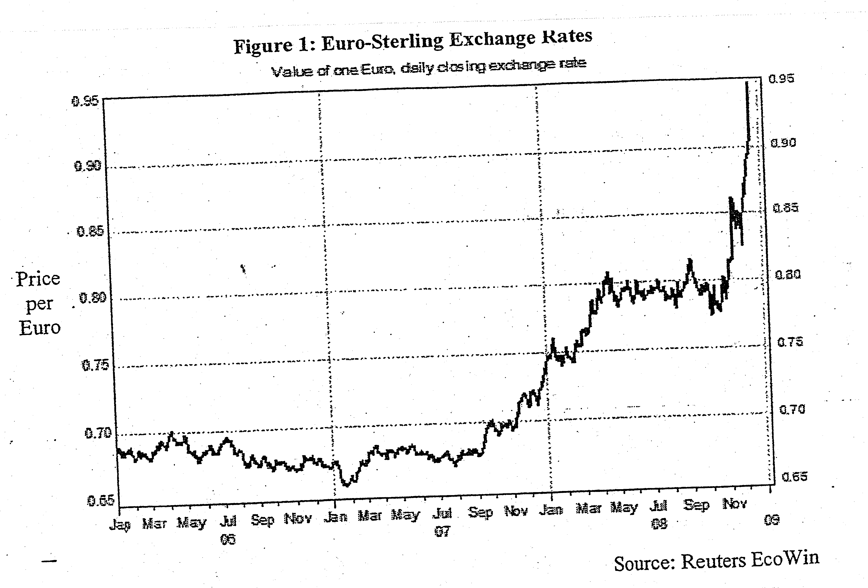
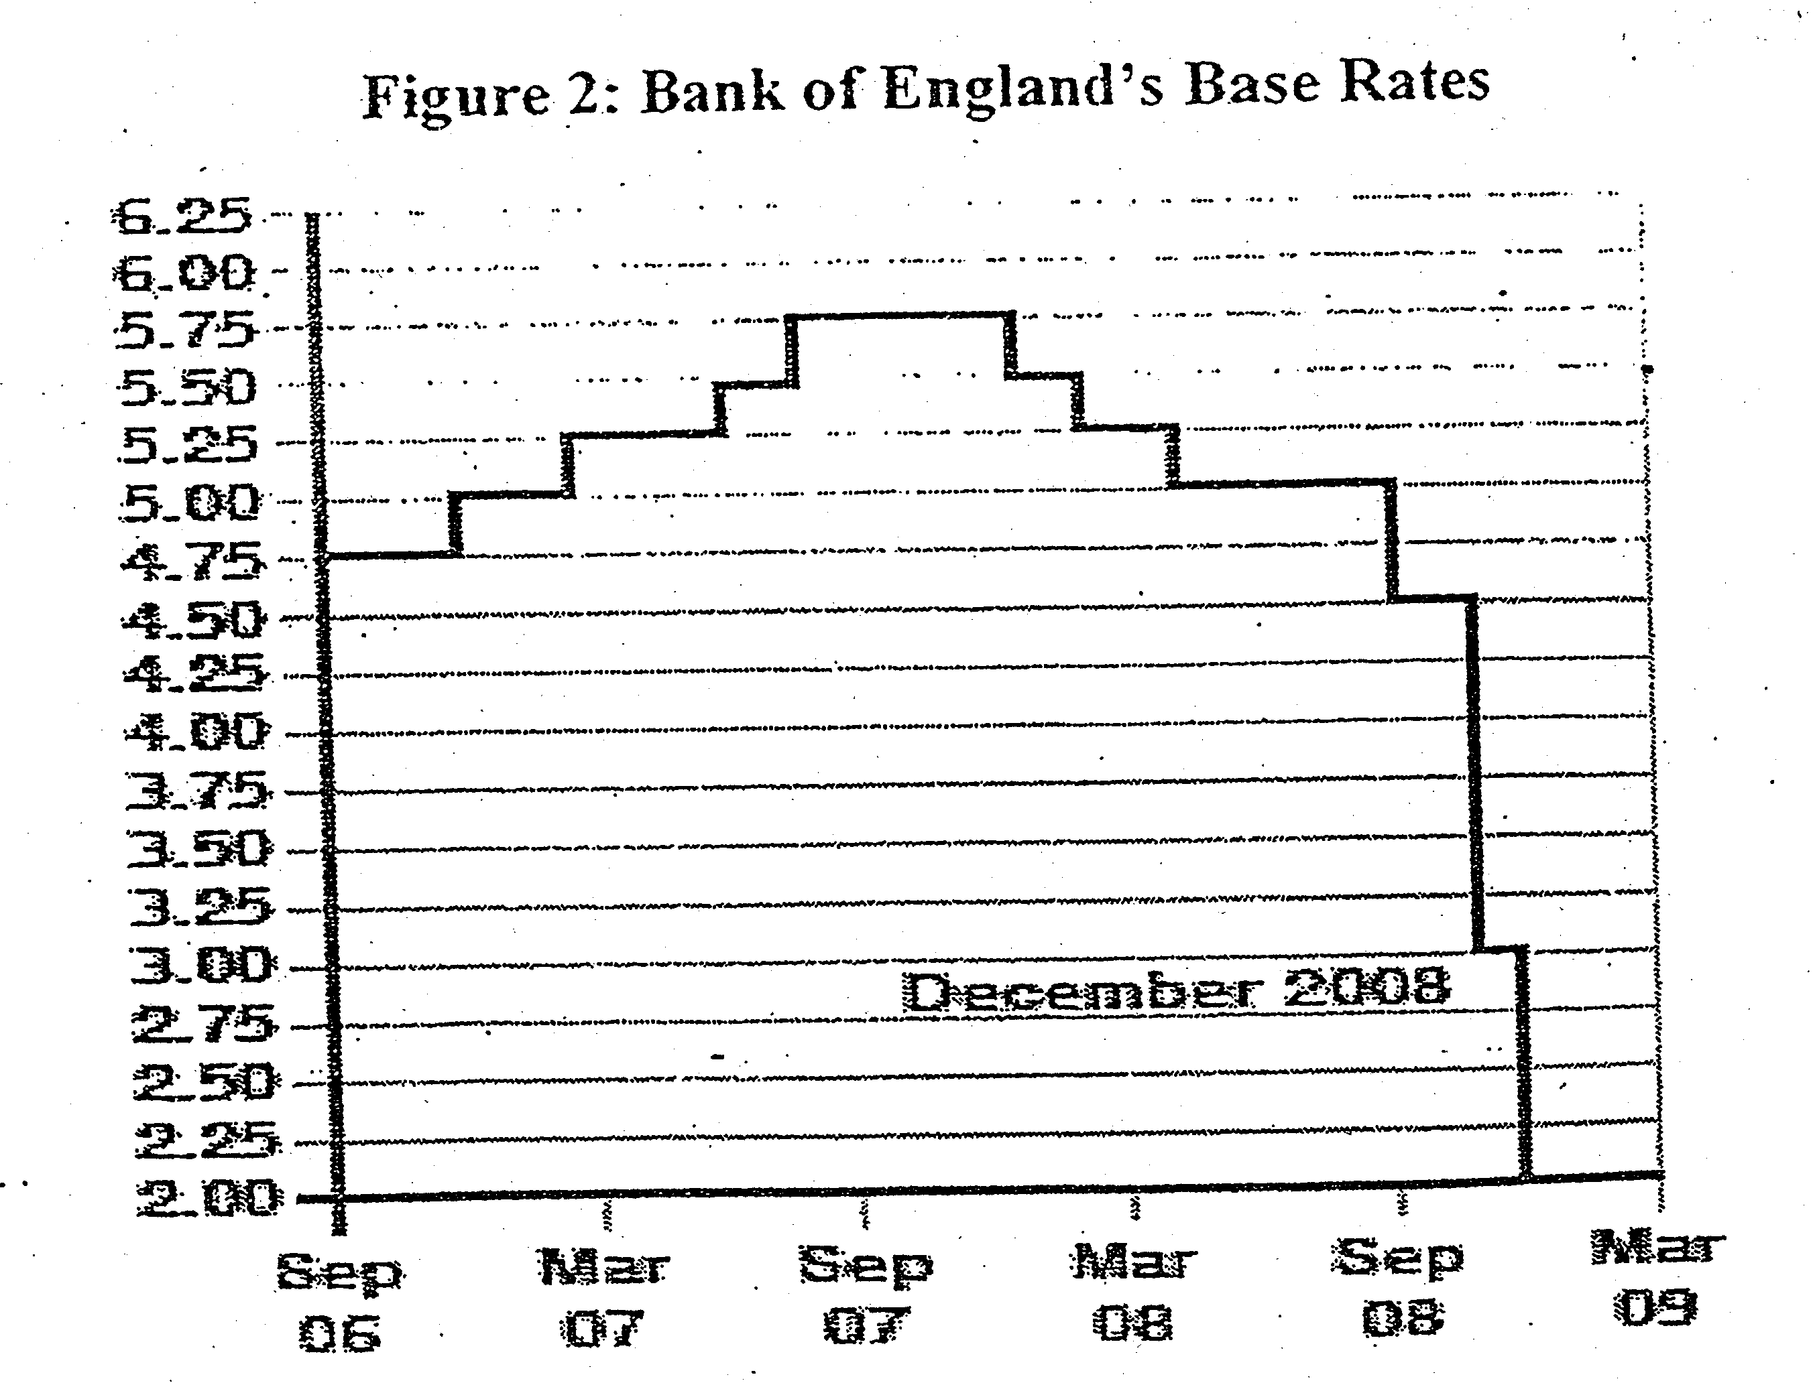
Fall in interest rate from Oct 07
↑Capital Outflow
↑SS of Pound
↓Capital Inflow
↓dd for pound
Depreciation

10.2 Trend Analysis for Exchange Rate.
- Describe the trend of UK exchange rate or Jan 06 to Dec 09.
UK exchange rate against euro dollar has been stable from Jan 06 to Jan 07, but it depreciates sharply after Jan 07 till Dec 09. There was a sharp depreciation from Sept 09 to Dec 09

- Compare the trend of UK exchange rates and interest rates from Sept 06 to Dec. 06
Interest rate rises from Sep 06 to Oct 07 and falls from then till March 09. The fall in interest rate was steeper from Sept 08 to Dec 08

Exchange rate against Euro was stable from Sept 06 to Oct 07 but depreciates from then till Mar 09. the fall in exchange rate against Euro was extensive from Sep 08 to Dec 09

- Explain the link between exchange rates and interest rates.
Rise in interest rate will encourage short term capital inflow which will raise the demand for Euro which will lead to the appreciation of euro.

A fall in interest rate will lead to short term capital outflow will raise the supply of euro which will lead to depreciation.

