H2 Economics 2018 – CSQ – Trade, Protectionism, Forex & Globalisation – Q2
Global Trade Issues

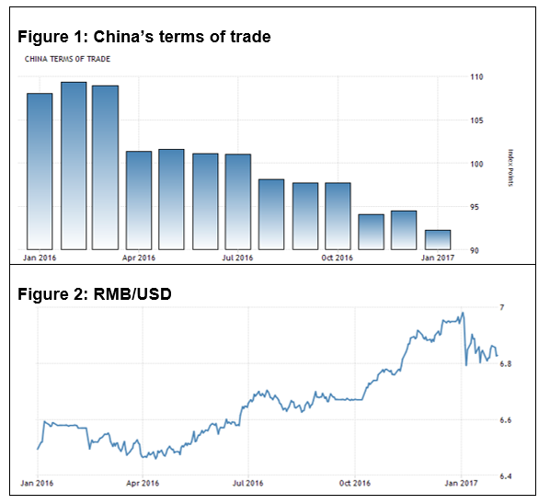
Source: National Bureau of Statistics of China; OTC Interbank

Extract 4: China’s exports and imports tumble amid weak demand, yuan decline
China's exports and imports for September came in well below expectations, dented by weak demand at home and abroad. In yuan terms, exports fell 5.6 percent on-year and imports rose 2.2 percent. The September trade surplus came in at 278.35 billion yuan ($41.40 billion).

The trade data came against the backdrop of a recent decline in the yuan, which over the past week has touched its lowest levels against the dollar in six years. The Chinese currency has tumbled recently against a basket of currencies of China's trade partners.
The World Trade Organization (WTO) projected global trade would register its fifth straight year of sub-3 percent growth, citing shifting exchange rates and falls in commodity prices.

The WTO is the international organization that deals with the global rules of trade between nations. It pledges to promote an ‘open, non-discriminatory and equitable multilateral trading system’ to promote national and international efforts to better protect and conserve environmental resources and to promote sustainable development.
Adapted from cnbc.com, 12/10/16

Extract 5: US challenges China raw material export duties
The United States challenged China's export duties on nine key metals and minerals on Wednesday, arguing they violate Beijing's commitments to the WTO and give an unfair advantage to Chinese manufacturers.

China said it respected WTO rules and that the duties had been imposed as part of efforts at environmental protection. It said that China's export duties have been imposed in the face of "daily worsening pressure on resources and the environment" and are to help with sustainable development.

U.S. Trade Representative (USTR) seeks to remove China's export duties of 5 percent to 20 percent on antimony, cobalt, copper, graphite, lead, various magnesia compounds, talc, tantalum and tin, which it said are key inputs into U.S. industries, including aerospace, autos, high-tech electronics and chemicals.

USTR said the duties impose higher costs on U.S. manufacturers, while Chinese competitors do not have to pay them, encouraging companies to locate production in China.

"These duties are China's attempt to game the system so that raw materials are cheaper for their manufacturers and more expensive for ours”.

For example, he said graphite imports from China were about $24 million last year, but the mineral is not produced in the US and is a key ingredient in brake linings, an industry which supports 20,000 US jobs, and in lithium ion batteries for electric cars as well as in lubricants.
Source: Reuters.com, 14/7/16

Extract 6: China upset at high US tariffs on steel imports
China has voiced discontent at high punitive tariffs announced by the United States on Chinese steel products in the latest trade conflict.

The US Commerce Department announced that it would impose punitive tariffs ranging from 63.86 per cent to 190.71 per cent on China’s steel products. Other steel-producing nations like India, Korea and Japan had not been spared of such tariffs either. The steel tariffs on China came after US imposed 52.25 percent anti-dumping duties on Chinese-made large washing machines in January.

Trump threatened during his presidential campaign to label China a currency manipulator and impose up to 45 per cent duties on Chinese imports. Chinese officials have warned there would be no winners in a trade war between the superpowers. Beijing is preparing to retaliate if Trump launches a trade war.

“Trump pledged to reverse the US trade deficit against China and attract manufacturing to flow onshore to create more jobs. The US will seek every possible chance to challenge China in trade issues,” he said.

For years, China’s steel products, along with other manufactured products in overcapacity sectors, have been at the centre of trade disputes as China’s trading partners such as the US and the European Union claimed China was dumping their products, hurting local rivals.

China’s Ministry of Commerce said that the issues in the steel sector were rooted in sluggish demand and weak global economic recovery. “Trade protectionism would hurt not only exporting countries but also US consumers and downstream industries such as manufacturers of value-added products that use steel as an input.” “Moreover,
30 years of protection have distorted the US steel market”, it added.

The US Department of Commerce indicated that “primary metal manufacturing” which includes steel, copper and aluminium, added about $60 billion to the economy in 2015 while downstream manufacturers that utilize steel as an input generate value-added of $990 billion, more than 16 times larger. While employment by primary metal manufacturers was 400,000, downstream manufacturers employed 6.5 million, also 16 times greater.
Source: Forbes 23/5/16, scmp.com, 4/2/17

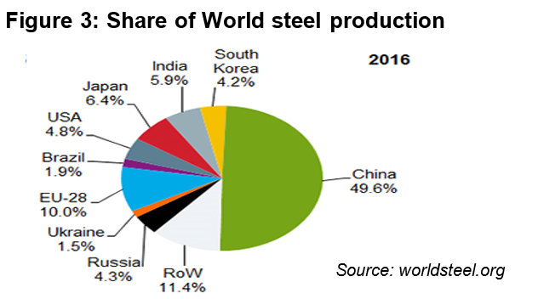

Table 2: Selected Economic Indicators for USA

Year | GDP  (annual % change) | Labour productivity- output per hour  [in non-farm business sectors (annual % change) ] | Exports value  (millions USD) | Imports value  (millions USD)
2014 | 2.4 | 0.8 | 2,375,905 | 2,866,241
2015 | 2.6 | 0.9 | 2,263,907 | 2,764,352
2016 | 1.6 | 0.2 | 2,208,072 | 2,712,866
Source: Various

Extract 7: Issues revolving around the Chinese Yuan
China said it has never used its currency as a tool to gain an advantage in trade and was not seeking a "currency war", after U.S. President Donald Trump criticized Beijing for harming American companies and consumers with a devaluation of its yuan. The U.S Senate might pass a bill which would pressurize China on her yuan.

"We have no intention of fighting a currency war. From a long-term perspective this is not beneficial to China," said Chinese Foreign Ministry spokesman Lu Kang.

While China was widely viewed to have held down the yuan to gain a trade advantage five to 10 years ago, many economists say that in the past year, Beijing has been spending hundreds of billions of dollars in reserves to prop up the yuan's value. But the currency still fell nearly 7 percent last year, its biggest loss against the dollar since 1994.

Some economists argue that the overall U.S trade deficit is the result of the saving decisions of US households. Americans are spending more than they produce and the policies of foreign governments affect only how that deficit is divided among America’s trading partners. The decision to withdraw the U.S from the Trans-Pacific Partnership (TPP), a trade pact with 11 other countries further adds to the problem.

Some critics argued that US pressure on the yuan would simply shift manufacturing to other low-cost producers such as Bangladesh or Vietnam, and the United States would still be uncompetitive.
Source: Various sources
Questions

Suggested Answers
(a)(i) Define terms of trade. [1]

Terms of trade (TOT) refers to the rate at which a country exchanges its exports for imports and is calculated as the ratio of the price of exports over the price of imports. Computation: Px/Pm×100.

(a)(ii) Describe the trend in China’s Terms of trade over the period Jan 2016 to Jan 2017. [1]

China TOT worsens/deteriorates/declines.

(a)(iii) Explain two reasons for the trend identified in a(ii). [4]

Deterioration in the terms of trade can be due to a fall in Px and /or a rise in Pm. Likely reasons:

Depreciation of RMB as observed from Figure 2 where value of RMB/USD has increased suggesting an appreciation of the USD against the yuan or a depreciation of the yuan. A depreciation of the Chinese currency results in a fall in the relative price of Chinese exports in foreign currency and a rise in the relative price of imports in terms of yuan, hence resulting in a declining terms of trade for China.

Extract 4: ‘global trade would register its fifth straight year of sub-3 percent growth, citing …falls in commodity prices’. This implies weakening global trade likely caused by slowdown in global economic growth. Hence, weaker global demand for Chinese exports leads to price of Chinese exports resulting in a worsening TOT for China.

Extract 4: ‘China's exports and imports for September came in well below expectations, dented by weak demand at home and abroad’. Weak demand abroad lower global DD for Chinese exports  lower Px. In addition, students can infer that both China’s Px and Pm fell, but with Px falling more than Pm TOT worsens.
Decrease in export demand – decrease in PX – TO worsen

(b) From the perspective of WTO, assess the case for and against China’s export duties on raw materials. [4]

Extract 4 last para stated that WTO’s aim is to promote an ‘open, non-discriminatory and equitable multilateral trading system’ with national and international efforts to better protect and conserve environmental resources and promote sustainable development.

From Extract 5, the Chinese government impose duties or taxes on her exports of minerals and metals such as copper, graphite and lead.

Case for China’s raw material export duties
Ext 5: China said it respected WTO rules and that the duties had been imposed as part of efforts at ‘environmental protection’ with "daily worsening pressure on resources and the environment" and are to help with ‘sustainable development’.

Explain:
- Tax on raw materials exports ↓SS of raw materials to abroad ↑P & ↓Qdd of raw materials for foreign mkt helps reduce the over-production (due to negative externality from mining – e.g. pollution, environmental degradation)
- Slow down the rate of depletion of minerals: slow down the fall in quantity of resources more sustainable outcome – prevent falling LRAS: prevent future generations from suffering from slower econ growth & SOL

Case against China’s raw material export duties
Ext 5: ‘the duties impose higher costs on U.S. manufacturers, while Chinese competitors do not have to pay them, encouraging companies to locate production in China’

"China's attempt to game the system so that raw materials are cheaper for their manufacturers and more expensive for ours”

The above suggests discriminatory pricing higher price for foreign buyer than for domestic (China) buyer of minerals. This contravenes WTO’s initiative.

Explain the undesirable effect:
- Tax on raw materials exports ↓SS of raw materials to abroad (eg US, EU etc) ↑P of raw materials for foreign firms manufacturing final goods like autos, aerospace, electronics COP for foreign firms↑ translates into higher Px for them. Result: their exports lose export competitiveness compared to the same goods manufactured in China, due to the ‘unfair’ pricing of inputs

Evaluation
- Whether WTO should rule for or against China’s export duties
- Depends on priority of WTO- which aim is more impt: Sustainability (eg. for that purpose should also impose a tax on Chinese firms using the limited resource? or equity?
- Depends on how rapid the resource depletion is
- Depends on how widespread the negative impact is-- If it affects several countries, then costs > benefits
(c) Trump has labelled China a currency manipulator and has pressurised China on her yuan. To what extent would such a move by the US government resolve the problems of growth and trade balance of the US economy? [8]

From Table 1: falling growth rate; rising US trade deficit (table 2; ext7)

Thesis: Appreciation of yuan is effective in resolving the problems of falling growth and trade deficit of US:
When the Yuan appreciates against the USD, this means US$1 can exchange for less foreign currency. For US, the price of imported goods and services from China will appear relatively more expensive in terms of USD and this leads to Americans buying fewer made-in-China imports. Americans may also switch towards domestically-produced import substitutes which are relatively cheaper now.

At the same time, US goods and services would be relatively cheaper to its trading partners and this may lead to a rise in US exports. Assuming Marshal-Lerner condition holds, net exports of US will rise and this will reduce the trade deficit of the US.

A rise in (X-M) and a rise in C on domestically-produced goods would also lead to a rise in AD for US. Assuming that US is operating with spare capacity, via the multiplier effect, this will result in a multiplied increase in real NY, stimulating actual growth, as shown below.

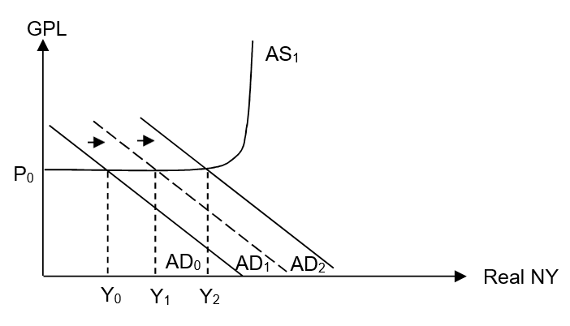
Anti-thesis: Appreciation of yuan is not effective due to limitations and other factors accounting for the loss in export price competitiveness
1) Limitations of the appreciation of yuan
Higher price of imported made-in-China inputs will result in increased cost of production for US firms leading to fall in AS and resulting in an increase in GPL (cost-push inflation) and a fall in real NY. For example, extract 5 highlighted that imports of graphite from China are a ‘key ingredient’ in brake lining industry. Hence a fall in AS would result in lower real output, adversely affecting US’s actual growth. Moreover, her higher inflation, especially if the inflation rate is higher relative to other countries, could eventually worsen US export price competitiveness for her final goods such as autos fall in Qd for exports (assuming PEDx>1) fall in X (export revenue) ceteris paribus, worsen US’s trade deficit.

Yuan appreciation might result in a rise in price of imported made-in-China factor inputs for American firms. In response to rising COP and lower profits, US firms may offshore to other developing economies to tap on cheaper factor inputs as highlighted in extract 7: where US pressure on the yuan would simply shift manufacturing to the other low-cost producers such as Bangladesh or Vietnam, and the United States would still be uncompetitive.”. The resultant fall in I and AD could worsen the falling growth rate of the US economy.

2) Other factors that may account for US trade deficit:
Extract 7 mentioned that ‘the overall U.S trade deficit is the result of the saving decisions of US households. Americans are spending more than they produce’. This implies that due to the consumerist culture in US, Americans tend to save less and spend more on goods and services including imports. Even with China’s yuan appreciation, the higher price of made-in-China’s imports into US may not deter the Americans’ purchase of these goods. Hence US’s import expenditure may still not be curbed, meaning US’s trade deficit problem might not be resolved despite yuan appreciation.

Extract 7 suggest that ‘Some economists stated that US pressure on the yuan would simply shift manufacturing to other low-cost producers such as Bangladesh or Vietnam, and the United States would still be uncompetitive’.

The above implies that world markets might switch away from relatively more expensive Chinese-made goods and buy from Bangladesh or Vietnam instead of from US, because these countries are able to produce these goods at relatively lower cost than US as US doesn’t possess comparative advantage in manufacturing for low-value added goods which Bangladesh or Vietnam are likely to specialize in. As a result, US’s X may still not rise, implying that US’s trade deficit problem would still persist. Without a rise in X, US’s AD and RNY (actual growth) would not improve too.

The slowdown in productivity growth of US workers (Table 2) also suggests a lack of competitiveness in US goods and services. Falling productivity growth could imply upward pressure on unit cost, leading to fall in SRAS and a resultant increase in GPL. This could in turn lead to a loss in export price competitiveness and limit extent of the effectiveness of appreciation of yuan in boosting NX of US.

Evaluation
An appreciation of yuan against the USD seen to be effective as a temporary or SR measure to minimize the adverse macroeconomic impact of trade and growth for the US economy especially if China is indeed alleged to practise unfair competition by manipulating her exchange rate. However, in the longer run, it would not be effective as it does not target root causes of US trade deficit.

Ultimately, there is a need for alternative policies by the US govt. to improve her competitiveness (price and non-price) by adopting ss-side policies. For example, more govt spending on R&D to develop CA in new growth/higher valued-added sectors / invest in education and re-skilling to improve productivity of workers.

(d) Discuss what determines whether American firms and households are more likely to win or lose, with the imposition of tariffs on imported steel by the US government. [10]

US households (HHs) - American consumers of final goods (Consumer goods using steel as FOP), American workers. US Firms- US Steel producers, US producers of goods using steel as FOP such as cars, electrical appliances etc.

Define tariff and briefly explain impact of tariff with a tariff graph
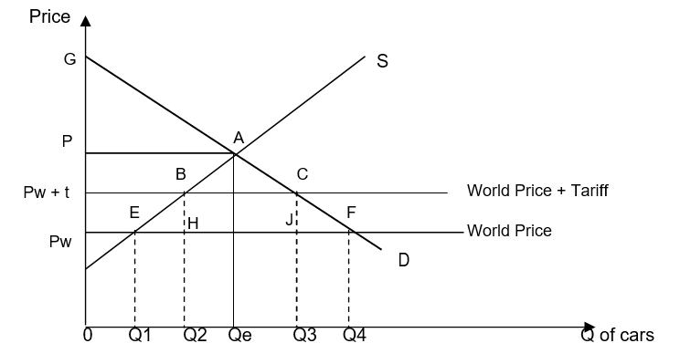
Effects on stakeholders (US firms and HHs):
- US Steel Firms win (rise in domestic Qss from Q1 to Q2, ↑PS of Pw EB Pw+t)
- US Steel workers – HHs win

However:
- Loss of CS (area Pw FC Pw+t): US steel consumers lose i.e. US Firms (downstream producers) which need steel as FOPs lose (eg autos, shipbuilding, construction, electrical appliances etc) - higher COP, less profits
- Downstream producers may retrench workers – US workers from these industries (HHs) lose
- US-made consumer goods eg cars, electrical appliances: more expensive due to higher COP incurred by downstream producers – US households (HHs) lose

Determinants of whether stakeholder is more likely to win/lose
(I) For US HHs
US workers (Steel and downstream)

Depends on quantity of labour employed for steel vs downstream producers in US
- Cite evidence: ‘While employment by primary metal manufacturers was 400,000, downstream manufacturers employed 6.5 million, also 16 times greater’ (ext 6 last para)
- US steel tariffs protect US steel workers but at the expense of many others. Net job losses US workers (HHs) more likely to lose

US consumers of final consumer goods:
Depends on avail of substitutes for the more expensive US-made consumer goods
- Are there foreign-made substitutes to the relatively > expensive US-made cars, washing machines, microwave ovens etc? Do these imported items also face trade barriers (tariffs/quotas) into US?
- Ext 6: Para 2: tariffs were imposed on China-made large washing machines. If such tariffs applies to many other imported consumer goods, that would imply that there may be no good substitutes US HHs/consumers more likely to lose
- In LR, if downstream producers are able to rely less on steel input/find alternative to steel (see point 4) and overcome higher AC brought about by steel, then consumers may not lose.

II) For US Firms
US Steel Firms:
- Likely to win in SR due to protective effect of tariff which is applied directly on them
- But in the LR, whether US steel firms are more likely to win/lose depends on their ability to become more efficient and competitive.
- If US steel firms take steps to improve productivity, process/product innovate can boost competitiveness (price & quality) in > sustainable manner, without need for further govt protection ↓AC &/or ↑DD: ↑r margin
- Then again, table 2 shows fall in productivity growth over time Gains are less likely, at least for now.
- Moreover, long period of protection (30 years - ext 6) might have bred complacency and inefficiency in US steel firms COP & prices uncompetitive relative to foreign firms (even with tariffs) no significant rise in DD, TR, profits
- Evaluate: The extent of losses to US steel industry is contingent on the strategies undertaken by downstream industries. Given that downstream producers suffer higher COP and might lose profits, the downstream producers might undertake strategies (see next point) to reduce reliance on steel, or to offshore production to developing countries. Such decisions would more likely lead to ↓DD, TR and r for US steel industry.

Downstream producers in US
- With tariffs imposed on steel from several countries, in SR, downstream producers in US would lose profit due to ↑COP.
- But in LR, whether they are more likely to win/lose depends on whether they can increase AR and/or reduce AC to overcome loss of r.
- Eg:
  - If can find alternative to steel as input or rely less on steel as input
  - If undertake more efficient methods of production to offset higher AC from steel tariffs
  - If decide to offshore to other countries to bypass steel tariffs and to lower overall COP more likely to win if able to ↓AC cet par, ↑r

Other possible points:
- Depends on govt’s use of tariff revenue- whether it is used to reduce inequity If so, low income households may win / lose less
- Depends on the extent of tariff imposed For Steel producers: higher the tariff the greater the extent of domestic steel production gain more
- Depends on the formation of a domestic monopoly in the steel industry in LR (‘protection for 30 years’), if foreign firms are excluded consumers of steel / downstream firms lose

Conclusion
- Ultimately, perhaps the ‘over-arching’ determinant may be the purpose & length of steel tariff protection as well as the efficacy of US govt.
- If there is no intention to remove protection over time, or if it had been adopted as populist measure, then workers, consumers and firms more likely to lose in the LR. Effect: Slows down the transfer of scarce resources to other higher VA areas slow down EG more prolonged unrealized gains for workers and producers, high opportunity cost to US firms and HHs
- US may not possess CA anymore in producing steel. Fig 3 shows that US doesn’t possess large endowment of steel in the world at all. That implies that US is better off reallocating her resources towards other areas -- but whether US workers and firms can gain in terms of moving up value ladder might depend on factor mobility, level of R&D to develop new areas of CA etc. So the quality of govt intervention affects such development too.

