Economics MCQ – Chapter 2.5 – Demand and Supply & Elasticity Concepts

Q1. The diagrams show different conditions of demand and supply for a product.
In which diagram would market price remain unchanged if consumers’ incomes fell?

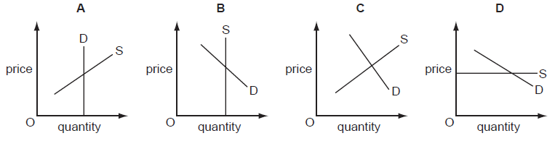

( )

Q2. In 2011, a company selling milk in glass bottles replaced them with new plastic bottles. When they were introduced, the equilibrium quantity on the market fell.
What could be a reason for this fall?

- Consumers preferred the new bottle because it was lighter to carry.
- Milk from the farms used to fill the bottle cost more.
- The bottle was cheaper than the existing glass bottle to produce.
- The new bottle was introduced with a successful advertising campaign.
( )

Q3. Which change would make the supply of a product more price elastic?

- an increase in the number of close substitutes for the product
- an increase in the proportion of firms working at full capacity
- a reduction in the time taken to make the product
- a reduction in the time that the product can be stored
( )
Q4. Which will encourage domestic producers to grow more maize?
- granting subsidies to maize producers
- increasing the sales tax on maize
- removing guaranteed minimum prices for maize
- removing quotas on imported maize

( )

Q5. There is a sales tax (VAT) on a good which has a price elasticity of demand greater than 1 (>1). Which of the following correctly matches a change in sales tax to the change in total expenditure on the good?
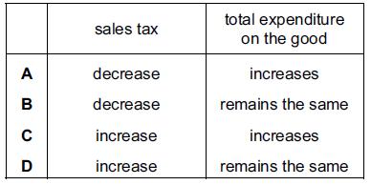
( )

Q6. Supermarkets sell petrol (gas) outside their stores. They reduce the price of petrol below other suppliers to attract more customers to buy goods in the store when they buy more petrol. If this were successful, how might it be shown on demand and supply diagrams?

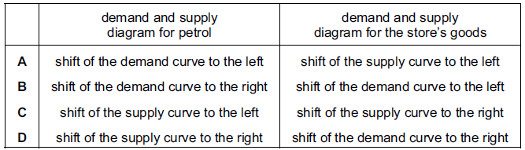
( )

Q7. Many people are life-long, devoted fans of the Los Angeles Lakers basketball team in the United States. The team’s stadium can seat 19 000 spectators and tickets are always sold out.

What does this suggest about the price elasticity of demand and the price elasticity of supply of tickets to watch the Lakers play?

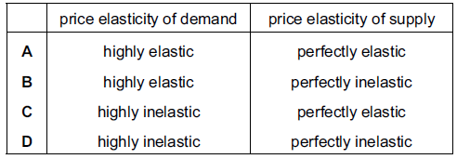
( )

Q8. A supply curve for a commodity is drawn to show how quantity supplied varies with

- government taxes.
- income.
- tastes.
- the price of the commodity.

( )

Q9. In 2010, floods caused severe damage to wheat production. How would this be shown on a market demand and supply diagram for wheat?

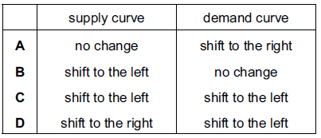
( )

Q10. The demand for a good is totally inelastic with regard to price. What will happen to the firm’s revenue if the price rises by 20 %?

- It will fall by 20 %.
- It will fall to zero.
- It will remain unchanged.
- It will rise by 20 %.

( )

Q11. The market for a normal good is in equilibrium at point X. Consumers’ incomes fall and the cost of producing the good rises.
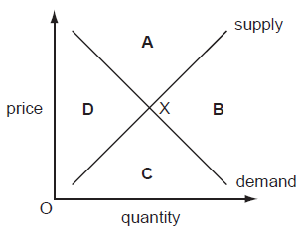

In which area of the diagram will the new equilibrium be?
( )

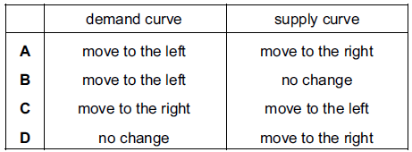
Q12. Wet weather in 2009 led to a fall in the sales of summer clothes. To support businesses the government reduced the sales tax (VAT). How would these events be shown on a demand and supply diagram for summer clothes?
( )

Q13. Drought in African countries often results in poor harvests. Other countries then help by sending quantities of food. What are the likely results of these events for the price of food in the drought-affected countries?

- It will fall and then rise.
- It will rise and continue to rise.
- It will rise and remain at this higher level.
- It will rise and then fall.
( )

Q14. The graphs, drawn to the same scale, show the demand curves of four firms. The market price is $10. The price then falls to $8. Which firm will have the largest increase in total revenue?

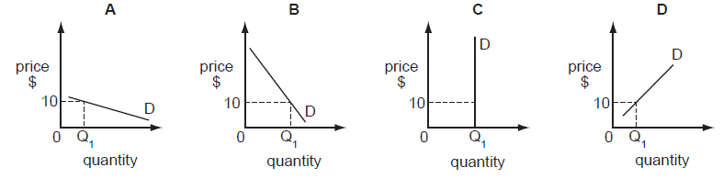

( )

Q15. The diagram shows demand and supply curves for a product at its equilibrium price P.

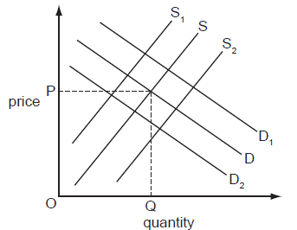

How would the introduction of a subsidy be shown?
- Demand would shift to D₁.
- Demand would shift to D₂.
- Supply would shift to S₁.
- Supply would shift to S₂.
( )

Q16. Which statement could explain a decrease in the demand for natural rubber?

- Demand for car tyres has increased.
- New techniques of producing substitutes for rubber have been introduced.
- Productivity of rubber plantations has increased.
- The area of land on which rubber is grown has increased.

( )

Q17. The table illustrates the demand and supply for rice in a market in Africa.

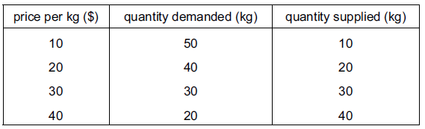

When the price rises from $20 to $30 per kg, what is the approximate price elasticity of demand for rice?
- 0.25
- 0.5
- 1.0
- 2.0
( )

Q18. The diagram shows that when a tax of $2 on a good raises the supply curve from S₁ to S₂, the price to the consumer rises from $4 to $5.
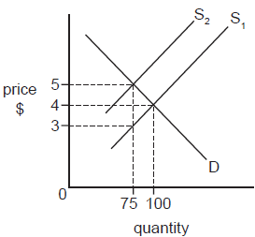
What is the total tax yield to the government?
- $75
- $150
- $200
- $375
( )

Q19. The market for a good was in equilibrium. A change occurred which resulted in a new equilibrium with a higher price for the good and a lower quantity traded. What change would have caused this?

- The demand curve moved to the left.
- The demand curve moved to the right.
- The supply curve moved to the left.
- The supply curve moved to the right.
( )

Q20. It was reported that a company producing designer clothes had increased its revenue by 20 % at a time when it decreased its prices. What does this suggest about the demand for these goods at that time?

- It was perfectly price elastic.
- It was perfectly price inelastic.
- It was price elastic.
- It was price inelastic.

( )

Essay Question 1
The costs of production in the motorcycle industry have risen significantly in recent years.

- Using a demand and supply diagram, analyse the effect of an increase in production costs in the motorcycle industry on the equilibrium price and the equilibrium quantity of new motorcycles. [6]

- Explain the concept of price elasticity of supply. [4]

- Discuss to what extent time is the main influence on the price elasticity of supply. (5)

Essay Question 2
- Explain what is meant by price elasticity of supply. [3]

- Explain what influences the price elasticity of demand of a product. [7]

- Discuss how knowledge of price elasticity of demand can help the producers increase revenue if they know the demand for their product is price inelastic. (5)

TOP SELLER

