Economics MCQ – Chapter 4 – The individual as producer, consumer and borrower

Q1. Which function of money enables people to compare the worth of different products?
- Medium of exchange
- Standard for deferred payments
- Store of value
- Unit of account
( )

Q2. A merchant travels abroad for a few days to buy samples of low-value goods from a range of manufacturers. Which property of money would be least necessary for this to take place smoothly?
- Acceptability
- Divisibility
- Durability
- Portability
( )

Q3. Why do banknotes function as money?
- They are backed by gold.
- They are durable.
- They are generally acceptable.
- They have intrinsic value.
( )

Q4. Which function is performed by both commercial banks and central banks?
- Acting as bankers to the government
- Advising the government on monetary policy
- Dealing in foreign exchange
- Fixing the main interest rate
( )

Q5. An individual has various financial assets. What is the most easily available as cash?
- A current (checking) bank account
- Government bonds
- Share certificates in a public company
- Time deposits in a savings bank
( )

Q6. Which motive is most likely to increase the wish to open a savings account?
- To have cash immediately available
- To prepare for future expenditure
- To satisfy essential needs
- To widen present consumption choices
( )
Q7. In most countries, which organisation controls the banking system?
- Central bank
- Commercial bank
- Investment bank
- World Bank
( )

Q8. Share prices on the stock market are most likely to rise if
- Employment falls.
- Interest rates fall.
- Interest rates rise.
- Tax rates rise.
( )

Q9. The ways of making and receiving payments continue to develop. As well as cash, debit cards and credit cards, mobile (cell) phones are now being used to make payments.

Which method of paying for products provides no information to sellers about their customers?
- Cash
- Debit cards
- Credit cards
- Mobile (cell) phones
( )

Q10. A stock exchange is a market in which
- a system of barter operates.
- the interest rate is fixed.
- the value of the exchange rate is determined.
- shares are bought and sold.
( )

Q11. ‘Savers suffer as inflation rises to 4.4 %.’
Which function of money is most involved in this statement?
- means of deferred payments
- medium of exchange
- store of value
- unit of account
( )

Q12. What function does a central bank provide for the general public?
- accepting deposits
- issuing banknotes
- making loans
- providing overdrafts
( )

Q13. A person is keen to repay a large debt owed on his credit card.
What is likely to cause that person to reduce the credit card repayment and spend more from his weekly wage?
- an increase in interest rates
- an increase in the price of essential products
- an increase in the range of products available
- an increase in weekly earnings
( )

Q14. A commercial bank is appointed to act as a country’s central bank. What new function would it now have?
- Controlling monetary policy
- Dealing in foreign exchange
- Ensuring security for loans
- Holding liquid assets
( )

Q15. Why would people use their savings to buy shares on a stock exchange?
- To allow easy access to their income
- To earn a fixed income
- To keep their money in a safe place
- To make a capital gain
( )

Q16. What is the function of a stock exchange?
- It enables shareholders to sell their shares.
- It fixes fair prices for shares.
- It promises to buy unsold shares.
- It sets the number of shares.
( )

Q17. Anything used as money must have
- a fixed supply.
- general acceptability.
- recognition as legal tender.
- value in itself.
( )

Q18. What is most likely to be the main function of a central bank?
- controlling the money supply
- investing in commerce and industry
- issuing and processing credit cards
- making loans to individuals
( )

Q19. What is a function of a central bank?
- to decide government spending
- to determine all interest rates
- to issue new currency
- to lend to private businesses
( )

Q20. When will a trade union find it easier to achieve higher wages for its members?
- when consumers demand more of the product made
- when the company has a decrease in profits
- when the cost of raw materials increases
- when unemployment increases
( )

Q21. Some lawyers charge very high rates per hour for their services.
What best explains this?
- The lawyers are very skilled.
- The lawyers work long hours.
- The lawyers work part-time and need a high hourly rate.
- The law profession is a popular career.
( )

Q22. The table shows the average monthly wage in Bahraini Dinars (BHD) for different groups of workers in Bahrain in 2011.

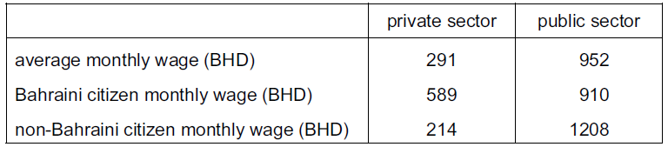

Which statement is most likely to be consistent with these statistics?
- Bahraini citizens are more productive than non-Bahraini citizens in the public sector.
- The demand for Bahraini citizens is greater in the private sector than the public sector.
- The public sector employs better educated workers than the private sector in Bahrain.
- There is a greater supply of non-Bahraini citizens in the public sector than the private sector.

( )

Q23. What could reduce the ability of a trade union to gain a pay rise for its members in a shoe factory?
- an increase in sales of shoe exports
- a rise in the demand for shoes
- a rise in the productivity of shoe workers
- more people willing to work in the shoe industry
( )

Q24. What might encourage a consumer to save rather than to spend?
- being made unemployed
- discounts on products
- government subsidies to producers
- high interest rates
( )

Q25. The table shows the proportion of income saved for different age groups.

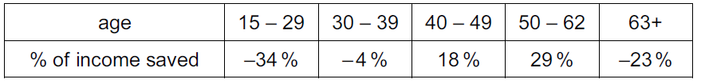

What can be concluded from this data?
- The 50 – 62 age group has the highest level of income.
- The 50 – 62 age group saves the highest proportion of its income.
- The older age groups earn more than the younger age groups.
- The youngest age group spends more than the oldest age group.
( )

Q26. What is usually a function of a trade union?
- to determine the amount of dividend paid
- to negotiate wage levels with employers
- to recommend redundancies
- to take responsibility for organising sales of companies’ products
( )

Q27. Why is a surgeon likely to have a higher wage rate than a hospital porter?
- The surgeon has been in the job a longer time.
- The surgeon has a longer training period.
- The surgeon is older.
- The surgeon is in a trade union.
( )

Q28. What is an advantage for a worker in part-time rather than full-time employment?
- a higher wage
- greater employment protection
- more opportunity for other activities
- greater chance of promotion
( )

Q29. What is likely to cause wages in an occupation to be low?
- a high level of responsibility
- high unemployment
- the need for special skills
- unpleasant working conditions
( )

Q30. When will a trade union be most effective in pursuing its members' interests?
- The economy is in recession with rising unemployment.
- The employers have few orders for the product.
- The government passes a law to increase competition in the labour market.
- The members' wages make up a small part of total costs.
( )
Q31. Which group is likely to save the largest proportion of its income?
- employed workers
- retired people
- school students
- unemployed workers
( )

Q32. What is not included in a person’s stock of wealth?
- a gold watch
- annual income
- an oil painting
- company shares
( )

Q33. What might cause the wages of bus drivers to rise?
- Their productivity falls.
- The number of bus routes falls.
- The number of people making bus journeys falls.
- The supply of bus drivers falls.
( )

Q34. What will lead to an increase in spending?
- an increase in the rate of unemployment
- a reduction in the rate of interest
- a reduction in expenditure by firms on advertising
- an increase in the rate of income tax
( )

Q35. What is not a function of a trade union?
- to act as a pressure group to change labour laws
- to negotiate with employers over conditions of work
- to promote the sales of products made by its members
- to protect the living standards of its members
( )

