J2 H1 Economics CSQ Q10

Living and Studying in the United States (US)

Figure 1: Changes in the Prices of Selected Goods and Services
in the US
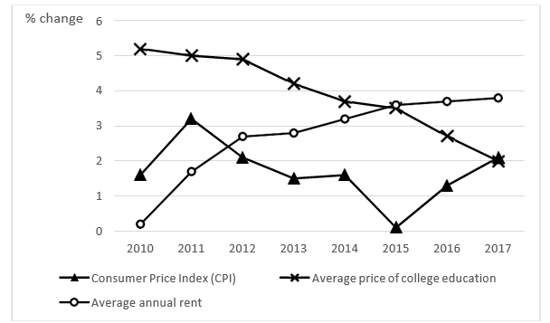
Note: College refers to university in the US
Source: Statista, accessed July 2018

Extract 1: Rising rents make housing unaffordable

California's high housing costs have pushed many tenants to the edge of affordability. Even if they have steady work, the cost of putting a roof over their heads demands a staggering share of income. One reason rents have risen steadily in California is a lack of apartment construction relative to job and population growth. Those who are less well-off have to make tough decisions: move to a cheaper area or cut back on cellphone services, restaurant outings and other basic necessities.

Source: Los Angeles Times, December 2017

Extract 2: Rent control does more harm than good

California voters will decide in November whether to give cities new freedom to expand the use of rent control (a maximum price on rental units). The rent control battle comes as California continues to face a housing affordability crisis. Six of the nation’s 11 most expensive rental markets are in the state, and rents have increased by 40% in the last three years. These prices affect low-income residents the most: 1.7 million California families pay more than half their income on rent. Rent control, tenants’ groups thus argue, is necessary to insulate people from price hikes and allow them to stay in their neighborhoods.

But rent control is not without its woes, causing housing shortages that reduce the number of low- income people who can live in a city. It also disincentivises landlords from upgrading their rental units, resulting in entire neighbourhoods running the risk of becoming decayed and abandoned. Finally, landlords facing lower returns from rental units often convert them into housing units for sale, leading to fewer rental units in the rental market.

Another solution that has been surfaced to tackle the problem of rising rents includes giving households tax rebates or welfare payments to offset rent hikes. The money for the system would come from taxes on landlords, which would effectively spread the cost among all tenants and landowners instead of laying the burden on the vulnerable few.
Source: Bloomberg, January 2018 and Los Angeles Times, June 2018

Extract 3: Colleges reduce tuition fees while online courses see higher enrolment

US college tuition fees are growing at the slowest pace in decades, following a nearly 400% rise over the past three decades that fueled middle class anxieties and a surge in student debt. In the last three decades, higher education was one of the economy’s most unstoppable growth sectors, with the number of two- and four-year colleges increasing by 33% over the period. However, this looks set to change in the next few years. Due to changes in population demographics, the number of new high-school graduates grew 18% in the early 2000s, but only 2% in 2017. The slowing growth in the number of domestic college-ready students has thus far been offset by growth in the number of foreign students seeking to study in US colleges. The number of Chinese college students in the US ballooned from 67 000 in 2006 to more than 350 000 today due to an emerging Chinese middle class willing to pay full price for a foreign education.

Still, college remains a daunting expense for many households. A Federal Reserve survey released in May showed 37% of Americans age 30 and younger who had not attended college said it was too expensive. As a result, some profit-driven colleges have started offering discounts on college tuition fees in a bid to attract students.
With traditional university programs getting more expensive and competitive, there has been a boom in the number of alternative degree programmes that are taking advantage of the internet and more flexible teaching and learning formats to fill the gap in the higher education market. Based on data from more than 4 700 colleges and universities, more than 6.3 million students in the US embarked on an online degree in 2016, a 5.6% increase from the previous year.

Source: Wall Street Journal, July 2017 and US News, January 2018

Extract 4: Is college worth it?

A recent list of top colleges in the Chronicle of Higher Education provides vivid evidence that higher education is the ticket to economic mobility – according to the Bureau of Labour Statistics, median annual earnings for Americans without a degree amounts to $35 256 while the unemployment rate for the same population is 8%. In contrast, Americans with a degree have a median annual income of $59 124 and 2.8% unemployment.

However, the full value of college education goes well beyond dollars and cents. College prepares students to succeed with not only the vocational skills to earn a good living but with the curiosity, adaptability and inclination to respond effectively to the changes and challenges they will face throughout their lives. These benefits extend beyond the college graduates themselves – cities with more college graduates offer higher wages to non-college graduates, all else being equal. And better-educated workers create and develop productive industries; that productivity in turn creates more good jobs for the rest. Ultimately, higher education in New York is a driving force – an economic engine of opportunity for businesses, students, employers and graduates who stay and work in the city, with New York's higher education institutions contributing an estimated $7.5 billion to New York in 2012.

Source: Crain’s New York Business, December 2017

Extract 5: Are higher education subsidies necessary?

The US Department of Education spends tens of billions of dollars a year on subsidies for higher education. The bulk of the spending goes to student aid, with the balance going to educational institutions. Supporters of larger government subsidies to higher education often argue that higher education would be under-provided in the absence of government intervention. But higher education subsidies may not be necessary, and should in fact be reduced. Most people already have a strong incentive to invest in their own higher education even if the government does not subsidise it because it will lead to higher earnings for themselves. As a result, the subsidies disproportionately benefit people who are expected to earn higher future incomes as a result of their advanced educations.
By cutting federal subsidies, tuition fees and related costs would be restrained as students shopped around for the best deals. In turn, that would force schools to reduce their bloated costs. In recent years, while student groups and college officials have criticised supposed funding cuts, colleges and universities have been in the midst of a building boom, while administrative staffing has grown rapidly.
Source: Downsizing the Federal Government, November 2015

Questions

(a) Figure 1 shows that the average price of college education is increasing at a decreasing rate. However, the Consumer Price Index does not follow the same pattern. Suggest why this is possible. [2]

(b) Extract 1 states “Those who are less well-off have to make tough decisions: move to a cheaper area or cut back on cellphone services, restaurant outings and other basic necessities.”

Explain the above statement using the concepts of scarcity, choice and opportunity cost. [3]

(c) Discuss whether the imposition of rent control is ultimately beneficial to society. [8]

(d) With reference to Extract 3, explain why “some profit-driven colleges have started offering discounts on college tuition fees”. [2]

(e) Assess whether demand or supply factors account more for why the average price of college education only increased marginally in 2017. [8]

(f) Comment on whether the online courses offered by higher education providers should be considered as public goods. [4]

(g) Using evidence from the data, explain the determinants of a rational prospective student’s decision on whether to participate in college education. [6]

(h) “Supporters of larger government subsidies to higher education often argue that higher education would be under-provided in the absence of government intervention. But higher education subsidies may not be necessary and should in fact be reduced.”

Using evidence from the case study and/or your own knowledge, discuss whether the US government should increase or decrease subsidies to higher education. [12]
[Total: 45]

