June Intensive Revision 2015
MCQ – Chapter 3 – The individual as producer, consumer and borrower

Q1. A group of workers in a firm joins a trade union. What would the union be expected to do?
- Arrange for labour-saving technology to be introduced
- Discuss safety issues in the workplace with the employer
- Ensure job security by promoting the firm’s products through advertising
- Negotiate new contracts with major buyers of the firm’s products
( B )

Q2. In which occupations do wages tend to be lowest?
- In those where the work is dangerous
- In those where there is an excess supply of labour
- In those where workers are paid on a monthly basis
- In those where workers need long training
( B )

Q3. When might rapid inflation together with low interest rates be a source of concern for a consumer?
- When a consumer lives on a pension linked to the consumer price index
- When a consumer needs to use savings for regular expenditure
- When a consumer pays a fixed rent for their accommodation
- When a consumer wishes to buy a good on credit
( B )

Q4. In 2008, economic conditions in the UK were uncertain and the rate of inflation increased. It was reported that consumers had increased their purchases of rare stamps which continued to rise in value. What is not a reason for such purchases?
- To avoid risk
- To diversify their investments
- To overcome the effects of inflation
- To switch from spending to borrowing
( D )

Q5. The construction industry in Dubai relies on many migrant workers from India. Which combinations of changes in the economies of Dubai and India would be most likely to increase the wages of construction workers in Dubai?
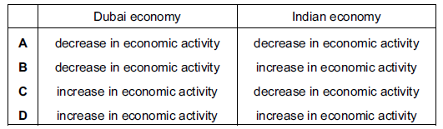
( D )
Q6. In August 2007 the Central Bank of Swaziland increased its interest rate from 9.5% to 10%.Which effect would this be likely to have on producers and consumers?
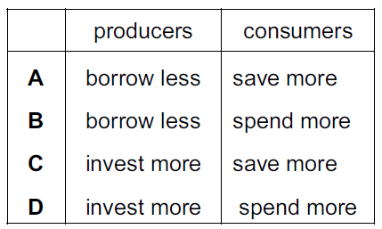
( A )

Q7. Why might a family increase the proportion of its income it spends on food?
- Some of the children start work
- The government increases the benefits it pays to families
- The number of children in the family increases
- The second parent becomes employed
( C )

Q8.In 2007 the average annual pay of a scientist in the UK was £37 290. The average annual pay of a laboratory technician was £26 157. What could explain this difference in earnings?
- Laboratory technicians have stronger bargaining power than scientists
- Laboratory technicians have to work more unsociable hours than scientists
- The period of training for scientists is longer than that for laboratory technicians
- The supply of scientists is high relative to demand for their services
( C )

Q9. What will be the most likely effect of a fall in interest rates on saving and borrowing?
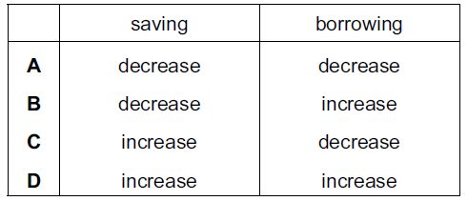
( B )

Q10. A worker’s choice of occupation can be influenced by wage and non-wage factors. What is a non-wage factor when choosing to work in a factory?
- Bonuses paid for increases in productivity
- Changes in hourly rates for items produced
- Financial rewards for length of service
- Opportunities for promotion and advancement
( D )

Q11. When will a trade union find it easier to achieve higher wages for its members?
- When consumers demand more of the product made
- When the company has a decrease in profits
- When the cost of raw materials increases
- When unemployment increases
( A )

Q12. What might be a direct benefit to the individual worker of a specialised job?
- Specialization enables a better quality product to be produced
- Specialization enables the firm to introduce more machinery
- Specialization enables the worker to become more skilled
- Specialization makes better use of resources
( C )

Q13. The table shows the change in real incomes for a number of occupations between 1978 and 2008.
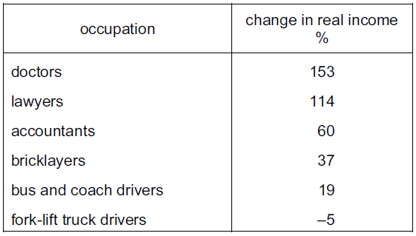
What can be concluded from the table?
- All occupations were better off in 2008 than in 1978
- Fork-lift drivers earned the lowest wages in 2008
- Doctors have earned more than lawyers since 1978
- Professionals received higher percentage increases in income than manual workers
( D )

Q14. Which function of money enables people to compare the worth of different products?
- Medium of exchange
- Standard for deferred payments
- Store of value
- Unit of account

( D )

Structural Questions
Question 1

In this era of globalization, how can the trade unions help the workers to overcome the problems that they may face in the event of Covid-19? (8)

Structure of discussion

- Explain the problems that the workers face during the Covid-19

There is a disruption in the economy and the production will be affected – state the problems the workers face in this current economic recession.

- Based on the functions of the trade unions, explain how the trade unions can help the workers.

Question 2

