June Intensive Revision 2015
MCQ – Chapter 2 – The Allocation of Resources – Demand and Supply

Demand and Supply
Q1. Which will encourage domestic producers to grow more maize?
- granting subsidies to maize producers
- increasing the sales tax on maize
- removing guaranteed minimum prices for maize
- removing quotas on imported maize
( A )

Explanation: The provision of subsidies to maize producers will lower the cost of production, inducing the increase in supply of maize. Sales tax will raise the cost of production, inducing the fall in supply of maize. Minimum prices (floor price) for maize is above the equilibrium price, creating a surplus condition, which benefits the producers. The removal of minimum price will discourage domestic producers to raise supply of maize. The removal of quotas of imported maize will increase supply of imported maize, which will not encourage domestic producers to grow more maize.

Q2. Supermarkets sell petrol (gas) outside their stores. They reduce the price of petrol below other suppliers to attract more customers to buy goods in the store when they buy more petrol. If this were successful, how might it be shown on demand and supply diagrams?

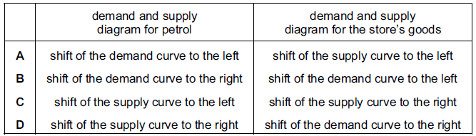
( D )

Explanation: The inclusion of sale of petrol by supermarkets will raise the supply of petrol, indicating a rightward shift of the supply curve. If the supermarkets were successful in attracting more customers, the demand for store’s goods will increase, indicating a rightward shift of the demand curve.

Q3. A supply curve for a commodity is drawn to show how quantity supplied varies with
- government taxes
- income
- tastes
- the price of the commodity
( D )

Explanation: The supply curve is drawn in a way in which price of a good is positively related with the quantity supplied of the good.
Q4. In 2010, floods caused severe damage to wheat production. How would this be shown on a market demand and supply diagram for wheat?
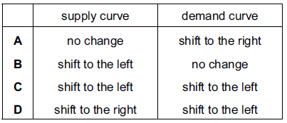
( B )

Explanation: The floods are seen as unfavorable weather conditions, which is a non-price determinant of supply for wheat. As such, the severe damage to wheat production will lead to the fall in supply of wheat, indicated by the leftward shift of the supply curve. There is no change in the demand curve.

Q5. The market for a normal good is in equilibrium at point X. Consumers’ incomes fall and the cost of producing the good rises.
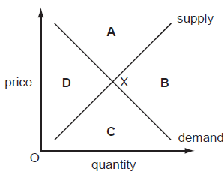
In which area of the diagram will the new equilibrium be?
( D )

Explanation: The fall in consumers’ income will lower their purchasing power, leading to the fall in demand, indicated by the leftward shift of the demand curve. The rise in cost of production will lead to the fall in supply of the good, indicated by the leftward shift of the supply curve. As such, while it is uncertain whether the equilibrium price has increased or decreased, the equilibrium quantity will fall.

Q6. Drought in African countries often results in poor harvests. Other countries then help by sending quantities of food. What are the likely results of these events for the price of food in the drought-affected countries?
- It will fall and then rise
- It will rise and continue to rise
- It will rise and remain at this higher level
- It will rise and then fall
( D )

Explanation: Drought in African countries will lead to the fall in supply of food, creating a shortage condition that caused the price of food to increase. The food aid provided by other countries will increase the supply of food, thus causing the price of food to fall.
Q7. The diagram shows demand and supply curves for a product at its equilibrium price P.
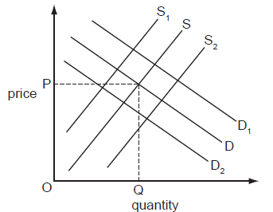
How would the introduction of a subsidy be shown?
- Demand would shift to D₁
- Demand would shift to D₂
- Supply would shift to S₁
- Supply would shift to S₂
( D )

Explanation:The introduction of a subsidy will lower the cost of production, leading to the increase in supply of the product, indicated by the rightward shift of the supply curve from S to S₂. There is no change in the demand curve.

Q8. Which statement could explain a decrease in the demand for natural rubber?
- Demand for car tyres has increased
- New techniques of producing substitutes for rubber have been introduced
- Productivity of rubber plantations has increased
- The area of land on which rubber is grown has increased
( B )

Explanation: The introduction to new techniques of production for substitutes to natural rubber will lower the cost of production of these substitutes, thus raising production of these goods that will lower the price of substitutes to rubber. As such, consumers will increase demand for substitutes and decrease demand for natural rubber.

Q9. The market for a good was in equilibrium. A change occurred which resulted in a new equilibrium with a higher price for the good and a lower quantity traded. What change would have caused this?
- The demand curve moved to the left
- The demand curve moved to the right
- The supply curve moved to the left
- The supply curve moved to the right
( C )

Explanation: Assuming demand remains unchanged, the fall in supply will lead to a shortage condition that creates an upward pressure on price, resulting in the increase in equilibrium price and fall in equilibrium quantity.
Q10. The diagram shows an initial equilibrium point (X) in a market and a new equilibrium point (Y).
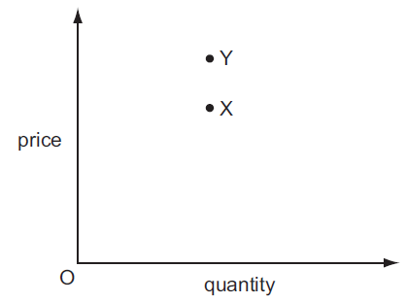
Which combination of changes in demand and supply could have caused the movement from X to Y?
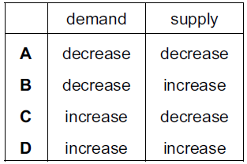
( C )

Explanation: First, identify the changes in the equilibrium price and quantity. The equilibrium price has increased from X to Y, while equilibrium quantity has remained unchanged. The likely case is that the demand has increased, while the supply fell. Draw out the diagrams to determine the changes in demand and supply, so as to achieve the change in the points from X to Y.

Q11. Russia is the world’s third largest exporter of grain but much of the country’s farmland was damaged by fire in 2010.

How would this be represented on demand and supply diagrams for the Russian grain marketand for a country importing Russian grain?
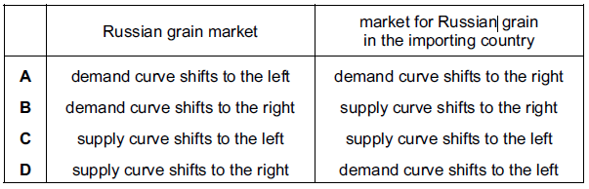
( C )

Explanation: The fire in 2010 will lead to the fall in supply of grain, indicated by the leftward shift of the supply curve in the Russian grain market. Also, the supply curve will shift left in the market for Russian grain in the importing country.
Elasticity of Demand and Supply
Q1. Which change would make the supply of a product more price elastic?
- an increase in the number of close substitutes for the product
- an increase in the proportion of firms working at full capacity
- a reduction in the time taken to make the product
- a reduction in the time that the product can be stored
( C )

Explanation: Shortened time period for production of a good will enable the firms to raise production at a higher level, thus causing the supply of the product to be more price elastic.

Q2. Many people are life-long, devoted fans of the Los Angeles Lakers basketball team in the United States. The team’s stadium can seat 19 000 spectators and tickets are always sold out.

What does this suggest about the price elasticity of demand and the price elasticity of supply of tickets to watch the Lakers play?
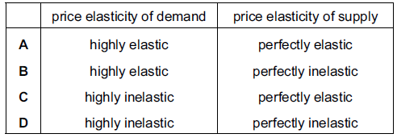
( D )

Explanation: The supply of the stadium seats is perfectly inelastic due to the fixed capacity of production, given the limited space. The demand of the stadium tickets is highly inelastic as event is popular and much sought-after, such that many consumers will want to purchase the tickets.

Q3.The demand for a good is totally inelastic with regard to price. What will happen to the firm’s revenue if the price rises by 20 %?
- It will fall by 20 %
- It will fall to zero
- It will remain unchanged
- It will rise by 20 %

( D )

Explanation: If the demand for a good is perfectly inelastic, the demand curve is shaped as a vertical line in a graph of price against quantity. As such, when price increases, the total revenue increases by the same percentage. TR = PxQ

Q4. The graphs, drawn to the same scale, show the demand curves of four firms. The market price is $10. The price then falls to $8. Which firm will have the largest increase in total revenue?

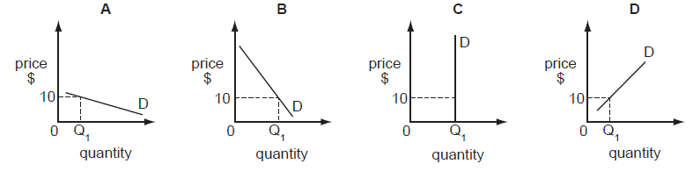

( A )

Explanation: Total Revenue = Price x Quantity Demanded
A producer should reduce price when the demand for a good is price-elastic, so as to maximize total revenue. A producer should increase price when the demand for a good is price-inelastic, so as to maximize total revenue. In this question, since price fell from $10 to $8, the firm that has demand for its good that is price-elastic will have the largest increase in total revenue.

Q5. The table illustrates the demand and supply for rice in a market in Africa.

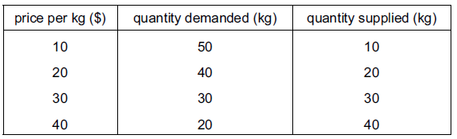

When the price rises from $20 to $30 per kg, what is the approximate price elasticity of demand for rice?
- 0.25
- 0.5
- 1.0
- 2.0
( C )

Explanation:
$$PED=\frac{Percentage change in quantity demanded}{Percentage change in the price of the good concerned}=|\frac{30-40}{10}x 100\%|=1.0$$

Q6. It was reported that a company producing designer clothes had increased its revenue by 20% at a time when it decreased its prices. What does this suggest about the demand for these goods at that time?
- It was perfectly price elastic
- It was perfectly price inelastic
- It was price elastic
- It was price inelastic

( C )

Explanation: The producer will increase its total revenue when the price of designer clothes is lowered as the demand for the designer clothes is price-elastic.

Q7. The diagrams show different conditions of demand and supply for a product. In which diagram would market price remain unchanged if consumers’ incomes fell?
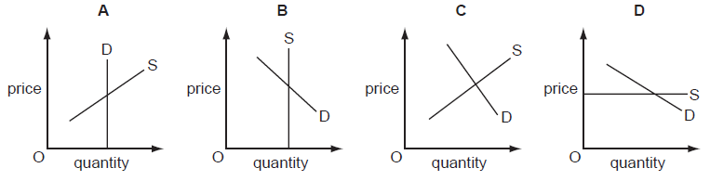

( D )

Explanation: The fall in consumers’ income will lower their purchasing power, leading to the fall in demand, indicated by a leftward shift of the supply curve. Price will remain unchanged if the supply curve is perfectly elastic, which is horizontally-shaped.

Q8. For what would price elasticity of demand be used?
- calculating current disposable income
- calculating the rate of price inflation
- estimating changes in a company’s cost
- identifying changes in consumer spending patterns
( D )

Explanation: The PED measures the responsiveness of change in quantity demanded as a result of the change in price of the good. The PED concept can be used to determine which goods consumers are more likely to spend on.

