June Intensive Revision 2015
MCQ – Chapter 2 – The Allocation of Resources – Demand and Supply

Demand and Supply
Q1. Which will encourage domestic producers to grow more maize?
- granting subsidies to maize producers
- increasing the sales tax on maize
- removing guaranteed minimum prices for maize
- removing quotas on imported maize
( )

Q2. Supermarkets sell petrol (gas) outside their stores. They reduce the price of petrol below other suppliers to attract more customers to buy goods in the store when they buy more petrol. If this were successful, how might it be shown on demand and supply diagrams?

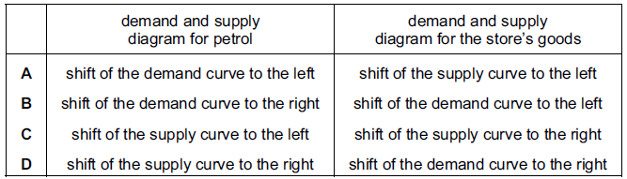
( )

Q3. A supply curve for a commodity is drawn to show how quantity supplied varies with
- government taxes
- income
- tastes
- the price of the commodity
( )

Q4. In 2010, floods caused severe damage to wheat production. How would this be shown on a market demand and supply diagram for wheat?
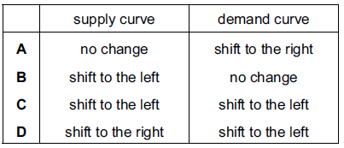
( )

Q5. The market for a normal good is in equilibrium at point X. Consumers’ incomes fall and the cost of producing the good rises.
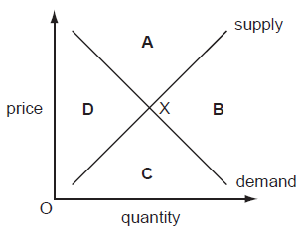
In which area of the diagram will the new equilibrium be?
( )

Q6. Drought in African countries often results in poor harvests. Other countries then help by sending quantities of food. What are the likely results of these events for the price of food in the drought-affected countries?
- It will fall and then rise
- It will rise and continue to rise
- It will rise and remain at this higher level
- It will rise and then fall
( )

Q7. The diagram shows demand and supply curves for a product at its equilibrium price P.
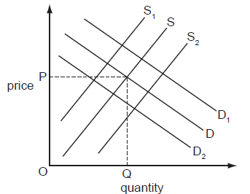
How would the introduction of a subsidy be shown?
- Demand would shift to D₁
- Demand would shift to D₂
- Supply would shift to S₁
- Supply would shift to S₂
( )

Q8. Which statement could explain a decrease in the demand for natural rubber?
- Demand for car tyres has increased
- New techniques of producing substitutes for rubber have been introduced
- Productivity of rubber plantations has increased
- The area of land on which rubber is grown has increased
( )

Q9. The market for a good was in equilibrium. A change occurred which resulted in a new equilibrium with a higher price for the good and a lower quantity traded. What change would have caused this?
- The demand curve moved to the left
- The demand curve moved to the right
- The supply curve moved to the left
- The supply curve moved to the right
( )

Q10. The diagram shows an initial equilibrium point (X) in a market and a new equilibrium point (Y).
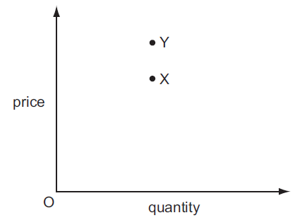
Which combination of changes in demand and supply could have caused the movement from X to Y?

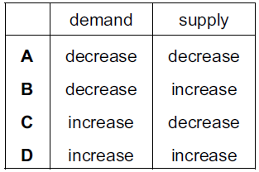
( )

Q11. Russia is the world’s third largest exporter of grain but much of the country’s farmland was damaged by fire in 2010. How would this be represented on demand and supply diagrams for the Russian grain market and for a country importing Russian grain?
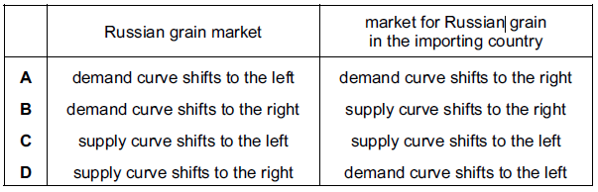
( )

Elasticity of Demand and Supply
Q1. Which change would make the supply of a product more price elastic?
- an increase in the number of close substitutes for the product
- an increase in the proportion of firms working at full capacity
- a reduction in the time taken to make the product
- a reduction in the time that the product can be stored
( )

Q2. Many people are life-long, devoted fans of the Los Angeles Lakers basketball team in the United States. The team’s stadium can seat 19 000 spectators and tickets are always sold out.

What does this suggest about the price elasticity of demand and the price elasticity of supply of tickets to watch the Lakers play?
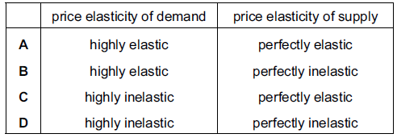
( )

Q3.The demand for a good is totally inelastic with regard to price. What will happen to the firm’s revenue if the price rises by 20 %?
- It will fall by 20 %
- It will fall to zero
- It will remain unchanged
- It will rise by 20 %

( )

Q4. The graphs, drawn to the same scale, show the demand curves of four firms. The market price is $10. The price then falls to $8. Which firm will have the largest increase in total revenue?

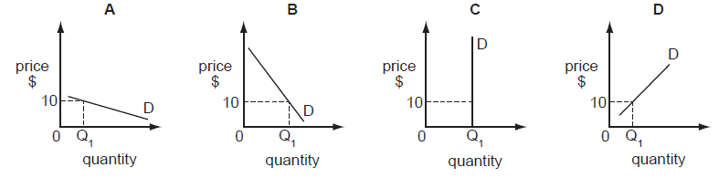

( )

Q5. The table illustrates the demand and supply for rice in a market in Africa.

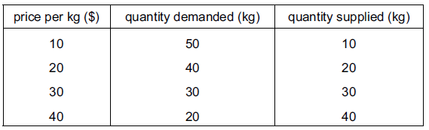

When the price rises from $20 to $30 per kg, what is the approximate price elasticity of demand for rice?
- 0.25
- 0.5
- 1.0
- 2.0
( )

Q6. It was reported that a company producing designer clothes had increased its revenue by 20% at a time when it decreased its prices. What does this suggest about the demand for these goods at that time?
- It was perfectly price elastic
- It was perfectly price inelastic
- It was price elastic
- It was price inelastic

( )

Q7. The diagrams show different conditions of demand and supply for a product.
In which diagram would market price remain unchanged if consumers’ incomes fell?
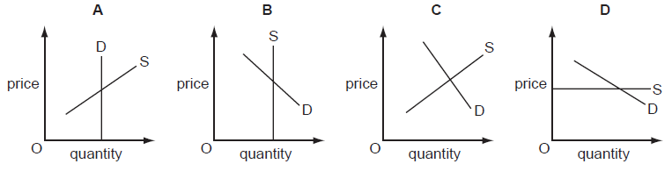

( )

Q8. For what would price elasticity of demand be used?
- calculating current disposable income
- calculating the rate of price inflation
- estimating changes in a company’s cost
- identifying changes in consumer spending patterns
( )

Structure Question

Question 1

- Explain two demand factors affect the price of private condominium. (4)
- Explain two supply factors that affect the price of condominium (4)
- Explain why the price of condominium rises despite an increase in the supply of condominium (8)

