JC Economics CSQ – Term 3 2014
Cost of Production/Market Structures

The wireless telecommunications industry

Extract 1: Telecommunications as an industry

The telecommunications industry is made up of a complex set of suppliers and service providers. The key companies in the telecommunication industry include:

•Telecommunication product and equipment manufacturers
These companies manufacture products that are used by both customers and other companies in the same industry. They include satellite and broadcast network equipment, wireless and wired landline equipment, computer networking equipment and mobile phones.

•Telecommunication service providers
These companies, or service providers, provide voice or data services and operate wirelessly or over traditional wired land lines. The top wireless telecommunications service providers in the United States are Verizon Wireless and AT&T Mobility.

Source: http://www.technofunc.com, accessed 4 August 2013

Extract 2: AT&T to buy T-Mobile for $39 billion

AT&T announced that it had agreed to buy T-Mobile for $39 billion. The proposed deal is a "horizontal merger" that would combine two companies that had been direct competitors. The deal would leave just three major companies in the United States: AT&T, Verizon and the much smaller Sprint Nextel.

Some critics denounced the merger saying it would most likely lead to higher prices. "Consumers have borne the brunt of the increasingly concentrated market for mobile phone service," Senator Herb Kohl, who heads the subcommittee on antitrust, competition policy and consumers rights, said.

AT&T customers, though, could benefit in one notable area: service. Both AT&T and T-Mobile operate on the same technology, known as Global System for Mobile Communications (GSM), which is the de facto global standard for mobile communications. Thus the combination should provide better coverage. Their network technology fits nicely together so AT&T could better use some of T-Mobile's electromagnetic spectrum, helping to relieve some of the pressures on its network and turning its capacity constraint into "an efficient capacity-enhancing combination".

The deal would also provide significant cost savings roughly $3 billion a year for the new company. The combined company is expected to close hundreds of retail outlets in areas where they overlap, as well as eliminate overlapping back office, technical and call center staff. It may also drastically reduce advertising spending.

Scale will be critical as AT&T continues its aggressive rollout of the next generation wireless network, known as 4G. The company has been slower than rivals to deploy the 4G LTE technology. When that takes off, phone manufacturers can expect strong demand for the latest mobile phones and devices that are compatible with this wireless network.

The transaction is expected to start a fierce battle as regulators scrutinise the effect of the deal on competition and consumers. Critics contend that the proposed merger would leave Sprint as the only remaining national provider to compete with AT&T and Verizon Wireless. But Sprint would be less than half the size of either of its competitors. In addition to facing significant network scale disadvantages, it would have an increasingly difficult time securing mobile phone arrangements with manufacturers comparable to those of its two dominant rivals.
Adapted from www.nytimes.com, accessed 24 July 2013

Extract 3: Europe trails US in next-generation wireless

The mobile wireless markets in the EU are characterised by lower revenues, lower prices, lower intensity of use, lower quality, less product differentiation and consumer choice, a slower pace of innovation and lower rates of capital investment than the mobile wireless market in the United States (US). Industry analysts say that Europe has lagged behind because its telecommunications market is much more fragmented and competitive than that of the US. European consumers therefore pay much less to use mobile services in the region, with EU prices almost half that of the US on average. However, this low pricing has come at a cost to investment and innovation.
Adapted from http://www.ft.com, accessed 1 August 2013

Extract 4: Innovation and new technologies

One of the principal drivers in the growth of wireless services is the ability of mobile connections to facilitate companies' drive to cut costs and improve environmental performance through reducing energy use. Numerous opportunities exist for wireless telecommunications to reduce carbon emissions and energy costs, including mobile tele-presence, virtual offices and smart grids, meters and network monitoring. Research shows that in 2020, these new wireless opportunities, supported by mobile services, could save 2.4% of expected carbon emissions.

New technologies can make a significant contribution to the challenge of reducing greenhouse gas emissions. As more and more devices are connected through broadband networks, many companies are innovating new technologies and services to benefit from and facilitate this transition. Demand for new technologies is growing with the proliferation of smart grids, cars and cities, all of which require an enhanced Intelligent' infrastructure of communications technologies.

Adapted from UN Global Compact-Accenture CEO Study: Towards a new era of sustainability in the communications industry, 2011

Table 1: Service revenues of key wireless service providers, 2008 – 2011 (millions of dollars)

Service Provider | 2008 | 2009 | 2010 | 2011
Verizon Wireless | 42,602 | 52,046 | 55,629 | 59,157
AT & T | 44,249 | 48,563 | 53,510 | 56,726
Sprint Nextel | 28,435 | 25,832 | 25,894 | 27,390
T-Mobile | 19,242 | 18,926 | 18,733 | 18,481

Table 2: Service connections for key wireless service providers, 2008 – 2011 (thousands)

Service Provider | 2008 | 2009 | 2010 | 2011
Verizon Wireless | 77,009 | 82,120 | 95,536 | 103,247
AT & T | 72,056 | 85,445 | 87,535 | 92,167
Sprint Nextel | 48,338 | 48,133 | 49,910 | 55,021
T-Mobile | 32,758 | 33,790 | 33,734 | 33,185

Figure 1: US wireless provider market share, 2011 (% of total wireless subscribers)

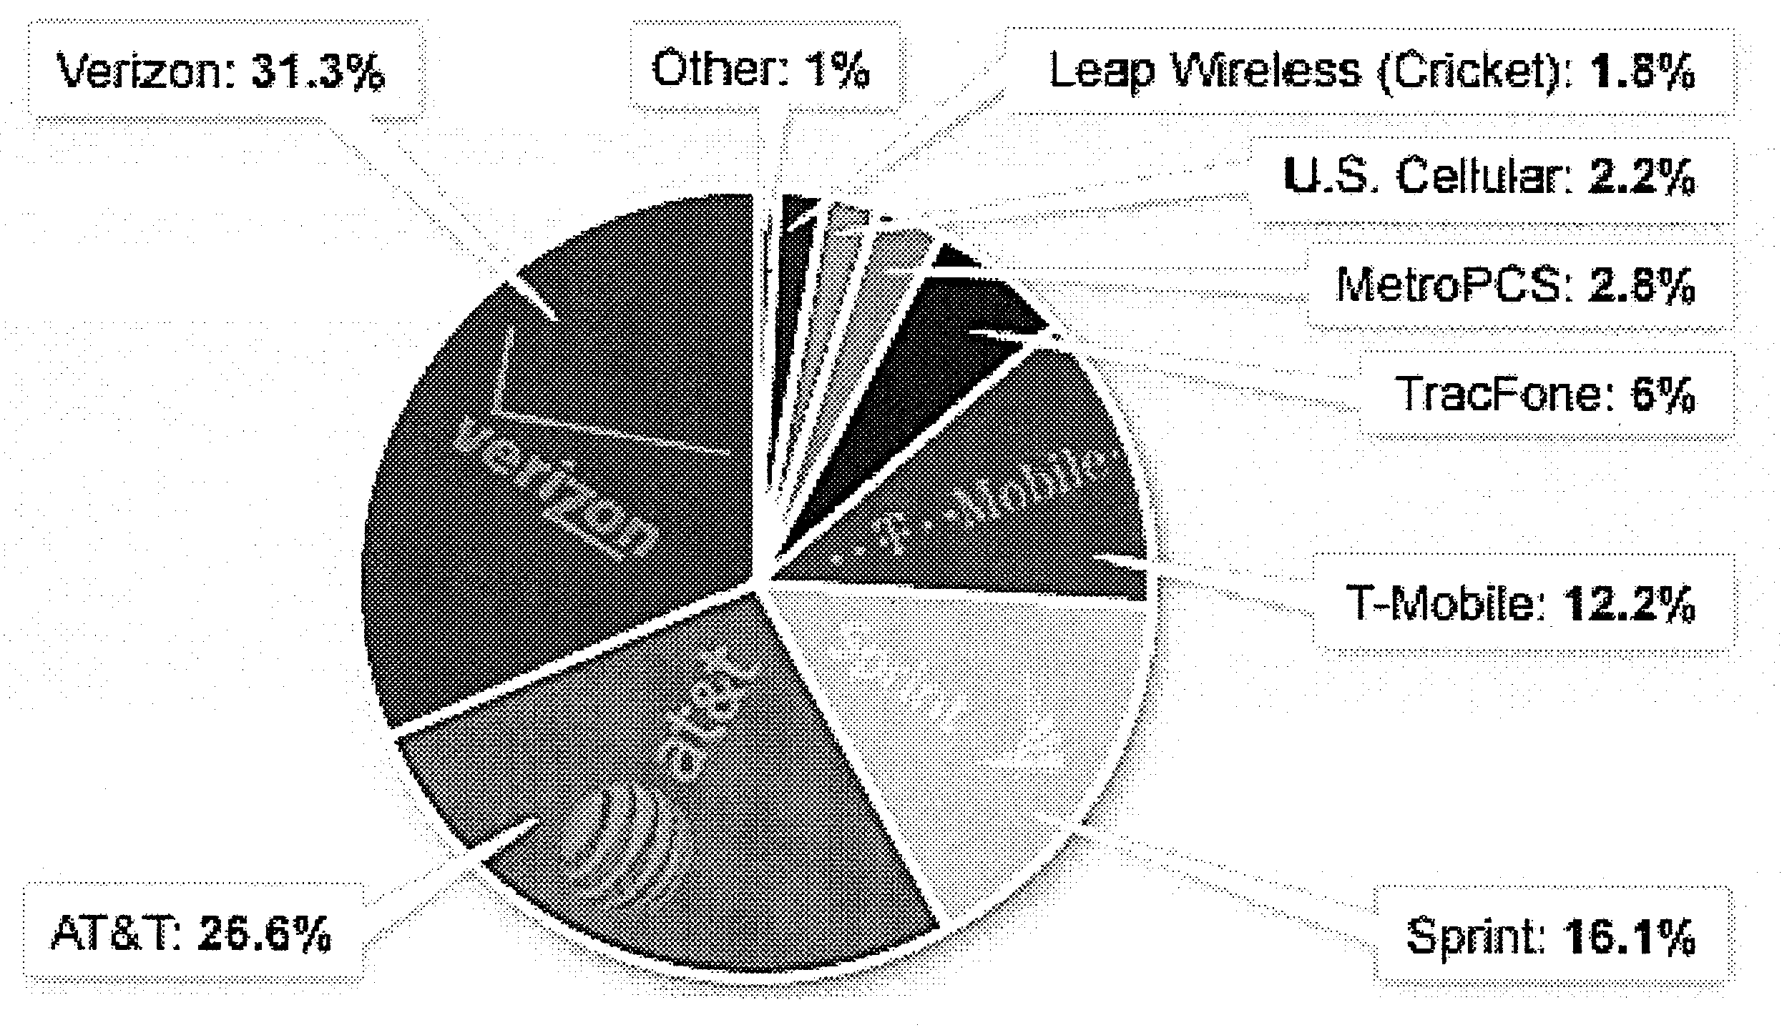
Source: http://money.cnn.com, accessed 30 July 2013

Questions

(a)(i) Compare the change in service connections of key wireless service providers between 2008 and 2011. [2]

(ii) How far does this comparison explain the difference in revenue growth of the key wireless service providers in Table 1? [4]

(b) With reference to the data where appropriate, explain the likely reasons for the proposed merger between AT&T and T-Mobile. [6]

(c) Assess how customers and different companies in the telecommunications industry may be affected by the proposed merger between AT&T and T- Mobile. [8]

(d) With reference to the wireless telecommunications industry, discuss whether more competition or more innovation is the key to achieving a more efficient allocation of resources. [10]

[Total: 30 marks]

Suggested Answers

(a)(i) Compare the change in service connections of key wireless service providers between 2008 and 2011. [2]

Similarity
The service connections of all the key wireless service providers have generally increased.

Difference
Service connections for AT&T and Verizon Wireless increased by the greatest extent.

OR
Service connections for AT&T and Verizon Wireless increased throughout the stated period but service connections for Sprint Nextel and T-Mobile dipped in 2009 and 2010 respectively.

(a)(ii) How far does this comparison explain the difference in revenue growth of the key wireless service providers in Table 1? [4]

Revenue is defined as the amount of money that a company actually receives during a specific period. It is calculated by multiplying the price at which goods or services are sold by the number of units or amount sold. From Table 1, service revenue grew for Verizon Wireless and AT&T but fell for Sprint Nextel and T-Mobile.

Perspective 1: The comparison can explain the difference in revenue growth
Verizon Wireless and AT&T reported an increase in service connections throughout the stated period. Hence a higher number of connections when multiplied with the price (assumed that it is unchanged) would give rise to a higher amount of revenue. Similarly, Sprint Nextel and T-Mobile had lower levels of connections in 2009 and 2010respectively. This explained why they received less revenue in the same year as well.

Perspective 2: The comparison cannot explain the difference in revenue growth
Revenue for T-Mobile fell in 2009. This occurred despite the increase in the connections reported in the same year. This could be due to a fall in price that is of a greater extent than the increase in connections that year. In conclusion, more information such as price of wireless service charged by the companies to ascertain other factors that may be responsible for the difference in revenue growth.

Perspective 1: The comparison can explain the difference in revenue growth
As the service connections for AT&T and Verizon Wireless increased by the greatest extent, they also saw an increase in the revenue between 2008 and 2011. As the increase in service connections for Sprint Nextel and T-Mobile were much smaller, their revenue fell, possibly due to a fall in price.

Perspective 2: The comparison cannot explain the difference in revenue growth
While the service connections of all the key wireless service providers increased between 2008 and 2011, the revenue grew for Verizon Wireless and AT&T but fell for Sprint Nextel and T-Mobile. This could be due to a fall in price that is of a greater extent than the increase in connections for Sprint Nextel and T-Mobile. 2/77 for each perspective

(b) With reference to the data where appropriate, explain the likely reasons for the proposed merger between AT&T and T-Mobile. [6]

The proposed merger between AT&T and T-Mobile is a horizontal merger (Extract 2, para 1) which is a merger between 2 firms in the same industry and at the same stage of production with a similar range of services.

Assuming the new merged firm aims to maximise profits, the proposed merger allows the new firm to enjoy cost and revenue advantages and increase profits.

Cost advantages
The proposed merger would increase the scale of service provision for the new firm. This gives rise to greater economies of scale which lowers the firm's long run average cost. Such economies of scale can be technical in nature. For example, both AT&T and T-Mobile operate on similar network technology (Extract 2, para 3). When these are combined, the benefits in terms of relieving current network congestions and greater capacity to support the wireless network exceed the cost of consolidating and maintaining the technology. In addition, the high costs of setting up the next generation wireless network, 4G LTE technology (Extract 2, para 5) can be spread over a larger subscriber base. Economies of scale can also be of managerial and marketing types. There can be gains from streamlining and specialisation as overlapping processes and operations such as retail outlets, back office, technical and call center staff are eliminated (Extract 2, para 4). With network scale advantages, the new firm would also be able to secure more favourable mobile phone arrangements with manufacturers (Extract 2, para 6).

Revenue advantages
If merged, the new company will take 38.8% share of the wireless provider market (Figure 1) and can rival the biggest player Verizon Wireless (which has 31.3% share) easily. Sprint Nextel having 16.1% is the smallest player and poses little threat to the new company. Almost a monopoly, the demand for wireless services provided by the new company will be more price inelastic. This allows the new company to increase price further without fear of customers switching to other firms, raising its total revenue. The possibility of earning supernormal profits given lower costs and greater revenue may also provide for greater funding to introduce newer and more efficient technology for wireless communications. This can deter the entry of potential firms who are unable to compete and further establish the monopoly power of the new firm.

(c) Assess how customers and different companies in the telecommunications industry may be affected by the proposed merger between AT&T and T-Mobile. [8]

1. Impact on customers

Perspective 1: Negative impact on customers
With the merger, demand has increased and has also become more price inelastic (AR₂). The merged firm thus is able to raise price of wireless services further from P₁ to P₂ thus lowering consumers' purchasing power, assuming no change to cost conditions. The firm is hence even more allocatively inefficient as the firm will charge a price (P₂) even higher than the original price (P₁). This is supported in Extract 2 whereby critics predict that the merger would most likely lead to higher prices as a result of the "increasingly concentrated market for mobile phone service". Thus, the customers place a higher value on the last unit of the service than the additional cost of providing it. Consumers may also face fewer choices and more inconveniences as the hundreds of retail outlets are closed down and less call center staff are hired to man the service hotlines.

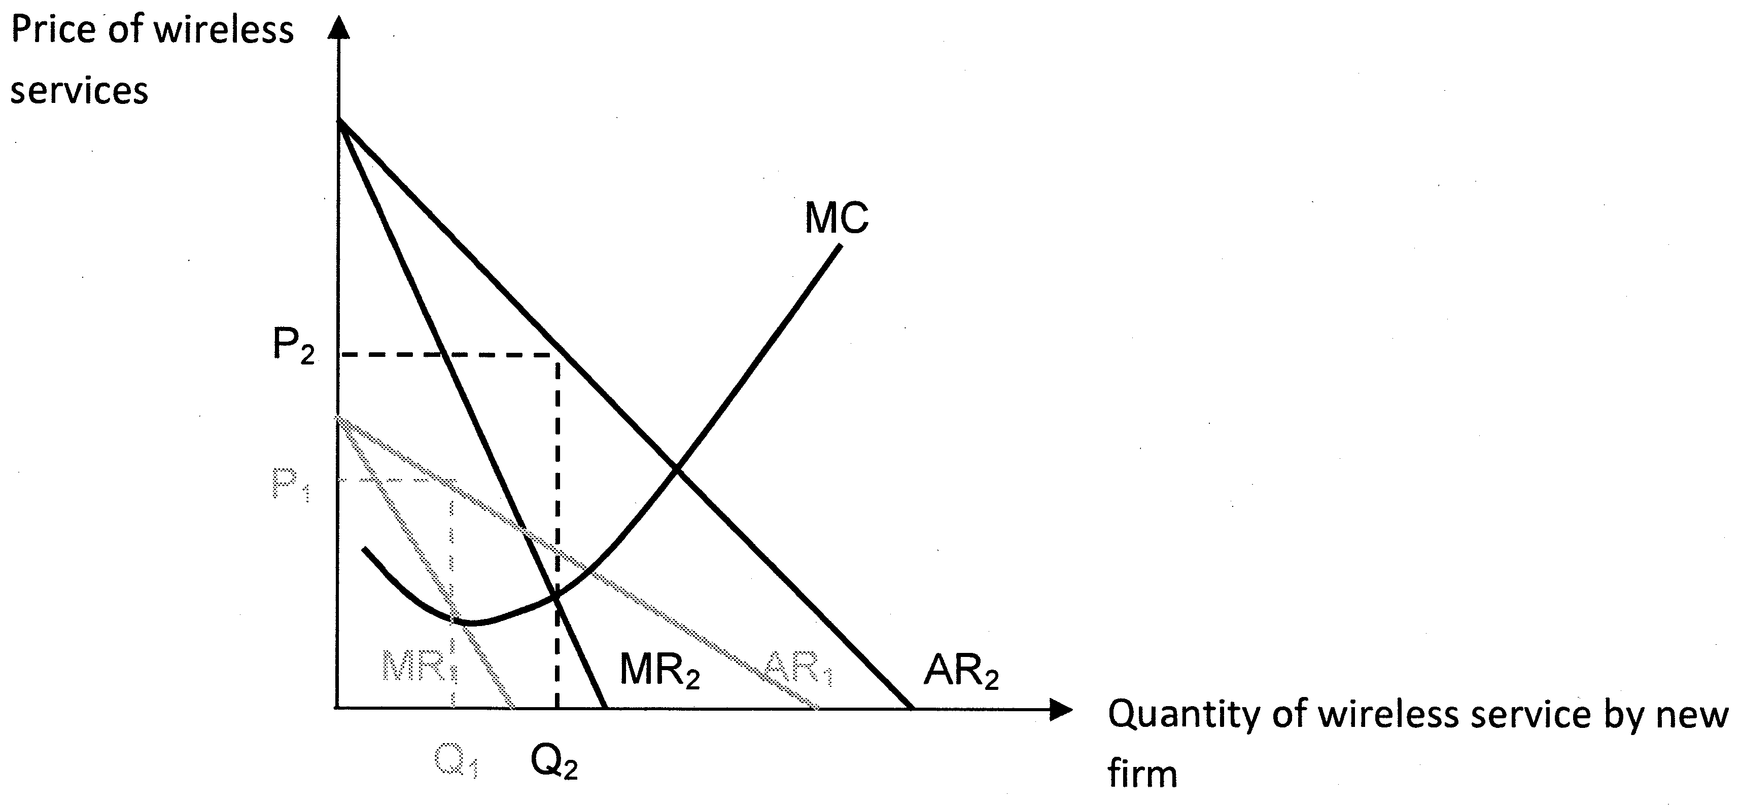

There may be other social disadvantages to the customers. The supernormal profits earned by the merged firm may be seen as an exploitation of customers because of the transfer of income from a large majority of customers to a small minority of large producers. This leads to inequitable income distribution.

Perspective 2: Positive impact on customers
However, customers may also benefit from the merger. As explained in (b), the merged firm is able to enjoy lower costs of production of about $3 billion due to reduced advertising spending and elimination of overlapping operations (Extract 2, para 4), enabling it to charge a lower price, thereby improving consumer surplus and welfare. In addition, service may improve for customers with the enhancement of network capacity (Extract 2, para 3) so that they benefit from less dropped calls, wider coverage and faster connection speeds. In addition, it is possible for the merged firm to channel supernormal profits to fund the roll-out of the next generation wireless network, 4G LTE, (Extract 2, para 5) so that, together with the introduction of new compatible mobile phones, customers benefit from greater dynamic efficiency.

2. Impact on companies supplying the new firm equipment such as satellite, broadcast network equipment, wireless equipment.

Perspective 1: Negative impact on companies
The merged firm has stronger bargaining power to negotiate for lower prices of the equipment. Thus the companies would earn less revenue and profits.

Perspective 2: Positive impact on companies
With combined resources, the merged firm is likely to be more aggressive in developing its 4G technology (Extract 2, para 5). Thus, the companies supplying the necessary technology and infrastructure would benefit from an increase in demand and thus higher revenue and profits. In addition, the companies could benefit from lower transaction costs as they have to deal with only one large firm instead of two.

3. Impact on companies producing mobile phones e.g. Samsung, Apple

Perspective 1: Negative impact on companies
The merged firm has stronger bargaining power to negotiate for lower prices of the mobile phones to be bundled with the wireless service. Thus the companies would earn less revenue and profits.

Perspective 2: Positive impact on companies
Wireless service and mobile phones are goods in joint demand. When demand for the new 4G technology increases after it is rolled out by the merged firm, demand for 4G phones will similarly increase. These companies can expect higher revenues and profits. Given that mobile phones are becoming more sophisticated and more expensive when purchased separately, they can also tie up with the new firm for attractive bundling packages to increase the appeal and sales of their mobile phones.

4. Companies in direct competition with the new firm e.g. Sprint, Verizon

Perspective 1: Negative impact on companies
Sprint will be less than half the size of either of its competitors and therefore find itself at a competitive disadvantage. In addition to facing significant network scale disadvantages, it would have an increasingly difficult time securing mobile phone arrangements with manufacturers comparable to those of its two dominant rivals (Extract 2, para 6), reducing the appeal of its packages, causing its demand and hence revenue to fall. It also faces the risk of being acquired by Verizon.

Perspective 2: Positive impact on companies
With the merger, Verizon would cease to be the market leader. Faced with such a threat, Verizon may be incentivised to improve efficiency and service as well as lower price to compete more fiercely with the new firm.

Evaluation
On the whole, the proposed merger is likely to have a more direct impact on the customers and direct competitors than other companies supplying the new firm equipment and mobile-phones. In addition, the nature of the impact is also more likely to be positive on the non-price aspect (e.g. service, marketing) but negative on the price aspect.

(d) With reference to the wireless telecommunications industry, discuss whether more competition or more innovation is the key to achieving a more efficient allocation of resources. [10]

Efficiency in resource allocation entails both allocative efficiency and productive efficiency. Allocative efficiency is achieved when it is impossible to change the allocation of resources in order to make everyone better off (i.e. cannot make someone better off without making someone else worse off.) Productive efficiency is achieved when a given level of output in the market is produced at the lowest possible cost, i.e. any point on the long-run average cost (LRAC).

Perspective 1: More competition is key to achieving a more efficient allocation of resources
The European wireless markets are characterized by more competition (Extract 3). This is because there are a lot more wireless service providers in the EU than in the US. When there is more competition due to the entry of new firms, firms are likely to be less allocative inefficient. This is because with more competition and more substitutes, demand is lower and is less price-inelastic for each firm. Firms have less monopoly power to charge very high prices.

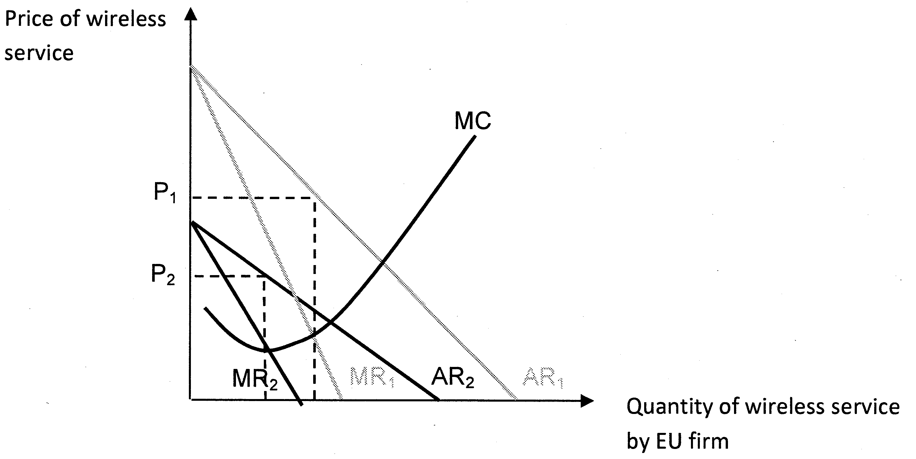
As seen from the above diagram, price (P₂) exceeds marginal cost by a smaller amount as a result of more competition. This implies that there is less under-allocation of resources. This is an improvement in terms of efficiency in resource allocation.

In addition, there is also less productive inefficiency. Due to greater competition or threat of entry from potential firms, the existing firms may be forced to minimise costs and put in more effort to seek the lowest-cost method of production. This also improves the allocation of resources in the provision of wireless services.

Perspective 2: More innovation is key to achieving a more efficient allocation of resources
However from Extract 3, more competition has come at a cost to investment and innovation. The European telecommunications sector is falling far behind the US because its telecommunications market, being more competitive than that of the US, earns lower revenue and thus is unable to channel sufficient funds for investment in technology development. Yet, as seen in Extract 4, these investments in wireless telecommunications technologies can potentially reduce carbon emissions and energy costs by 2.4% in 2020.

Carbon emissions generated, say from air travel, could potentially lead to global warming which imposes external cost on not just the country itself, but the rest of the world as well. As seen in the diagram below, due to the presence of negative externalities from air travel, there is a divergence between private marginal cost (PMC) and social marginal cost (SMC). The market equilibrium level of air travel is at Qe whereby private marginal benefit = private marginal cost (PMB=PMC). However, at Qe, SMC>SMB and society values an additional unit of air travel less than what it would cost society to produce it. Socially optimum level of air travel is at Qs whereby SMB=SMC, thus there is an over-allocation of resources to air travel that leads to deadweight loss to society, resulting in market failure.

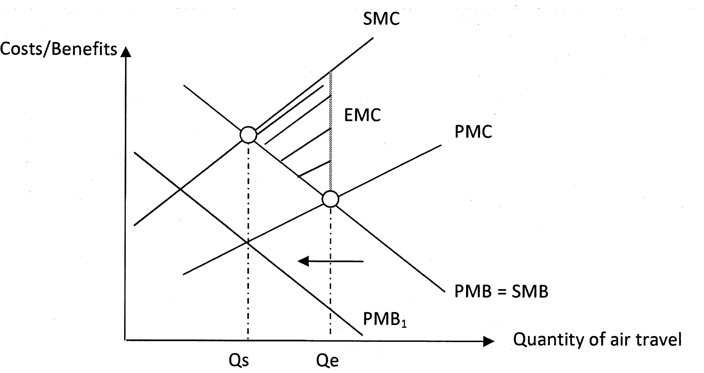
When there is greater innovation in wireless communications to support areas such as mobile tele-presence, virtual offices and smart grids, meters and network monitoring (Extract 4, para 1), there is less of a need for air travel as virtual meetings can be set up easily. Therefore, advancement in technology in wireless communications can reduce the reliance on travelling and reduce the perceived benefits of travelling and shift the PMB curve to the left, leading to a more socially optimal level of activity at Qs, improving the allocation of resources.

Other than reducing negative externalities, innovation in wireless communications also generates positive externalities in the form of higher labour productivity and economic growth. However, the market under-allocates resources to innovation. Hence, when more resources are channelled to innovation, this also helps to improve the allocation of resources.

In addition, innovation to develop more cost-efficient means of production and facilitate companies' drive to cut costs (Extract 4, para 1) can also bring about greater productive efficiency. If the firm passes on the cost savings to consumers, it would lead to lower prices for consumers and greater allocative efficiency too.

Evaluation
In conclusion, from a static point of view, there should be more competition to achieve a more efficient allocation of resources. However, from a dynamic point of view, there should instead be more innovation. The wireless telecommunications industry is unlike the standard textbook industry. It is characterised by dynamism, product differentiation, economies of scale and scope and network effects. Given such an industry, it is more important for firms in the industry to earn supernormal profits (i.e. only possible with less competition and a more concentrated market) to finance innovation.

Government regulation of such markets must take into account the effect on incentives for ongoing innovation and investment. Increasing the number of competitors in dynamic markets like the wireless telecommunications industry can actually lower consumer welfare by reducing the incentives of all firms in the market to innovate and invest.

