2012 T4 J2 CSQ Q1 – Stagflation

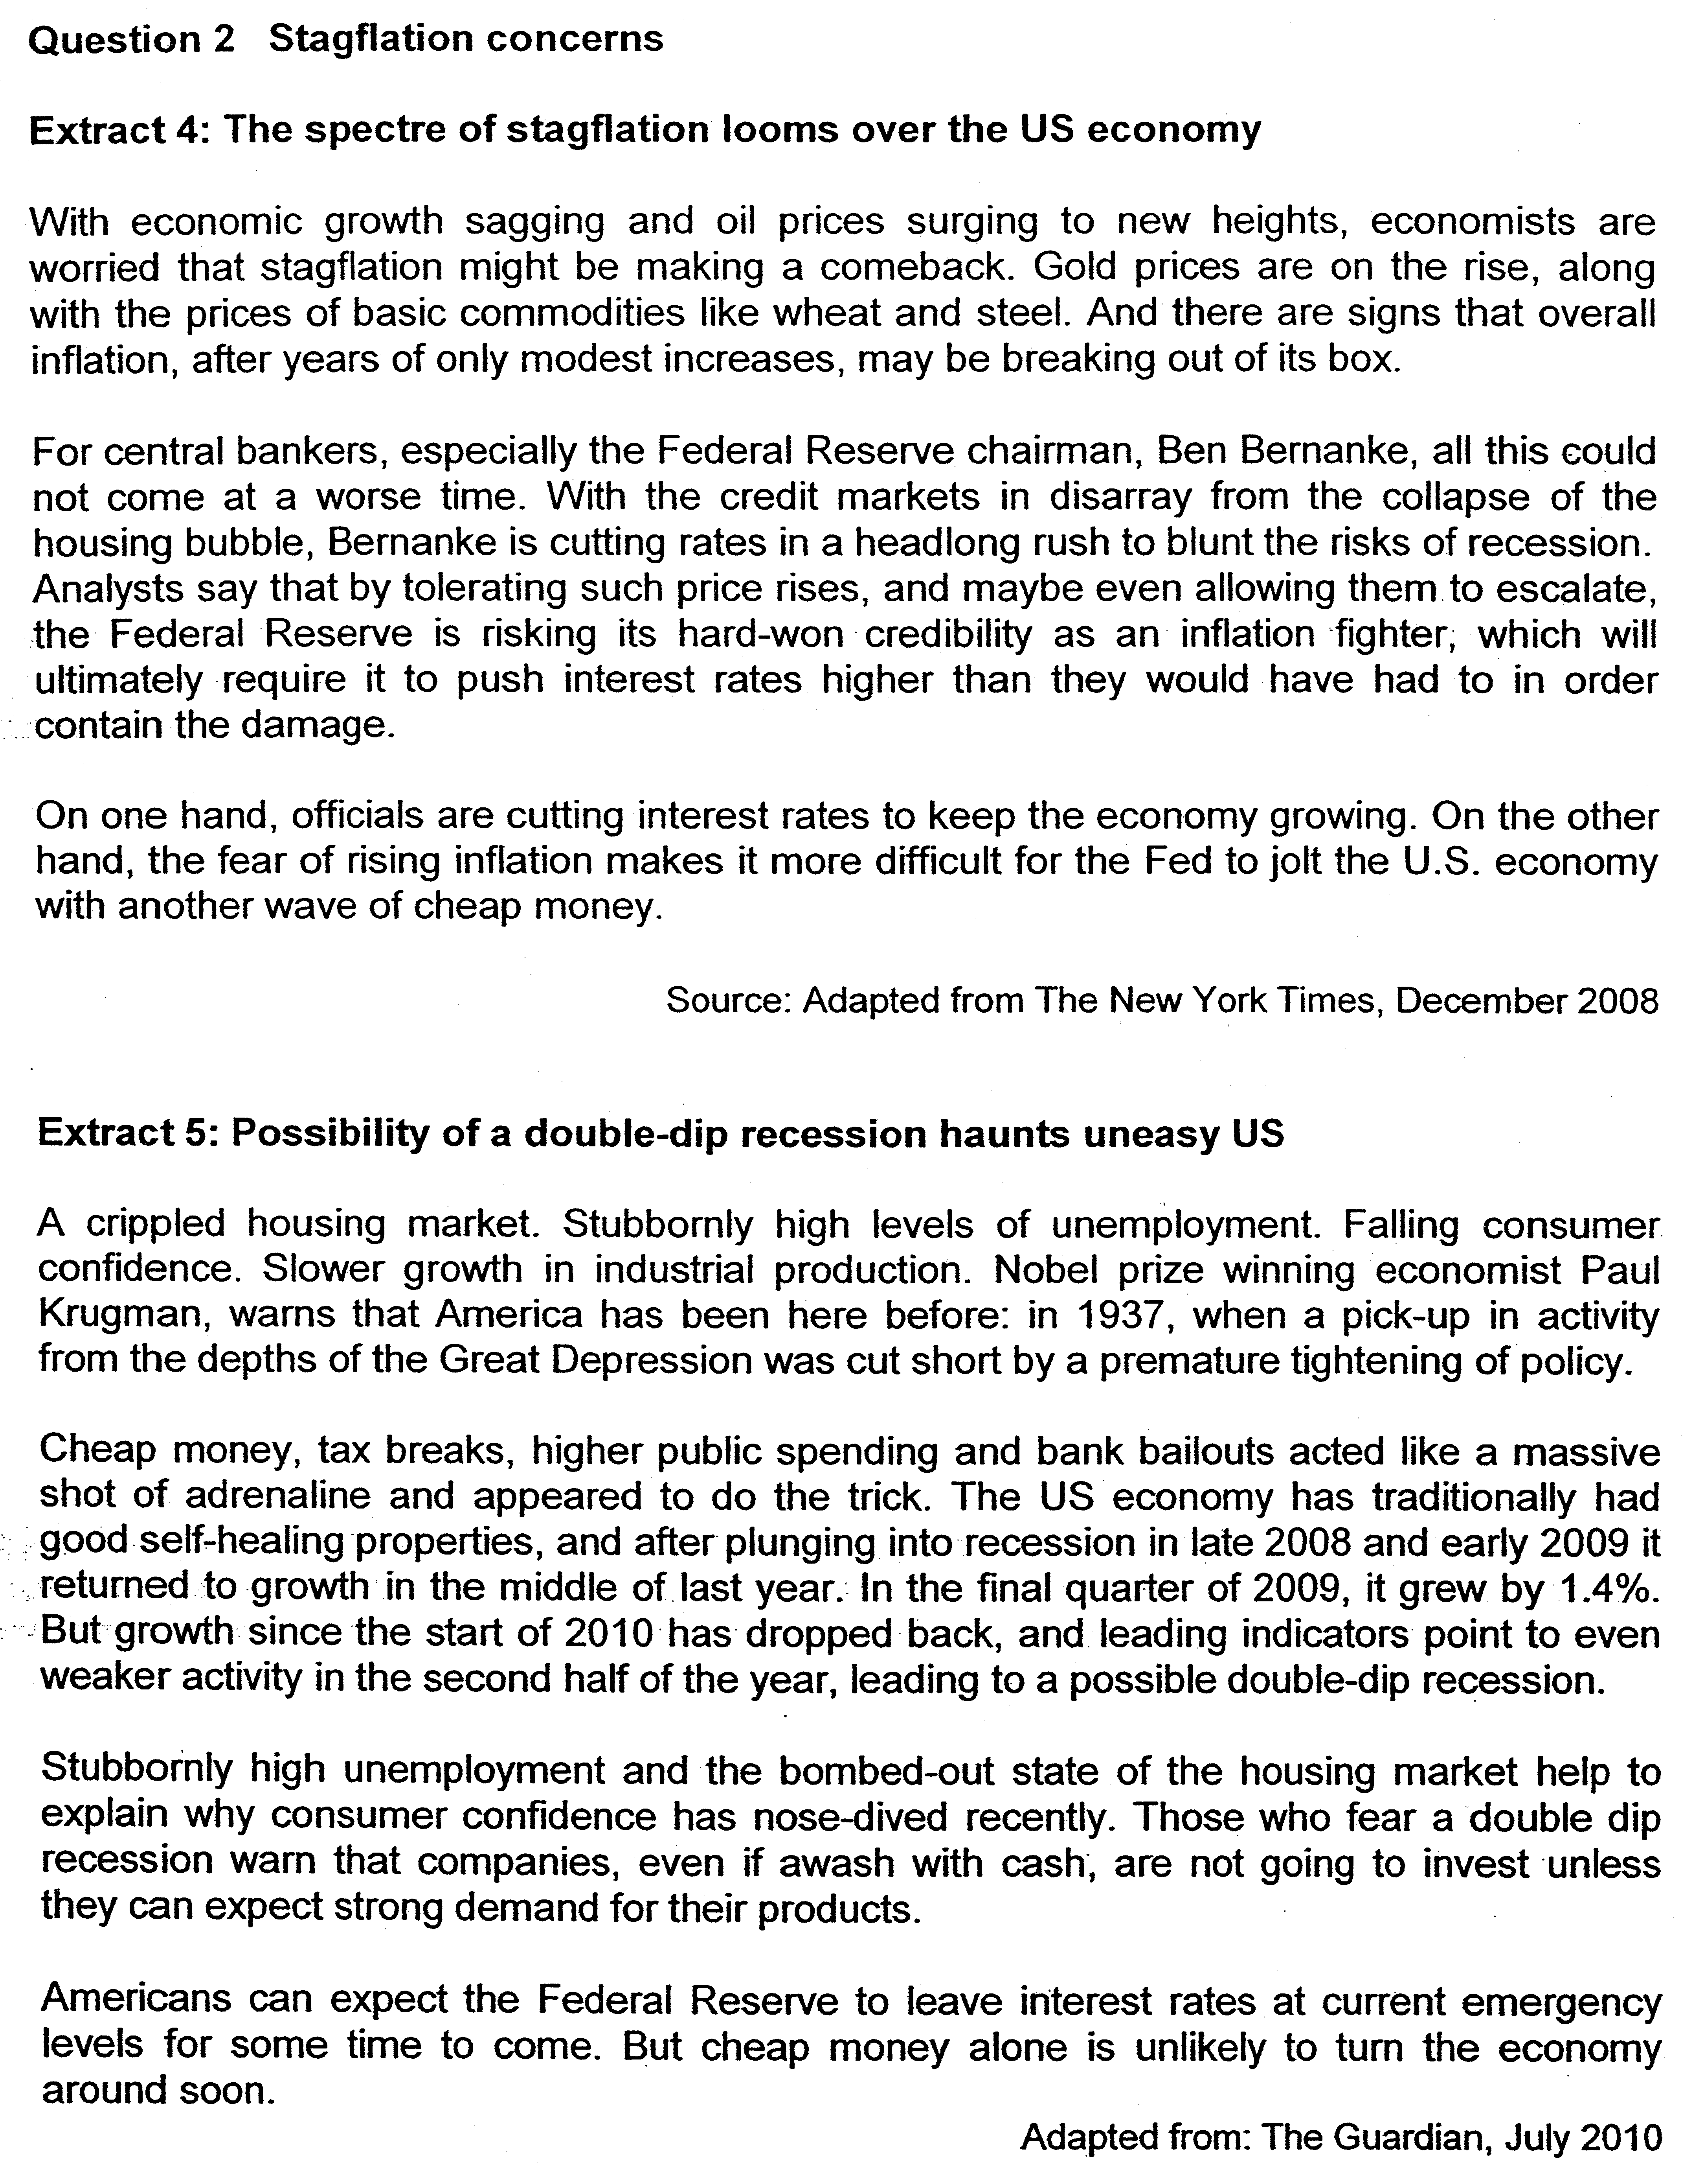

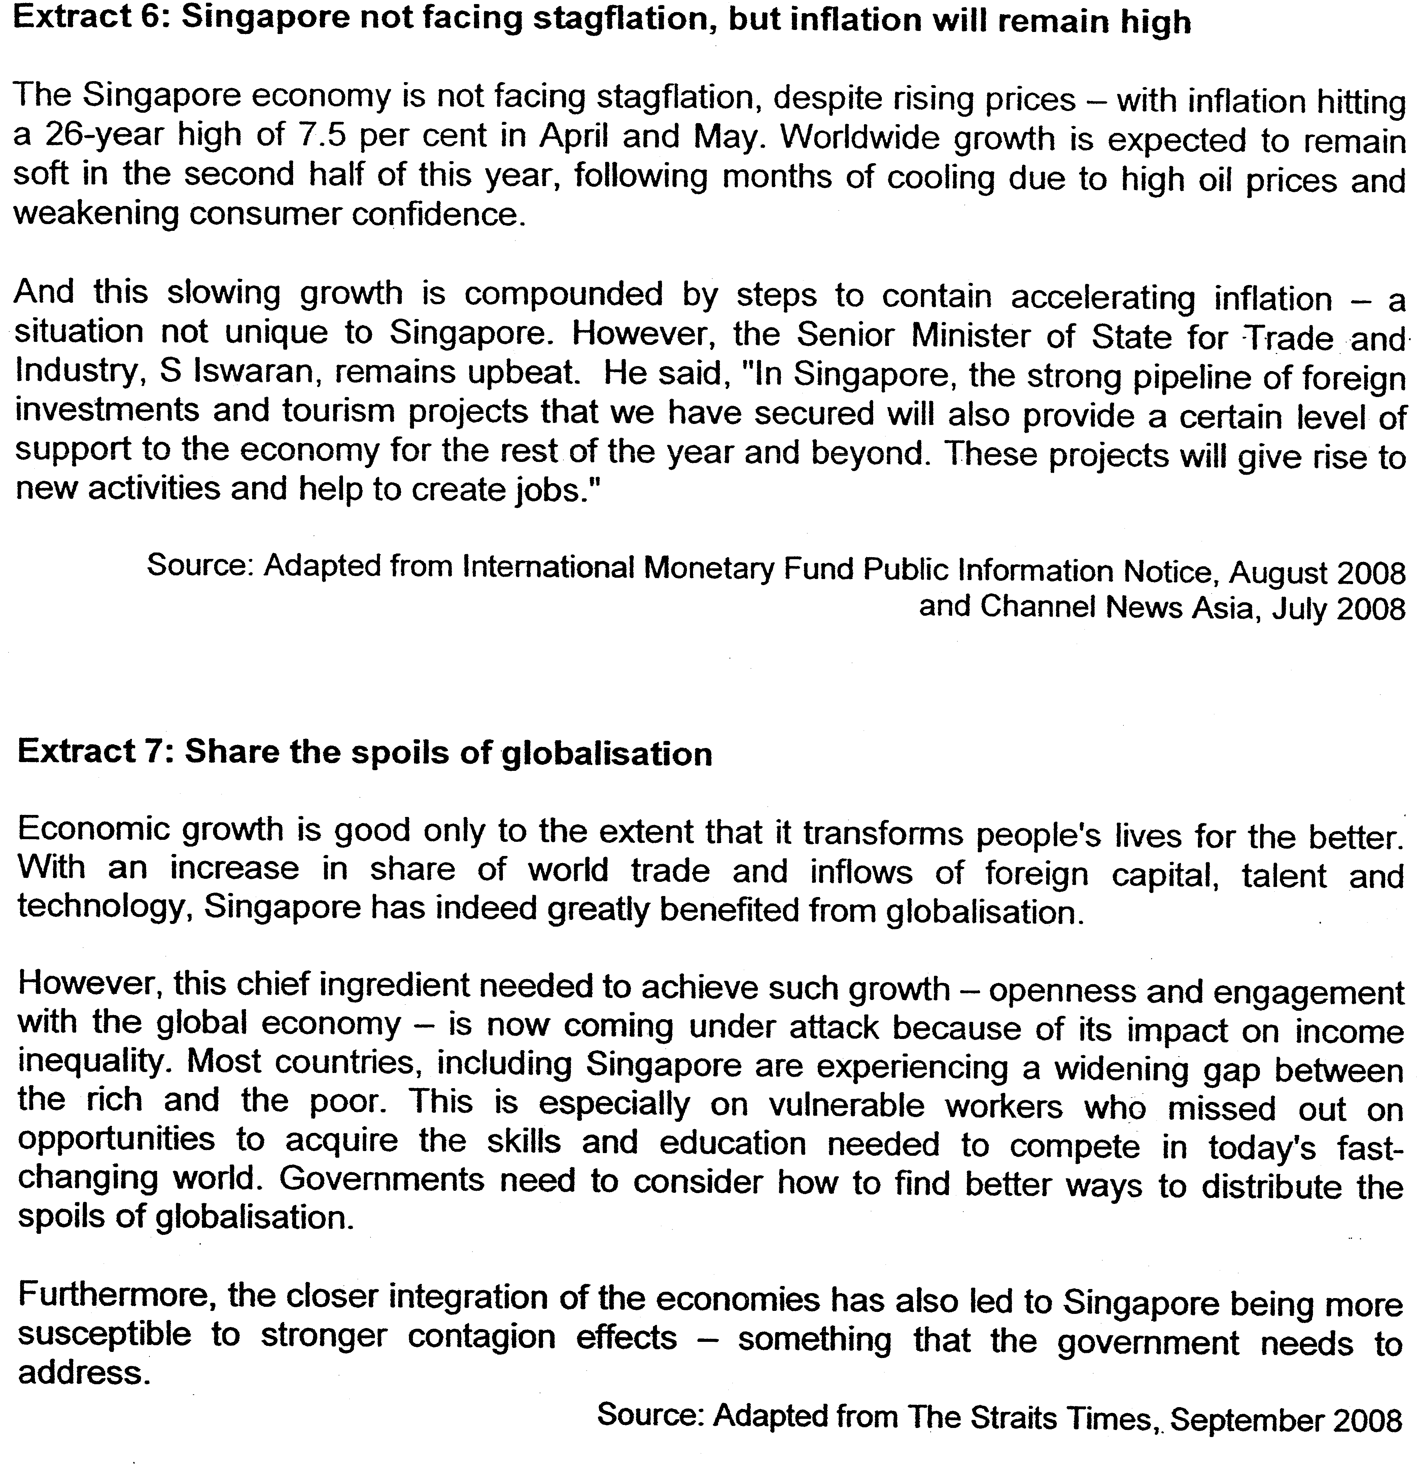

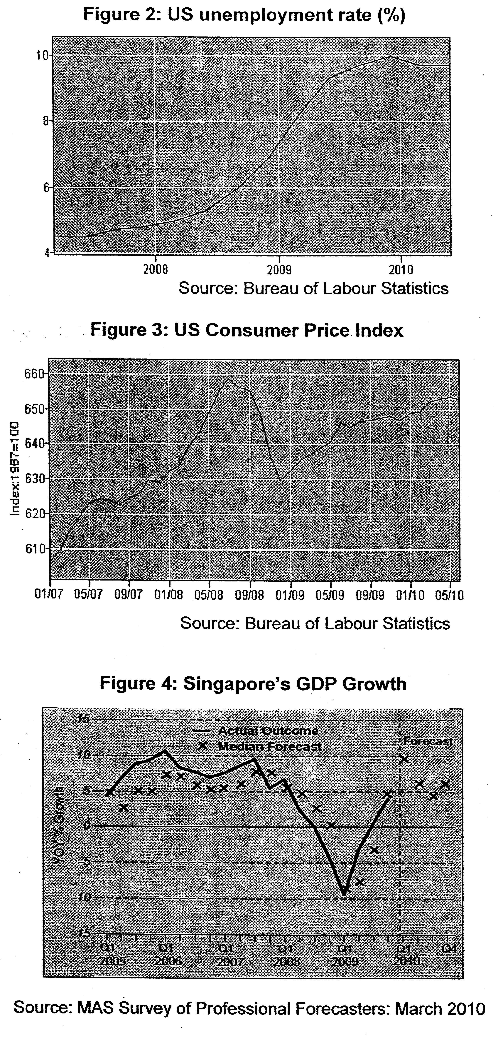

Questions
(a)(i) From Figures 2 & 3, compare the trends for unemployment and consumer prices from 2008 to 2010. [2]
(ii) Explain how the data suggest that the US is heading towards stagflation. [2]

(b)(i) Account for the US government's concern with unemployment and inflation. [4]
(ii) Evaluate the effectiveness of the policies implemented by the US to address the issues of low economic growth and high inflation. [6]

(c) Using AD/AS analysis, explain why the Senior Minister of State remains upbeat about the future economic situation in Singapore in spite of the high inflation rate. [6]

(d)(i) Using Figure 4, describe the trend of GDP growth in Singapore from 2007 (Q3) to 2009 (Q3). [2]
(ii) Discuss the view that the problems of increasing globalisation have outweighed the benefits for Singapore. [8] (DON’T NEED TO DO?)

[Total: 30 marks]

Suggested Answers
(a)(i) From Figures 2 & 3, compare the trends for unemployment and consumer prices from 2008 to 2010. [2]

Both trends were generally rising. [1m] CPl, however, fell sharply at the end of 2008 by about 30%. [1m]

(ii) Explain how the data suggest that the US is heading towards stagflation. [2]

The data indicates that US is likely to head towards stagflation. With reference to Fig 2, USA is facing a rising unemployment rate. Her unemployment rate has been rising from 4% to about 10% in 2010. This suggests a sharp contraction of her national output over the same period of time. [1 m]

Extract 1 states that there might be cost-push inflation due to surging oil and gasoline prices. This is supported by Figure 3 where US CPl has risen by about (660-608/608X100= 8.8%) from 2007 to 2010. [1m]

(b)(i) Account for the US government's concern with unemployment and inflation. [4]

Effects of unemployment:
1) Loss in Production and Income
The loss of jobs brings about reduction in production and income, worsening likelihood of a double-dip - seen in extract 2

2) Loss in Tax Revenues + increase in G
The government loses tax revenues due to the loss in income due to the unemployed no longer pay income tax. Moreover, the government needs to spend on welfare payments. - increased spending seen in extract 2

Effects of inflation:
1) Negative effect on investment & growth

Investors may not be willing to invest due to lack of consumer confidence & cost push inflation may worsen the situation - seen in extract 1

2) Worsens unemployment

(ii) Evaluate the effectiveness of the policies implemented by the US to address the issues of low economic growth and high inflation. [6]

Since the US is facing 2 main problems: high inflation rate and unemployment rate, they have tackled the problems by adopting:

1) Expansionary monetary policy i.e. cutting of interest rates
2) Expansionary fiscal policy (through tax breaks & higher public spending)

These 2 policies would increase AD of the economy, hence increasing national output and reducing unemployment rate. However, this policy will worsen the inflation rate as they will cause GPL to increase. Hence, Fed Reserve has to manage the two problems carefully as there are apparent conflict between the policy and the achievement of two goals.

(c) Using AD/AS analysis, explain why the Senior Minister of State remains upbeat about the future economic situation in Singapore in spite of the high inflation rate. [6]

The Minister remains upbeat about the Singapore economy as Singapore is expecting a strong pipeline of foreign investments and tourism projects that will provide support to the Singapore economy. The expected rise in FDI and X will bring about a rightward shift of AD curve and hence increase the real national income of the country hence creating employment for the locals. (2m)

Inflationary pressure arising from the rise in AD is not a concern for the country as the rise in I will also bring about a rightward shift of the LRAS curve. Hence, cushioning the rise in GPL, bring about a sustained economic growth for Singapore. (2m)

Diagram showing rightward shift of AD and AS is a must. (2m)

(d)(i) Using Figure 4, describe the trend of GDP growth in Singapore from 2007 (Q3) to 2009 (Q3). [2]

GDP growth fell sharply for the period 2007Q2 to 2009Q1 (1m) before it started to increase until Q3 2009 (1m)

(ii) Discuss the view that the problems of increasing globalisation have outweighed the benefits for Singapore. [8]

Thesis: problems of globalisation - income inequality, structural unemployment & contagion effects

Anti-thesis: benefits of globalisation - increased trade & FDIs leading to growth, influx of foreign talents & technology transfer

Stand: Benefits outweigh costs, especially if government can step in with relevant policies to negate the costs of globalisation. Suggest policies that the government can use.

