.J2 H2 Economics CSQ – Market Failures – Q2 (University Education)

The Higher Education Market

Table 1: Government expenditure per student (S$) in Singapore

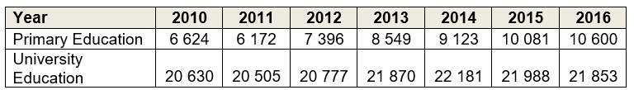

Source: data.gov.sg, accessed August 2018

Table 2: Gini Coefficient (2017)
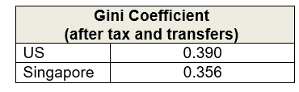
Source: The Straits Times, August 2018

Table 3: GDP per capita (US$)
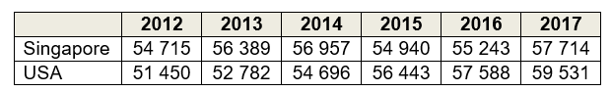
Source: World Bank, accessed August 2018

Figure 1: Government budget balance of Singapore and USA (as % of GDP)

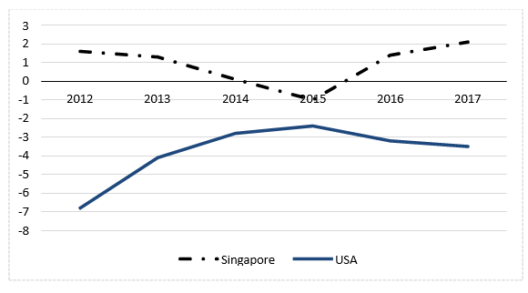
Source: Singapore Budget 2018; Congressional Budget Office, April 2018

Extract 1: Rise in price of university education in Singapore

The price of attending university in Singapore has jumped 38% on average since 2007. Official data showed that Singaporeans are spending more on higher education. Singapore's median household income grew 10% over the period and Consumer Price Index (CPI) rose 25%, yet university tuition fees were up 38%.

Increased labour costs in Singapore could have been a large contributing factor in the big jump in university costs, besides the cost to universities of owning and maintaining buildings, covering utilities and buying research equipment.

Government subsidies play a role in increasing education affordability in Singapore. And Singapore's increases in higher education tuition fees were, in fact, relatively tame when compared to other countries. College tuition in the U.S. increased by 50% between 2001 and 2015. However, rising demands from provisions for the ageing population, healthcare and other social needs in Singapore may threaten the sustainability of the government spending on higher education.

Adapted from: CNBC, October 2016

Extract 2: Returns from pursuing higher education

Unlike primary education, higher education provides individuals with concrete skills and capabilities, which in turn allow them to command a substantial wage premium when they enter the labour market. An increasing number of young Singaporeans are furthering their studies for this reason. There is a desire to learn more specialised skills, or secure a better job and higher pay check. Youths today also have a greater desire for personal fulfilment, which spurs them on to learn more about a subject they are interested in.

Nonetheless, there are compelling reasons to heavily subsidize higher education. There are social returns to higher education. Private returns – such as higher employability and wages – have positive social effects as well, in terms of lowering poverty and crime rates. Numerous productivity benefits also arise from higher education. For instance, economists hypothesise that a city with more human capital would be able to generate more knowledge capital, and the productivity gains from that would then spill over and raise incomes for the whole economy.

Moreover, even if the returns to higher education were completely private, there is a case for government to intervene to ensure that there are equal opportunities. While it is generally feasible for individuals to fund their own tertiary education through loan schemes, the lower- income may face credit constraints because of their lack of collateral. Evidence from abroad also suggests that the lower-income tend to underestimate the returns to education due to lack of information. Hence, a key component of government expenditure on higher education is channelled towards ensuring that higher education remains affordable for the population at large.

Adapted from: Singapore Budget 2010

Extract 3: Budget cuts in higher education in the United States

Almost a decade since the Great Recession hit in 2008-2009, US government spending on public colleges and universities remains well below historic levels. The recession led to record- breaking declines in government revenue, and the slow recovery prolonged its impact.

The funding decline has contributed to higher tuition and reduced quality on campuses as universities have had to balance budgets by reducing faculty and limiting course offerings. At a time when the benefit of a university education has never been greater, policymakers have made going to university less affordable and less accessible to the students most in need. This has jeopardized the ability of many to afford the higher education that is key to their long- term financial success and led to rising student debt levels for those who still pursue higher education. High school students who cannot afford the rising fees in universities are opting to start work earlier instead.

To help more young people reach their full potential — and, in turn, boost the economy and quality of life — it is necessary for policymakers to target financial aid at students on the margins and those most hampered by limited resources. This can be in the form of need- based financial aid which is awarded to students who have demonstrated financial need and might otherwise struggle to afford college.

Adapted from: www.cbpp.org, August 2017

Questions

(a)(i) With reference to Table 1, compare the government expenditure per student on primary and university education in Singapore between 2010 and 2016. [2]

(ii) Explain one possible reason for the difference observed in (a)(i). [2]

(b) With reference to Extract 2, explain how investment in human capital can ‘raise incomes for the whole economy’. [4] (don’t do)

(c) Use the concept of opportunity cost to explain one possible effect on each of consumers of education and the US government due to the ‘rising student debt levels’ described in Extract 3. [4]

(d) Assess whether supply factors, rather than demand factors, are the key cause of rising price of university education in Singapore. [8]

(e) Discuss whether Singapore should follow the US in lowering its higher education subsidies to better achieve the government’s microeconomic objectives. [10]

[Total: 30]

