Suggested answers for CSQ1
(a) Identify two differences in the change in price of healthcare with that of all items in Singapore from 2011 to 2016 (2m)
- Overall the price of healthcare (12.5%) experience a higher increase of 1.8 times then all items (6.9%) in Singapore
- In 2016, the price of healthcare increase, but the price of all items in Singapore fell.
[2]
(b) Summarise the data shown in Table 2 on the number of different types of nursing homes in Singapore from 2012 to 2016.
Overall trend: the number of public nursing homes increased, whilst the number of private and non-for-profit nursing homes has fallen.

Refinement: The number of the private nursing home remains the highest each year. OR The number of public nursing home remain the lowest each year.
[2]
(c) Explain why the “healthcare expenditure is expected to triple by 2030” (extract 1) and comment on the effects.
Explain (5m)
- Increase in Demand higher life expectancy/Ageing population + chronic diseases increase in DD by a great extent over a sustained period of time (due to the chronic nature and higher lifespan to demand for healthcare) Increase in TE ( PxQ)
- Fall in Supply shortages of labour in the healthcare industry upward pressure in wages increase unit COP of supplying healthcare healthcare is a necessity and broadly defined hence PED < 1. Increase in price of healthcare leads to a less than proportionate fall in qty Dd gain in TE resulting from a rise in price outweigh the fall in Qty dd due to a fall in TE Overall TE increases.
- Hence, both the increase in DD and fall in SS in healthcare reinforce the increase in TE leading to a very large extent into the future.

Comment: Up to 3 further marks for valid and relevant comment on the effects:
- Challenge the claim “expected to triple” comment on the extent of increase.
(Point) In the future, changes in production techniques in the healthcare industry (e.g. The option of AI) may (Economic linkages) increase the productivity hence lower the unit COP. Hence this mitigates the increase in TE. Given the (Evidence) trend that other countries such as Japan are adopting AI, Singapore may follow the model of Japan given the similar demography and hence this is likely to happen to large extent. (Link back to question) Thus, the increase in TE may be to a smaller extent than ‘triple’ effect.

- The increase in expenditure may happen in a shorter time frame then suggested by the extract (i.e. earlier than 2030). This may happen if the demand for healthcare increases faster than expected. In challenging the ceteris paribus assumption, apart from demography changes of ageing population, compounded by chronic diseases occurrence there could be evolving health issues in the younger working adult segments of the population due to mental health problems or work-stress related health issues in the Singapore population. Hence demand will increase by a larger extent, within a shorter time period.

- The effect of healthcare expenditure increase in the future could mean that from the perspective of consumers and government, higher opportunity costs is incurred.

Higher healthcare expenditure borne by the consumer imply that there is a trade off in expenditure on other consumer goods, assuming the incomes of households remain unchanged. On the other hand, higher healthcare expenditure may imply that the government will need to increase gov expenditure to provide higher subsidies to lower income households and hence incur an opportunity costs in expenditure on other developmental areas such as education This also assumes that the government revenue remains unchanged.

The extent of opportunity costs incurred maybe higher for households because relative to the government, their incomes are likely to be remain unchanged for a longer period of time. Whereas the government can easily garner more resources through policy changes leading to higher tax revenues.
[8]

(d)With the aid of a demand and supply diagram, explain a possible reason why Japan is experiencing a “persistent shortage” (Extract 2) in the labour market for healthcare.
- Explain a possible demand increase or supply fall of labour.
- Define shortage: Qty DD > Qty SS @ W1 wage level, shown on the diagram.
- An accurate labelling and use of a labour dd-ss diagram.

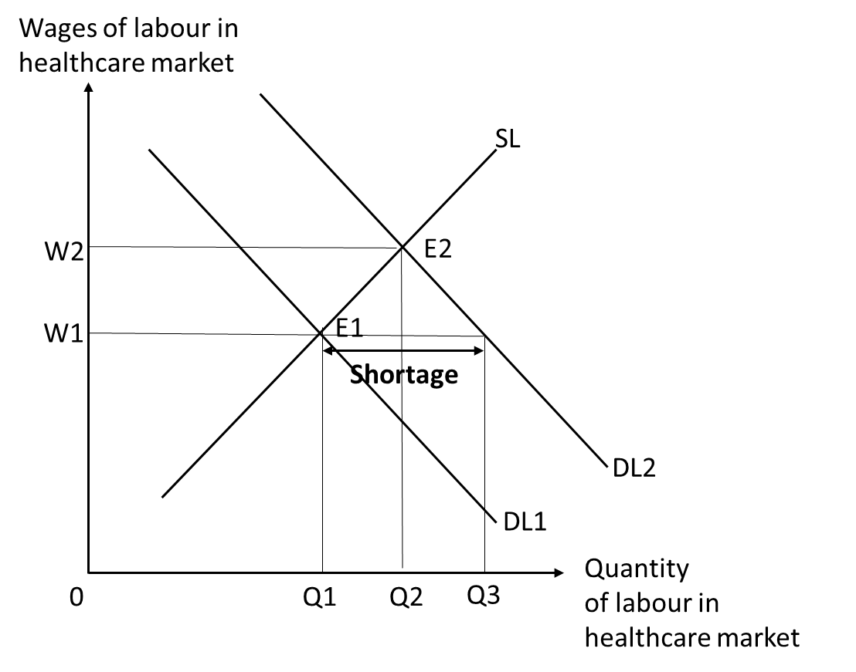
Evaluation
- Address “persistent”
- Short term rigidity, wages unable to adjust upward due to contract agreements.
- Time lags for wages to price to clear the labour market.
- Before a new equilibrium is reached, DD increases again/ SS falls again leading to a shortage again.
[4]

(e) With reference to Extract 2, explain the impact of an increase in competitiveness of Japan-made AI-enabled medical devices on two components of Japan’s aggregate demand.

- Define competitiveness - price competitiveness, non-price competitiveness
- Define AD: C + I + G + X-M
- With reference to Extract 2 there is government investment in the development of AI the investment can be in the form of a subsidy to the research & development An increase quality and applicability of AI in the healthcare sector increase in non-price competitiveness Increase in DD for Japan medical devices by foreigners with reason/linkages X revenue increases

- A government investment can also mean a direct subsidy to the production of AI enabled medical devices lower unit COP of AI enabled devises An increase in price-competitiveness healthcare sector switch from imported medical devices to purchase cheaper domestically produced medical devices Cd
[4]

(f)With reference to data, assess the factors that a government would have considered in deciding whether to invest in AI in the healthcare sector.

- Constraints: For a government to invest in AI to apply to the healthcare sector, it will involve expenditure on R&D and development of capital goods e.g. Robotics related to healthcare sector However, the constraints that the government faces will influence this decision. For e.g. a government with a budget deficit may not have the funding to do so, but the government with a budget surplus ( Singapore in Table 1) will have the capabilities.

- Benefits: The government will need to have information about the benefits and be able to monetize it. The benefits of developing AI in the healthcare sector involve “Automate routine” (Extract 3). This will increase productivity of healthcare services in turn deepening the quality and quantity of healthcare services produced thus raising the material and non-material SOL of citizens. Other forms of benefit can include early detection of diseases, enabling patients to seek medical earlier that can potentially be cheaper. Thus, the overall costs of medical fees to the household will be reduced.

- Costs (explicit and opportunity costs): It is very costly to research in R&D of AI in healthcare, thus the same value of expenditure in AI cannot be deployed in other sectors e.g. education, thus incurring an opportunity cost. Such trade-offs can be high for emerging economies where the development of healthcare, education and other social sectors still require more expenditure.

- Unintended consequence: An unintended consequence is structural unN, the application of AI can cause technological unN in the short term due to the lack of skills to manage robotics.
- Criteria: Time. The long-term prospects of healthcare industry see a fast-growing demand and a situation of shortages of manpower. Assuming a government is not constraint by the budget, the benefits factor is the most important to consider as a permanent long-term solution to alleviate the manpower shortages and also improve the quality of healthcare. No doubt, AI will be very costly, without it, solving recurring issues (higher wages of labor due to shortages) in the healthcare market over time, may incur as much or more costs.

- Finally, unintended consequence though negative, can also be offset by unintended beneficial consequences. For e.g. the adoption of AI can lead to technological transfer of knowledge to workers, thus raising their skills on the job. For government such as Japan that can also export the capital goods, AD and ADL can increase to encourage further employment in the country.
[7]

(g) (i) Explain how information failure has caused an inefficient allocation of resources in the healthcare market.

Define information failure in the healthcare market:
- under-estimation of the private benefits in consumption of healthcare
- For example, consumption of healthcare services such as regular health screening or primary healthcare improves the health status of a person over the long term and the good health enjoyed later on age enables the individual to be more productive in their work and raises their salaries over their working lives.
- However, the increases in income as well as healthcare costs savings are in the future, uncertain and difficult to estimate accurately. This lack of information leads people to underestimate the private benefits healthcare and leads to an under-demand and under-consumption of education as seen in Figure 1 where MPB1 (info failure) <MPB2 (perfect information), and it is assumed that there is no externality in consumption of healthcare since only information failure is relevant in this question.

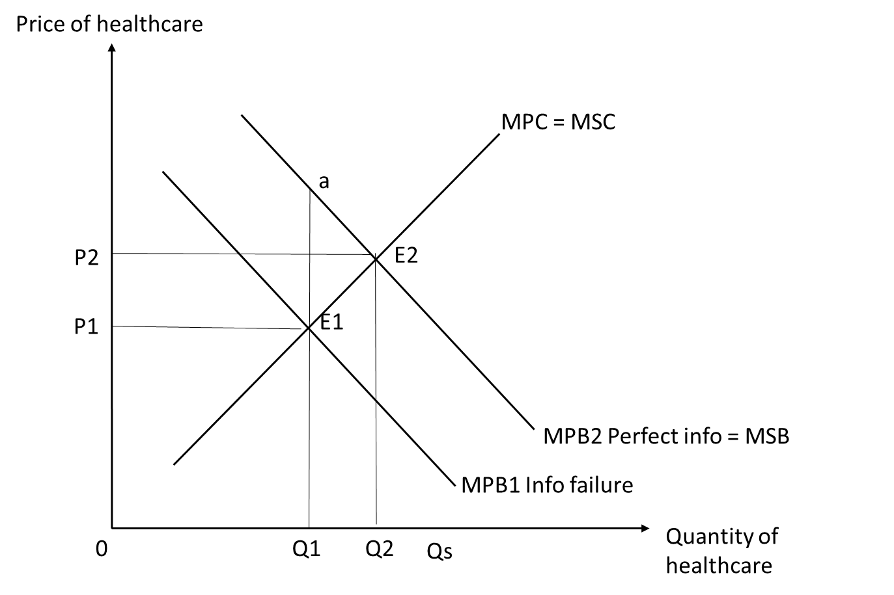

- The market equilibrium is at E1 where MPB1=MPC as producers and consumers maximize their self-interest and suffer from information failure. The market output will be at 0Q1 and market price at OP1.
- Society's welfare is maximized at MSB = MSC where there is perfect information. The socially optimal level of output is at 0Q2 and the socially optimal level of price is at 0P2 and this is where society’s welfare is maximized. The society’s welfare is maximized as producing one more or one less unit will reduce society’s welfare.
- There is, thus an underproduction and underconsumption of Q1Q2 units of the good which means that there is an underallocation of resources into the market for education.
- Total social cost from consuming Q1Q2 units of the good (Q1E1E2Q2) is less than the total social benefit from consuming Q1Q2 units (Q1aE2Q2), leading a welfare loss of area E1E31. This is also known as a deadweight loss
- Hence there is allocative inefficiency in the market where the right amount of the good is not produced and there is market failure. [6]

(ii) Extract 4 mentions that the Singapore’s healthcare system emphasises on a shared responsibility between the government and people.
Using evidence from the case study and/or your own knowledge, discuss the extent to which shared responsibility is the best approach to address inefficiency and inequity in Singapore’s healthcare market.

Introduction:
State aim of government: All governments, including the Singapore government, aims to maximise societal welfare, and in the aspect of healthcare market, it aims to achieve efficiency in resource allocation and equity in distribution.

Link to the Extract (4) and address the question: As mentioned in Extract 4, one unique feature of the Singapore’s healthcare system is its emphasis on a shared responsibility between the government and people. Such a shared responsibility is anchored by a co-payment system where individuals can use their Medisave account to offset the costs of various treatments, and is partially subsidised by the government. In addition, the Medisave account is a compulsory national savings scheme, indicating that it is also a form of legislation. However, there are possible drawbacks in this policy, which are discussed below.

Body/ Development:
Thesis: Shared responsibility is the best approach for the healthcare market in SG
Explain Step (1) What the policy is about + Step (2) How well the policy works + Step (3) How well the policy works (Benefits)
Firstly, the shared responsibility feature is a combination of legislation and subsidies.
The shared responsibility is akin to “a co-payment system” (Extract 4), meaning that patients (e.g. consumers) can “use their Medisave account to offset the costs of various treatments, with a portion being covered by government subsidy and in cash by the patient”. Since the government also partially subsidises for the patients’ healthcare expenses, this would mean that when the government grants a subsidy of E3F equivalent to divergence between D1 and D3 at output, 0Q3. This reduces the unit cost of supplying healthcare. With the decrease in unit cost of production, there is now more potential profit for each unit of output the industry produces. The producers are incentivized to increase the quantity supplied at every price thus shifting the supply curve from S to S₂ as shown below. The market output thus increases from 0Q₁ to the socially optimum output of education, 0Q₃, correcting the under-allocation of resources. The market price falls from 0P1 to 0P2. The socially ideal price of OP3 is not attained.

Quantity of healthcare
Pros of shared responsibility:
- More importantly, since this is a shared responsibility between government and its people, the Singapore government minimises the risk of over-subsidy in this case, which in turn may reduce the extent of government failure due to imperfect information. It also reduces the excessive worsening of government budget, and in turn, the government is then able to allocate its budget to other equally or more important sectors (e.g. education), depending on its priorities. Hence, the opportunity cost incurred here as opposed to a full subsidy is a lower.
- In addition, such as shared responsibility approach raises the incentive for consumers (patients) to take care of their health, as they still have to pay a portion via their Medisave account. This will reduce the risk of the unintended consequence of overconsumption of healthcare services as opposed to a full-fledged subsidy.
- Being a market-based solution, subsidy can be easily implemented to bring about socially ideal level of resource allocation without excessive government monitoring as compared to other measures. It has greater flexibility and fairness as the amount of subsidy can be varied to reflect the extent of information failure and external benefit that arise in the healthcare market. In addition, it gives the patient an incentive to undertake more healthcare (e.g. raise in demand) since it reduces additional private costs of healthcare at any given level of output.
- Answer the question / Link back to the question: Overall, this suggests that shared responsibility may be the best approach for the healthcare market in Singapore.
Antithesis (1): Shared responsibility is not the best approach for the healthcare market in SG
Explain Step (3) How well the policy works (Costs)
- However, Extract (4) also mentions that “in recent weeks, the affordability of healthcare services…had come under spotlight”. This suggests a possible under-subsidy by the government, thereby unable to achieve a socially optimal level of output in the healthcare industry. As such, government failure ensues. This is further supported by Extract 1, which states that “healthcare expenditure is expected to triple by 2010, reducing the affordability of healthcare and hence a higher subsidy may be required to eliminate the welfare loss. (students can choose to illustrate the possible government failure on a diagram)
- Answer the question / Link back to the question: Overall, this suggests that shared responsibility may not be the best approach for the healthcare market in Singapore.
Antithesis (2): Shared responsibility is not the best approach for the healthcare market in SG
Explain other policies pertaining to context and/or with own contextual knowledge

E.g. Government provision (direct provision):
Since shared responsibility via co-payment system has its limitations, it may not be the best approach for the healthcare market in Singapore. Thus, the Singapore government can consider using direct provision instead.
Government can provide healthcare services directly to consumers (in this case this is the firms) free of charge e.g. fully subsidizing the cost of healthcare.

For example, the Singapore government could perceive the extent of market failure in the healthcare market to be extremely large and chooses to provide free healthcare services to its citizens. Referring to the diagram below, assume that the extent of positive externality and information failure generated is extremely large at EQs. Without government intervention, the market equilibrium is at DD = SS (MPB1 = MPC1) where there exists a severe under-consumption of QmQs. Free government provision of healthcare results in the marginal private cost incurred to be at 0 (MPC2) and the supply curve to be perfectly price elastic (S2). With free provision of healthcare (P=0), the new market equilibrium is now at D1 = S2 (MPB1 = MPC2) and consumption is at the socially optimum level of Qs.

There is effectively a 100% subsidy by the government. Deadweight loss of CED is eliminated and the right amount of the healthcare services is being produced thereby achieving allocative efficiency. In this instance, providing healthcare free leads to an efficient and equitable allocation of an economy’s resources.

Quantity of healthcare
Pros of direct provision:
- Direct provision by the government ensures efficiency in the market by solving the shortfall directly. Moreover, state provision allows the government greater control over the quality and quantity of the healthcare services to be provided. This makes it easier to intervene in the healthcare market to achieve their goals.
- High initial investment is needed to set up hospitals and healthcare facilities and to ensure that it is provided at the right amount. If the provision of healthcare is left entirely to the private sector, there would be insufficient investment and the market failure will still persist. Direct provision by government would ensure an optimal provision of healthcare is consumed and coordinated in the public interest.
- State provision of healthcare ensures that the poor are not left out and there is equality of opportunity. There are some things that should be provided not according to the ability to pay but according to need. It should be provided as a right. Given the inequality in income, people have unequal access to healthcare services and lower income groups might not be able to afford. If healthcare services are left to market forces, they will only be accessible to the higher income groups. The income inequality would persist and worsen over time, eroding social cohesion.
Cons of direct provision:
- However, direct provision requires spending by the government which may worsen the government’s budget position. In addition, financing such expenditure by tax revenue may result in unintended consequences such as the disincentive effects on investment and work, hampering economic growth in the long term. Raising direct taxes decreases household’s incentives to work and firm’s incentives to invest. Higher personal income tax decreases disposable income (income after minus taxation and addition of transfer payments). This increases the opportunity cost of working (or lowers the opportunity cost of enjoying leisure). Hence workers may have less incentive to work longer hours, work more efficiently. Or it might entice people that were previously employed to give up work. At every price individuals are less willing to work and each market produces less output. If enough individual supply curves shifted, the total amount the economy can produce decreases.
- There is the risk of government failure. Governments face the constraint of being unable to gather enough information to determine the right amount to provide in the market. Public ownership may also create more problems if it is plagued by bureaucracies.

E.g. Legislation:
In addition, the government can also consider legislation. Legislations are rules and regulations for compliances. For instance, the government has made certain vaccinations such as those administered to a child before 1 year of age (e.g. for Diphtheria & measles) compulsory.
Punitive measures will be established. There will be monitoring and checking to ensure that consumers adhere to the compulsory vaccinations in the market for healthcare. Otherwise, such lawbreakers will be punished e.g. they may have to pay a fine. Such measures when put in place ensure compliance; and law breakers will be taken to task. The fear of being punished upon violation of the laws prevent the stealing of intellectual property and increases the incentives to consume more healthcare towards socially optimal, thereby correcting the market failure.

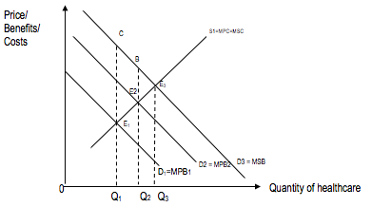
The benefits of these legislations raise the industry’s demand of healthcare as individuals compliant with the laws to avoid punitive measures. This is shown by a rightward shift of demand curve for healthcare from D1 to D2 (or MPB2) as shown in the diagram above. There is now more incentive to pursue healthcare. At every price level, the quantity of healthcare demanded increases. This results in the industry undertaking education at MPC =MPB2 an increase of Q1 to Q2. The industry is now nearer to the socially optimum level of healthcare, OQ3, and there is underproduction of fewer units (Q2Q3) of healthcare services thus reducing the deadweight loss from E1E3C to E2E3B. Market failure as a result has been reduced. If government intervention is very successful and the policy is very effective, the industry will be able to internalize the full external benefits and MPB increase to MSB leading to the market failure fully corrected.

Pros of legislation:
- Legislation is considered to be a powerful tool as it is mandatory. While market-based solutions may be a more sophisticated means of reaching a socially efficient output, command-and-control methods are usually more straightforward to devise, easier to understand and easier to implement. It is used when it is not possible or effective to rely on changing market signals. E.g. when the extent of the market failure is extensive or plagued with high degree of uncertainty, it is only realistic to use regulations.
Cons of legislation:
- However, laws require costly monitoring and enforcement. For this measure to be effective, the government needs regular checks to ensure adherence. This requires large amount of manpower to monitor and enforce, which involves high opportunity cost. The penalties for violations also need to be severe enough for the measure to be a deterrent.
- In addition, legislations are also considered to be a blunt instrument compared to market-based solutions as it is not sensitive and cannot be customised to the needs and circumstances of the individual patients (e.g. consumers) and can only be changed through legislation which may be burdened by bureaucracies.
E.g. Education & campaigns:
Moreover, as mentioned in gi, information failure / imperfect information as a source of market failure also exists in the market for healthcare. Thus, another policy to solve this source of market failure would be education & campaigns.
The Singapore government can conduct many healthcare awareness campaigns (e.g. diabetes campaigns etc). By doing so, the government can educate the public through mass media and carry out campaigns to teach the citizens the importance of consuming healthcare. Private benefits will be appropriately valued and demand for the good will increase, increasing production and consumption of merit goods towards socially optimal level. Referring to the diagram above, if such provision of healthcare successful in addressing the information failure and thus increasing demand from D1 to D2, raising production and consumption from Q1 to Q2, the inefficiency would be reduced. The deadweight loss has decreased from E1E3C to E2E3B.
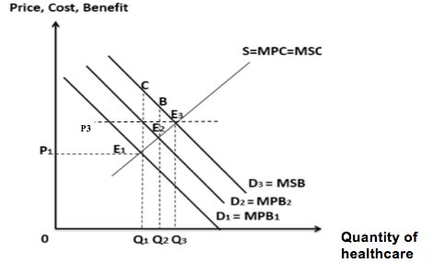
Pros of education & campaigns:
- Public education may also appeal to people’s social responsibility to care for others. Once citizens are convinced, demand for the good will rise further increasing the consumption of the good closer to the socially optimal amount. Public education is particularly useful in addressing one of the 2 problems of merit goods such as healthcare - information failure.

Cons of education & campaigns:
- Public education is a long-term and costly process to undertake with uncertain outcomes. The success of this measure depends on the receptivity of the target audience which is highly unpredictable. In addition, financing public education requires government spending which may be financed by high taxes, creating disincentive effects on work and investment. There will be adverse effects on economic growth.

Synthesis & Evaluative Conclusion:
Overall, whether shared responsibility is the best approach to the healthcare market in Singapore depends on:
- State / size of government budget if budget constraint is a concern, then shared responsibility could be considered as the best approach as it is only a form of partial subsidy as opposed to a full-fledged subsidy that may worsen the government budget by a larger extent. For the Singapore government, the budget may not be a constraint as it is experiencing mainly a surplus (Table 1), though high opportunity costs may still be incurred.
- Government’s objective if the government’s purpose is to prioritise equity over efficiency, then perhaps the shared responsibility approach is not the best approach as it is only a partial subsidy as opposed to a full fledged subsidy approach. However, the shared responsibility approach may be considered relatively more efficient than other policies such as MediFund and full subsidy as it reduces the risk of overconsumption of healthcare.
- Extent of information that government possesses may lead to over/ under subsidisation of healthcare this is minimised by the shared responsibility approach may then be considered as the best policy
- Root cause if healthcare is seen as a merit good, then the root cause would be imperfect information education & campaigns would be the best approach in solving the information failure. However, in the context of SG, the main source of market failure in the healthcare market could be inequity instead, and hence perhaps subsidy/ shared approach etc may be a better approach.
Or any other possible synthesis points, as long as they are relevant and appropriate in the context of the question.
Overall conclusion: Since there are pros and cons in each policy suggested, this implies that there is no best approach to the healthcare market. Perhaps, it would be wise for a rational government to implement a plethora of complementary policies instead of relying on 1 as the best approach. This is supported by Extract 4, which states that “having the right policies that nimbly address the different motivations and needs of various income groups is vital”. Also, Extract 4 proposes making refinements /tweaks to the current existing policies, such as revising Medisave withdrawal limits via means-testing approach (e.g. “meets the needs of those who need it most”.) This can perhaps better target the equity issue (e.g. “empowering self-reliance with targeted support”), and hence solve the sources of market failure in a more concerted manner.

