Suggested answers for CSQ 1 - Macro
(a) (i) With reference to Figure 1, state what happened to the average exchange rate of the Singapore dollars between 2015 and 2018. [1]
Depreciated [1]

(ii) With the aid of a demand and supply diagram, explain one possible reason for the change observed in a(i). [3]
- Positive GDP growth (Table 3) increasing national income increase purchasing power increase demand for imported goods increase supply of SGD in exchange for foreign currency to buy imported goods [1], assume ceteris paribus surplus of SGD in foreign exchange market [1] depreciation of SGD
- Diagram [1]: rightward shift of SS of SGD

OR

- Increase in GPL of SG gds & svs (positive inflation rates in 2017-2018 in Table 3) Px ↑ m.t.p ↓ Qdx, assuming demand for SG exports is price elastic X ↓ foreigners’ spending on SG exports fall decrease in demand for SGD [1], assume ceteris paribus surplus of SGD in foreign exchange market [1] deprecation of SGD
- Diagram [1]: leftward shift of DD of SGD

Note: Can accept any other plausible reason.

(b) To what extent can it be concluded from Table 3 that the standard of living in Eurozone in 2018 is better than in 2015? [7]
Define SOL
- SOL is classified into material and non-material well-being where material well-being is the amount of goods and services enjoyed by the individuals in the economy while non-material well-being involved how quality of life is affected.

Thesis: Explain how data suggest how the living standards of Eurozone has improved.

SOL in Eurozone has improved. From Table 3, growth rates is increasing at a decreasing rate for some of the periods but growth rates are positive for majority of the periods. This suggest that GDP is still increasing over the years just that the extent of the increase is smaller in certain years such as 2016 and 2018 but not sufficient for us to see slow growth is happening. The positive growth rates suggest that rate of increase in amount of goods and services increases and material well-being of citizens rises. More jobs are created and there is also increase in wage growth. The economy is also less susceptible to negative shocks. This is further supported by Extract 5 where growth is said to rise fastest. This suggest that business confidence has improved, which higher investment rate, which supports material SOL is higher.
Also, the GINI coefficient that is close to zero and smaller over the years suggest that income distribution is relatively equal and hence a rise in real GDP per capita could mean that SOL for the majority should increase not only the minority rich.
Moreover, there is a fall in unemployment increase in jobs and income able to buy more goods and services thus improving material SOL. Also, lower unemployment less social problems, less stress from being unemployed improve non-material SOL. The lower unemployment rate also lower government spending which is supported by the decrease in budget deficit (% of GDP). Furthermore, inflation rate has increased but it still fall under the healthy range of below 3%. This reflects price stability which increases investors’ and consumers’ confidence and increase real income which increase material well-being.
Anti-Thesis: Explain living standards of Eurozone may not have improved because there are data that prove otherwise and insufficient data to ascertain.

Also, the unemployment rate is high at above 5% rate for both periods. Although unemployment rate has improved, the level is still in an unhealthy range which reflect that there are spare resources in the economy and a wastage of resources. Hence, standard of living may not increase.

Moreover, there are insufficient data to ascertain that SOL has improved.
- Real GDP figures are not presented
A rise in nominal GDP per capita may overstate the change in SOL as it may be due to an increase in GPL and not actual production. High Inflation as reflected by rising general price levels higher general price level of goods and services consumers having lower real purchasing power lowering their ability to purchase goods and services lower quantities of goods and services consumed lower material SOL.

- Not sufficient to assess non-material SOL
SOL is made up of both material and non-material wellbeing. There is a need to include more indicators such as PSI, literacy rate, life expectancy, etc. to take into pollution levels or stress levels which are better able to assess Eurozone’s non-material SOL. For instance, high growth rate through rapid industrialisation and long working hours can increase pollution and stress which worsen health of individuals. This reduce quality of life.

(Choose one)
Conclusion: Address question intent on SOL.
There are missing data on indicators such as CO2 emission, stress levels and life expectancy to have accurate assessment on the quality of life of Europeans over the years. Moreover, the GDP growth rates indicates the material well- being of the country. It does not show tell us whether individuals are better off because it does not inform us about the income distribution.
Even so, the majority of the data suggest that the SOL of Eurozone has improve. For instance, Gini coefficient showed a downward trend and other than unemployment rate, all other indicators are in the ideal range. To have a more accurate measurement of the data, there needs to be a composite indicator such as the Human Development Index to better inform us. The HDI measures the real GNP per capita, life expectancy and educational attainment.
A higher real GNP/capita, longer life expectancy and higher education attainment would be reflected by a higher HDI. A higher GNP/capita reflects higher material well-being. Longer life expectancy indicates the ability of the people in the country to lead a long and healthy life while a higher education attainment indicates the ability of the people to acquire knowledge and hence, get better job opportunities and obtain higher job satisfaction. This ensure better quality of life.

(c) With reference to Extract 5 and using AD/AS analysis, explain and comment on how “higher energy prices and a stronger euro may be headwinds to growth this year”. [8]
Interpret ‘headwinds to growth’
Headwinds to growth meant that there is slow growth or decrease in growth in the economy.
Explain how higher energy prices and stronger euro will reduce growth.
From extract 5, the stronger euro will increase external value of euro which cause price of exports in foreign currency to increase and price of imports to fall. This reduces export demand and increases quantity demanded of imports. Assuming Marshall Lerner condition holds where (PEDx+PEDm)>1, there will be a fall in net exports and hence AD falls. Since (X-M) is a component of aggregate demand, AD falls. The fall in AD will increase inventories and reduce production of goods and services. This reduces employment of factors of production. Real output falls. This threatens growth in Euro.
Furthermore, the higher energy prices suggest that unit cost of production is higher. Firms driven by profit-motive respond by increasing the prices of their goods and decreasing their output level. This is represented by a reduction of SRAS. This increases general price level and reduces real output which worsens the growth in Euro.
Comment how higher energy prices and stronger euro may not reduce growth.
The extent of fall in AD due to stronger euro is dependent on the size of external demand. If external demand is small, there will be an insignificant fall in AD and hence growth rate. With stronger euro, prices of imported goods fall. This is likely to be the case since the domestic demand is large and the Eurozone will provide sufficient demand for goods and services.
If EU countries is reliant on imported raw materials, this will reduce unit cost of production and increase SRAS. This reduces imported inflation and increases real output. Furthermore, if there is discovery of alternative energy sources, the higher energy prices will not persists in the long term and this will not cause a fall in real output. Hence, growth may not reduce significantly.
Overall judgment: Overall, the positive business and consumer sentiments due to the domestic factors should cause an overall increase in growth. The extent of increase in AD due to stronger global growth and quantitative easing programme in Extract 5 is huge. Moreover, the indicators in Table 3 has generally showed an improvement in SOL over the years as elaborated in part (b). While stronger euro and higher energy prices will decrease growth, the overall impact on growth will still be positive.

(d) With reference to Extract 8, identify and explain the main types of unemployment in Singapore. [6]
- Demand-deficient unemployment [1]
- is due to a fall in the aggregate demand for labour caused by an economic recession, and wages being sticky downward.
- Extract 8: … slowing economy… lacklustre sentiment has stunted job creation and prompted a wave of layoffs
- Poor economic outlook fall in C and I AD falls [1] firms are unable to sell their current level output cut back on production reducing the amount of labour they employ fall in AD_{L} + wages are sticky downwards [1] real wage remains constant and creates surplus of labour [1]
Note: Students can explain with the aid of diagram.

- Structural unemployment [1]
- is caused by the changing pattern of demand or supply in the economy.
- Extract 8: … skills mismatches in the labour market are on the rise due to the unrelenting technological change that leave old skills outmoded… moving towards higher value-added, niche sectors… require specialised skills that most retrenched PMETs do not have and it may take a while to acquire…
- SG moving towards higher value-added, niche sectors that require specialised skills in medical technology and data analytics retrenched workers from ‘sunset’ industries like manufacturing sector do not have the require specialised skills unable to gain employment in the ‘sunrise’ industry remain unemployed [1]

(e) Explain the impact of higher unemployment on employees, the government and an economy. [8]
The unemployment rate is three times higher in Eurozone as compared to Singapore. The unemployment rate remains around the healthy range of around 3-5% in Singapore while there is a decline for Eurozone. It is important to keep unemployment rate within the healthy range because it affects different agent of an economy, which is the individuals, firms and economy. We will look at the negative and positive impacts of unemployment on different agents of an economy.
Devt (1) Negative impacts of higher unemployment
- On the economy
1. Loss of output
Most significant disadvantage is the opportunity cost involved:
Unemployed people lower output
Under-utilisation of resources
Loss in potential output
operating inside PPC
GDP is lower than it should be because of the idle resources in the economy.
2. Decline in investment and implication on potential growth
With the rising youth unemployment due to mismatch of skill sets in Eurozone and structural unemployment due to technology advancement in Singapore increase idle labour resource as young graduates and less educated young workers are not taking on the available factories jobs loss of output as these idle labour can be utilised to achieve higher output, hence resulting to a lower than expected actual economic growth. In addition, workers are skill set and knowledge become obsolete and de-motivate workers to work in LR fall in productivity level and efficiency production capacity fall LRAS to fall reduce potential growth.
Government’s macro-aim of high and sustainable economic growth
is not achieved worsens economic health of a country
Slowdown in actual (GDP) growth
Households earn lower income
less purchasing power
able to consume fewer goods and services
Lower material standard of livingresu
3. Undermine consumer and investor confidence
Job insecurity increases with higher unemployment which result to lower consumer confidence and hence fall in C. With consumer who are unwilling to spend, firms will face falling demand and profits. Firms will reduce expected return from investment and I will fall. With both C&I falls, this will cause a greater fall in AD and hence negative growth and unemployment.
- On the government
- Impact on government budget
Larger government resources required to restructure the economy to solve unemployment problem hence worsen budget position
Budget deficit in recent years:
1. expenditure on training subsidies, unemployment-related benefits, health and to combat increased crime rate;
2. personal income & corporate taxes.
More difficult for govt to pursue other development projects due to lower revenue from direct and indirect taxes. As the unemployed does not pay income tax and pay less goods and services tax, government’s tax revenue will fall.
As shown in Table 3, budget position of Eurozone improve as unemployment falls over the period.
- Distribution of income becomes more uneven.
The group that are most badly affected are the older & less skilled workers retrenched mainly from the low value-added manufacturing industry loss of income lowers material aspect of SOL. Government is thus faced with worsening market failure due to increasing inequity.

- On employees
Those who are employed more productive
1. Unemployed loss of income lower purchasing power lower material well-being
2. Loss of status + stress of being unemployed lower non-material well-being
This is supported by Extract 8 where increase in individuals taking on psychological services due to job changes. The severity of unemployment will depend on the duration of unemployment. This is because workers will be more discouraged if they cannot find jobs for extended period of time. Deskilling will happen where skills that they possessed will be obsolete and they will no longer be actively looking for job and drop out of the labour force as supported by Extract 6. This is likely to be a serious problem for Eurozone where youth unemployment is on its high.
3. Distribution of income becomes more uneven
The group that are most badly affected are the older & less skilled workers retrenched mainly from the low value-added manufacturing industry loss of income lowers material aspect of SOL as supported by Extract 8. Government is thus faced with worsening market failure due to increasing inequity

Ranking the consequences of a higher rate of unemployment [Not required in this question but is required as evaluative point if the question is higher order thinking question with the command words like “discuss”]
Wastage of resources is the most significant consequence due to its pervasiveness – it affects many economic agents. With a higher rate of unemployment, more resources are wasted as the economy experiences negative economic growth. There is a need for government intervention if unemployment rate is high and increasing and is especially worrying if it is due to structural unemployment where it is a long term unemployment as the impact persist in the long term.
(f) Discuss the extent to which a government from the Eurozone should adopt the policies implemented by the Singapore government to achieve both economic growth and low rate of unemployment. [12]

Problems encountered by the Eurozone e.g. Greece and Spain:
- sustained EG but expected to slow down due to “higher energy prices and a stronger euro” (Extract 5)
- high rate of unemployment (structural unemployment), especially youth unemployment

Policies implemented by the SG govt (Extract 9):
- SS-side policy (interventionist) retraining: “provide a skilled workforce that continues to take up training”
- DD-mgmt policy (fiscal policy) “higher government spending on research and technology”
- Trade policy FTA: “integrated and global digital economy by co-developing international trade rules …” [Free Trade Agreements help to promote sales of exports in foreign countries hence X ↑ AD ↑ … (adjustment process) real o/p ↑ actual growth + ↓ demand-deficient unemployment]

Explain how any 2 adopted policies work + strength(s) & limitation(s) (contextualised to the Eurozone) must link to both EG (AG + PG) and/or unN+

- SS-side policy (interventionist) retraining: “provide a skilled workforce that continues to take up training”
What is it:
  - Govt can provide subsidies for education and training. Education and training aim at increasing labour mobility and labour productivity.
How it works:
  - With retraining, labour productivity increases, allowing workers to be more employable. Equipped with more relevant skills, this will help to reduce the mismatch of skills and thus, improve labour mobility across industries.
How well it works:
Strength
  - able to deal with their structural unemployment + youth unemployment as it equips the youth with more skills to join the industries as the main cause of the high youth unemployment is due to lack of skills (Extract 5)
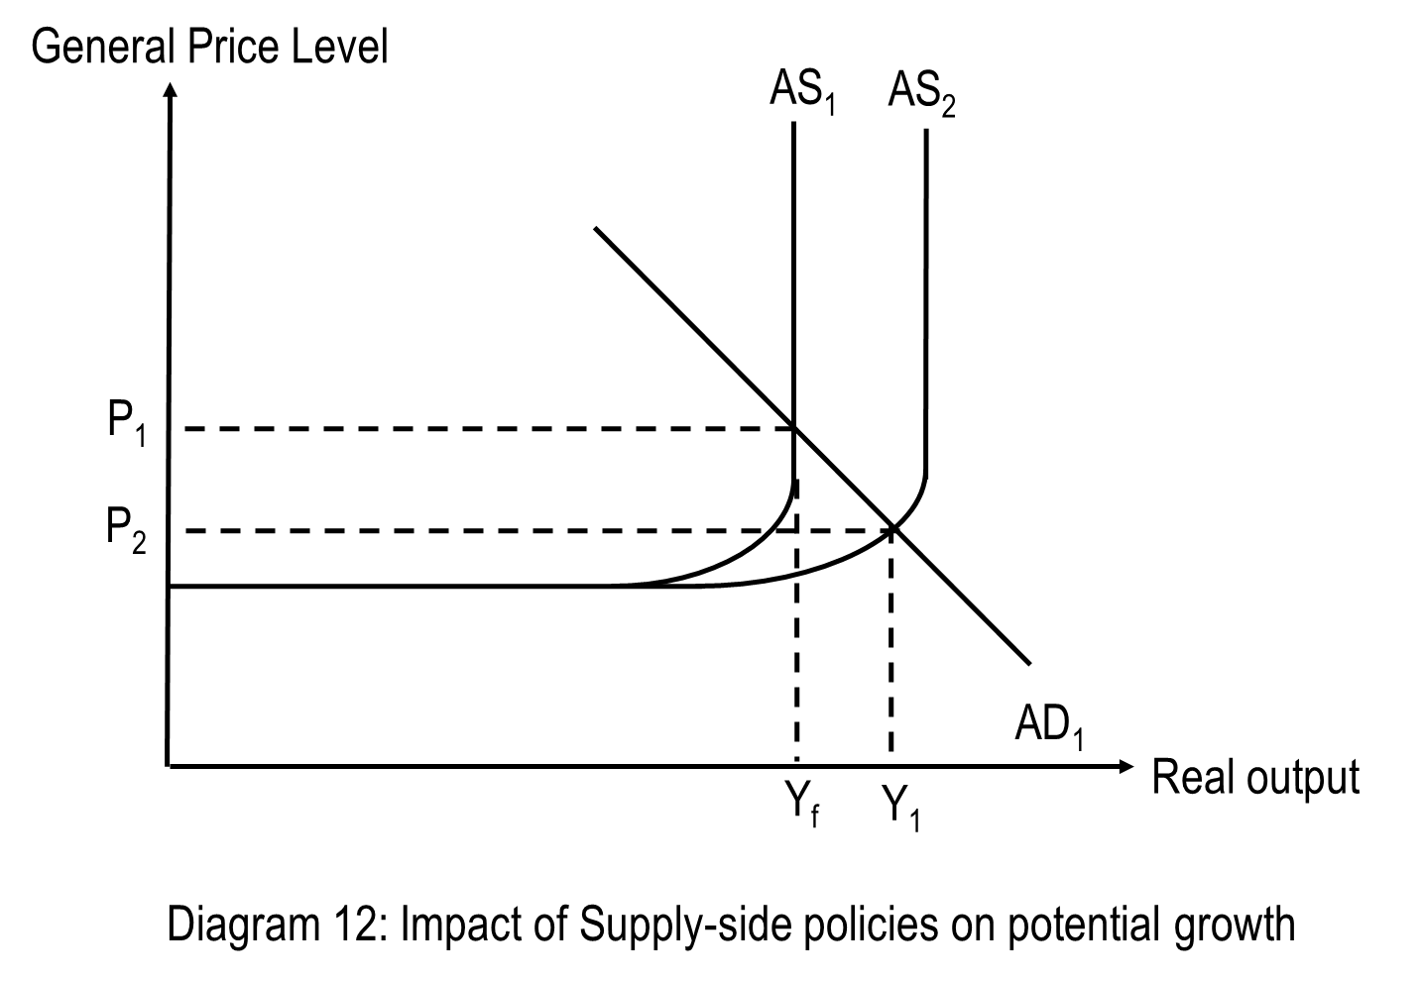

Training increases the skills of labour, leading to increases in labour productivity. Workers will be able to produce more output per man hour. This increases individual market supply curves. If enough individual supply curves are impacted, total output that the economy can produce increases. Productive capacity of the economy increases. AS shifts right from AS1 to AS2, leading to potential economic growth.
  - Assuming that there is a certain level of AD, real national output increases from OYf to OY1, resulting in actual economic growth.
  - Able to boost both actual and potential growth by attracting more FDI
  - May also help to achieve inclusive growth as the displaced workers now have the skilled to gain employment again.
Limitation
  - Supply-side polices are costly, their outcomes seen only in long-term and often these outcomes are uncertain. Policies requiring education and training requires significant investments and have high opportunity cost. Since Greece and Spain were suffering from debt crisis, the government will not be able to finance the spending and if they do, they will need to divert spending from other developmental projects. Some other public amenities will have to be given up which may affect the standard of living of their people.
  - Financing of the education and training subsidies might also require the government to raise taxes, which would result in unintended consequences. An increase in personal income tax would lead to lower disposable income and lower opportunity cost of leisure thereby creating a disincentive to work. Similarly, an increase in corporate tax could discourage investment as the after-tax profits would be lowered. All of these could lower the production capacity of the economy, thereby lowering national income and output, resulting in negative economic growth. As seen in Table 3, the Eurozone is already experiencing slowing growth so it might be possible that the growth might slow down even more if the govt finances it via raising taxes.
  - It also takes time to improve literacy & numeracy skills, and to complete an apprentice or a degree! Hence, it will take several years before improvements in education and training result in higher labour productivity. In addition, the effectiveness of this measure is more uncertain. Thus this may not be an effective policy to deal with the pressing high youth unemployment in the short run and “very hard for the Government or employers to force workers down a particular skills pathway, because everyone has different abilities” [Extract 8] workers may not be receptive to retraining

- DD-mgmt policy (fiscal policy) “higher government spending on research and technology”
What is it:
  - Fiscal policy refers to the use of government spending and taxation to achieve the macroeconomic policy objectives such as high and sustained economic growth, low and stable inflation, full employment and a healthy balance of payments.
How it works:
  - Expansionary fiscal policy may be employed to reduce demand deficient unemployment. This involves reducing taxation and/or increasing government expenditure.
  - A rise in government spending on public projects like research and technology will raise AD directly via a rise in government expenditure.
  - Hence, an expansionary fiscal policy raises AD via the increases in G. This increase in AD, from AD1 to AD2 as depicted in diagram 1a promotes actual economic growth via the multiplier process. Real national output increases from Y1 to Yf.
  - Potential growth may also be realised in the long run as there is an increase in AS due to the improvement in quality of factors of production when there is innovation via R&D.
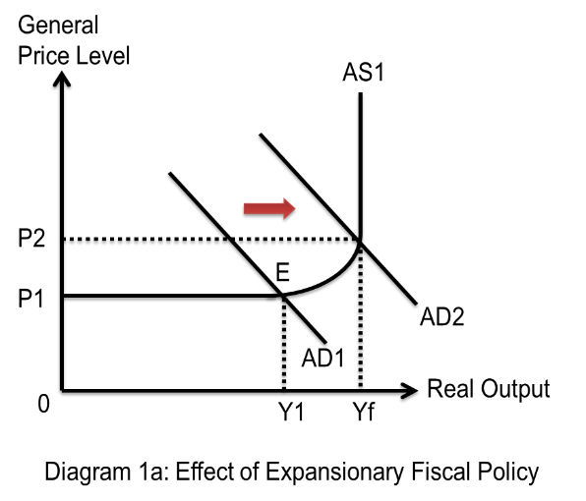
  - Diagram 1b depicts demand deficient unemployment in an economy represented by the horizontal distance of L_{D}Ls due to sticky wages at W₁. When the real output rises, firms produce more goods and services. As such, they need to hire more factors of production like labour to produce these goods and service. Since labour is a derived demand, the demand for labour rises. This is represented in diagram 1b by a rightward shift in aggregate demand for labour from ADL1 to ADL2 bringing about an increase in employment from Ld to Ls. Demand deficient unemployment is eliminated. Unemployment rate falls.
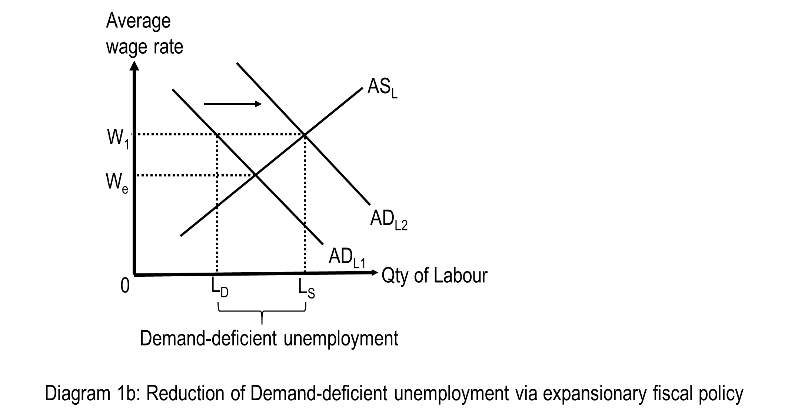
How well it works:
Strength
  - Thus, expansionary fiscal policy shifts AD to the right, promoting actual economic growth. There is an inverse relationship between changes in real national output and unemployment rate. Increases in real output leads to falls in unemployment rate.
  - Hence, expansionary fiscal policy reduces demand-deficient unemployment.
  - Able to boost both actual and potential growth by attracting more FDI.
  - If the R&D is in terms of green technology, it may help to achieve sustainable growth as the increase in output will not cause as much harm to the environment via lower emissions of pollutants or greenhouse gases. There may also be improved methods of production that make use of lesser raw materials thus leading to a slower rate of depletion of resources, allowing a more sustainable rate of growth.
Limitation
  - If AD increases too fast such that AD is persistently greater than AS, demand-pull inflation will result. Demand–pull inflation is defined as a situation where AD is persistently greater than AS, close to or at full employment of all resources. The excess demand cannot be met because existing resources are fully or almost fully employed. This will bid up prices of real output, causing demand–pull inflation. This may be worrying for Eurozone as the inflation rate was already on the rise [Table 3].
  - Another unintended consequence of using fiscal policy is the crowding out effect. If the increase in government spending is financed by borrowing, it will be competing with the private sector for funds. This increase in demand for funds creates an upward pressure on interest rate which rises. Higher interest means higher cost of borrowing, discouraging firms from investing (reducing I) and individuals from buying on credit (reducing C). Thus, we say government expenditure crowds out private expenditure. In the extreme case, the fall in consumption and investment may completely offset the rise in government expenditure, with the result that AD does not rise at all. Hence, government’s attempt to tackle negative growth may be rendered ineffective.
  - If government increases spending and reduces tax rates, in an attempt to promote economic growth through increasing AD, there is a risk of government running into budget deficit. A budget deficit in any one year is where government’s expenditure (including benefits) exceeds its revenue from taxation. If the government runs persistent deficits over many years, these debts will accumulate. In order to finance these debts, government may resort to borrowing, which may further enlarge its national debt to service. The government may also need to increase the tax rate in future, which may result in the unintended consequences of disincentive effects on work. Thus, labour productivity rate may fall in the future and hinder potential growth. Too huge a government debt weakens investor confidence which may lead to capital flight. It also reduces credit rating of the country making it more difficult & expensive (may have to pay higher interest rates) for a country to borrow money to finance its expenditure. This slows down the progress of the economy.

Evaluative conclusion: (Similarity to characteristics + Nature of issue)
What policies a country should implement or adopt depends on the nature of the economy and the economic situation of the economy. Although the Eurozone may find that adopting the policies may help in their youth unemployment problem and in boosting growth, the policy decision to increase G might be constrained by a government’s fiscal position. The Eurozone is suffering from a slightly higher budget deficit as compared to SG (except for 2018) some member states also suffering from budget deficit hence may not have sufficient funds to provide retraining or spend on research and technology which may worsen their budget deficit may cause consumers and investors to lose confidence in the economy which they have managed to build up over time.
However, Extract 5 mentioned “confidence had been hitting record levels since the crisis years in the Eurozone and unemployment was down to pre-crisis levels” hence this shows that although the countries in Eurozone might have problem adopting the policies due to limited budget, the situation is improving hence the scale of implementation of the policies may not need to be so big. Hence the countries in Eurozone may still adopt the policies but to a limited extent, depending on the amount of funds they can afford to spend. They should be adapting where appropriate.

