Types of graphs for microeconomics

1. Market Adjustment Process

Example 1
How far does the data in Figure 1 show that the change in US oil production was the key reason for the change in oil price between January 2013 and January 2016? [4]

Trend
Oil Price fell in the time period as US oil production rose. (1)

Explanation
Rise in production of US oil, fall in demand for imported oil, thus, the demand for oil market fall. Fall in US demand for oil, surplus, prices also fell. (1)

But it may not be the key reason because the extent of rise in US oil production is rather small as compared to the extent of the fall in world oil prices as seen in figure 1, especially in Jan 2015. Thus, it could be due to other factors such as slowing world economic growth as mentioned in extract 1. (1)

Diagram and description (1)

Example 2

(b) With the help of a supply and demand diagram, explain the likely impact of increasing population and lower energy costs on the market for public transport. [6]
-the resulting change in price and output – cs, ps, total revenue
An increasing population means more users for public transport, which leads to a rise in the demand for public transport trips from Do to D1. A shortage of EoA at Po results in the equilibrium price and quantity of public transport increasing from Po to P1 and Qo to Q1 respectively.

With lower energy costs, the unit cost of producing public transport trips falls, which results in a rise in the supply of public transport trips from So to S1. Equilibrium price falls from P1 to P2, while equilibrium quantity increases from Q1 to Q2.

Prediction – why increase in demand is greater than increase in supply

Draw and describe diagram

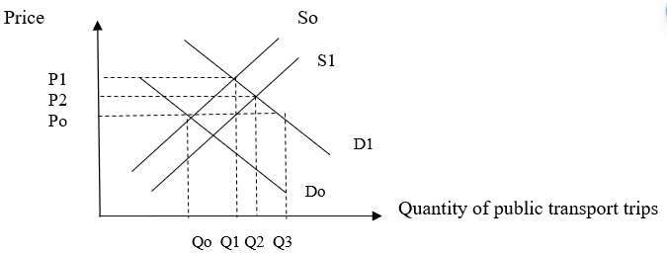

2. How the firm can increase revenue by decreasing price when the demand is price-elastic

(d) In Extract 2, the chief executive of Next considers the effect of an 8% rise in the price of Next’s clothes. With reference to the concept of price elasticity of demand, explain the expected impact of this price rise on the firm's total revenue. [3]

As considered by Next’s chief executive, the effect of an 8% rise in the price of Next’s clothes will lead to a reduction in quantity demanded of Next’s clothes. If as projected, the fall in quantity demanded is about 10%, which has more than proportionate decrease in quantity demand in response to increase in price and this will contribute to a fall in total revenue.

Price of Next’s Clothes

P₁
Gain
Fig. 1 – Price-elastic demand for Next’s Clothes
P₀

SS
Loss

Qty of Next’s Clothes
Q₀
Q₁

As seen from the diagram, there will be a fall in the total revenue for Next’s clothes as the gain in revenue due to the rise in price of Next’s clothes is lesser than the loss in revenue due to the fall in quantity demanded of Next’s clothes, given that the demand is price-elastic, given that the price elastic demand for clothing is price-elastic.

It is likely that the demand is price-elastic since there are extensive substitutes like Primark and Asda and other stores, given its high degree of competition. As clothes are durables, which means there is low degree of necessity of demand for the good, shaping it to be price-elastic in demand.

3. How subsidy affect the market equilibrium

As seen from the diagram, the provision of subsidy contributes to the lowering of cost of production, and this leads to an increase in supply from So to S. Consequently, the price of the good falls from Po to P1 and the quantity increases from Qo to Q1. The producers and consumers both gain benefits as represented by the shaded region while the society gains welfare as seen in the shaded portion (ABC).

4. How removal of subsidy affects the market equilibrium

As seen from the diagram. the removal of subsidy causes a rise in cost of production and this causes the supply curve to reduce the supply from So to S1. This causes the price to rise from Po to P1 and a fall in quantity demanded from Qo to Q1. Besides this change, the consumer and producer benefit is reduced and the welfare gain is reduced by the portion marked ABC.

5. How increase in direct tax affect market equilibrium

As seen from the diagram, the imposition of taxation (specific) causes a rise in cost of production and this leads to a fall in supply from So to S1. Consequently, the price of the good rises from Po to P1 and the quantity demanded falls from qo to q1. There will be a rise in welfare loss and the produce and consumer incur producer tax burden and consumer tax burden respectively as represented by the shaded portion.

6. How Sales tax would affect the market equilibrium

As seen from the diagram, the Sales tax which is percentage-based and varied based on the price level. This contributes to the rise cost of production and the supply curve pivots to the left from So to S1. This causes the price to increase from Po to P1 and contributes to a fall in quantity demanded from qo to q1 and there will be a loss of welfare loss as represented by shaded portion ABC while the producer and consumer benefit both are incurred.

7. How price ceiling affects the market equilibrium

A maximum price set artificially by the government to ensure that goods are bought and sold at that price level which is below the market equilibrium price level. There will be a reduction in qty supplied and an increase in qty dd, which will cause an excess dd condition. E.g. HDB Public Housing

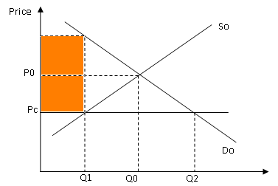

As seen from the diagram, the market equilibrium at Eo where the price and output level is at Po and Qo. When price ceiling is imposed, the prie is lowered rom Po to Pc and this causes an increase in quantity demand from qo to q2 and a decrease in quantity supplied from qo to q2, creating an excess demand condition (shortage) from q1 to q2. If this is not matched by a supply from buffer stock, a black market price occurs Pb where black market is allowed to occur.

8. how floor price affects the market equilibrium

A minimum price set artificially so that goods are bought and sold at that price level which is above the market equilibrium price level.

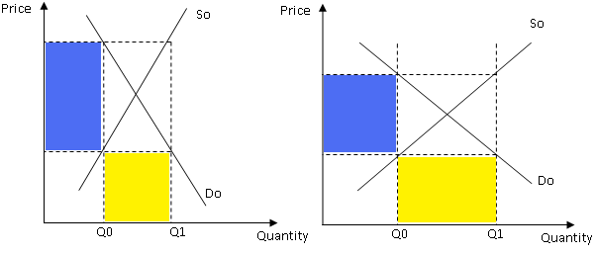

As seen from the diagram, the price and output are originally set at Po and Qo. The imposition of the floor price raises the price from po to p1 and this causes an decrease in quantity demanded from Q* to Q2 and am increase in quantity supplied from Q* to Q1 and an excess supply condition occurs from Q1 to Q2. To clear the excess supply condition, a buffer must be created.

