Lsn 1 - CSQ Q1 Market Failures
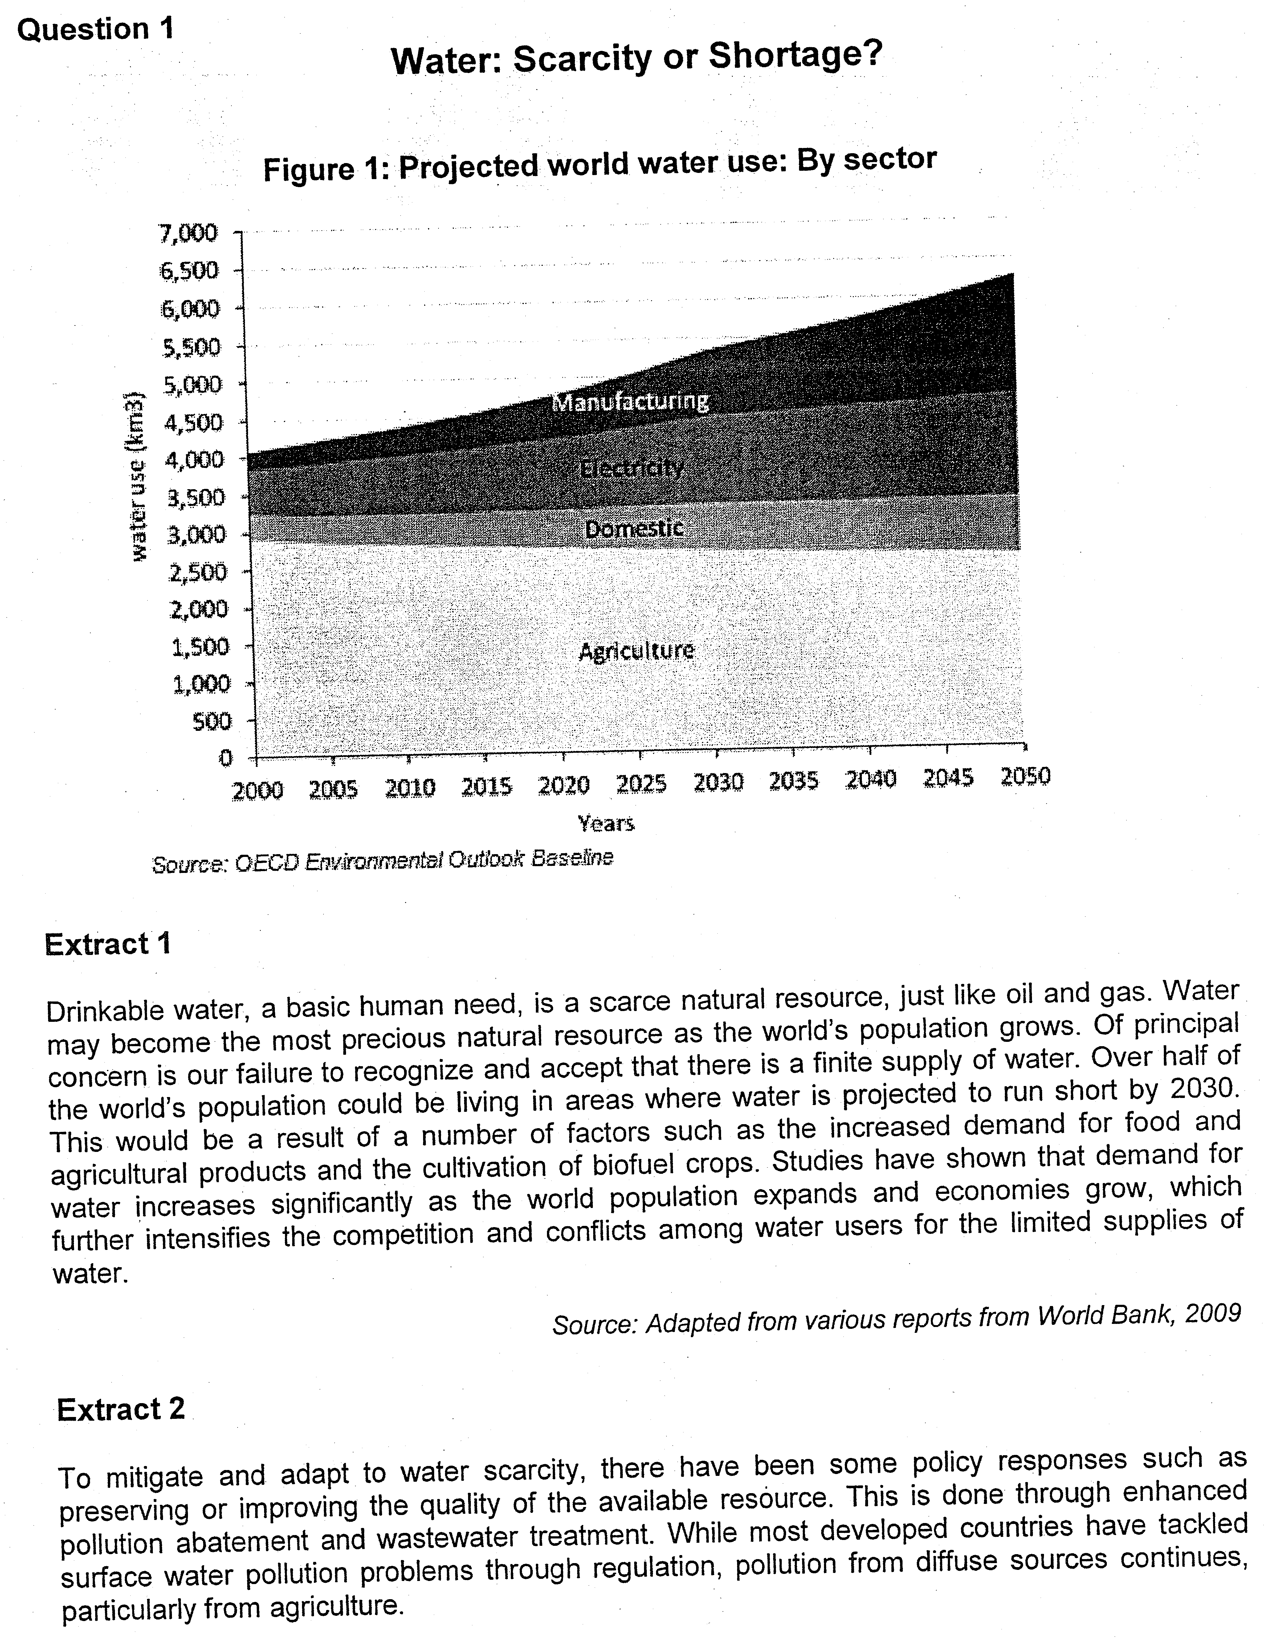

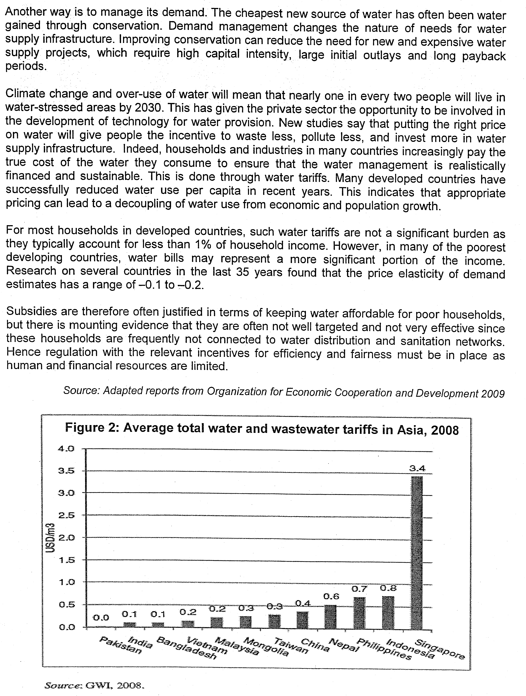

policies adopted against water usage
- subsidy
- tariff
- Quotas – rationing – price mechanism fails to work
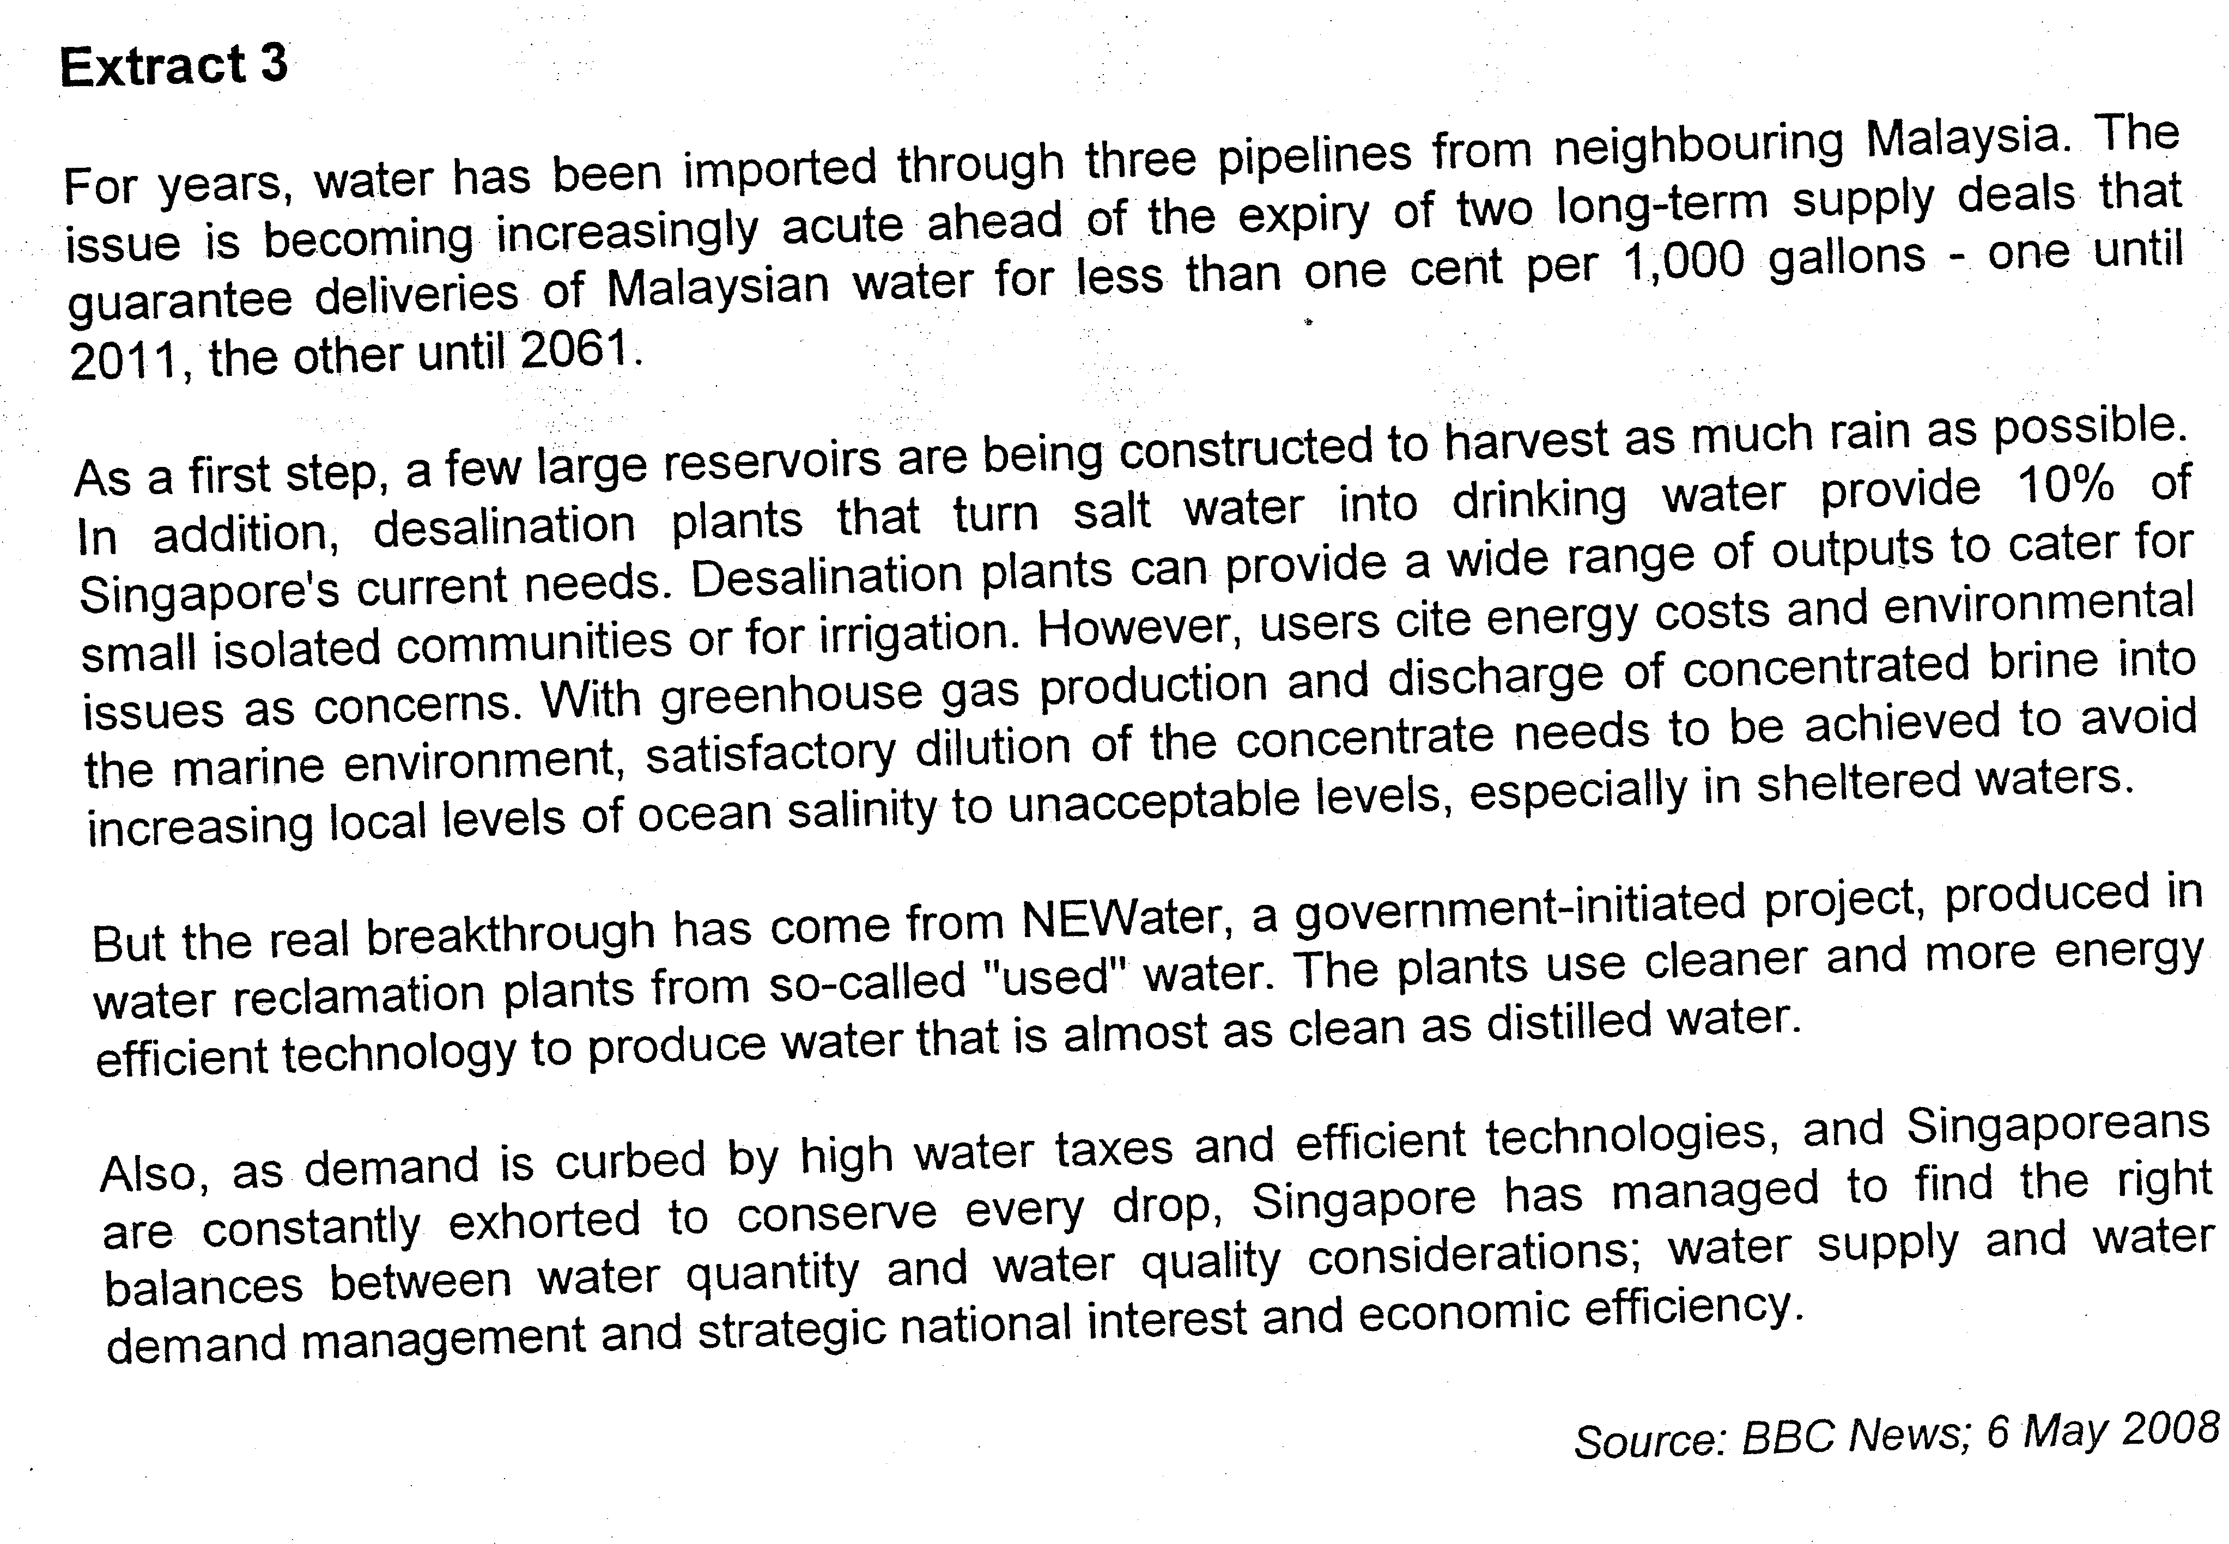
Questions
(a) (i) Compare the trends of projected water use in Figure 1. [2]
(ii) With the aid of economic theory and materials provided, predict the trend of the price of water in the next few decades. [4]

(b) Explain the economic justification for governments to intervene in the provision of water treatment. [4]

(c) To what extent does 'putting the right price on water’ (Extract 2) achieve the two microeconomic objectives of efficiency and equity? [8]

(d) Distinguish between the concepts of 'shortage' and 'scarcity’. [4]

(e) Examine the relative effectiveness of the methods adopted by countries to tackle the problem of shortage of clean water. [8]
[Total: 30]

Suggested Answer

(a)(i) Compare the trends of projected water use in Figure 1. (2)

Projected water use was rising for Manufacturing, Electricity and Domestic sectors, except for Agriculture [1]

Manufacturing and Electricity contribution to water use is projected to rise more significantly [1]

(ii) With the aid of economic theory and materials provided, predict the trend of the price of water in the next few decades. (4)

- Rising water usage (population, climate, economic growth, wastage) DD expected to rise shift rightwards of DD curve [1]
(From Extract 1, the demand for water increases significantly as the population increases and economies grow)

- Scarce resource + limited supply, rising pollution SS expected to either remain fairly unchanged / rise marginally (insufficient information) [1]
(Difficult to develop water catchment areas/prevent pollution)

- Rise in DD > change in SS price rise [1]

- Moreover, DD and SS highly inelastic + price rise (likely) more significant [1]

- Draw diagram/Describe diagram

As seen from the diagram, the increase in demand from Do to D1 for water is greater than the increase in supply of water from So to S1, contributing to an excess demand at Po. This will create an upward pressure, causing the price of water to rise from Po to P1 while the quantity of water rises from Qo to Q1. As both the demand and supply of water are both price-inelastic, the price of water will rise sharply.

(b) Explain the economic justification for governments to intervene in the provision of water treatment. (4)

- Explain how water as a merit good may be under-produced by the private sector and thus need government intervention

Water treatment might be under-provided by the market as private enterprises may ignore the benefits of clean water on the wider community (i.e. they only care about the revenue they will receive). Moreover, such projects have high capital intensity, requires large initial outlay and has long payback periods that presents a challenge to private enterprises

P₀
Qty of Education Services
Cost/Benefit
Q_{S}
Q_{M}
SMB = PMB + EMB
SMC
PMB
DWL

The presence of positive externality seen in terms of the survival needs of the population will not be considered by the private supplier as they only focus on the profit incentives, considering only the private cost and benefit. Given this situation, the production or supply of water by the private sector will be underproduced, leading to the rise of deadweight loss seen in term of the welfare gain not reaped by the society, which are the needs of the society.

As seen from the diagram, the presence of positive externalities will contribute to the rise of external benefit which will lead to the pivotal shift of the PMB (private marginal benefit) to SMB (social marginal benefit = private marginal benefit + external marginal benefit) due to the presence of external marginal benefit. Without government intervention, the market equilibrium will be at Q_{m} which is below the social equilibrium level at Q_{s}, where SMB is greater than the SMC, giving rise to welfare loss (deadweight loss), as seen in the shaded portion.

(c) To what extent does 'putting the right price on water’ (Extract 2) achieve the two microeconomic objectives of efficiency and equity? [8]

Balance between goals of efficiency vs equity expected especially for a necessity where issues of affordability need also to be considered

- Explain how 'right' price on water can achieve efficiency

If left to market forces, only private benefits and costs are considered (MPB = MPC):

- Price regulates quantity demanded (prevent wastage) to truly reflect MPB
- Price regulates quantity supplied (affected by pollution which raises marginal cost of production) to truly reflect MPC
- Price incentivise investments through rewarding profits (price vs cost)

- Explain how 'right' price not possible via market system without govt intervention due to externalities (pollution costs, wastage, lack of investments)

- Market unable to capture cost of negative externality (pollution) right 'price' is lower
- Lower 'price' leads to wastage in consumption
- Lower 'price' may not be sufficient to induce investment in water management technology that bring about lower cost of provision in the future
- Pricing through market is not efficient (MSB ≠ MSC)

Therefore the "right" price should take into account external costs that are not captured in the market system to achieve efficient allocation of resource. (therefore impose tax)

- Explain how government intervention via tax could achieve a more efficient allocation of water resource (raise 'price' of water & curb excess consumption).

The imposition of tax will raise the cost of production of water and this will lead to a reduction in supply that will raise the price of water. Consequently, there will be a fall in quantity to the social equilibrium level where there is no welfare loss.

P₁
P₀
PMC (S₀)
Qty of Road Usage
Cost/Benefit
Q_{S}
Q_{M}
SMC
SMC’ = PMC + tax (S₁)
SMB
DWL

As seen from the diagram, the imposition of tax will increase the cost of production, contributing to the reduction in the supply from S₀ (PMC) to S₁(SMC’), leading to a rise in price from P₀ to P₁ which will result in the fall in quantity from Q_{m} to Q_{s}.

In the process of taxation, the external cost seen in the production cost will be internalized as part of the cost of production which will be taken into the consideration by the consumer and producers. Welfare loss and excessive external cost be reduced due to lower consumption and production. Thus, it be seen that there is social optimization of water allocation when there is government intervention to set price of water at the optimal level.

Equity concerns will examine if the 'right' price takes into account affordability of households to scarce resource.

- Explain why equity is not a problem for developed countries where water charges ('price' of water) does not constitute a significant burden for households.

- Price of water is changed according to usage and taxation is imposed on those who excessively use it
- Explain why equity may be a problem
- For poorer countries, similar water charges represent a more significant portion of income. Problem magnified by highly inelastic demand for water (- 0.1 to -0.2).
- Subsidies solution to keep it affordable when not targeted worsens equity problem. To help the lower income group afford the use of water, the rich may set more benefit if they use more. Subsidies are given to both the rich and the poor.
- Moreover, measures undertaken for water pricing policies need to be sustainable. (Need to consider the cost of financing)

- Evaluation
There is inherent conflict in the allocation of resources like water as more subsidies to the poor will undermine efficiency but promote equity. There will be excessive usage of water which will lead to overconsumption that will give rise to deadweight loss, but the welfare of the poor will be taken care of, since subsidies will promote equity as water is affordable to them. On the other hand, the imposition of taxation will promote the efficient usage of water but will undermine equity as the poor will have to pay a higher price for water.

In sum, the issue of equity and efficiency of usage of water can be resolved but the conflicting issue exists. Only an optimal solution of complementary policies are introduced will the problem of conflicting issues be solved.

SG – tax the consumers as large percentage of consumers can afford – make the consumers more careful with the usage
subsidy to the consumers for those who cannot afford and subsidy to producers to increase the supply – lower price

(d) Distinguish between the concepts of 'shortage' and 'scarcity’. [4]
- definition and features
- implication – can it be eliminated?

- Shortage is a situation when the qty dd > qty ss at the existing market price. [1]
- Scarcity is a situation when limited resources are not able to satisfy unlimited wants. [1]
- Explain how shortage can be eliminated through adjustment when price changes but scarcity can never be eliminated. [2]

The shortage of water can be resolved as the excess demand condition will lead to the rise in price of water which will eradicate the shortage. The rise in price of water will lead to an increase in the quantity supplied of water, where the rise in price of water will contribute to a fall in quantity demanded of water, eradicating the excess demand condition.

However, the problem of scarcity will not be eliminated since wants are unlimited or the supply of resources (water) is limited. Wants are unlimited as the need for water is a recurring demand under the condition of growing population while the supply of water is limited by the land space and undermined by extensive pollution. Consequently, with limited supply and unlimited demand, there will be a condition of scarcity.

(e) Examine the relative effectiveness of the methods adopted by countries to tackle the problem of shortage of clean water. [8]

Identify govt intervention methods: subsidies, tariffs, regulations, SS-side measures to boost access

1a. Curb Demand Tariffs
How they work/evaluation
Tariffs raise the price of waterreduces quantity demandedmost direct meansnot targetedpoor may suffer more (equity issue)

Applied in Developed Countries
Tariff account for less than 1% of household income despite highly inelastic DD (Extract 2); subsidies in other countries to help poor

Applied in Singapore
Figure 2 shows water tariff (including wastewater) for S’pore highest in selected countries
High water taxes used (Extract 3)

1b. Education
How they work/evaluation
Change mindsets via education and campaigns reduce wastage, improve conservation reduce the DD takes time for habits to change more difficult for larger countries

Applied in Developed Countries
Extract 2 mentioned DD management could reduce the need for expensive water projects but does not show any material evidence for other countries

Applied in Singapore
Extract 3 – “exhorted to conserve every drop” is evidence of water conservation campaign high level of reach to general populace given the smaller size and higher population density

1c. Use of Efficient Technology
How they work/evaluation
Adoption of newer and more efficient technology to reduce water usage reduce DD high costs involved initially needs incentives usually government initiative/coercion/regulation

Applied in Developed Countries
Extract 2 – mentioned development of technology for water provision – not reducing DD

Applied in Singapore
Extract 3 – “DD is curbed… efficient technologies” suggests use of means to reduce usage (e.g. Water reduction taps; push-release taps; water-saving cisterns etc.)

2a. Boost Supply, Reduce pollution
How they work/evaluation
Lower pollution levelsground and surface water can be usedcheaper clean water need for regulation on pollution abatement assignment of property rights for polluters to take responsibility clean-up costs vs ‘punishment’

Applied in Developed Countries
(Extract 2 , para 3) – “increasingly paying true cost” – shows government policy options (tariffs) to provide incentive to waste less, pollute less and invest more in water infrastructure; more prevalent in countries with large natural sources of water

Applied in Singapore
Figure 2 shows high wastewater tariff imposed by S’pore but little else regarding curbing pollution; perhaps since we have little natural waters sources

2b. Import
How they work/evaluation
Buying water from neighbouring countries increases SSbut reliance on foreign source strategic dependence/political ties

Applied in Developed Countries
Not applicable for countries with large sources of natural groundwater

Applied in Singapore
Traditional source but contracts are running out

2c. Build Reservoirs
How they work/evaluation
Building reservoirsincrease SS high costs involved, land sites needed high opportunity costs for alternative land usage

Applied in Developed Countries
Not applicable for countries with large sources of natural groundwater

Applied in Singapore
Initial plans to complement import of water through the use of reservoirs but opportunity costs are high for land-scarce country

2d. Desalination
How they work/evaluation
Desalinationincrease SS suitable for small communities sea water available but high energy costs, greenhouse gas released and high concentration of brine affects marine environment

Applied in Developed Countries
Not applicable for countries with large sources of natural groundwater

Applied in Singapore
Provides only 10% of needs (Extract 3) but high costs involved and advent of newer technology provided new alternatives

2e. Conservation (recycle)
How they work/evaluation
Conservation through recycled waterless pollution and energy use involvednew technology adoption costssustainable solution

Applied in Developed Countries
Conservation via reduction in use of water; multiple use of same pool of water (Extract 2, para 2) water gained through conservation

Applied in Singapore
Government initiated and funded research to find better ways to supplement existing sources – NEWater (recycles wastewater)

Conclusion
Different countries with very different factor constraints (land, availability of groundwater, access to seawater) and size (economies of scale in certain production, reach of education campaigns) will use different policy mixture to tackle water scarcity issue.

