Lsn 1 - CSQ Q1 Market Failures
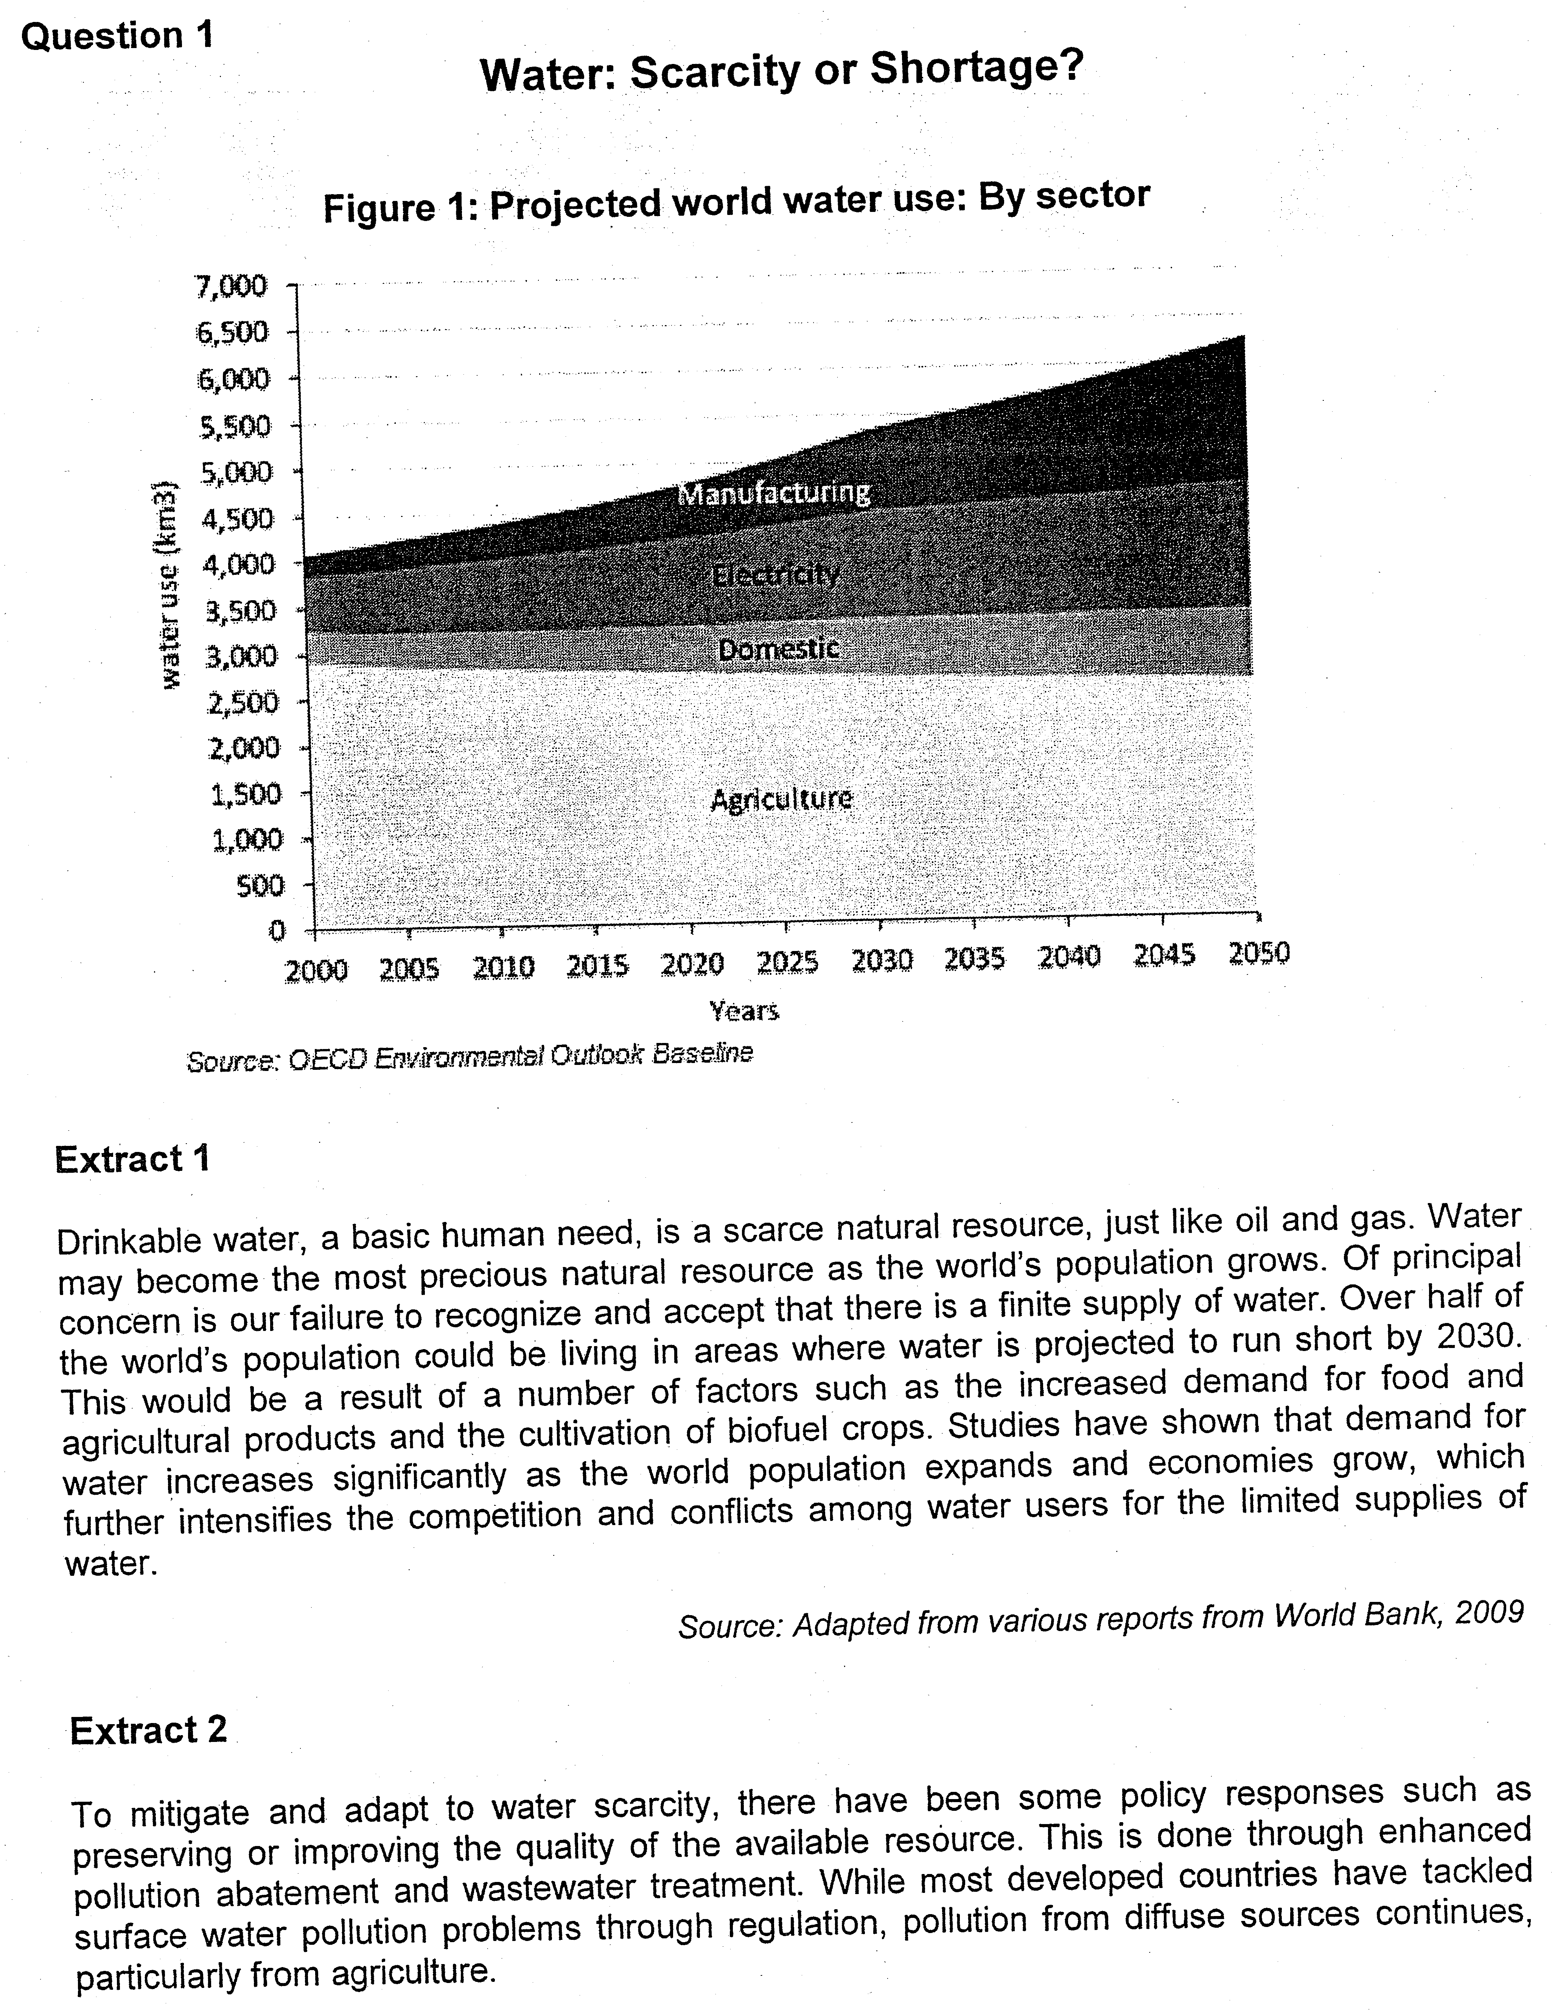

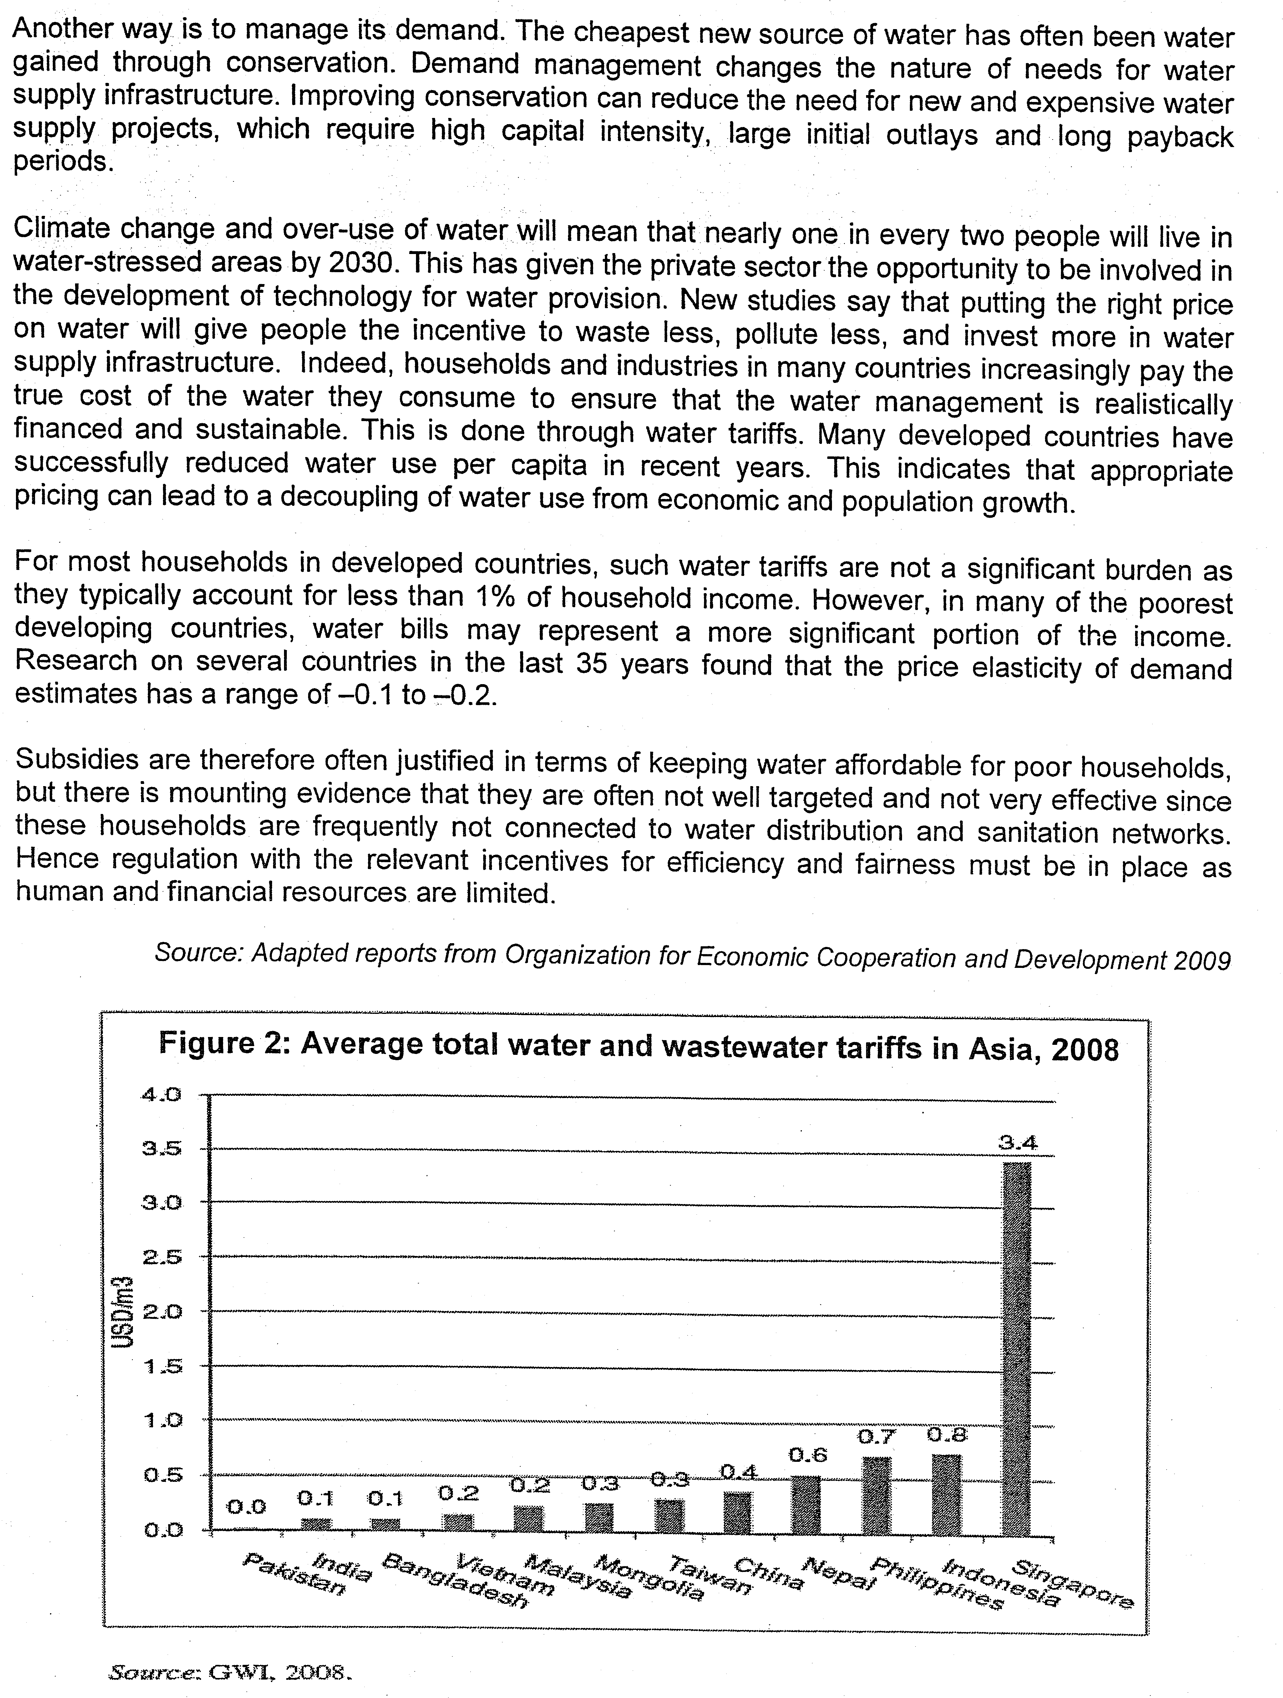

policies adopted against water usage
- subsidy
- tariff
- Quotas – rationing – price mechanism fails to work
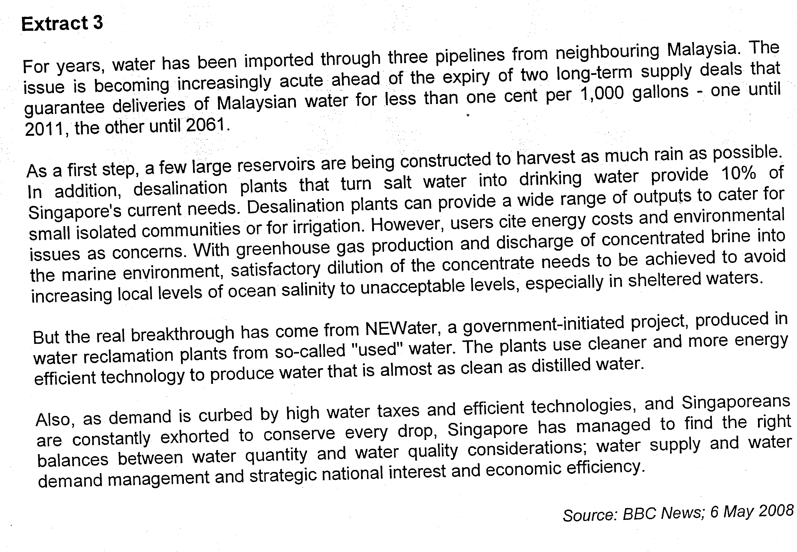
Questions
(a) (i) Compare the trends of projected water use in Figure 1. [2]
(ii) With the aid of economic theory and materials provided, predict the trend of the price of water in the next few decades. [4]

(b) Explain the economic justification for governments to intervene in the provision of water treatment. [4]

(c) To what extent does 'putting the right price on water’ (Extract 2) achieve the two microeconomic objectives of efficiency and equity? [8]

(d) Distinguish between the concepts of 'shortage' and 'scarcity’. [4]

(e) Examine the relative effectiveness of the methods adopted by countries to tackle the problem of shortage of clean water. [8]
[Total: 30]

