Question 1: Tackling Diabetes Figure 1: World price of rice
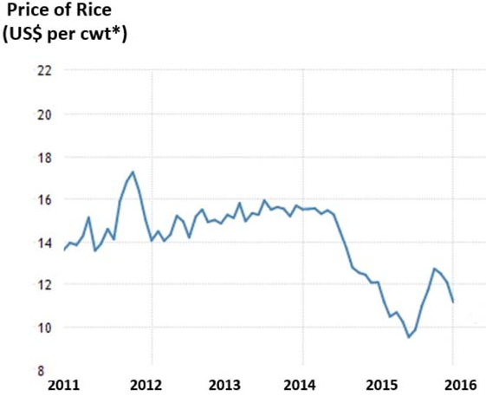
* A hundredweight, Cwt, is a unit of measurement for weight used in certain commodities

Source: www.tradingeconomics.com, accessed 15.07.18

Extract 1: Global food prices drop to a five year low

Factors that are driving the sharp decline in international food prices include cheap oil that contributed to abundant global supplies of food in 2014, as well as prospects of a bumper crop for wheat, maize and rice in 2015. The agriculture and food sector continue to benefit from cheaper chemical fertilizer, lower fuel and transportation costs brought on by the previous year’s oil price declines.

Between August 2014 and May 2015, wheat prices plunged by 18%, rice prices dropped by 14% and maize prices declined by 6%. However, the arrival of El Nino, the appreciation of the U.S. dollar and the recent increase in oil prices could drive up food prices in the coming months.

Adapted from The World Bank, 1 July 2015

Extract 2: Challenges of the global rice market

As rice is one of the staple grains for a large number of the world’s population and to ensure food security, reduce poverty and help traditional farmers adapt to the effects of climate changes, profitable rice cultures must survive on less land, with less water and with less labour. Thus, the rice production system must be more efficient, environmental-friendly and more equitable.

Rice yield per stalk of plant has fallen as a result of the decline in investments made in productivity research since the early 1990s. On the other hand, the areas used for rice cultivation in some of the biggest rice producing countries in the world have been decreasing greatly because the land was re- purposed for other needs, such as urban expansion as well as biofuel production. Also, water resources have become scarcer, and water is vital for traditional rice cultivation methods. In addition, labour hands are more difficult to find because young farmers are more interested in finding jobs in other industry sectors that are better paid.

The challenges that the rice industry has to face are complex, and involve the creation of sustainable strategies that will primarily enable the production needed to cater to the growing demand for rice due to rapid population growth, especially in the areas where traditional cultivation technologies are

intensively used. Such strategies should also ensure profitable productions to keep rice prices at an affordable level for a growing consumer market.

Adapted from AgronoMag, 2 October 2017

Extract 3: Curbing diabetes in Indonesia

Diabetes, along with other non-communicable diseases (NCDs), is the leading cause of death in Southeast Asia. As a developing country, Indonesia is facing a double burden of diseases. In 2014, approximately 71 percent of deaths were attributed to NCDs and 6 percent of the total were due to diabetes. Yet, most of the population is still not aware of the urgency of combatting this disease.

There are 2 key reasons for the lack of urgency. Firstly, people still strongly believe that diabetes is a genetic disease; hence, they embrace the diagnosis as part of inevitable heritage from their ancestors. Secondly, it is because we live in what public health experts call an obesogenic environment — an environment that promotes gaining weight and one that is not conducive to weight loss. Jakarta is a perfect example. We have all gone through the phase of making life goals to work out more and eat healthily. But many of us have failed. Staying outdoors is out of the question due to severe pollution, and sidewalks are crowded with vendors and using private vehicle is much more comfortable than sharing public transportation. These aspects beyond our personal choice that directly — or indirectly
— affect our population’s health are called social determinants of health.

In response to the growing problem of obesity and diabetes, the government said that it will be making efforts to reduce dependency on rice by promoting other sources of carbohydrates. Although Indonesia is the world’s third-largest rice producer, the country usually needs to import rice from Vietnam or Thailand to maintain stable prices and meet a huge rice demand at home. “This food diversification program is part of our effort to reduce people’s dependency on rice,” said Agung Hendriadi, head of the Agriculture Ministry’s Food Sovereignty Agency. Among the alternative local foods promoted by the government are yam, arrowroot, cassava, corn and sago. According to data by the Agricultural Ministry, Indonesia’s rice consumption per capita is estimated at 124 kilograms this year, which is considerably higher than Malaysia (80 kg), Thailand (70 kg), Japan (50 kg) and South Korea (40 kg).

Adapted from Indonesia Expat, 26 October 2017

Extract 4: Mexico's sugar tax

Mexico has high rates of obesity – more than 70% of the population is overweight or obese – and sugar consumption. More than 70% of the added sugar in the diet comes from sugar-sweetened drinks. Coca-Cola is particularly popular and holds a place in the national culture.

Mexico’s sugar tax appears to be having a significant impact for the second year running in changing the habits of a nation famous for its love of Coca-Cola, and will encourage countries troubled by obesity and contemplating a tax of their own.

An analysis of sugary-drink purchases, carried out by academics in Mexico and the United States, has found that the 5.5% drop in the first year after the tax was introduced was followed by a 9.7% decline in the second year, averaging 7.6% over the two-year period. The tax, which is just 1 peso (4p) per litre of sugary drink, had its biggest impact on the poorest households, where the decline in purchases was 18.8ml per person per day in 2014 and 29.3ml in 2015.

Health experts worldwide have been watching the progress of the Mexican tax closely because it could potentially lower the rates of obesity-related diseases and type 2 diabetes in a country with a population of more than 122 million. The Euromonitor International suggested that the Mexican tax may be too low to have the desired effect and that a higher tax introduced in Berkeley, California, has been a bigger success.

The taxes are a headache for US drinks manufacturers such as Coca-Cola and Pepsi that are struggling to diversify their businesses into healthier foods and drinks as they face declining

consumption of their core products. The US beverage industry has lobbied heavily against the taxes, saying it would hurt jobs and that sugar taxes do not work.

Adapted from The Guardian, 22 February 2017

Questions

- (i) With reference to Figure 1, summarise how the world price of rice changed from
2011 to 2016. [2]

  - Using a demand and supply diagram, explain two possible reasons for your observation. [4]

- Extract 2 states that there was a re-purposing of land. Identify the choices available and the opportunity cost of such a decision. [2]

- Explain how a rise in the productivity levels of rice farming may affect resource allocation in the market for biofuels. [4]

- (i) With reference to Extract 3 and using an appropriate diagram, explain why the market for rice fails. [5]

  - Explain how the Indonesian government’s food diversification programme mentioned in Extract 3 may impact the economy, and comment on the likely impact on its standard of living. [7]

- Analyse how Mexico’s sugar tax would harm the US drinks manufacturers and employees, and discuss briefly whether it is inevitable that the US drinks manufacturers will be adversely affected.
[9]

- Using evidence from the case study and/or your own knowledge, discuss whether the best course for Indonesia is to follow Mexico’s policy of taxation in its push to
discourage Indonesians from consuming rice. [12]

[Total: 45]

