J1 June Intensive Revision 2014
Market Failures (Type II) – Q3

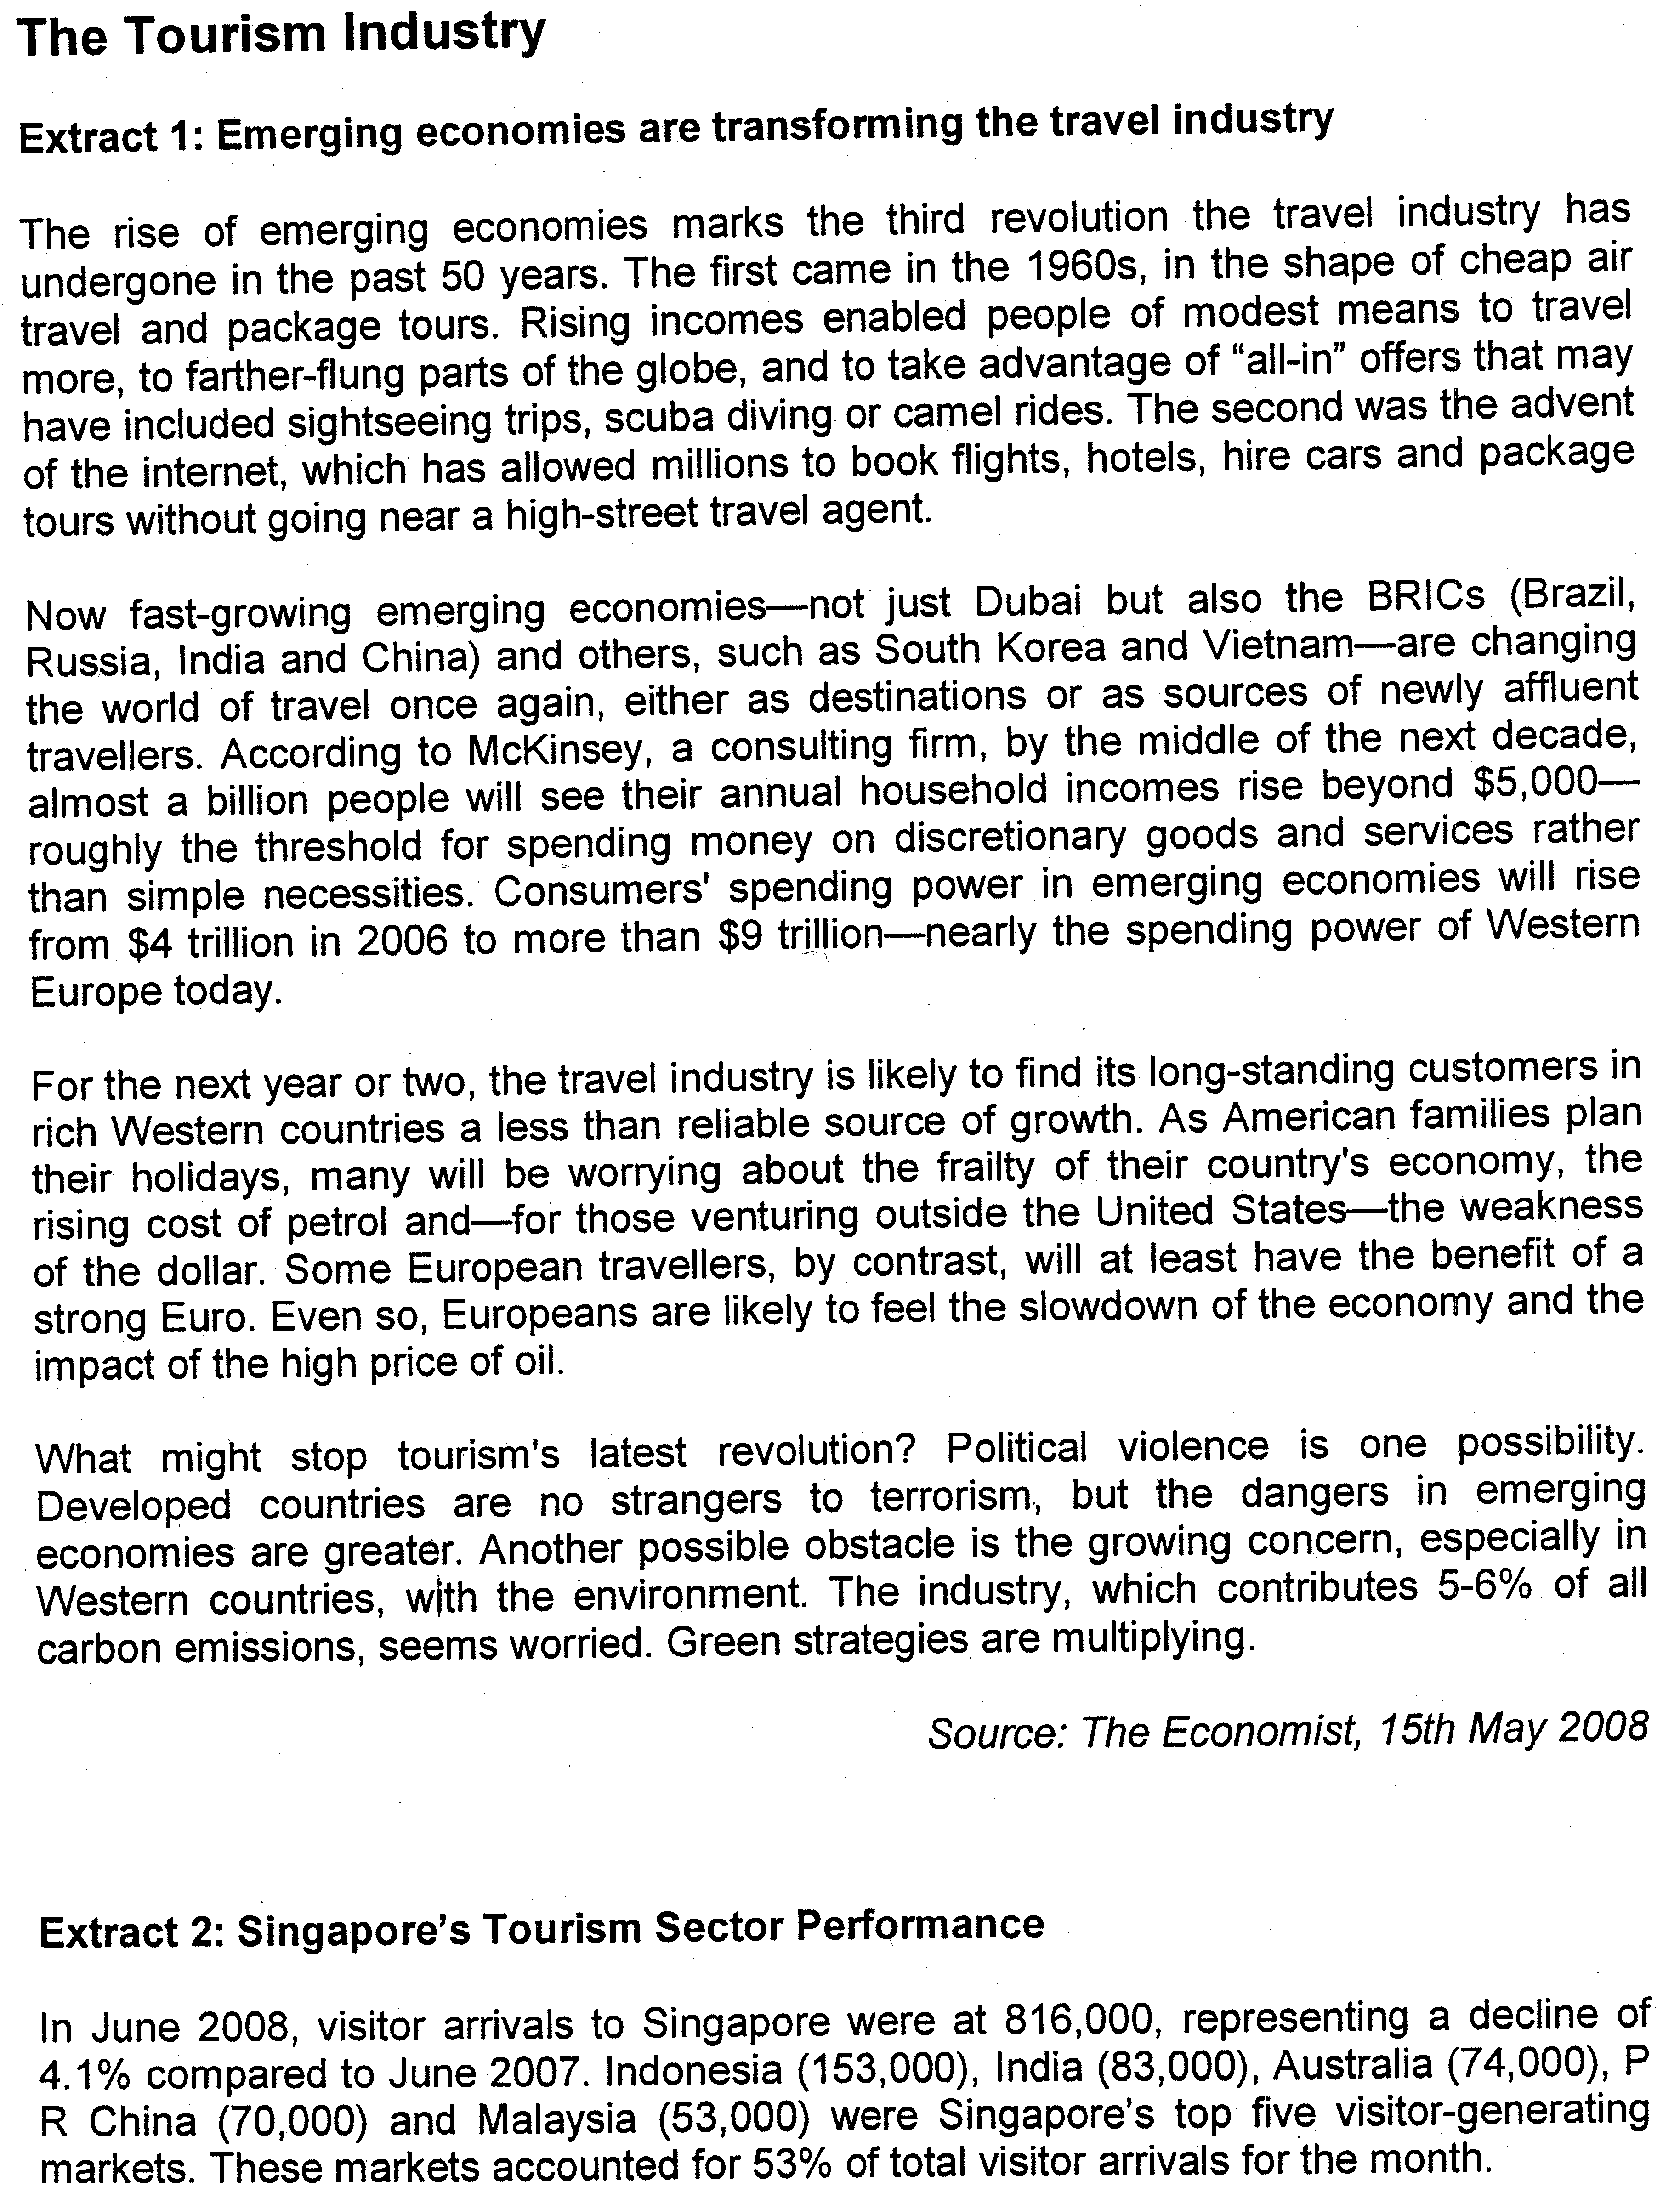

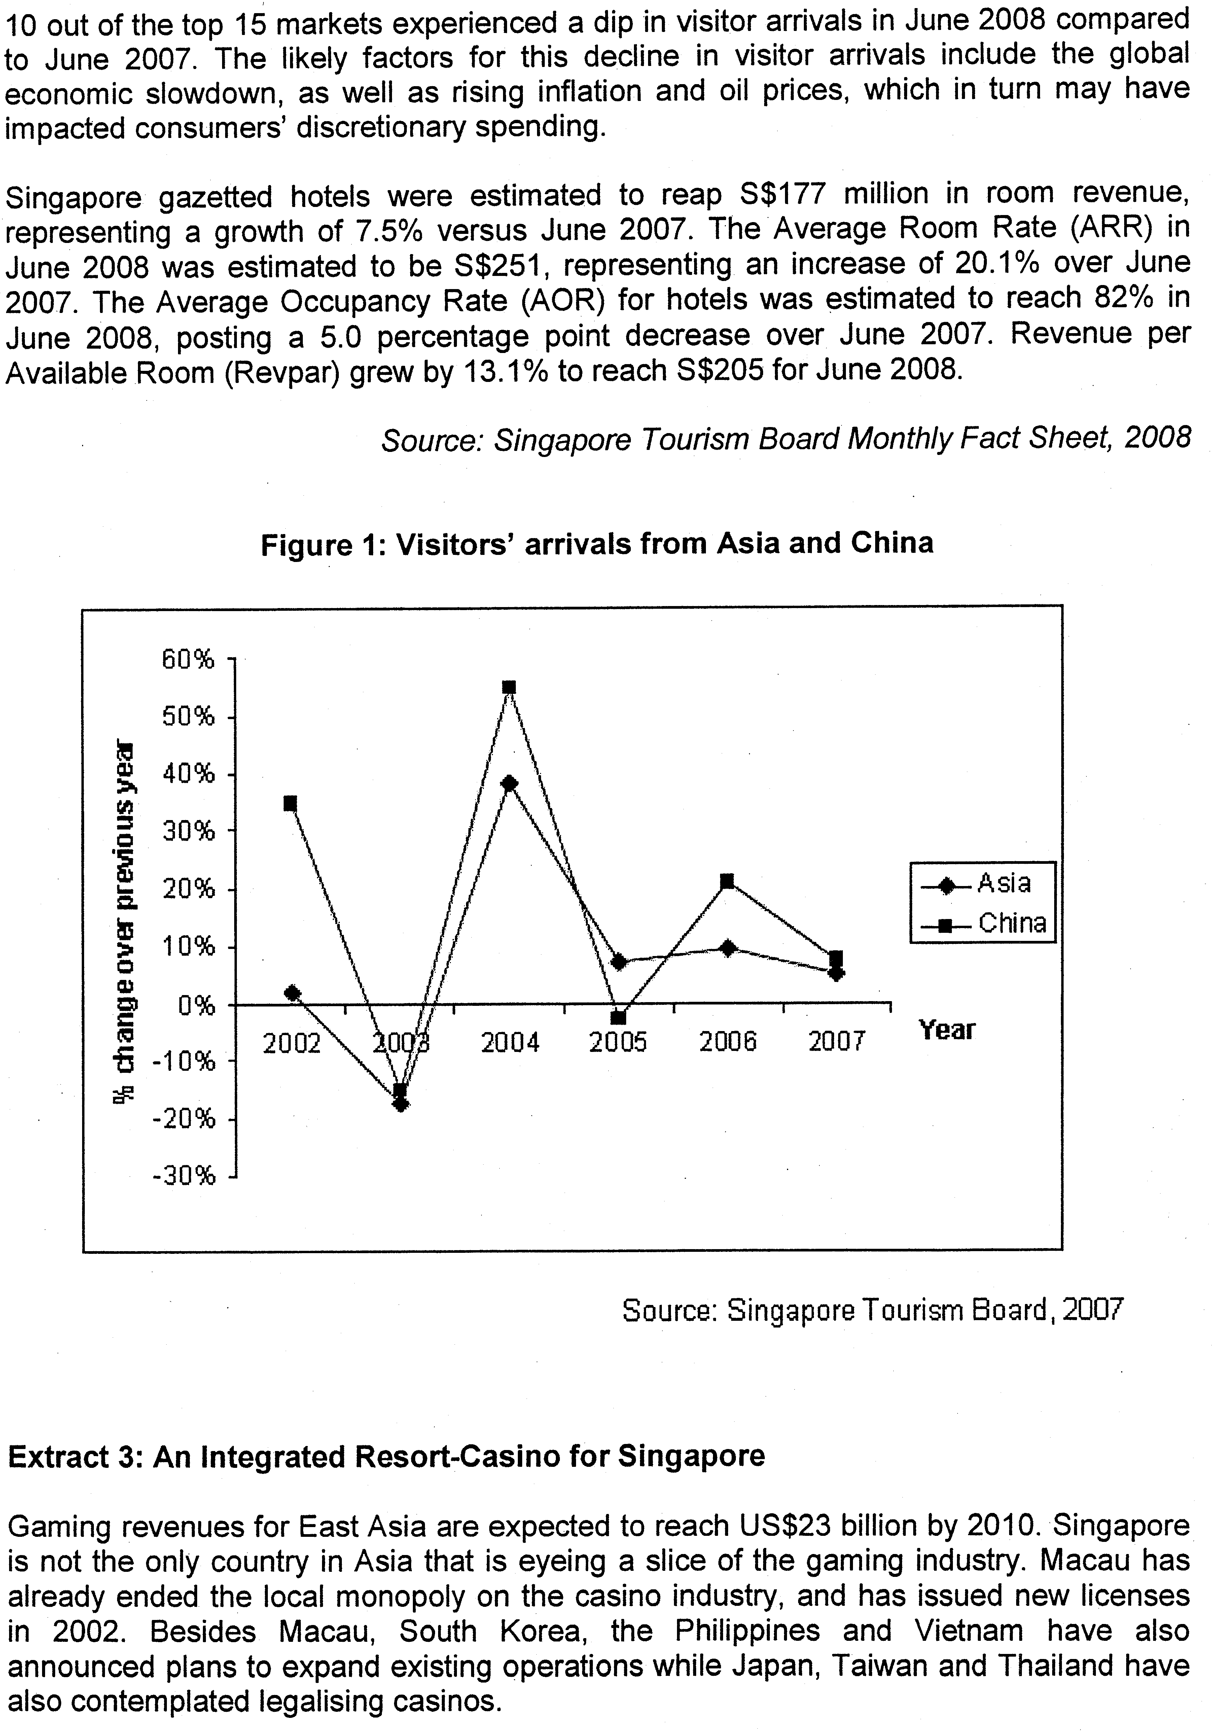

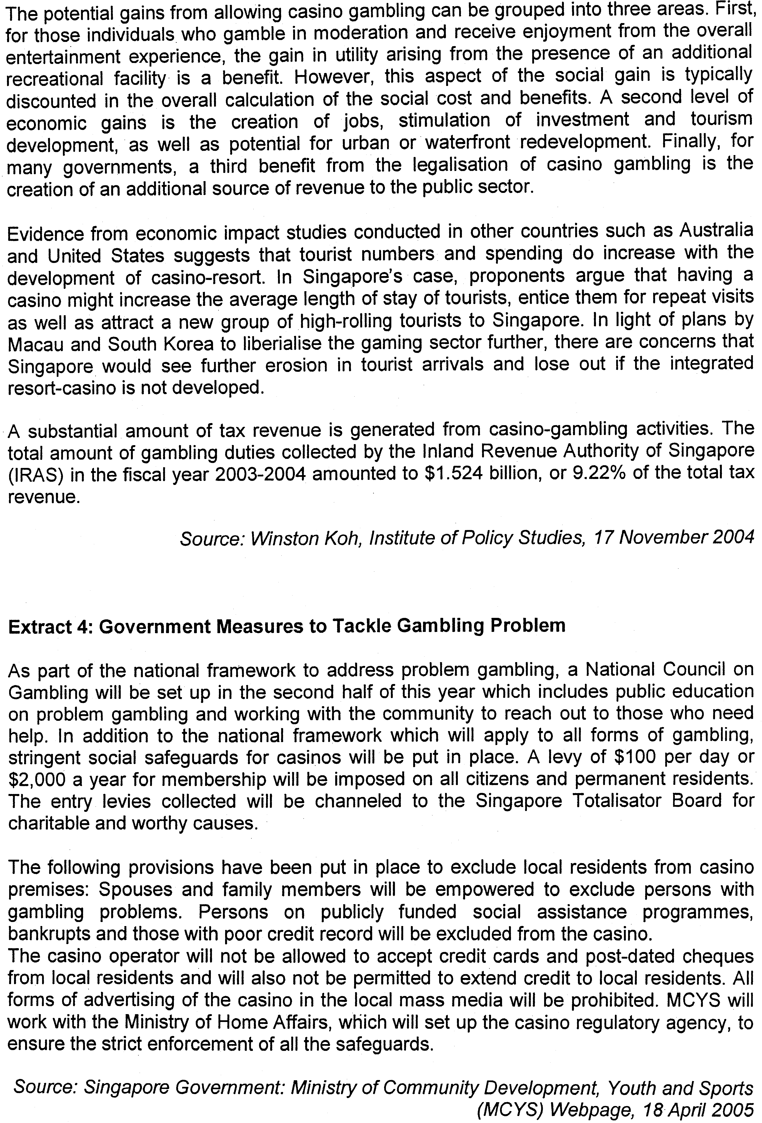

Questions
(a) Compare the change in visitors' arrivals from Asia with those from China over the period 2002-2007. [2]

(b) In Extract 2, Singapore Tourism Board announced that "Revenue Per Available Room (Rev par) grew by 13.1% to reach S$205 for June 2008".
Using a demand and supply diagram, explain the rise in Revpar. [4]

(c) Explain the rationale for government intervention in the gambling industry. [6]

(d) Evaluate the effectiveness of the measures implemented by the Singapore government to solve the market failure in the gambling industry. [8]

(e) Identify the present challenges in Singapore's tourism industry and assess to what extent Singapore's upcoming integrated resorts is effective in dealing with these challenges. [10]
[Total: 30 marks]

Suggested Answers

(a) Compare the change in visitors' arrivals from Asia with those from China over the period 2002-2007. [2]

The percentage change over the previous year for visitors’ arrival from Asia and those from China over the period 2002-2007 followed similar changes in the pattern but it can be observed that the percentage of over for China fluctuated more volatile than for Asia.

(b) In Extract 2, Singapore Tourism Board announced that "Revenue Per Available Room (Revpar) grew by 13.1% to reach S$205 for June 2008".
Using a demand and supply diagram, explain the rise in Revpar. [4]

Change in the Revpar would mean that the average revenue or price of a typical hotel in the industry has increased which is derived by the total revenue attained divided by the number of occupants. When the Revpar has increased or the price has risen despite the fall in number of visitors over 2007,it would mean that the supply of hotel accommodation has decreased as result of higher cost of production whereby the supply rooms can be supplied at a higher price level. As the reduction is supply is greater than the fall in demand, the price will still rise despite the fall in the number of tourist.

As seen from the diagram, the fall in supply that will induce a rise in the price which is sharp as the demand in price-inelastic, given the fact that the tourist would have a high degree of necessity of demand for hotel accommodation when they visit Singapore.

c) Explain the rationale for government intervention in the gambling industry. [6]

Government needs to intervene into the gambling industry as it will create deadweight-loss which will undermine the welfare of the society when there is over consumption and production in the industry as this is a demerit good which creates external cost.

Without the consideration of the external cost, the industry will attain market equilibrium level where the private cost (PMC) represented by the cost of production of the gambling services will intersect with the private benefit (PMB) of the society will be represented by the utility of satisfaction and revenue of the consumers or national income produced by the gambling industry at the level of quantity. However, with the consideration of the external cost which is the cost that arises from the social problems in the gambling industry that will affect the society, it will mean that the efficient level of production or consumption should be at the level where the PMB is equal to the SMC which will include the private and external cost. Without government intervention, there will dead weight loss incurred at the market equilibrium level of production as the society will need to pay for the cost of social problems such as high crime rates that may occur because of the gambling problems

As seen from the diagram, the presence of external cost will lead to the pivotal shift of the PMC to SMC which means that there is over production as the social equilibrium level of output at Qs is above the market equilibrium level of output at Qm. Thus, at the market equilibrium of output, deadweight loss represented by the shaded portion will arise if there is no government intervention.

(d) Evaluate the effectiveness of the measures implemented by the Singapore government to solve the market failure in the gambling industry. [8]

In this industry, the government can adopt rules and regulation, public education and tax regulation to regulate the gambling industry and these measures will be attempt to adjust the consumption and production level to the social optimal level where the PMB is equal to SMC.

Through public education and counselling, the government will attempt to discourage the consumers from excessively consuming the services. The public education will be focusing on inculcating the right attitude in seeing it as a form leisure that we shall not indulge. However, such a measure is not effective when the consumers are very compulsive gamblers whose mindsets are hard too changed. The nature of promotion will also determine the success as the coverage may not be extensive enough to help the individuals who have not been targeted by the promotion. Furthermore, the industry may not want to be regulated as it will interfere with their development as seen in how the RWS has dropped the counselling services by social group.

In addition to this, membership levy of $100 will act like a tax imposition that will raise the cost of consumption which will raise the price of the services and thus, lower the quantity of demanded to the social optimal level at Qs. This will then lower down the external cost and eradicate DWL.

Through this measure, the government is able to discourage consumption to the social optimal level as it affects the consumer’s cost of services since the consumers will have to internalize the external cost. Furthermore, the government will also be able to attain a new source of government expenditure which can be used for other aspects of development. Nonetheless, the demand for this gambling service may be price inelastic due to the high degree of necessity of demand and the unwillingness to substitute other forms of leisure and thus, the reduction in quantity will be not able to reach the social equilibrium level and the level of DWL will still exist. The imposition of the local citizens and residents will undermine the rights of the consumers and reduce the market demand which will threaten the profitability of the industry.

As for the use of regulation, the government can create exclusion list to forbid those who are compulsive gamblers and high risk individuals from patronizing the casino so as prevent the rise of social and family problems. However, in thisapproach, it may create infringements of the rights of the consumers in a democratic society. The government can also prevent the excessive use of advertisements in a targeted approach to forbid the operators to conduct targeted advertising to encourage gambling but such a measure will be too restrictive for the operators. It is also impose such a measure as the content and approach of advertising is debatable.

