2018 JC2 H2 ECONOMICS PRELIM CSQ 1
Figure 1: Plastic Waste and Recycling Rates in Singapore
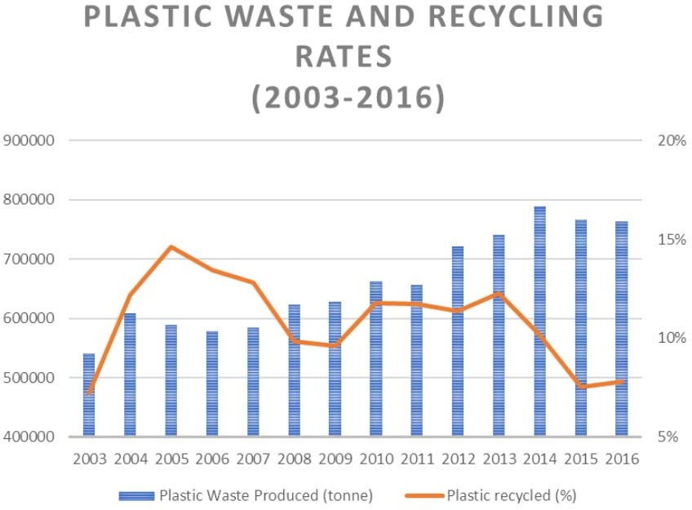
Plastic Recycled (%)
Plastic Waste Produced (tonne)
Source: National Environmental Agency (n.d.). Waste Statistics and Overall Recycling
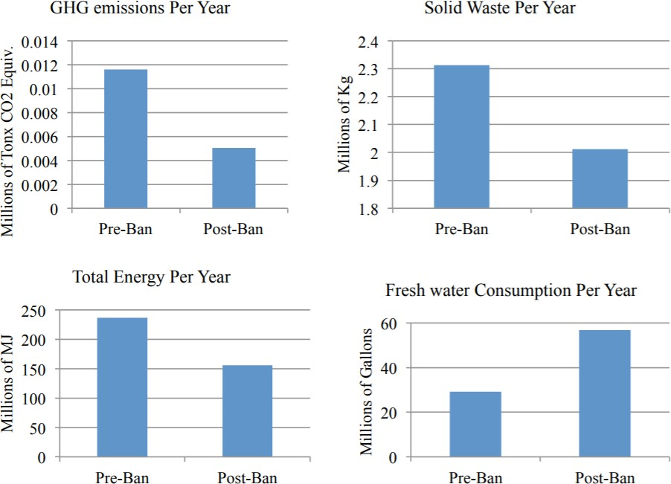
Figure 2: Change in environmental impacts of Pre- and Post-Ban Bag-use in San Diego
GHG emissions Per Year
Solid Waste Per Year
0.014
0.012
0.010
0.008
0.006
0.004
0.002
0
Pre-Ban
Post-Ban
Total Energy Per Year
250
200
150
100
50
60
40

20
0
Pre-Ban
Post-Ban
0
Pre-Ban
Post-Ban
Fresh Water Consumption Per Year
Post-Ban
Pre-Ban
2.4
2.3
2.2
2.1
2.0
1.9
1.8
Millions of Tonx
CO2 Equiv.
Millions of Kg

Footnote: GHG – Greenhouse gas; MJ – Megajoule; Fresh Water consumption due to paper bag production and washing of reusable bags
Millions of MJ
Millions of Gallons
Source: Center for Sustainable Energy, Plastic Bag Bans: Analysis of Economic and Environmental
impacts, 23 October, 2013

Extract 1: A War the World Must Win

Kathmandu alone uses around 4,700,000 to 4,800,000 plastic bags daily. In Nepal, 16 per cent of urban waste is comprised of plastic, which is 2.7 tons of daily plastic garbage production.

Besides the sheer quantity of plastic waste being produced, one of the major problems with plastic is its resistance to degradation. A conservative estimate puts the average time for one single plastic bag to completely biodegrade at 500 years. This means that not only most of the plastic we use during our lives will outlive us, but that our plastic footprint also will affect the generations to come.

The Hindu Kush Himalaya covering the connected mountains of eight countries — Afghanistan, Bangladesh, Bhutan, China, India, Myanmar, Nepal and Pakistan — are the source of ten great rivers that provide drinking water, irrigation, hydropower and life, and eventually reach the oceans. The flow of water from the Himalayas to the oceans also carries plastics and solid waste, posing a threat to both ecosystems and people in the mountains, plains and seas. In Nepal, plastic waste is well known for clogging the rivers and streams in the mountains and hills, resulting in flash floods.

Source: A War the World Must Win, The Statesman, 3 July 2018

Extract 2: England's plastic bag usage drops 85% since 5p charge introduced

The number of single-use plastic bags used by shoppers in England has plummeted by more than 85% after the introduction of a 5p charge last October, early figures suggest.

More than 7bn bags were handed out by seven main supermarkets in the year before the charge, but this figure plummeted to slightly more than 500m in the first six months after the charge was introduced, the Department for Environment, Food and Rural Affairs (Defra) said. This shows that plastic bag consumption can be price-sensitive to UK consumers.

Retailers with 250 or more full-time equivalent employees have to charge a minimum of 5p for the bags they provide for shopping in stores and for deliveries, but smaller shops and paper bags are not included. There are also exemptions for some goods, such as raw meat and fish, prescription medicines, seeds and flowers and live fish.
Source: Adapted from England's plastic bag usage drops 85% since 5p charge introduced, The
Guardian, 30 July, 2016

Extract 3: Designing a solution to plastic bag waste that fits

Plastic bags are given out freely with purchases at supermarkets. Approximately 3 billion plastic bags were used in Singapore in 2011, resulting in an average of 1.6 plastic bags used per person on a daily basis. This high annual usage of plastic bags has been cause of much concern from environmentalists and concerned members of the public alike.
Several countries and cities around the world have already introduced legal measures such as plastic bag levies and taxes, to put an end to the practice of shoppers receiving an unlimited

amount of plastic bags at no charge. These financial disincentives take two main forms – taxes that are enforced on plastic bag manufacturers or importers for the plastic bags sold by them and levies that are imposed on consumers at the point of sale. On a worldwide scale, more than 75 countries have taken steps to reduce the consumption of single-use plastic bags. About one- third of these have instituted bans, approximately one-third have instituted fees. A tax on plastic bags would be the most direct and effective way of correcting this market failure.
On the other hand, environmental advocates, while encouraging the recycling of plastic bags, propose several alternatives to traditional plastic bags, including biodegradable or compostable bags for single-use purposes, paper bags for single-use purposes, reusable bags made from low density polyethylene (LDPE) or non-woven polypropylene, and cotton tote bags. However, in the real world, recycling carries costs that are often overlooked. For example, recycling paper could cause more severe water pollution or soil contamination as the removal of ink from paper requires harsh chemical treatment, with the resultant sludge needing to be disposed of somehow. The process of recycling could also be more energy intensive than the extraction of raw materials.
Source: Multiple sources

Questions
- Describe the trend of plastic waste production and plastic recycled from 2010 to
2016. [2]

- Explain the probable price elasticity of demand for plastic bags in the UK. [3]

- (i) Explain the source of market failure for the plastic bag market mentioned in Extract 1. [2]

(ii) With the use of a diagram, illustrate how free provision of plastic bags
worsens the issue of market failure identified above. [5]

- With reference to Extract 3 and any other data, comment on the effectiveness of the solutions proposed by the environmental advocates to reduce consumption of
plastic bags in Singapore. [8]

- Assess the factors the Singapore government should consider when deciding between imposing a ban and a tax on plastic bags. [10]

[Total : 30]

