Suggested Answers for CSQ 1

a) Explain whether free primary school education possesses the two characteristics of a public good. [4]
Non-rivalry: Non-rivalry in consumption means that the consumption of the good does not reduce the total supply available to others. [1m] Primary school education is rivalrous (There are limited student headcount in schools). [1m]
Non-excludability: Non-excludability in consumption means that once the good is made available, it is difficult or costly to exclude non-payers from consuming it. [1m]
Primary school is excludable. It is easy to deny entry of the non-payer into the school as all students must be registered. [1m]
b) i) Extract 2 stated that “tuition is worth more than a billion dollars annually here, almost double the $650 million spent on it in 2004.”
Account for the growth of the billion dollar Private Tuition industry. [5]
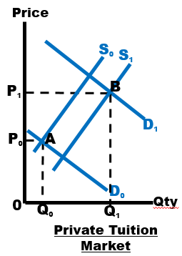
- Increase in demand (↑P&Q): “doing well at national examinations is a priority for many parents and students.” (Extract 2, para 2) [1m]
- Increase in supply (↓P&↑Q): “number of tuition centres has steadily grown” (Extract 2, para 2) [1m]
- ↑DD > ↑SS [1m], thus increase in PxQ (Growth) is substantial. [1m]
- Accurate diagram showing double shifts, explain [1m]

ii) Explain the likely opportunity cost of parents spending several hundreds or thousands of dollars on tuition each month. [2]
- Opportunity cost - net benefit that could have been derived from the next best alternative forgone as a result of a decision made
- Forgoing ‘big ticket’ items e.g. upgrading the home (house), purchasing a family car, family holiday trips etc. (explain how an item is the next best alternative given up for the expenditure on tuition). [1m]
iii) Explain the likely value of price elasticity of supply for tuition services. [3]
- PES measures the responsiveness of quantity supplied of a good due to a change in the price of the good itself, ceteris paribus. [1m]
- Elasticity of supply is dependent on the availability of ‘qualified tutors’ (Extract 2, para 3). Since it is difficult to increase the number of tutors in a short time period in the tuition services, should there be a rise in price, quantity supplied for tutors rise less than proportionately. [1m] Thus, supply for tuition services is price inelastic thus PES<1. [1m]

c) In Extract 3, the author claims that “available subsidies are not able to keep up with education demand”. Explain how this affects the affordability of education to students. [5]
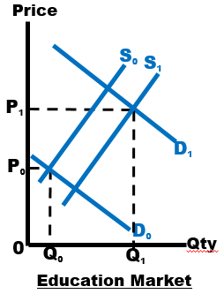
- Increase in number of students (Extract 3, para 3), increase in demand, price of education rises, making education less affordable. [1m]
- Subsidies increase supply of education, price of education decreases, making education more affordable. [1m]
- However the increase in demand is greater than the increase in supply, therefore price and quantity of education still rises [1m], price increases, reducing the affordability of education to students. [1m]
- Accurate diagram showing double shifts and rise in price of education. [1m]
*Subsidy to consumers accepted as well (Edusave)
d) Discuss the factors one should consider in deciding whether to pursue an overseas education. [8]
Synopsis: Students are to adopt the decision making model to analyse and evaluate the factors of consideration in the pursuit of overseas education.

Introduction:
- Provide an overview of the approach to be taken: Consumers would make consumption decisions that maximize their own well-being or satisfaction (utility maximization)
- Intended consequence/Objective of a student in pursuing an overseas a university education: Earn a higher income from having better qualifications and more sophisticated skill sets.
- Introduce the factors of decision making (benefits, costs etc.).

Body:
Benefits of overseas education (From Extract 4):
- Increased employment opportunities higher pay better future material SOL
- Availability of courses offered access to courses that are limited or unavailable in Singapore increase private satisfaction of entering a course of choice.
- Learn other cultures exposure to new experiences not available in Singapore improve individual’s non-material standard of living
- Suitability of teaching & learning approaches better learning experience (higher satisfaction from education)
- Develop personal skills (e.g independence) improve employability better future material standard of living.

Costs of overseas education (From Extract 4):
- Financial costs (expensive S$60,000 per year) opportunity cost, lower present material standard of living
- Difficulties of living alone (homesickness) higher private cost as compared to studying locally

Other possible factors:
Constraints of overseas education:
These could be financial constraints that the student faces. The amount of savings and ability to access loans could affect a student’s decision to pursue overseas education. The degree of financial dependency a prospective student’s family has on him/her might also be another factor as he/she may need to earn an income for the family and hence decide against furthering his/her studies overseas. The student would also need to meet the university admission criteria to be enrolled in a course.
Information of overseas education:
- Does the expected increase in future income from being a graduate outweigh the eventual costs of pursuing an overseas education?
- Uncertain information about the job market situation in future, e.g. if there is demand for workers with the skills that he/she is equipped with in the course of study.

Perspective:
In deciding whether to pursue overseas education, the prospective student may also have considerations beyond the self, e.g. his/her parents’ wishes, or if he/she is able to purposefully contribute to the community with the skills gained.

Unintended consequence of overseas education:
A prospective student who decides to enrol into overseas education in pursuit of higher qualifications might not have adequate skills which might be relevant to the future nature of work.
Changes:
- A crisis which occurs in the course of the prospective student’s study, for e.g. he/she faces health or emotional issues, may have an impact on the student’s decision to continue or alter his initial decision.
- Other changes could affect an individual’s decision to pursue overseas education. For example, a sudden rise in university fees may result in a re-examination of the decision.

Evaluative Judgement:
- The most important factor that the student will consider will be the benefits of pursuing an overseas education. In today’s fast changing world, where knowledge and skills get obsolete quickly, those keen on pursuing entrepreneurship might not want to devote critical years to pursuing higher learning, but to ride on the wave of technological change to embark on start-ups. Should benefits outweigh the costs, the student will then pursue overseas education.
- However to make a better informed choice, accurate information on the costs and benefits of overseas education is required such as does the expected increase in future income from being a graduate outweigh the eventual costs of pursuing an overseas education. Hence, accurate information is second to playing an important role in determining whether to pursue an overseas education.
Knowledge, Understanding, Application and Analysis
- L2 Question requirements are interpreted accurately.
- Appropriate economic concepts, theories and principles are used. Economic analysis is accurate, complete and well supported by contextual evidence. Factors considered clearly linked to satisfaction maximisation.
Appropriate diagrams are used to support economic analysis, where relevant. 4 – 6
- L1 Question requirements are interpreted inaccurately.
- Inappropriate economic concepts, theories and principles are used. Inaccurate economic analysis.
Inappropriate or wrong diagrams are used. 1 – 3
Evaluation

E Evaluative comments are well-explained and supported by economic analysis. 2
Unexplained evaluative comments. 1

e) (i) With the aid of diagrams, explain why there is an inefficient allocation of resources in the market for secondary and junior college education. [6]

Secondary and junior college education can be considered a merit good. A merit good is a good that the government considers to be socially desirable. A merit good is usually under consumed and thus results in the market to fail to provide the sufficient amount.

There are three main reasons why the market for secondary and junior college education may fail. It will be firstly the presence of high positive externalities, secondly imperfect information.

The first reason why market for secondary and junior college education fails is due to presence of positive externalities. A positive externality gives rise to external benefit which arises when first party actions generates benefits to a third party without the latter having to pay for them. In the case of secondary and junior college education, there are external benefits to the third party when individuals pursue secondary and junior college education.

When individuals consume secondary and junior college education, they will pursue to maximise their Net Private Benefit (Total Private Benefit – Total Private Cost). The Private benefit of consuming secondary and junior college education includes, the improvement in knowledge and ability to secure a higher paying job, place in university etc. The private cost of secondary and junior college education would include the fees as well as the opportunity cost of forgone income as one pursues education.

In consuming secondary and junior college education, the first party ignores the benefits accruing to third parties such as stimulating innovation and economic growth (Science, technology, engineering, and mathematics graduates appear to generate especially strong external effects, due to their role in stimulating innovation and economic growth – Extract 5).
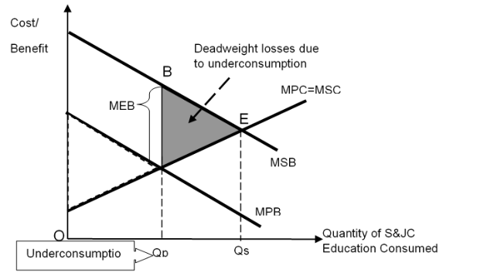
Fig 1 : Market Failure due to existence of positive externality

When positive externalities exist, marginal social benefit (MSB) will be larger than the Marginal private benefit (MPB), as shown in figure 1. The first party will strive maximise their Net Private Benefit (NPB) by consuming quantity Qp, where MPB=MPC. However, the output that maximizes Net Social Benefit (TSB-TSC), also known as the socially optimal output, Qs, occurs when MSB=MSC. Since Qs is greater than Qp, there is under-consumption of secondary and junior college education resulting in deadweight loss, as shown by the shaded triangle. Thus the presence of positive externality causes the market to fail. [3m]

The second reason that can cause the market for secondary and junior college education to fail is imperfect information. Here the first party do not have enough knowledge (absence of certain knowledge) to decide on the output that would maximise their net private benefit. For example, students may not be fully aware of the returns to education and get little information on universities and the careers prospects and future earnings of graduates after they have moved into the labour market.

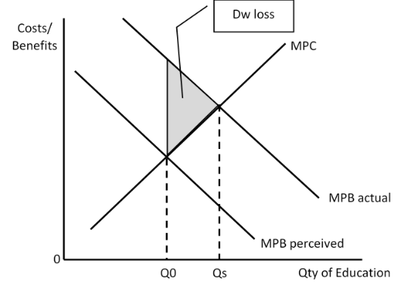
As seen in figure 2, the uninformed individuals will perceive their marginal private benefit, MPB, (and their demand) to be lower than what it actually is. This leads to the uninformed individuals believing that the quantity to be consumed is at Qperceived where MPBperceived = MPC (instead of Qactual where MPBactual = MPC) to maximise their net private benefit. Since Qactual is greater than Qperceived, there is under-consumption of university education resulting in deadweight loss, as shown by the shaded triangle. Thus the presence of imperfect information causes the market to fail. [3m]
Figure 2

(ii) Using evidence from the case study and/or your own knowledge, discuss whether free provision is the best approach in addressing the inefficiencies in the market for secondary and junior college education. [12]
Intro: Presence of positive externality and imperfect info have resulted in inefficiency in the market for secondary and junior college education. This answer will look at the merit and demerits of free provision as well as other approaches to address the inefficiencies.

Thesis: Free provision is the best approach
To correct market failures due to positive externalities, the government can engage in direct provision to increase the supply. For example, the Singapore government engages in direct provision of secondary and JC education through public schools to increase the supply and hence correct the market failure.

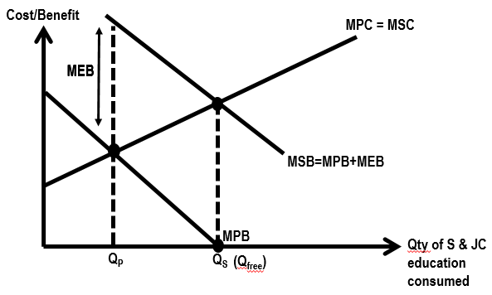
Show how Free Provision works
Consumers would maximize their net private benefits by equating its MPB to its MPC of secondary and JC education consumed (i.e. at Qp). But the social optimal output is at Qs (Q_{free}) which is also the quantity of secondary and JC education that would be consumed if price=0, therefore free provision at the output level of Qs is justified.

Anti-thesis: Free provision is not the best approach

Limitations of Free Provision
- Even though secondary and JC education is under-consumed, the government decision to provide that good free of charge to consumers may not be justified.
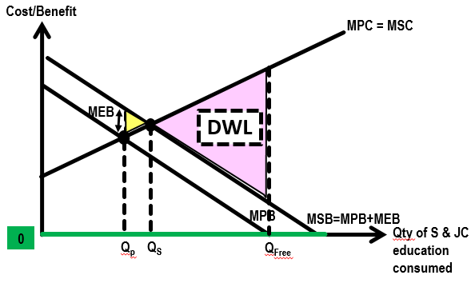

Due to the positive externality that arises from secondary and junior college education consumed, there is an under-consumption of secondary and junior college education. If secondary and junior college education is give free of charge (100% subsidised), consumers would choose to consume at output Q_{free} (see Figure). At this output there would be an overconsumption of secondary and junior college education as Q_{free} is more than the socially optimal level of Qs. There is also a greater deadweight loss. Hence, in this case it is not justifiable to provide secondary and junior college education for free. Efficient allocation of resources would be attained if a subsidy (not amounting to 100%) is provided such that consumption is at Qs.

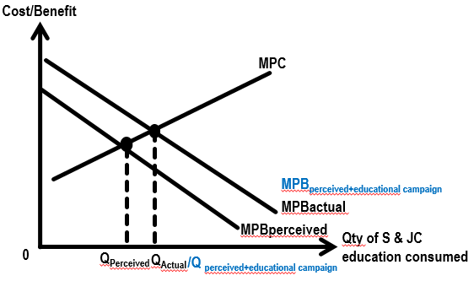
- Imperfect information in the market for secondary and JC education not addressed by free provision. For the case of imperfect information, the problem of consumer ignorance can be reduced through educational campaigns or advertisements to raise public awareness. All these advertisements aim to raise the perceived MPB to their actual MPB, so that the consumption of these goods will be at their optimal output levels as shown in Figure at output level Q_{perceived+educational campaign}. Hence, government intervention is necessary to help improve on the efficient allocation of resources.

Alternative Policies
- Consumption subsidies, bursaries & study grants

While the subsidy is generally given to producers, there are instances whereby subsidy is given to consumers directly. With reference to Figure below, when government provide subsidy to the consumers, the marginal private cost for consumers is reduced. Assuming the amount of subsidy is the same as the MEB, the consumer’s MPC will decrease and eventually consumer achieves socially optimal level of output where societal welfare is maximised at Qs.

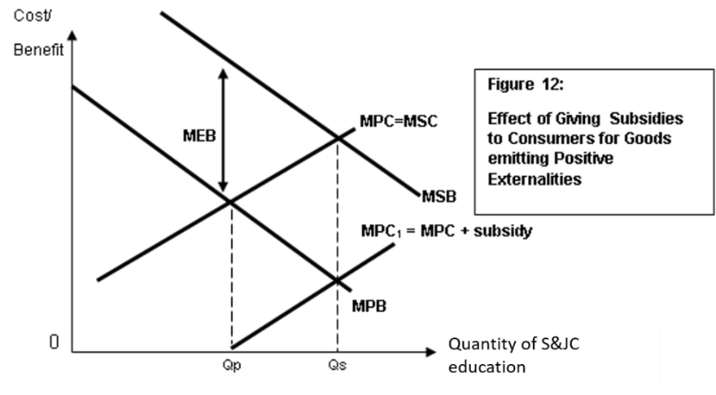
Advantages of subsidy
- This market-based measure rewards first parties for bringing benefits to third parties – an incentive element where the internalization of third party effects that allow for more production or consumption to take place leading to more efficient resource allocation.
- Subsidies can be varied according to the magnitude of the positive externality.

Disadvantages of subsidy
- Government needs to incur monitoring costs and the use of resources that may make fewer resources available in other markets.
- Government may over-subsidise or under-subsidise (choose either to talk about) if it cannot measure the MEB accurately given that it is difficult to monetise the external benefit enjoyed by the third party. Hence government is not able to determine the amount of subsidy to be provided. This may limit the effectiveness of the intervention towards achieving efficient allocation of resources. However, the subsidy provided (regardless of under-subsidizing or over-subsidizing) still helps to reduce the problem of under-consumption in the market.
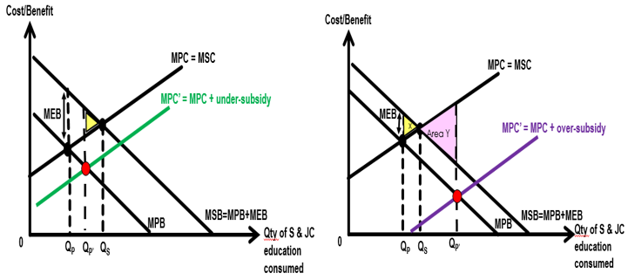
- It should also be noted that ensuring production levels does not always ensure the desired levels of consumption. Hence, other measures must also be implemented to achieve the desired effect.

- Rules and Regulation/Legislation
Compulsory education to ensure consumption of secondary and JC education is at the social optimal level (at Qs).

Advantages
- Rules and regulations are clear and simple to understand as well as easy to administer.
- Desired social outcome has a greater likelihood of being achieved as the market quantity (and hence allocation of resources) can be set by the government.

Disadvantages
- It incurs a compliance cost. The penalties for non-compliance must be sufficiently harsh and enforcement must be sufficiently frequent and rigorous for the regulation to be an efficient. This however, may imply the use of additional scarce resources which may pose a strain on the efficient resource allocation in other markets. The measure would be deemed to have failed if the deadweight loss created in other markets is greater than the welfare gains in the regulated market.
- Furthermore, legal restrictions tend to be a rather blunt weapon. It may remove the incentive of the parties involved from making personal choices not to add to the external costs. Legal limits to consumption would also erode the influence of consumer sovereignty in the marketplace.

Conclusion
Take a stand on whether free provision is the best approach in addressing the inefficiencies in the market for secondary and JC education. Substantiate with economic analysis looking at multiple factors such as timeframe, ease of implication etc. In general, when markets fail, governments should intervene, using appropriate intervention methods only when the benefits of intervention outweigh its costs. Furthermore, free markets could be efficient in the allocation of resources in the absence of market failure, and any form of government intervention would certainly worsen the efficient workings of the free market. Hence, governments should not intervene under such circumstances. This is why there is less agreement over the extent to which market fail especially in the case of imperfect information as each and every individual perceives the value of the good or service they consume differently.

Possible Conclusion:

Free provision is not the best approach in reducing the inefficiencies due to positive externality.

Firstly, free provision cannot be used to address inefficiency due to imperfect info since the root cause is not tackled. Secondly, to decide on the exact quantity of secondary and JC education to be consumed that will exactly reach socially optimal output level will be difficult due to the varying private benefit and cost of each student. Thirdly, subsidies would be better in this case since MPC falls and extent of subsidy is dependent on MEB but even monetising the value of MEB could result in inaccuracy.

Thus, the best approach would be compulsory education. It is said that science, technology, engineering and mathematics graduates generate strong external effects and thus contributes substantially to economic growth. In secondary and JC, the emphasis on science and math is large thus secondary and JC education compulsory will gear the students towards that direction.

Knowledge, Understanding, Application and Analysis
- L3 Question requirements are interpreted accurately.
- Appropriate economic concepts, theories and principles are used. Economic analysis is accurate, complete and well supported by contextual evidence. 3 policies well explained and discussed.
Appropriate diagrams are used to support economic analysis, where relevant. 6 - 9
- L2 Addresses some question requirements accurately.
- Some appropriate economic concepts, theories and principles are used. Economic analysis is accurate but incomplete.
- Attempts to address the context of the question but is incomplete.
[Total: 45 marks]

