Economics MCQ – Chapter 1 – Central Problem of Economics

Q1. Sam wrote a list of how he would prefer to spend his Saturday afternoon.

First choice  Second choice  Third choice  Fourth choice | Go to a cricket match  Watch the annual town parade  Go to the cinema  Visit relatives

Unfortunately a thunderstorm caused the cricket match and the town parade to be cancelled. Sam went to the cinema.

What was the opportunity cost of going to the cinema?

- going to the cricket match
- watching the town parade
- visiting his relatives
- losing his Saturday free time
( )
Q2. How does a production possibility curve show that scarcity exists?

- It shows that a rise in demand for one of the products increases its price.
- It shows that as more resources are used to produce a product, its price rises.
- It shows that at any point outside the production possibility curve an economy is wasting resources.
- It shows that there is a limit to the quantity of products that can be produced with existing resources and technology.

( )

Q3. A generating station was built to supply electricity to a rural village in Africa.
What was the opportunity cost to the local economy?

- the charge the villagers had to pay for the electricity
- the cost of the building materials
- the school that was not built as a result
- the wages of the workers

( )

Q4. An economy produces different types of goods using its limited resources. This can be illustrated by a production possibility curve.
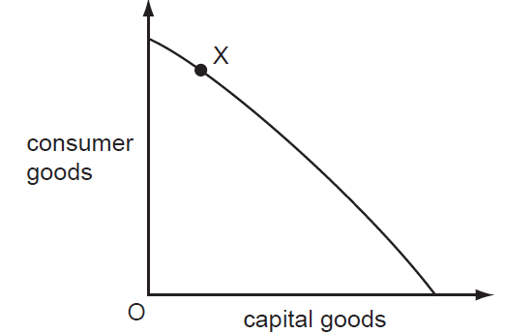

What does point X on the production possibility curve show?

- All resources are used for the production of consumer goods.
- More resources are allocated to producing capital goods than consumer goods.
- Resources are allocated to produce a mixture of consumer and capital goods.
- Total resources are not being fully utilised for production of these goods.

( )

Q5. In China the government is concerned about the level of poverty and the need for more resources in the poorer regions of the country. As a result, it is increasing its expenditure there and reducing it in the wealthier regions.

Which economic concept does this government policy illustrate best?
- diseconomies of scale
- market forces
- opportunity cost
- specialisation
( )

Q6. A country with a low income per head discovers large quantities of oil, which eventually makes everybody better off.
Why is the basic economic problem of scarcity not solved by this discovery?
- People may not get jobs in the oil industry.
- People’s wants are always changing and increasing.
- Prices of oil can fluctuate on the world market.
- Production of oil can damage the environment.

( )

Q7. Every business organisation faces the problem of satisfying wants.
What is the reason why wants are not fully satisfied?
- An economy can only produce a limited amount of goods and services.
- Governments cannot print enough money to pay for goods and services.
- There is an over-production of goods and services by business organisations.
- Workers are too skilled for the requirements of the jobs available.

( )

Q8. A university rejects 2000 qualified applicants who wish to study there.
What factor of production could have caused the university to make this decision?
- infinite quantity of capital
- scarcity of labour
- surplus of land
- unlimited supply of enterprise

( )

Q9. The diagram shows the choices for an individual between leisure and earnings.

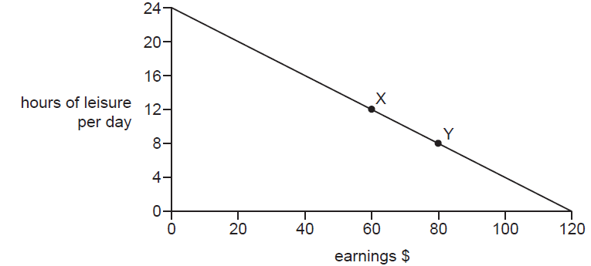

What is the opportunity cost to the individual of the extra earnings when moving from position X to position Y?
- $20
- $80
- 4 hours of leisure per day
- 8 hours of leisure per day

( )

Q10. What makes choice an important element in the basic economic problem?
- Increased demand leads to higher market prices.
- Limited resources have many alternative uses.
- Reaching a market equilibrium may take a long time.
- Scarce economic resources are distributed equally.

( )

Q11. A government is faced with the choice of spending on either education or healthcare.
Of what is this an example?
- conservation of resources
- monetary policy
- opportunity cost
- substitution of factors

( )

Q12. What is the basic economic problem facing all societies?
- how to achieve price stability
- how to keep employment levels high
- the extent to which incomes should be redistributed
- what will be produced, how and for whom
( )

Q13. Commercial companies are cutting down tropical rainforests for hardwood timber.
What is the opportunity cost to society of this activity?
- tax revenue from the sale of the timber
- the environment that is destroyed
- the products made from the timber
- the profits of the companies
( )
Q14. A hospital cannot treat all the people that need medical care.
This is an example of
- excess supply.
- limited wants.
- scarcity.
- unlimited resources.
( )

Q15. The table shows the various combinations of food and clothing which a village can produce using all its resources.
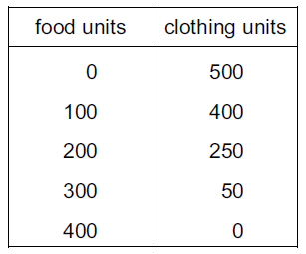

What is the opportunity cost to the village of increasing the production of food from 200 to 300 units?
- 50 units of clothing
- 100 units of clothing
- 200 units of clothing
- 250 units of clothing
( )

Q16. An economy is producing at X.
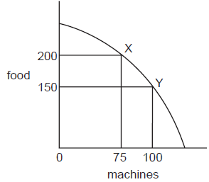
What is the opportunity cost of choosing to produce at Y instead of X?
- 25 machines
- 50 units of food
- 75 machines
- 150 units of food
( )

Q17. Construction companies are building new houses on land previously used for farming.
What is the opportunity cost to society of this activity?
- improved living conditions
- less congestion in city centres
- more homes for new homeowners
- some farm output
( )

Q18. A factory working at full capacity is producing tennis racquets and golf clubs. The management decides to produce fewer racquets and more clubs because of an increase in demand for golf clubs.

What is the opportunity cost of producing more golf clubs?
- the cost of retraining some workers to make golf clubs
- the cost of transporting and selling the extra golf clubs produced
- the materials bought to make extra golf clubs
- the tennis racquets that will not now be produced

( )
Q19. Which statement best explains why drought is an economic problem?
- Drought cannot be controlled.
- Rainfall is unreliable.
- The effects of drought involve the government.
- Water is a scarce good.
( )

Q20. In 2002 the government of Zimbabwe diverted US$18 million, originally intended to support private business, to help feed millions of people threatened by famine. Some of the money was used to import up to 1.8 million tonnes of corn.

What was the opportunity cost to Zimbabwe of this decision?
- the cost of the extra food
- the cost of the 1.8 million tonnes of corn
- the effect on private business
- the US$18 million
( )

Q21. An unemployed worker accepts a job.

Which of the following is the opportunity cost of this decision?
- the cost of travel to work
- the income from the new job
- the leisure time lost
- the training in the new job
( )

