Question 2: Education and productivity in Latin America

Table 2: Selected indicators of Latin American countries (2016)

 | Adult Literacy Rate | Life Expectancy (years) | GDP per capita (USD) | GDP per capita (PPP)
Argentina | 99.0 | 76.5 | 10 044 | 23 300
Brazil | 93.2 | 75.7 | 11 080 | 14 952
Mexico | 95.4 | 75.0 | 10 404 | 20 396

Source: World Bank

Extract 6: What is holding Mexico’s economy back?
With the election of a new president in Mexico, might Mexico see a higher rate of growth? Its economy has grown at a rate of about 2 percent per year for about a quarter century, about half the pace of other emerging nations. The sad reality is that the new Mexican regime probably cannot improve its economic performance unless it can address the basic problems with education and productivity.

Education is arguably Mexico’s most fundamental problem. In most emerging economies, if workers are ambitious and seek higher wages, they will invest in more education. Mexicans have traditionally had another choice — crossing the border to work in the United States (US. Mexicans who make this choice can move from earning 1 or 2 US dollar a day to 10 or 15 dollars an hour, though with higher living costs. It is hard to beat that boost simply by finishing high school or even college in Mexico.

So a lot of Mexico’s most ambitious lower-income people have an incentive to stop their education rather than invest in it. Near the peak of Mexican migration last decade, about 15 percent of the Mexican labour force was working in the US.

Source: Tyler Cowen, Bloomberg, 10 July 2018

Extract 7: Will more education increase growth in Mexico?

Education tops the to-do list for development experts, and with good reason. A broad understanding that education is central to people’s welfare has led governments to devote considerable resources to increase the coverage and quality of their education systems. While these efforts are certainly welcome, and will undoubtedly increase social welfare, the unstated assumption has been that they will contribute to growth everywhere. In other words, if only the supply of human capital could be enhanced and increased, then growth would accelerate.

Figure 1 depicts the financial returns from education in Mexico from 1996 to 2015. These are measured as the percentage difference in average wages of workers who completed primary education, junior high, senior high, and university education, relative to workers who did not complete primary education.

Figure 1: Returns to Education in Mexico
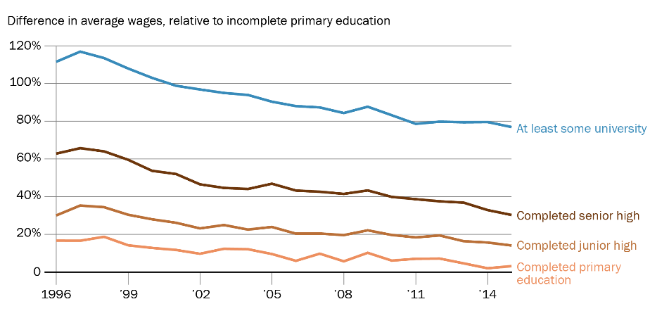

Source: Santiago Levy and Lopez Calva, 2016

The figure illustrates a puzzling trend: why did returns fall for those with more years of schooling? Evidence has shown that the supply of workers with more education has increased noticeably, so the answer to the puzzle must be on the demand side.

The demand for workers of various schooling levels depends on the type of firms present in a given market. In Mexico tortillas are produced by large firms with sophisticated machines, as well as by small firms with simple technologies. The former require engineers, accountants, and managers with business degrees; the latter, only workers with basic literacy and numeracy.

Mexico has numerous small low productivity firms and many self-employed workers in large informal sectors. If somehow the hundreds of small firms could be grouped into one large firm, the productivity of the sector would increase. There is an important debate as to what blocks productivity growth. However the lack of educated workers is certainly not the reason.

Source: The Brookings Institution, 22 March 2018

Extract 8: Can Latin American countries benefit from their large emigrant populations?

Since human interaction is critical for the transmission of knowledge and technologies, migrants can play a crucial role as carriers of knowledge across borders. Evidence shows that migration plays a role in improving industry-level productivity for both sending and receiving countries of migrants.

Given that knowledge transmission requires human interaction, engaging emigrants in programs to improve competitiveness and productivity could yield significant economic benefits. For instance, a firm could benefit from having its workers temporarily train abroad to learn new technologies or gain knowledge that could result in higher productivity upon their return.

Governments can enhance the transmission of knowledge process by encouraging those working abroad to return home, which could translate into faster productivity growth. This productivity boost can be attributed to three reasons. First, migrants are disproportionally more likely to become entrepreneurs, so return migration can increase business dynamism and productivity growth. Second, migrants bring knowledge (such as in technologies, management styles, and understanding of other markets) that can boost innovation and productivity at the firm level to existing firms. Third, return migrants create and foster business relationships with firms in the countries where they lived.

An important policy instrument could be for countries to offer fiscal incentives to encourage return migration. For example, the income tax rate could be reduced for a number of years upon return. The incentive structure could be designed such that all migrants benefit regardless of their occupation or skillset or, alternatively, the benefits could be targeted to migrants with experience in and knowledge of industries in which the country has an unrealized advantage. Identifying those industries, however, can be very difficult if not impossible – and letting governments choose at will may lead to corruption or inefficiencies.

Source: Dany Bahar and Ernesto Talvi, The Brookings Institution, 20 March 2018

Extract 9: Mexico launches ambitious economic plan
The Mexican government launched an ambitious plan to stimulate economic activity on the Mexican side of the US-Mexico border, reinforcing the country's commitment to manufacturing and trade, despite recent US threats to close the border entirely.

Mexico will slash income and corporate taxes to 20 percent from 30 percent in some states just south of the US, while halving the value-added tax in the region to 8 percent. Business leaders and union representatives have also agreed to double the minimum wage along the border to US$9.07.

The idea is to stoke wage and job growth via fiscal incentives and productivity gains. US President Donald Trump has repeatedly complained that low wages in Mexico lure jobs away from the US. Mexico committed to boost wages during last year's negotiations to improve its free trade agreement with the US and Canada.

Source: Associated Press and NBC News, 7 Jan 2019

Questions

(a) Using the information in Table 2, explain which country has the highest living standards and comment briefly on the effectiveness of these indicators as a measure of living standards. [6]

(b) Using AD/AS analysis, and with reference to Extract 6, explain how higher wages offered in the US may affect Mexico’s real national income and general price level. [4]

(c) With reference to Extract 9, explain the likely impact of slashing taxes and doubling the minimum wage on Mexico’s general price level in the short and long run. [8]

(d) (i) With reference to Figure 1, compare the trends in returns to education for the different levels of education in Mexico from 1996 to 2014. [2]

(ii) With reference to Extract 7 and using a diagram, explain how the grouping of small firms into one large firm may affect the wages of educated workers. [4]

(e) With reference to Extract 8, assess the impact of a government “encouraging those working abroad to return home” on an economy. [9]

(f) Extract 7 states that “if only the supply of human capital could be enhanced and increased, then growth would accelerate.”

Discuss the view that raising the level of education is the best way for Mexico to increase living standards. [12]

[Total: 45]

Adult literacy rate is the percentage of people, 15 years old and above, who can both read and write with understanding of short simple statements about their everyday life.

