J1 June Intensive Revision 2014

Market Structures (Type I) – Q1

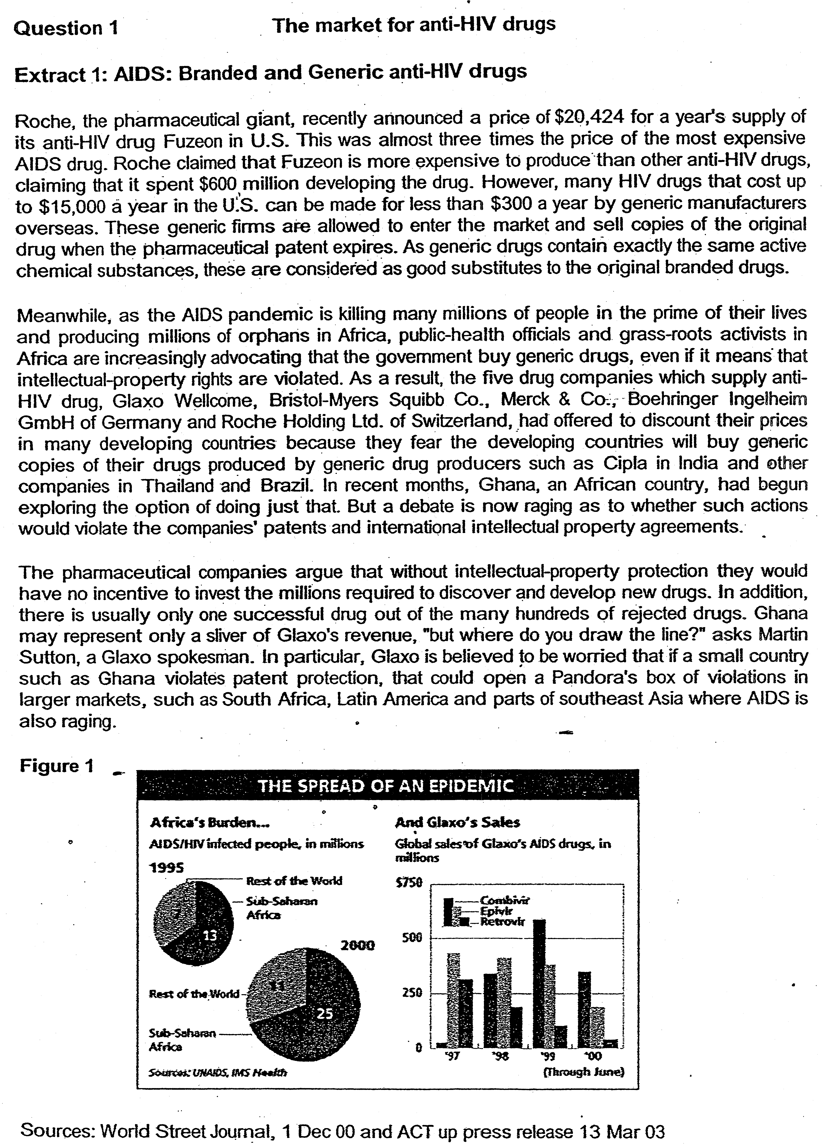

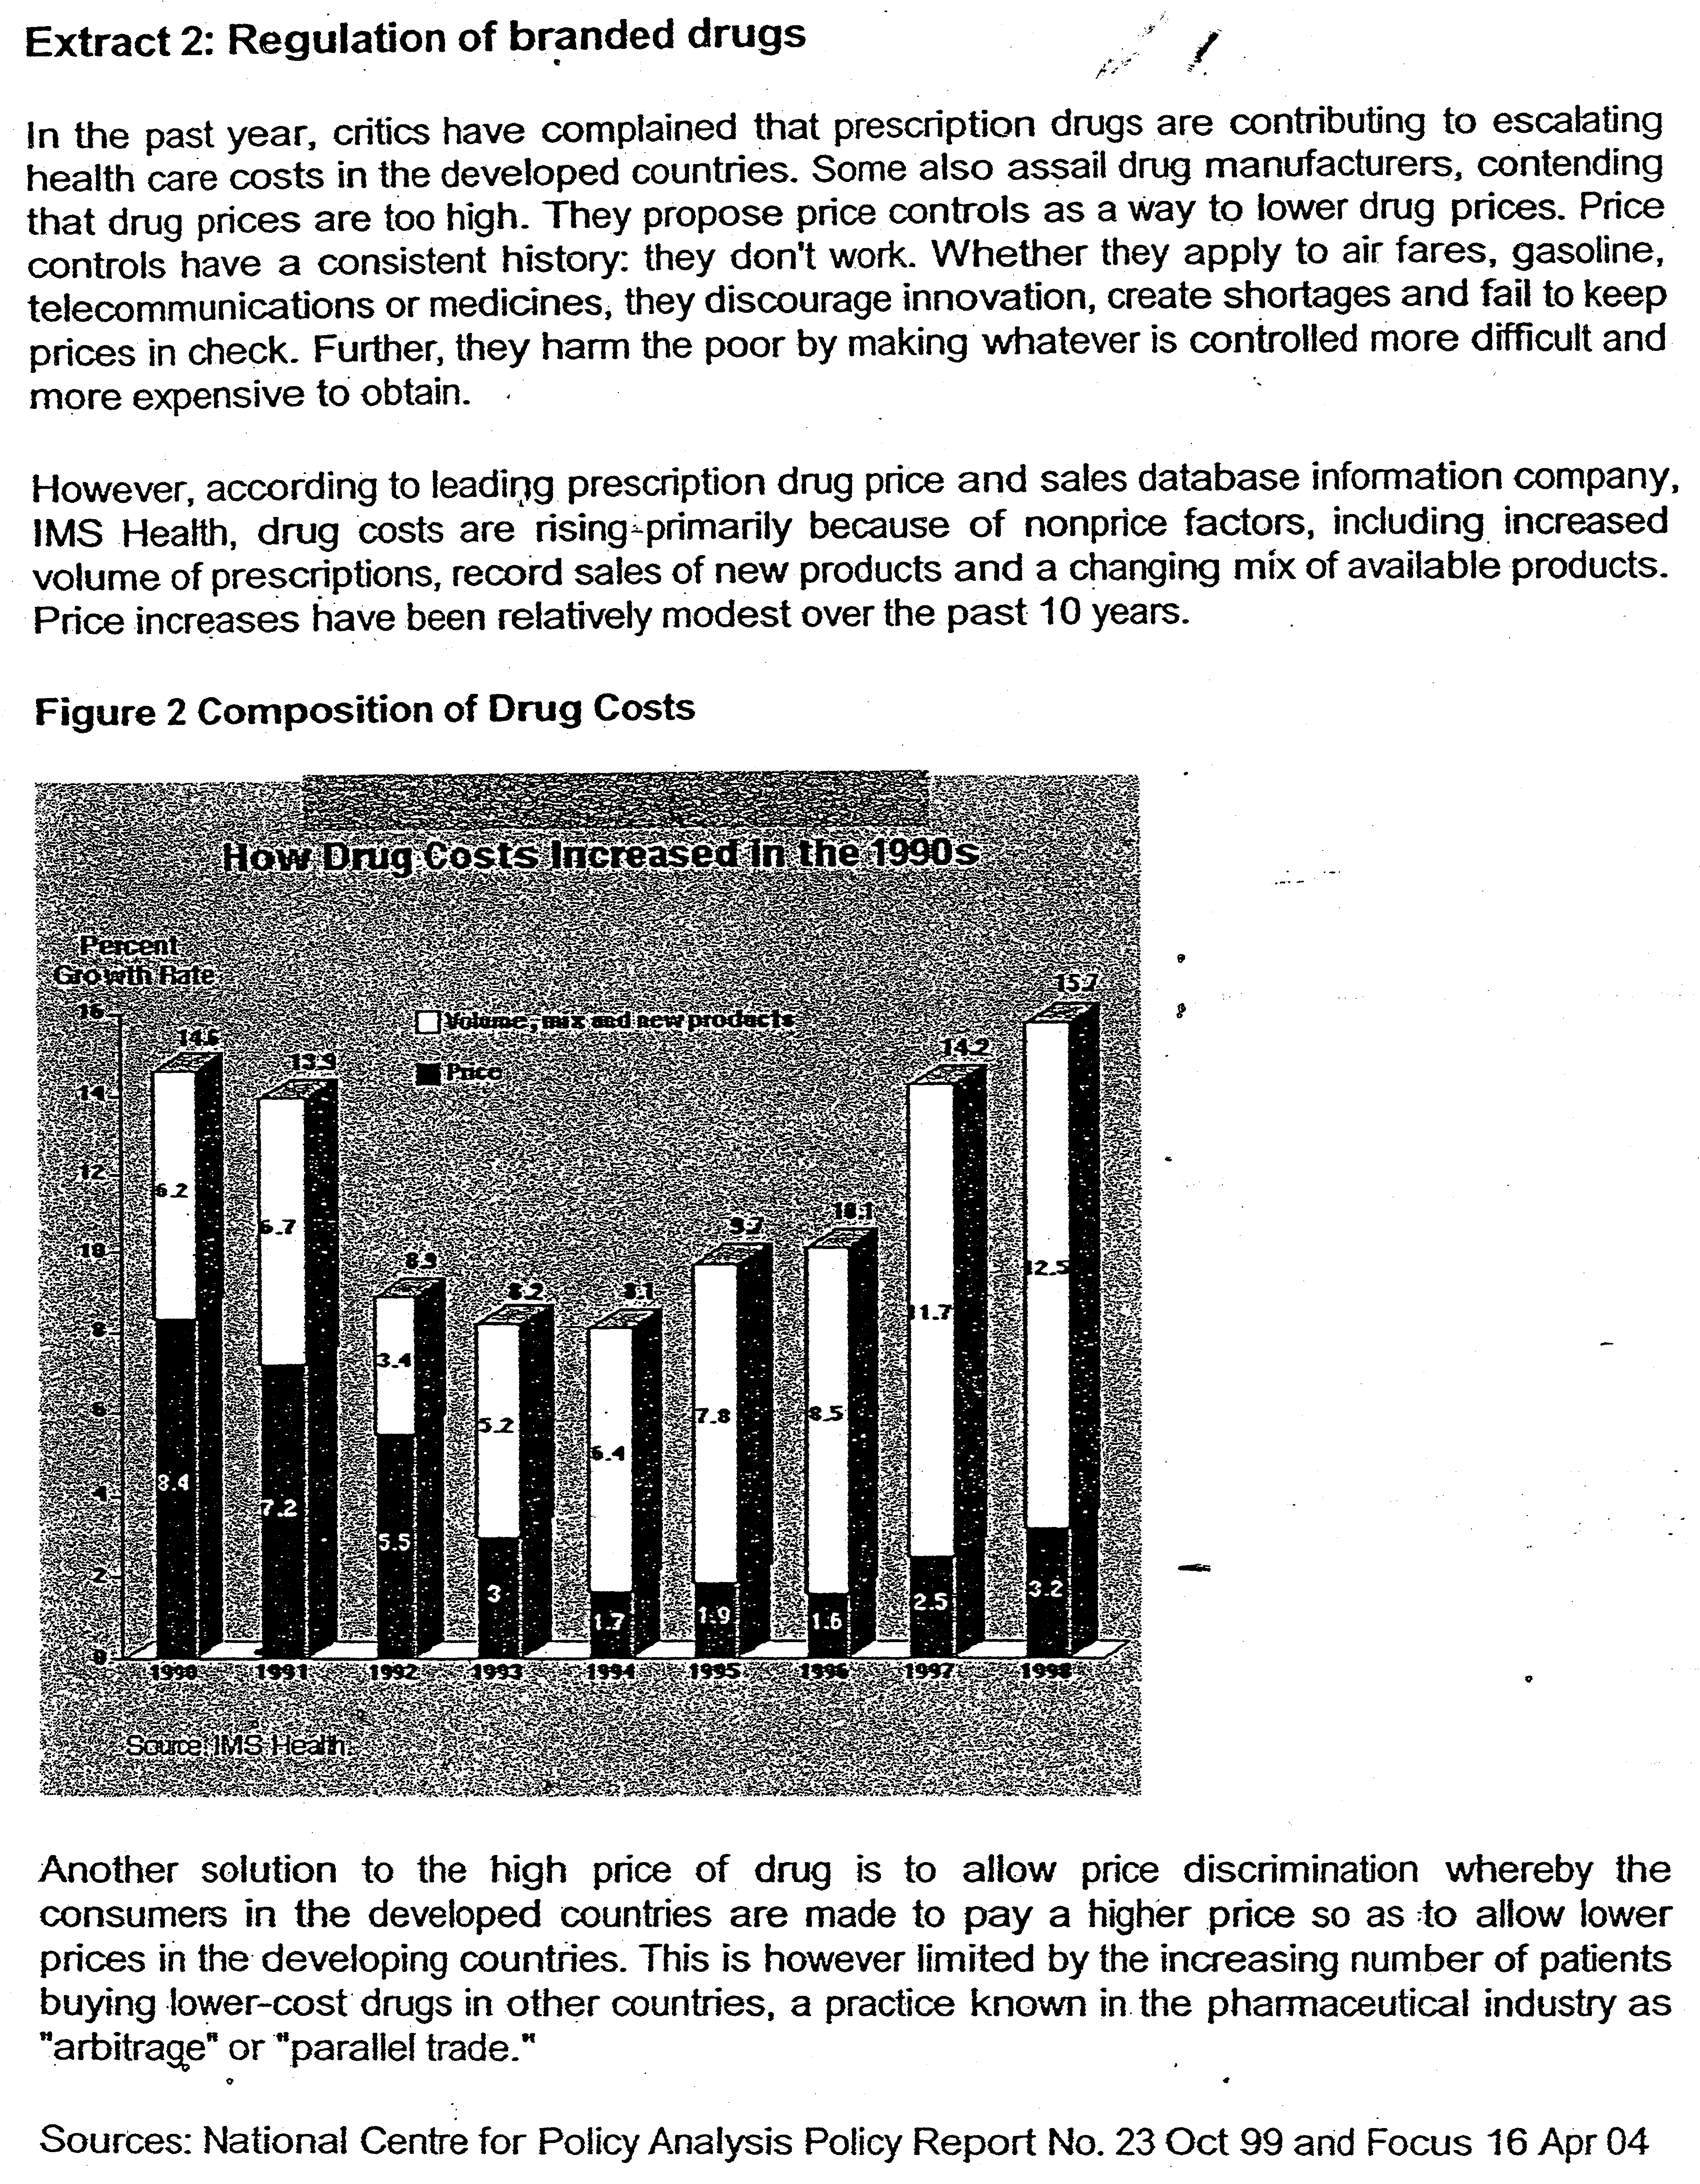

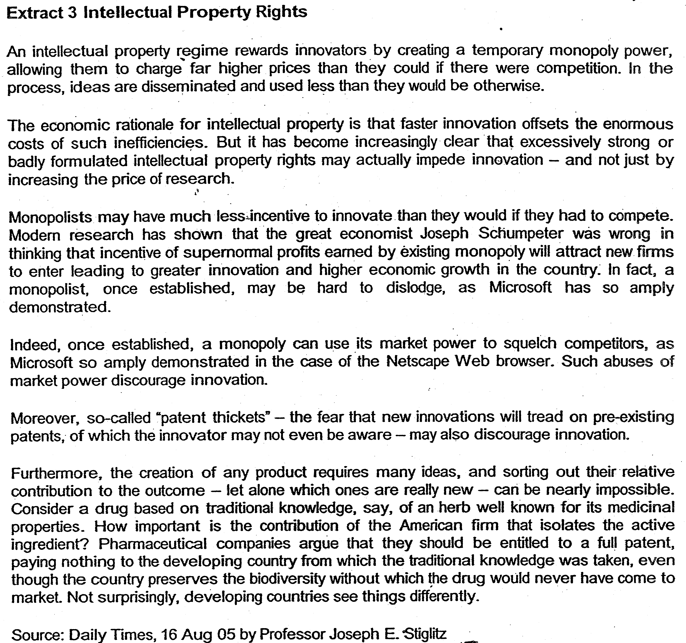

Questions
(a)(i) Describe the changes in sales of Glaxo's AlDS drugs from 1997 to 2000 using Figure 1. [2]

(ii) Using a diagram, explain how the change in number of AIDS patients and entry of generic AIDS drug producers affect the market for branded AIDS drugs.[4]

(b) (i)Drawing evidence from the data, identify and explain the type of market structure that the AIDS drugs producers operate in. [4]

(ii) With the use of data, assess whether government should implement price controls on AIDS drugs. [6]

(iii) Explain how price discrimination works in the market for AIDS drugs and analyse whether price discrimination can be effectively carried out in this market. [6]

(c) Evaluate the desirability of an intellectual property regime for all markets. [8]

Suggested Answers

(a)(i) Describe the changes in sales of Glaxo's AIDS drugs from 1997 to 2000 using Figure 1. [2]
Fell in general for all three [1] except for one of the drug, Combivir which rose in 1999 and fell after that again, [1]

(ii) Using diagram, explain how the change in number of AIDS patients and entry of generic AIDS drug producers affect the market for branded AIDS drugs. [4]

There is an almost 100% increase in the AIDS patients in the whole world with the bulk of the increase coming from sub-Sahara Africa, which belong to the lower income countries. The rise in AIDS patients will lead to an increase in the demand for branded drugs causing the demand curve to shift to the right. However the extent of increase in branded drugs depends on the income level of this new group of AIDS patients. [2]

The entry of generic drugs will lead to a fall in the demand for branded drugs as generic drugs are substitutes to the branded drugs. The extent of the fall depends on cross elasticity of demand between branded and generic drugs. This effect may be weak for new drugs such as Combivir. The net impact on the equilibrium price and output depends on the relative strength of the two events. [2]

(b)(i) Drawing evidence from the data, identify and explain the type of market structure AIDS drugs producers operate in. [4]

AIDS drugs producers are likely to operate in a monopolistic or oligopolistic market [1] This is because of substantial barriers to entry to this market due to high cost of R&D and patents for new AIDS drugs. Thus, there are only few (five) branded AIDS drugs producers with substantial market power to set high price when they introduce new drugs (e.g. high price set by Roche) and large market share of the new branded drugs (e.g. rising sales revenue of Glaxo's Combivir to more than $500m in 1999).

However, with the violation of property rights by developing countries to buy generic drugs, the market may become more monopolistic competitive as the market share of branded anti-AlDS drugs fall.

Evidence of mutual interdependence as branded drugs come together to offer lower prices for their branded drugs in response to low price of generic drugs and to drive out generic drug producers.

Price is not as rigid as it should be suggesting that it may not be oligopolistic but monopolistic competitive. There is inadequate concrete evidence provided such as market concentration to prove that it is oligopolistic.

(ii) With the use of data, assess whether government should implement price control on AIDS drugs. [6]

In this case, the price control takes the form of a maximum price or price ceiling.
It is set below the equilibrium price.

Price ceiling is recommended because it lowers the current price of the costly drug and make it readily available to the lower-income AIDS patients, thus leading to a better distribution of income. This is especially true for rising number of patients in the developing countries. Furthermore, the market for AIDS drugs is imperfect because the demand for AIDS drugs is inelastic and patients may be exploited by the large drug producers due to lack of information- The market power of the AIDS drugs producers may enable them to reduce output to raise price beyond the marginal cost leading to allocative inefficiency and market failure. Thus, price control may be justified to reduce the market power of the large AIDS drugs producers.

On the other hand, a maximum price on AIDS drugs may not be desirable as it reduces the incentive of firms to produce and invest in costly innovation. As a result few new and effective drugs are discovered and there may be a shortage of AIDS drugs in the market as demand exceeds supply. A black market may result causing the price of AIDS drugs to be even higher and to be out of reach for the poor. Furthermore, according to Figure 2, the increase in drug cost is only due marginally to the increase in price of drugs but largely to cost of innovation. This shows that price control may cause the drug producers to incur losses resulting in fewer drugs introduced in the market.

(iii Explain how price discrimination works in the market for AIDS drugs and analyse whether it can be effectively carried out in this market. [6]

Price discrimination refers to the practice of charging different prices for the same good in different markets for reasons not due to cost differences but due to different price elasticity of demand. In this case, higher price is charged in the developed country where the demand is more inelastic and lower price in the developing country where the demand is more elastic. In this way, the drug producer is able to maximize his total revenue.

For price discrimination to work, the producer must be able to control the supply of the good and separate the two markets to prevent resale of the good.

However, in this case, due to parallel sale of the drug from developing to developed country, the markets are not separated and thus price discrimination cannot work. Also, the drug producer may not have market power to control the supply of this drug as the generic drug producers have not complied with the patent and the governments of developing countries allow it to happen.

The falling sales of Glaxo's drug seem to suggest that the branded drug producers are not able to stop the generic drug producers from penetrating the market and thus preventing them from controlling the supply and practice price discrimination. Price discrimination will be more effective if the branded drug producers such as Glaxo can be successful in defending the patent rights and stopping the generic drug producers from penetrating the market.

(c) Evaluate the desirability of an intellectual property regime for all markets. [8J

Intellectual property right protects a firm's innovation from being copied by other firms and thus encourages more innovation. It however acts as a form of barrier to entry to prevent generic producers from entering the market thus giving the branded drug producer the market power to set high price for the drug.

Desirability
The positive outcome of having an intellectual property regime is that it encourages more innovation which is a positive externality. Without an intellectual property regime, producers are less willing to innovate because their innovation not only benefit themselves but can be easily copied and hence benefit other producers. This results in the social benefit of innovation higher than the private benefit As firms only consider the private benefit, they will tend to undertake lesser R&D leading to lesser product and process innovation. Thus, the presence of external benefits implies that the government should regulate to ensure a socially optimal amount of innovation. In addition, innovation involves a high fixed cost and thus cannot be easily affordable by small firms. Only large firms with large reserves and economies of scale will be able to afford it. Large firms need to invest a large amount of money in innovation as there is usually only one successful drug out of many hundreds of rejected drugs. Thus, large firms will only be willing to take up innovation if they are promised a supernormal profit which will reward them for their risky undertaking.

There are also macroeconomic benefits from innovation. Countries will be able to enjoy higher economic growth and healthier balance of payments as their pharmaceutical industry booms. As the income level of people and life expectancy rise, the demand for drug, which is income elastic, will rise more than proportionately.

Thus, the sale revenue of pharmaceutical firms will increase and thus contribute to higher economic growth and balance of payments to the country where it is based.

Innovation helps to increase the aggregate supply of the country and thus increase the potential growth of the country. New and effective drugs also improve the life expectancy of people and thus increase the standard of living of the country.

Costs
However, intellectual property rights lead to greater market power of firms. Thus they may be able to set high price beyond the marginal cost In addition, when the firm becomes larger and earns high supernormal profits, they use their market power to block the entry of new firms thus reducing the competition in the market This leads to allocative inefficiency and welfare is lost This is especially bad for the patients in the developed country who have to foot the high cost of development of new drug to subsidise the poorer patients in the developing countries due to price discrimination.

Professor Stiglitz also argued that an intellectual property regime may actually retards innovation rather than increase it as it deters small firms from engaging in innovation for fear of breaching patents. Many often, new drugs are found in university labs by scientists who do not belong to large firms but their ideas are developed further by large pharmaceutical firms.

Also, a property right regime causes developing countries to lose many of their traditional knowledge as the large pharmaceutical companies in the developed countries blocked their use through patents. This will lead to a slower growth and rising unemployment in the developing countries thus worsening their standard of living rather than raising it There is thus a widening income gap between developed countries which have the capacity to innovate and patent their innovation and developing country which do not have the capacity to innovate and patent

Conclusion (Synthesis)
Intellectual property regime is particularly important in industries such as the pharmaceutical industry where innovation is important It will lead to hew breakthrough in medical research which will benefit a country and the human mankind. However, to prevent the large firms from abusing their market power, patents should not for a given time only. This will motivate the firms to keep on improving on their products so that when their patents expire, they will still be able to keep their market share by coming out with new products. In this way, consumers can still benefit

Furthermore, government should regulate to prevent pharmaceutical firms from setting up unfair barriers of entry to prevent other firms from entering when the patent expires.

In this way, the market for Pharmaceuticals can still be competitive when the patent expires leading to more efficient allocation and higher consumer welfare.

