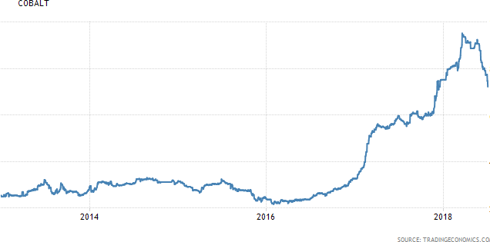
10000
8000
6000
4000
2000
2014
2015
2016
2017
2018
Answer all questions.

Question 1: The Rise of Electric Vehicles

Figure 1: Global price of cobalt (US$ per million tonnes)

Source: Trading Economics, accessed 5 July 2018

Figure 2: Global price of lithium-ion battery (US$/kilowatt-hour)

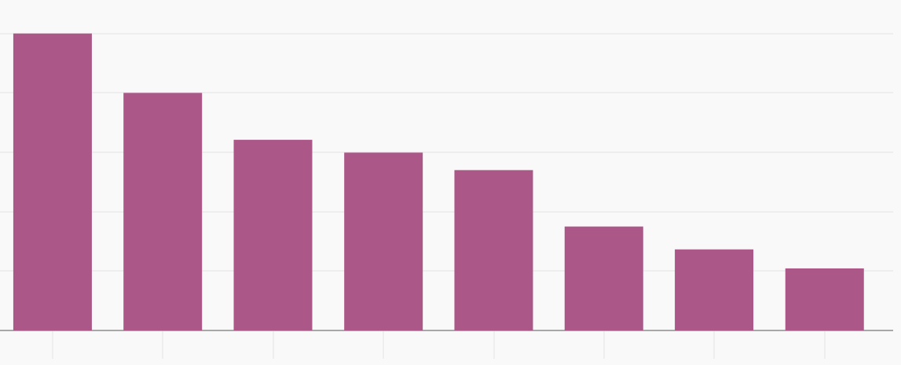
1000
800
600
400
200
0
2010 2011 2012 2013 2014 2015 2016 2017

Source: Bloomberg New Energy Finance, accessed 5 July 2018

Extract 1: Technology is fuelling the use of cobalt

Cobalt is a hard, shiny and greyish metal which has many strategic and irreplaceable industrial uses as a result of its unique properties. Currently used in numerous industrial chemical processes, close to half of the world’s cobalt supplied today is used in lithium-ion batteries, putting it at the heart of the drive for alternative and renewable energy systems. There has not been a good substitute to make lithium-ion batteries without the mineral. However, more than half of the world’s reserves and production of the metal are in one country, the Democratic Republic of Congo. This has led to a fear of shortage.

Mining companies are planning new cobalt operations that may balance supply and demand in the near term, but if electric vehicles continue to gain market share, any stabilisation may be short-lived. Each new electric vehicle, which runs on lithium-ion battery, uses about 10 kg of

cobalt. The use of cobalt is expected to accelerate further as electric vehicles will be close to reaching cost parity with internal combustion engine vehicles.

Sources: www.dartoncommodities.co.uk/ (accessed on 21 July 2018); CNBC, 16 April 2018

Extract 2: Diesel-powered cars are on their way out

Diesel-powered cars appeal to European drivers for their fuel efficiency and power. Carmakers like them because they emit less carbon dioxide than similar petrol engines do, making it easier to comply with stiff regulations. However, in recent years, governments have shifted gear. The advent of electric cars has knocked diesel off its perch as the fuel with the smallest carbon footprint. Diesel also releases greater quantities of nasty gases other than carbon, such as nitrogen oxides, than petrol does. Many cities in Europe, and farther afield, want to eliminate diesel cars from their roads as early as 2025. Governments hope that the void left by diesel will be filled by zero-emission battery-powered models. But mass adoption of such vehicles, which for now are expensive and have limited ranges in travel distance, still appears a way off.

Source: The Economist, 13 February 2018

Extract 3: Charging ahead, China’s dirty race for clean vehicles

After a decade of halting progress, electric cars are zooming ahead in China. Last year the number of registrations of new electric vehicles (EVs) in the country overtook that in America, making it the world’s biggest and fastest growing market. The category includes electric- only cars as well as plug-in hybrids that can also run on petrol. Analysts expect the market to grow by nearly 50% a year for the rest of this decade.

The government has had a big role in the marked expansion of EVs in China. It doles out generous subsidies to local makers, to parts suppliers and to those who buy the final products. Last year alone, China shovelled over 90 billion yuan in subsidies into the industry, which it calls “strategic”. This has led to queues of EVs on the streets, mostly of poor design and quality. China has yet to produce an EV manufacturer that can compete at the level of America’s Tesla Motors.

The Chinese government is also encouraging other Chinese firms, including the country’s tech giants, to innovate in the field. Tencent, a gaming and social media firm, is developing internet-connected EVs with Taiwan’s Foxconn. Alibaba, an e-commerce firm, is providing data and cloud-computing services to Kandi Technologies, a local EV-maker that is popularising the sharing of the vehicles.

Source: The Economist, 28 July 2016

Extract 4: Autonomous vehicles are just around the corner

Every day around 10 million people take an Uber ride. The company has made ride-hailing commonplace in more than 600 cities in 82 countries and Uber is experimenting the use of autonomous vehicles– cars that can drive by themselves. Autonomous vehicles have made rapid progress in recent years and can now be seen on the roads in several American cities, easily identified by the clusters of sensors on their roofs.

The combination of the use of autonomous vehicles and ride-hailing, together with a switch to electric vehicles, seems likely to undermine the logic of car ownership for many people. Ride- hailing services in the rich world currently cost around US$2.50 per mile, compared with about US$1.20 per mile to own and operate a private car. But the driver cost accounts for about 60% of the cost of ride-hailing. UBS, an investment bank, reckons that automation, competition and electrification (which makes cars more expensive to buy but much cheaper to run) will cut the cost of ride-hailing by 70%, to about US$0.70 per mile. UBS predicts that autonomous taxis will take off rapidly after 2025, with 80% of people using them in cities, where available, by 2035.

Source: The Economist, 1 March 2018

Questions

(a) Using examples from Extract 1, distinguish between complements in demand and derived demand.
[2]
(b) With reference to Extract 1, and using a supply and demand diagram, account for the sharp increase in the global price of cobalt between 2016 and 2018.
[4]
(c) Explain a factor that could be responsible for the trend in the global price of lithium-ion battery shown in Figure 2.
[3]
(d) Consider whether an expansion in the supply of cobalt by the mining companies will increase their total revenue.
[5]
(e) Explain whether electric vehicle is a public good. [4]
(f) Explain the market failure resulting from the usage of diesel-powered cars. [6]
(g) With reference to Extract 3, evaluate the policies adopted by the Chinese government to increase the production of electric vehicles in China.
[9]
(h) Discuss whether increasing production of electric vehicles, together with
driverless and ride-hailing transportation, will mean that governments do not need to intervene in the public transport market of buses and trains.

[12]

[Total: 45]

