Question 2: COVID-19 and impact on the World’s economy
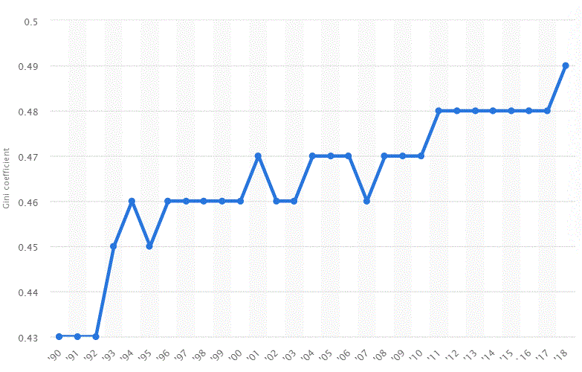
Figure 2: Gini coefficient in the US, 1990 – 2018
‘90 ‘95 ’00 ’05 ‘10 ‘15 ‘18 ‘18

Source: Statista, 2020
Table 1: Singapore top exports market and top imports source 2018
Source: UOB, 2018

Extract 5: The COVID-19 crisis and the collapse of the airline industry globally

The COVID-19 pandemic has caused a severe disruption to global economic activities. It was first reported in China in December 2019, with a cluster of cases of pneumonia in Wuhan, Hubei Province. The outbreak was declared a Public Health Emergency of International Concern on 30 January 2020. Almost as soon as news of the virus became widespread in late January, travel demand to Asia from the rest of the world plummeted.

Even before lockdowns were adopted across the globe, airlines began to drastically cut flights to China, and other locations in Asia as coronavirus-related anxieties led passengers to avoid travel to the region. As countries around the world have closed their borders, and many states and nations have locked down, air travel has declined significantly, with airlines suspending routes, grounding planes, and seeing low passenger numbers on their few remaining flights. Several governments have provided support, for e.g. President Donald Trump signed the stimulus bill that includes $58 billion in aid for airlines — $29 billion in payroll grants for workers, and $29 billion in loans for the airlines. Despite this, several airlines have already collapsed.

Adapted from Business insider, March 2020

Extract 6: Millions of Americans join unemployment line as COVID-19 savages economy

A stunning 26.5 million Americans have sought unemployment benefits since mid-March, confirming that all the jobs gained during the longest employment boom in US history have been wiped out as COVID-19 savages the economy.

The deepening economic slump amid nationwide lockdowns to control the spread of the coronavirus was underscored by other data, showing business activity sinking to an all-time low in April. They expect the unemployment rate will shatter the post-World War Two record of 10.8 percent touched in November 1982.

However, economists believe some people, who were thrown out of work because of state-mandated "stay-at-home" orders, have found employment at supermarkets, warehouses and delivery services companies.
Source: Channel News Asia, 24th April 2020

Extract 7: China’s technological warfare with COVID-19

The Fourth Industrial Revolution includes development of digital services and robotics technology such as artificial intelligence and machine learning. The resulting shifts and disruptions mean that we live in a time of great promise and great peril. The world has the potential to connect billions more people to digital networks, dramatically improve the efficiency of organizations and even manage assets in ways that can help regenerate the natural environment, potentially undoing the damage of previous industrial revolutions. However, experts have grave concerns: that organizations might be unable to adapt; governments could fail to regulate new technologies to capture their benefits; shifting power will create important new security concerns; inequality may grow; societies fragment.

China uses these emerging technologies of Big Data and artificial intelligence to respond rapidly to the impacts of COVID-19. Incorporating technologies, including 5G, artificial intelligence, Big Data and cloud computing, the industrial internet is a new, pan-industry infrastructure. Connecting data, while promoting data sharing and its evolving importance, enables the coordination of the entire industry chain. This has given the Chinese manufacturing industry a dramatic boost, leading to an amazing string of new production records.

An excellent example is the newly built Huoshenshan and Leishenshan Hospitals, which offer 2,600 beds in total. Containing the virus’ spread required additional facilities to handle the patient load and construction workers took just 10 days and 12 days respectively to build and equip both. Digital tools like Building Information Modelling (BIM), allowed the hospitals’ design institutes to utilize technological tools, bringing together hundreds of BIM designers nationwide. The hospitals’ design plans were produced in 24 hours and construction drawings in only 60 hours.
Adapted from World Economic Forum, 2020

Extract 8: Singapore’s response to economic issues caused by COVID-19

In view of COVID-19, the Ministry of Trade (MTI) revised Singapore’s GDP growth forecast for 2020 downwards to between ‘-7.0 and -4.0 percent”. The Singapore Government will draw S$31 billion from past reserves to fund the measures in the Fortitude Budget, with a larger sum set aside for contingencies. Altogether, Singapore is drawing up to a total of S$52 billion from past reserves this financial year – an unprecedented amount. On Tuesday (May 26), Deputy Prime Minister Heng Swee Keat announced in Parliament during the fourth Budget this year an SGUnited Jobs and Skills Package that will create close to 100,000 opportunities, which includes the jobs, as well as 25,000 traineeships and 30,000 skills training placements.

Adapted from Channel News Asia, 2020

Questions
(a) What can be inferred from the change in US’ Gini coefficient from 1990 to 2018? [2]
(b) Analyse how COVID-19 is likely to affect living standards in the US. [6]
(c) With reference to extract 5, explain how total revenue of airlines is likely to have changed and comment on whether this change will persist. [8]
(d)
(i) The Ministry of Trade (MTI) revised Singapore’s GDP growth forecast for 2020 downwards to between ‘-7.0 and -4.0 percent”.
Explain two factors that would likely determine the impact of Singapore’s growth on her trading partners. [4]
(ii) Using the concept of opportunity cost, explain how the government, producers and consumers of Singapore will be affected by the above growth forecast. [6]
(e) Using AD-AS analysis, evaluate the possible impacts of the Fourth Industrial Revolution on China’s economy. [7]
(f) In light of COVID-19, discuss whether expansionary fiscal policy is the most appropriate policy for Singapore to achieve inclusive growth. [12]
[45 marks]

