Essay Question 1
Explain how an increase in government expenditure will affect the economy?
(impact on economic growth, potential growth, the price level, employment and external equilibrium)

Explain how an increase in government expenditure will affect the economy?

Introduction
- Define government expenditure
- State that an increase in government expenditure will affect the economy via the AD-AS analysis

Main Body
1. Explain how an increase in government expenditure will increase AD and achieve actual growth
- Increase G raise efficiency of industries indirectly boost consumption increase disposable income higher level of purchasing power
- Increase G increase AD increase NY via k raise actual growth

2. Explain how an increase in government expenditure will increase AS and achieve potential growth
- Increase G infrastructural development and R&D expansion of resources due to high degree of mobility of resources
- Firms can attain higher efficiency of production raise output achieve potential growth seen by the rightward shift of the PPC

3. Show how increase in AD and AS will achieve sustainable EG
- Draw diagram
- Describe diagram

4. Explain the benefits of increasing government expenditure on the economy
(a) Improve standard of living
- Increase G spillover effects improve standard of living higher degree of convenience and comfort due to improved infrastructure and public facilities

(b) Higher efficiency of production
- Raise productivity
  - infrastructural development raise productivity of industries
  - manpower development raise skill competency of workers

5. Explain the detriments of increasing government expenditure on economy
(a) Inflationary condition
- Excess increase in AD due to increase in G under rising cost condition or full employment condition inflationary condition increase in general price level undermine the aim of fiscal stimulus

Explain how an increase in government expenditure will affect the economy?
- AD components
- Short term economic growth – real GDP (via k)
- Economic growth – real GDP and potential growth
- on the economy – the main aims of government – prioritize the aims

Introduction
Government expenditure refers to expenditure on goods and services spent that are for ordinary and development expenditure in areas such as, provision of public goods and defense. The change in government expenditure will affect the economy and this can be explained by the economic analysis of AD-AS.

Main Body
Government expenditure is used to improve infrastructure for the country to raise the efficiency of the industries and indirectly boost consumption through the increase in the disposable income that will provide a higher level of purchasing income. As a result, the increase in government expenditure will increase aggregate demand and via the multiplier process, lead to an increase in real GDP. Hence, the increase in government expenditure will raise actual growth.

In the multiplier process, the initial increase in the aggregate expenditure expands the circular flow of income, increasing the income of the factor earners to further expand the circular flow of income with new will co transactions. As long as transactions are made, the circular flow of income will continue to expand until the withdrawal effects is equal to the initial injections which will crease the expansion of the circular flow of income. Consequently, the national income will increase by several folds, depending on the value of the multiplier which is determined by the sum of Marginal Propensity to Withdrawal (MPW) that consists of Marginal Propensity to Save, Tax and Import. (MPW = MPS+MPSMPT+MPM).

The increase in government expenditure also involves infrastructural development and research and development (R&D) that leads to an expansion of resources, made possible with high degree of mobility of resources that the economy can attain with more infrastructures. As a result, efficiency of production is raised, allowing firms to produce more with the same units of resources, thus attaining potential growth, as seen by the rightwards shift of the Production Possibility Curve (PPC).

Y₁=YF0
Y₂
YF₂
LRAS₀
LRAS₁
P₁
P₀=P₂
GPL
Real GDP
AD₁
Y₀
AD_{o}
As seen from the diagram, the increase in government expenditure will induce a rise in aggregate demand from AD₀ to AD₁, contributing to a rise in real GDP from Y₀ to Y₁ and a rise in GPL from P₀ to P₁. Since the increase in government expenditure also leads to the expansion of resource capacity, the aggregate supply will shift to the right from LRAS₀ to LRAS₁, whereby the full employment is raised from Y_{F1} to Y_{F2}, lowering the cost condition, which will induce an increase in aggregate demand on a quantitative basis and thus, raise the real GDP from Y₁ to Y₂ with a reduction in GPL from P₁ to P₂. Hence, sustained economic growth is attained.

The increase in government expenditure will bring about spillover effects. One such benefit would be the improvement in standard of living, which can be seen from the higher degree of convenience and comfort brought about by improved infrastructure and public facilities.

Besides this, there will be a higher degree of efficiency in the economy which will raise productivity as the infrastructural development will raise the productivity of the industries while expenditure on manpower development will raise the skill competency of the workers.

As for government expenditure, given out as subsidies to lower income group, this will help to eradicate the unequal distribution of income and wealth, and thus eradicating the social dissatisfaction.
Most of all, the increase in government expenditure due to more provision of public services and infrastructural development will induce more production and thus provide more employment, especially significant for economies with large population.

However, there are detrimental impacts to be considered as seen in terms of the inflationary condition. When there is excess increase in aggregate demand under rising cost condition or full employment or when the economy’s potential growth fails to expand adequately, price level will rise, undermining the aim of the fiscal stimulus.

It is also important to take note of the rising public debts that may arise when the government is unable to raise sufficient tax revenue and may need to borrow more to finance public expenditure. Consequently, debts may be incurred. If the debts are internally incurred, it will be a higher tax burden for future generation and if the debts are externally incurred, it will lower economy’s future growth.

Conclusion
In sum, the impact of government expenditure on the economy is significant. The degree of impact depends on factors like the value of multiplier the areas of government expenditure and the nature of the economy.

government expenditure on infrastructural development – more efficient method of production – lower cost condition – raise profitability – induce FDI – improvement in capital account – BOP SURPLUS – appreciation of exchange rate

Essay Question 3
Explain the relative importance of factors that enhance economic growth in Singapore. [12]

Introduction
Economic growth refers to the growth of the production in terms of actual and potential production capacity. Actual economic growth refers to the actualization of resources into monetized products and services which is commonly measured as a percentage change in real GDP while potential growth refers to the expansion of availability of resources for production, measured in term of the rightward and outward shift of the production possibility curve (PPC). It is imperative to first examine the determinants of economic growth that affect both potential and actual growth before the importance of every factor can be analysed.

Main Body
Actual and potential growth can be achieved with the increase in aggregate demand and aggregate supply, such that sustainable economic growth is attained.

As seen from the diagram, the increase in aggregate demand from AD₀ to AD₁ will lead to an increase in real GDP from Y0to Yi but also an increase in price from P₀ to P₁. With a corresponding increase in aggregate supply from AS₀ to AS₁, the cost condition is lowered, such that aggregate demand will increase on a quantitative basis. Consequently, real GDP increases from Y₁ to Y₂ and price falls from P₁ to P₂ without experiencing rising cost condition, thus sustainable economic growth is attained.

The rise in aggregate demand can be seen in terms of domestic and external aspects. For internal demand, the rise in domestic demand is caused by the increase in consumption, government expenditure and investment. The increase in these aggregate demand components is influenced by factors such as low interest rate, rise in consumers' household income, positive market sentiment, social and economic needs. As for external demand, the global economic condition will affect economic activities and trading activities of the countries. For instance, the rise in national income in foreign countries and high inflation rate in trading partners of Singapore will contribute to greater reliance on Singapore imports. Also, the quality of goods produced will be affected by Free Trade Agreement (FTA), raising Singapore's export demand. Global positive market sentiment will lead to inflow of more Foreign Direct Investment (FDI) into the country.

Factors that affect potential growth in Singapore will determine the availability of resources for production. One such factor is land and raw materials. As Singapore lacks natural endowments, the shortage in supply of resources will lower resource capacity and undermine potential growth. Therefore, Singapore overcomes the shortage through trade, particularly the import of essential raw materials for production. Another factor that affects potential growth would be labour resources. This is determined by the population size of Singapore and the labor participation rate. Singapore experiences a labour shortage due to the low birthrate and small population size, thus it overcomes this limitation through the import of foreign workers and talents.

Besides, there are factors that affect the availability of resources. One such determinant is manpower development, which will affect the availability of skilful workers to match the needs of the industry, in terms of the quality and quantity of workers. Technological advancement will determine the extent of the utilization of the resources and efficiency of production. Also, an efficient and effective infrastructural and institutional development would expand Singapore's availability of resources and ensure the efficient utilization of resources.

To do so, the Singapore government has to implement effective economic policies and establish systems to sustain cost of import and expand sources of supply of resources from international markets as Singapore relies extensively on international market for these resources. In order to achieve this, the government needs to maintain a stable exchange rate which would help bring down the cost of imports. Furthermore, the adoption of an effective trade network system with efficient trading facilities and other Free Trade Agreements (FTAs) will help to expand our sources of supply of resources from international markets as trading activities will be proliferated.

Analysis – key determinants
Given the nature of Singapore's economy, it can be noted that the external influence that affects the determinants of economic growth will be more significant as Singapore relies on the external market for market demand and sources of resources. The foreign trade sectors are important sources of growth for the economy. In addition, the lack of funding and the need of higher degree of technological advancement to raise the rate of economic growth also supports the need for foreign direct investment (FDI), justifying the view that external factors influencing the flow of FDI will be more significant, such as exchange rate stability and an efficient trade network.

Conclusion
In sum, external factors of economic growth are more significant in Singapore due to the nature of Singapore's economy. However, it is still imperative to Singapore to implement policies and establish effective and efficient systems to ensure that the internal factors would benefit Singapore.

Essay Question 8
Explain two possible causes of a reduction in the size of the Singapore’s national income multiplier.

Introduction
The national income multiplier depicts the change in the value in income as a result of the change in the aggregate demand. It is a very important economic variable that will influence the degree effectiveness of demand management policy whereby its influence is determined by the withdrawal impact seen in the formula.

Main Body
1) State the formula of the national income multiplier

$$K= \frac{1}{MPS+MPT+MPM}$$

$$K=\frac{∆Natural Income}{∆Aggregate Expenditure}$$

Form the formula, it can be seen that the increase in the value of the MPS, MPT and MPM will lead to the reduction in the multiplier effect. This is because the withdrawal effects of the MPM (marginal propensity to withdrawal) will cause the contraction of the number of trade transaction cycle which will lead to a fall in national income.

One such source of the fall in the multiplier national income multiplier will be the marginal prosperity to save which measure the change in saving in response to a change in income. The presence of a poor welfare system and greater sense of precautionary need in Singapore will induce greater need to save. This will raise the value of MPS and thus decreases the multiplier.

Similarly, an increase in CPF compulsory saving stipulated legally by the government will raise the MPS and then reduce national income multiplier. The values of MPS can also be affected by high interest rate which means that the opportunity cost of consumption will be higher and thus, this increases the willingness to save. Another cause of a fall in national income multiplier is the rise in the marginal propensity to import (MPM) which measures the change in import in response to a change in national income. The value of MPM depends on the degree of import substitutability depicting whether the extent of the suitability of local goods in replacing imported goods. This would depend on the quality of imported goods and the availability of local goods. The availability of natural endowment would also influence the degree of need for imports. In Singapore, our lack of natural resources would mean that out MPM is very high. Furthermore, a high pace of economic development would raise the MPM as there is strong demand to import for resources for the need of production.

In sum, it can be seen that our national income multiplier can be quite small under the impact of a high value of MPS and MPM which would dampen the multiplier. A small national income multiplier would undermine the effectiveness of the demand magnet policies in influencing economic activities to achieve the aims of government policies.

a) Assume there is an open economy with a government sector. Explain the conditions for equilibrium in the circular flow in such an economy. (10)
b) Discuss how an increase in injections may affect the equilibrium level of national income. (15)

Introduction

The above-mentioned economy is a four sector economy whereby the multiplier effect is determined by the value of the MPW which consists of MPM (marginal propensity to import), MPS (marginal propensity to save) and MPT (marginal propensity to tax). When the economy is in equilibrium, there is no tendency for the national income to change unless there is a change in the variable influencing it. Under such circumstance, the level of withdrawals is equal to the level of injections.

Main body

1) Explain the notion of circular flow of income and equilibrium of national income

The circular flow of income refers to flow of income between the households and the firms which reflects the transactions of expenditure and the payment of services for the production. From the circular flow of income, the level of national income can be determined when there is no tendency of change in the circular flow of income and the level of national income is said to be in equilibrium. At this equilibrium level, the level of injections which consist of investment, government expenditure and export receipt is equal to the sum of withdrawals which consist of saving, taxation and import expenditure. When this occurs, the circular of income will experience no further expansion and the level of income is in equilibrium, implying the level of national income can be determined.

2) Illustrate the idea of equilibrium level of national income with a diagram, (important: must state how the economy adjusts from disequilibrium to equilibrium)

As seen from the diagram, the economy is in equilibrium when the level of withdrawals is equal to the level of injections, whereby the circular flow of income ceases to expand at the level of income Yο.

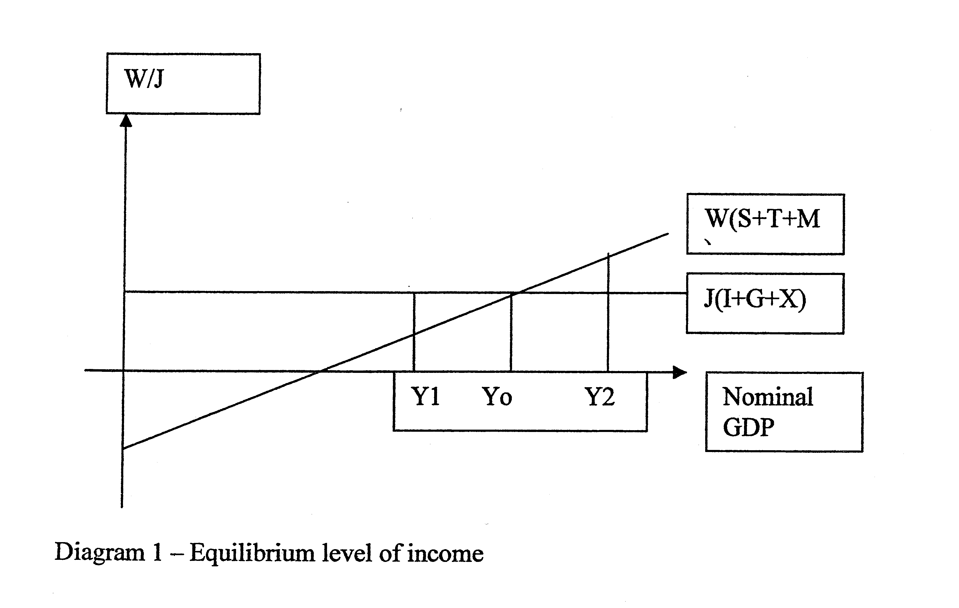
If the income level is at Y₁, the level of injection is greater than the level of withdrawals, implying that the circular flow of income will continue to expand as the AE is greater than the income level. This implies that the stocks are depleting, demanding an increase in production and unplanned investment has to be increased which will lead to the rise of national income via the multiplying effect, expanding the circular of income to reach its equilibrium at Y₀.

However, if the income level is at Y₁, the level of injection is less than the level of withdrawals, implying that the circular flow of income will reduce as the AE is less than the income level. This implies that the stocks are in excess, inducing a reduction in production and unplanned investment has to be reduced which will lead to the fall of national income via the de-multiplying effect, reducing the circular of income to reach its equilibrium at Y₀.

Consequently, it can be seen that the economy adjust to its equilibrium level through the reduction and increase in unplanned investment, influencing the circular flow of income until the level of withdrawals is equal to injection. At this equilibrium level of national income, it may be at, above or below full employment level.

b) Discuss how an increase in injections may affect the equilibrium level of national income. (15)

Introduction

At the equilibrium level of national income, the level of injections is equal to the level of withdrawals where there is no tendency for change in the level of national income unless there is change in the variable influencing. By virtue of an increase in the level of injection such an autonomous increase in the level of investment, the level of national income will increase via the multiplying process.

Main body
1) Explain how an increase in the level of injection such an increase in the level of investment would increase the level of national income, (demonstrate the multiplying process and illustrate with a diagram)

When the level of investment increases, there will be an increase in the injection into the circular flow of income and this will lead to the rise of national income via the multiplying process.

In the multiplier process, the initial increase in the aggregate expenditure expands the circular flow of income and provides new sources of income for the factor providers which then further expands the circular flow of income with new expenditures. As long as transactions are made, the circular flow of income will continue to expand until the withdrawal effects is equal to the initial injections which will cease "the expansion of the circular flow of income. Consequently, the national income will increase by several folds, depending on the value of the multiplier which is determined by the sum of the MPW (Marginal Propensity to withdraw - MPS + MPT +MPM).

