2019 H1 Case Study Question 2 – Mark Scheme

(a) Describe the trend in Singapore’s general price level from 2013 to 2017. [2]

Singapore’s general price level is increasing from 2013 to 2017, except for in 2015 and 2016.

(b) (i) Account for the change in UK’s inflation rate from 2015 to 2017. [4]

Inflation has increased from 2015 to 2017.

Possible reasons from Extract 6:

Surge in consumer spending fuelled by an increase in credit
- An increase in credit increases the ability of consumer to purchase big ticket items, resulting in an increase in Consumption Expenditure
- This increase AD, resulting in inflationary pressures if the economy is close to full employment and the economy is close to full capacity.

Increase in fuel/oil prices
- As fuel prices increase, this drives up the cost of production for firms. The extract states that cost of production is rising “at the fastest pace in more than eight years”
- This will decrease the SRAS. Firms pass on the rising costs to consumers, resulting in higher prices and greater inflationary pressure

Fall in the value of the pound
- A weaker pound results in an increase in cost of imports in terms of pounds. This increases the cost of importing raw materials, raising the cost of production for firms.
- This will decrease the SRAS. Firms pass on the rising costs to consumers, resulting in higher prices and greater inflationary pressure.
- Note: Students can also explain depreciation leading to increase in AD and demand pull inflation, however assumptions with regards to PED should be stated to get the full mark.

Students should explain any 2 factors from the extract

(ii) Comment on the impact that higher inflation rates may have on the standard of living of UK citizens. [6]

Higher inflation rates imply that the general price level and therefore cost of living in the UK is increasing at an increasing rate. This could have an impact on SOL in the UK, where SOL can be measured in both material and non-material terms.

Higher inflation rates may lower the standard of living for UK citizens:
- With higher inflation rates, cost of living increases and this reduces the purchasing power of UK citizens.
- With lower purchasing power, they are less able to buy and consume goods and services.
- With a lower level of consumption, material standard of living falls.
- Higher inflation may also cause growing inequity issues, as the increase in prices is more likely to affect low wage fixed income earners, who spend a larger proportion of their income on necessities.

Higher inflation rates may not lower the standard of living for UK citizens:
- However, purchasing power may not fall, as long as wage growth is able to keep up.
- Based on table 2, nominal wage growth has been exceeding the annual rate of inflation. This shows that wages are rising faster than prices, implying that UK citizens would be able to afford more goods and services rather than less.
- In addition, the government is also planning to cut taxes and freeze fuel duty (extract 6). If the government implements these measures, it would help to counter the effects of rising inflation rates on standard of living.

Overall comment:
- Without government intervention, standard of living may fall for low income households.
- However for the average household, the current level of wage growth is sufficient to exceed the increase in general price level.

(c) (i) Compare the change in nominal wage growth for the UK and for Singapore from 2013 to 2017. [2]

- Nominal wage growth has fallen for both UK and Singapore.
- Singapore’s nominal wage growth decreased to a larger extent compared to the UK.

(ii) Extract 7 states that ‘high levels of economic growth should, in ordinary times, lead to higher wages’.

Using a demand and supply diagram, explain this statement. [4]

- When there are high levels of economic growth, there is growing demand for goods and services. Firms increase production to meet the rising demand.
- The demand for labour is a derived demand dependent on the demand for goods and services. As production increases, firms hire more labour to increase production, leading to an increase in demand for labour.
- As demand for labour increases, there is a shortage of labour in the market as quantity demanded exceeds quantity demanded at the initial wage level. Thus there is an upward pressure on wages to clear this shortage.
- Wages will increase from W₁ to W₂ until a new equilibrium is reached.
- Accurately drawn diagram

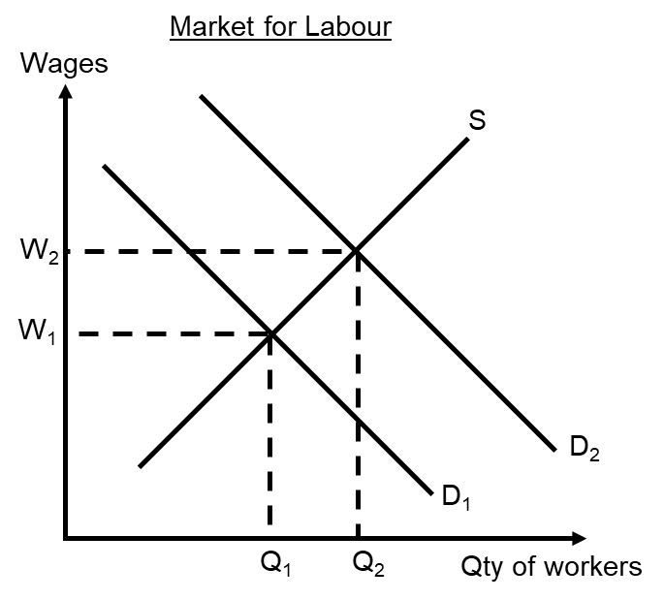

(d) With reference to Extract 8, explain why the UK government is ‘poised to raise interest rates’ and comment on whether the outcome will be desirable. [9]

Introduction:
- The objective of raising interest rates is to achieve a low and stable inflation rate.
- However, such a policy may have unintended outcomes on the economy as well.

Raising interest rate helps to address the problem of high inflation:
- UK is having a problem of rising inflation: extract 8 states that inflation is at 3% and is expected to increase further due to higher cost of food and fuel. This could be due to the low value of the pound following the Brexit vote.
- An increase in interest rate would result in an inflow of hot money into the UK economy.
- This increases the demand for pound sterling, resulting in an appreciation.
- A stronger pound will help to reduce the cost of imports in domestic currency, thus lowering the cost of imported raw materials such as food and fuel.
- The lower cost of production therefore increase the SRAS in the UK economy, resulting in less cost of push inflation (decrease in GPL).
- Note: Students may also explain a reduction in demand pull inflation, but this would not be as well supported with evidence from the extract.
- A lower inflation rate would be a desirable outcome given the rising inflation rate in the UK.

Raising interest rate may also lead to undesirable effects:
- It raises the cost of borrowing for households, making them less able to purchase big tickets items. Given the existing high level of inflation that reduces their real income, households are likely to be more affected by this. With less ability to purchase these big ticket items, standard of living would fall.
- The extract also states that the UK economy is not doing as well as other economies. This could be due to and uncertain business environment affecting firms’ confidence. An increase in interest rate that increases cost of borrowing could further reduce investments and decrease AD, leading to contraction in the economy.

Overall evaluation:
- Extent of increase in interest rates: the increase in interest rate is only by 0.25%, so it may not be significant enough to have a large impact. The interest rate was initially reduced from 0.5% to 0.25% to avoid a recession. Since the recession has been avoided, the government should increase it back to its original rate.
- Root cause of the problem: one of the root causes of the rising inflation problem in the UK is a weak pound and rising cost of imports. Therefore, increasing interest rate would address this problem and lead to a desirable outcome.
- Use of other government policies: The UK government may use other expansionary policies simultaneously to ensure a desirable outcome. For example, a decrease in taxes can help households to maintain their purchasing power even as interest rates increase.

(e) (i) Using AD and AS analysis, explain how an ageing population may harm Singapore’s economic growth in the short and long run. [6]

Short run effects:
On SRAS:
- An ageing population could lead to an increase in healthcare expenditure as mentioned in Extract 9, since the elderly are more likely to experience health related problems.
- In order to finance the increase in healthcare expenditure, the government may impose new taxes such as raising GST or taxing e-commerce transactions.
- Such taxes are imposed on producers, and raise their cost of production, resulting in a fall in the SRAS of the economy.
- This will lead to lower national output and slowdown growth in the short run.
On AD:
- An ageing population could result in falling incomes for the elderly as more workers retire. As disposable income falls, there is a decrease in consumption expenditure.
- In addition, the decline in the domestic labour force could affect business confidence as productivity falls and costs rise. This could lead to a fall in investments.
- The fall in C and I could then result in a fall in AD, leading to lower national output and slowdown growth in the short run.

Long run effect:
On LRAS:
- An ageing population could lead to a shrinking workforce as more workers retire. The number of workers retiring could exceed to number of workers joining the workforce.
- In addition, productivity may be lower as older workers may have skills that are out dated or less relevant to the progressing economy. The quality of workers may fall over time.
- As the government prioritises spending on healthcare over other areas such as building infrastructure, this would also limit the potential growth in the economy.
- Overall, LRAS may fall or remain stagnant, resulting in limited potential growth in the long run.

(ii) Discuss if loosening immigration policy is the best approach to deal with the challenges arising from an ageing population. [12]

Introduction: Students should identify the challenges arising from an ageing population.
Challenges arising from an ageing population:
- As mentioned in part (i), an ageing population could result in slow actual and potential growth
- Some specific challenges include lower productivity growth, rising costs, as well as a strain on the government budget due to increased healthcare expenditure and a smaller tax base.

Contextualise:
- Both Singapore and the UK are experiencing an ageing population.
- Singapore has always been relatively reliant on foreign workers, but the government has been trying to reduce reliance in recent years.
- The UK is also experiencing a productivity crisis where the older workers are unable to innovate as well as the younger workers. This has resulted in slow growth in wages.

Thesis: Loosening immigration policy may be the best approach to deal with the challenges arising from an ageing population.
Impact on growth:
- As mentioned in extract 10, loosening immigration policy may be necessary to cushion the adverse effects of a greying population.
- By loosening immigration policy, the supply of workers in the economy would increase, which would result in a downward pressure on wages.
- The lower wages would help to lower the cost of production, resulting in an increase in SRAS and growth in the economy.
- At the same time, the quantity of workers in the economy would increase, resulting in increase in the productive capacity as shown by a rightward shift in the LRAS.
- Thus the economy is able to experience both actual and potential growth.
- As the economy grows, business confidence would also improve, attracting more FDI and increasing investment in the economy.

Impact on budget position:
- Loosening migration policy also allows for a larger tax base, so that burden on the younger Singaporeans will not be so large.
- A larger tax base will increase tax revenue, which can be used to finance the increasing healthcare expenditure resulting from an ageing population.
- Thus, loosening migration policy would improve the government’s budget position and is more sustainable in the long run.

Anti-Thesis/Counter argument: Governments should tighten immigration policy instead of loosening it
Impact on productivity:
- Loosening immigration policy could result in lower productivity as the economy becomes over-reliant on low skilled foreign workers.
- With cheap low-skilled labour readily available, firms do not have the incentive to improve productivity, for example through skills training or automation.
- As such, there would be low productivity growth and the LRAS would remain stagnant.
- In addition, this could be a politically sensitive issue. With the large inflow of foreign workers, this could lead to overcrowding as well as other social issues if the foreigners have difficulty integrating into society.
- Because of these reasons, countries like Singapore have tightened immigration policy and are unwilling to reverse this stance.

Anti-Thesis/Counter argument: Governments should adopt other approaches to deal with the challenges arising from an ageing population.
- Instead of loosening immigration policy, the government should focus on improving labour productivity through various policies.
- Extract 7 states that the UK government has to take action to boost skills and creativity. This can be achieved through policies such as skills training and education.
- By subsidising skills training (or re-training for older workers), the quality of labour would improve, resulting in an increase in productive capacity and potential growth in the economy.
- The government could also subsidise or invest in R&D, to encourage firms to adopt a more capital intensive method of production.
- With such measures in place, productivity remains high and cost of production would be lowered even with an ageing population.
- This can be seen from extract 9, which states that Singapore remains an “attractive destination” for investments due to its advancements in industries such as finance and shopping.

Evaluation:
- Loosening immigration policy can help to alleviate the challenges associated with an ageing population, but should only be used in the short run.
- In the long run, over dependence on foreign labour could lead to other social problems and is not a sustainable approach. This is especially true for countries like Singapore whether space and resources are already limited.
- As such, governments should tighten immigration policy with regards to low skilled foreign labour, but remain open to inflow of high skilled labour. This will ensure long term productivity growth, while keeping the inflow of labour at a more sustainable rate.
- Economies such as the UK are larger and can also leverage on their larger work force as well.

