J2 June Intensive Revision
L8 – CSQ – Aims of Government/Macroeconomic Policies – Q4

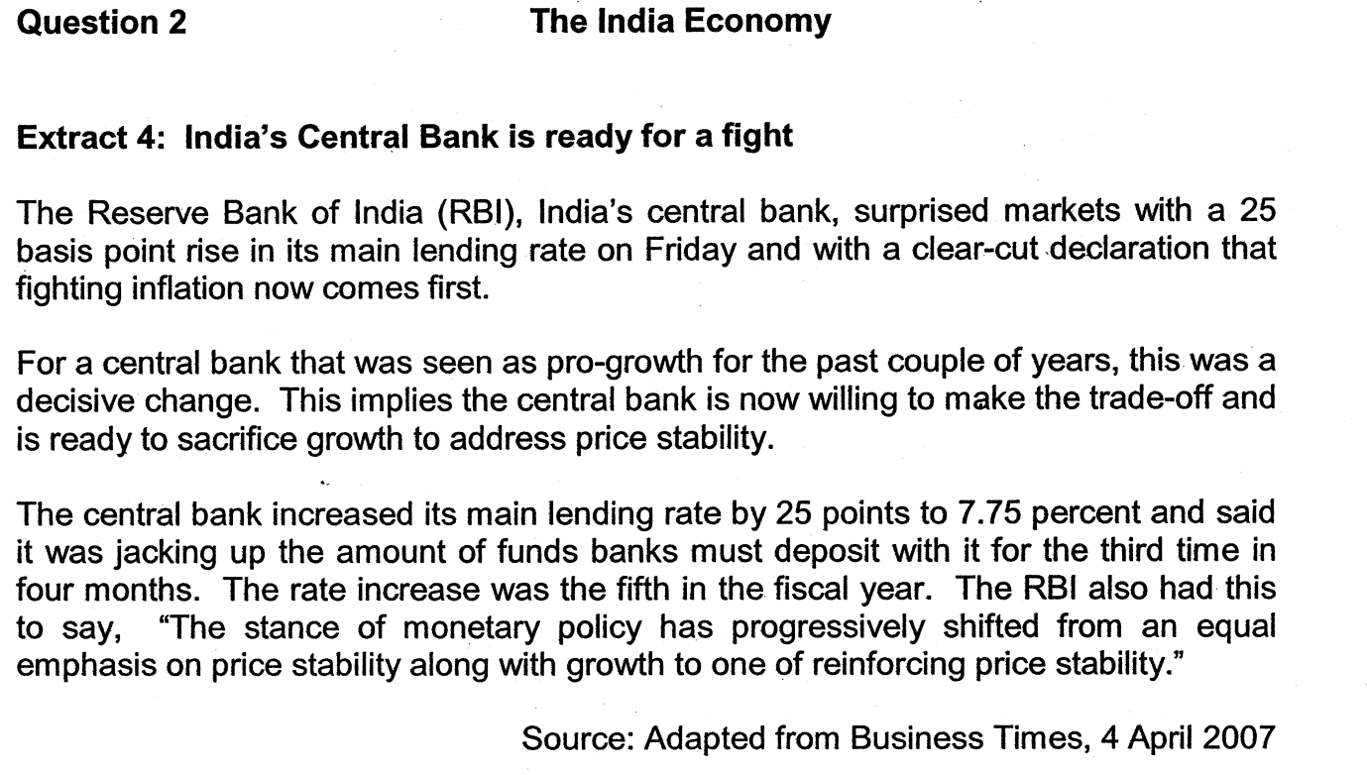
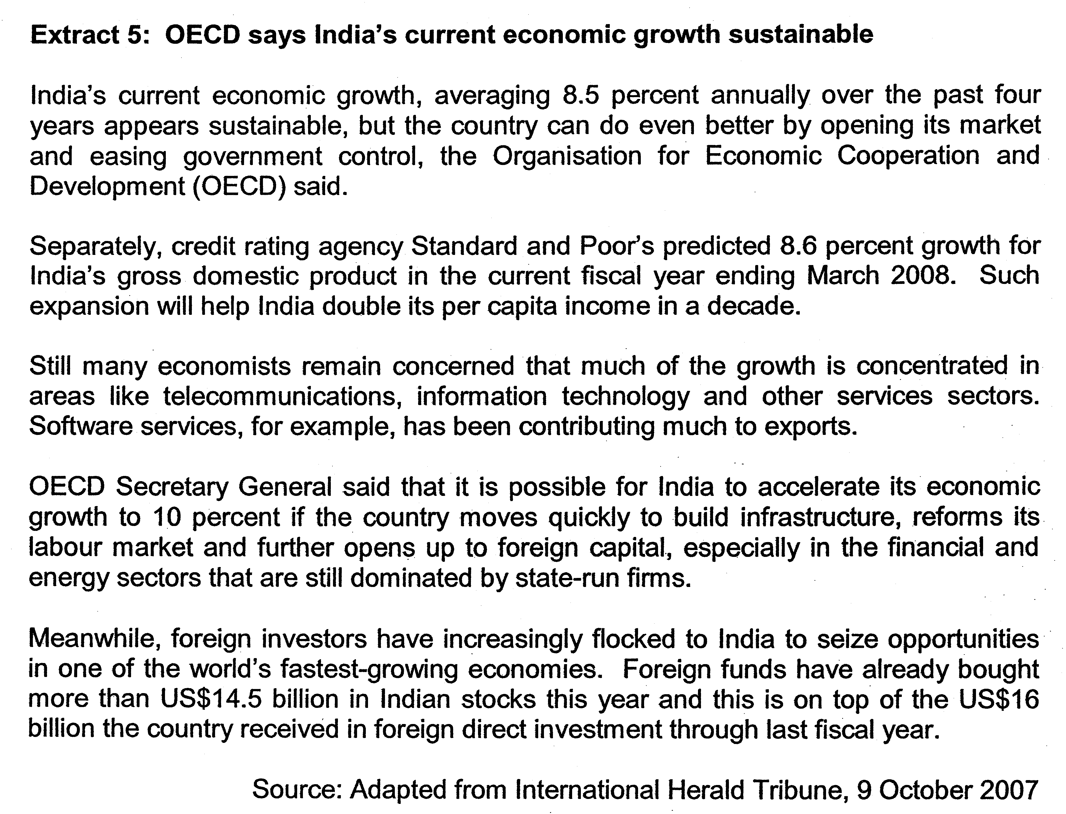
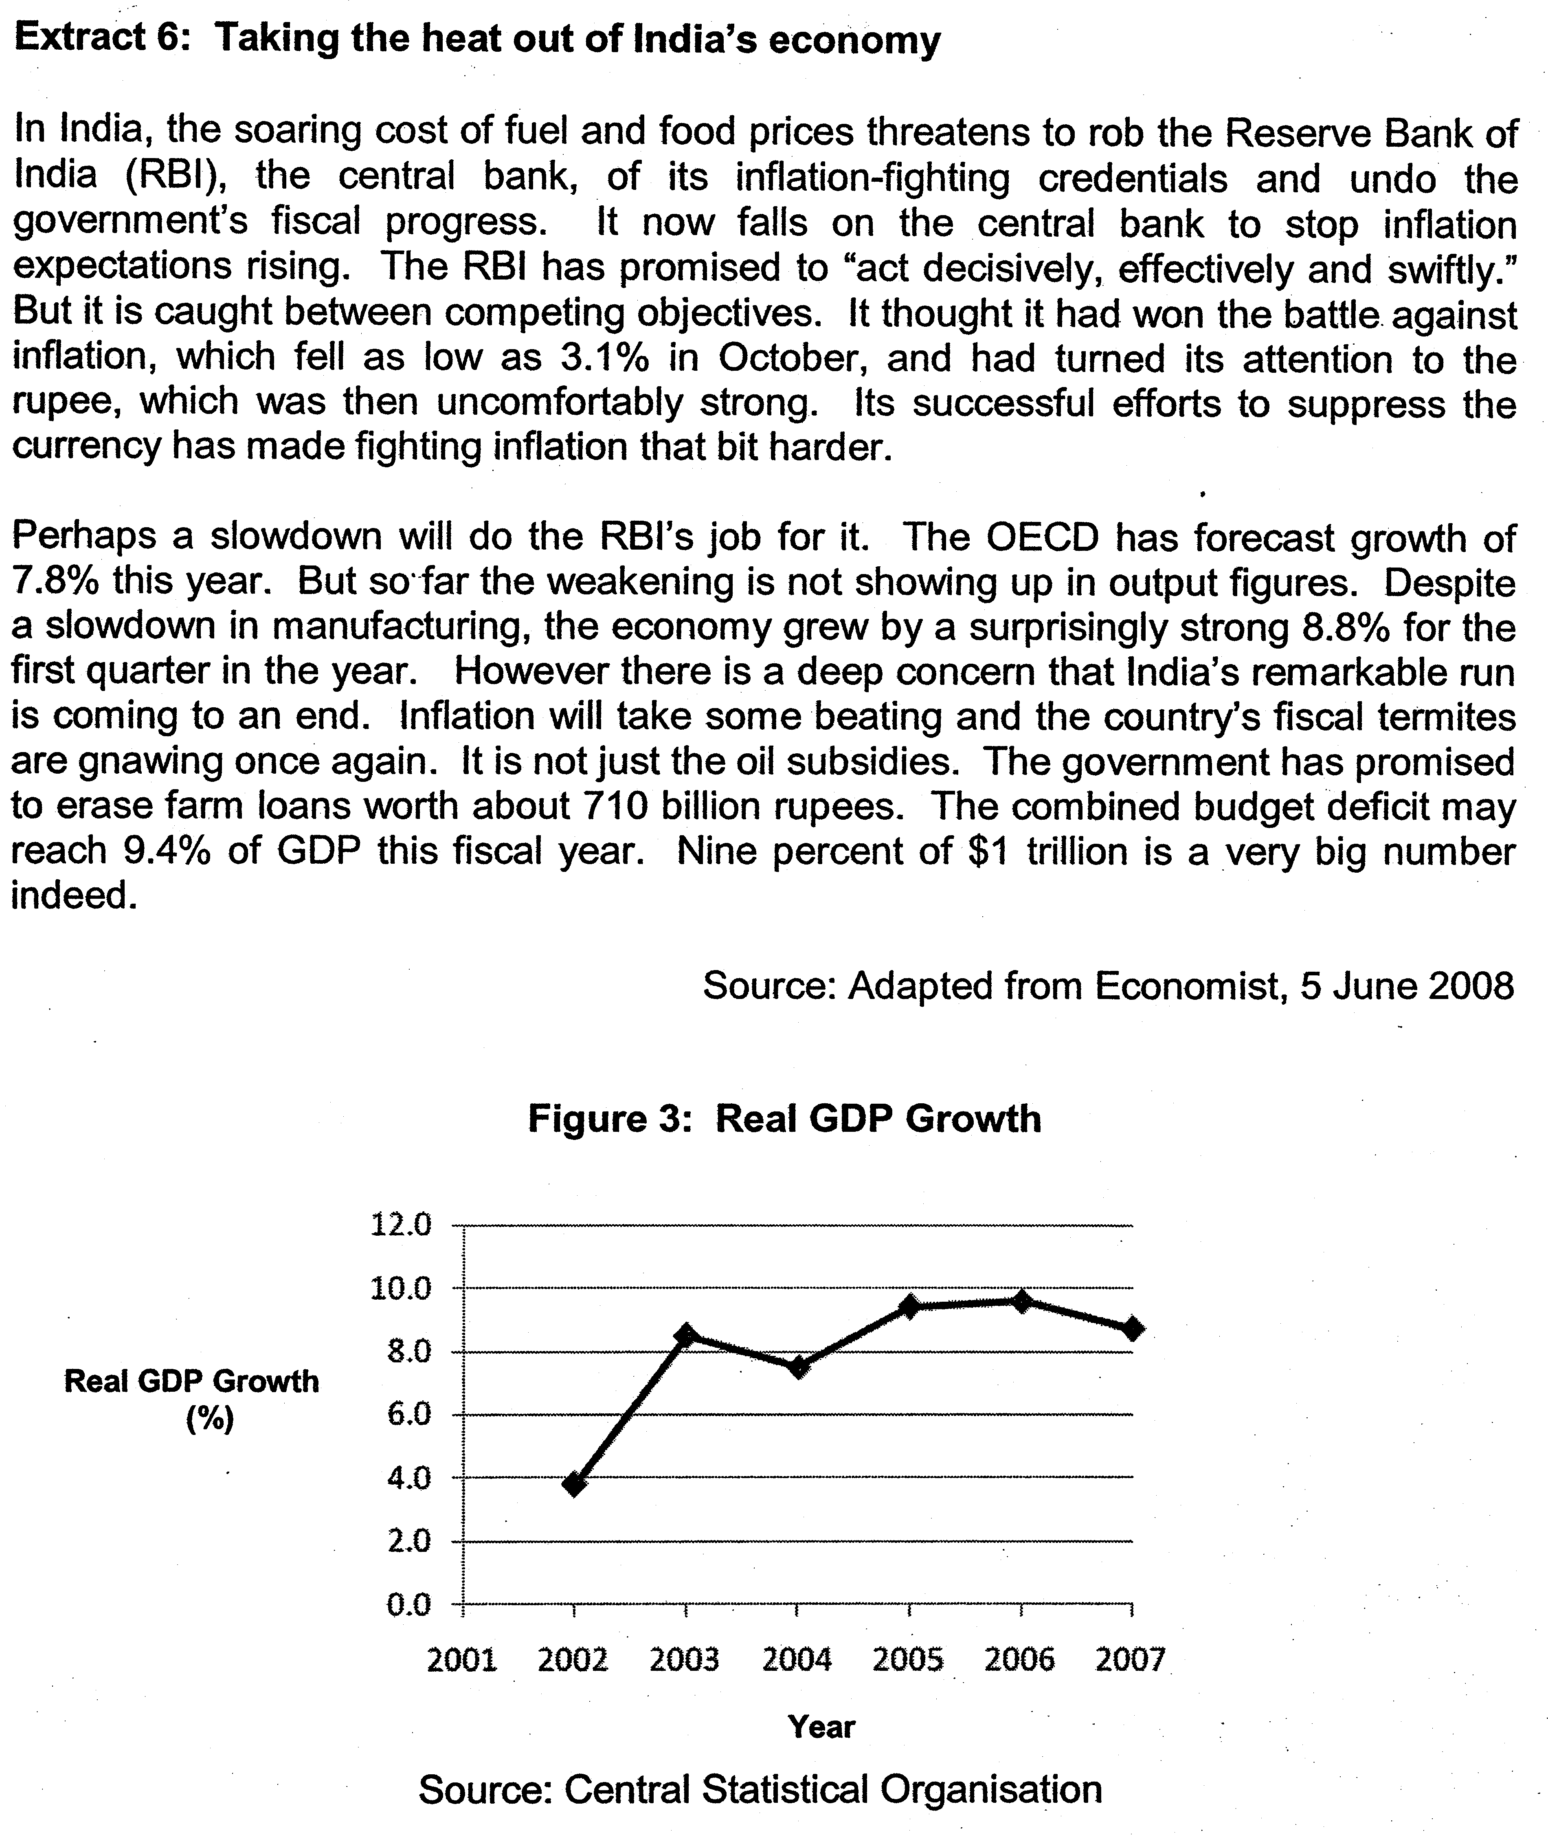

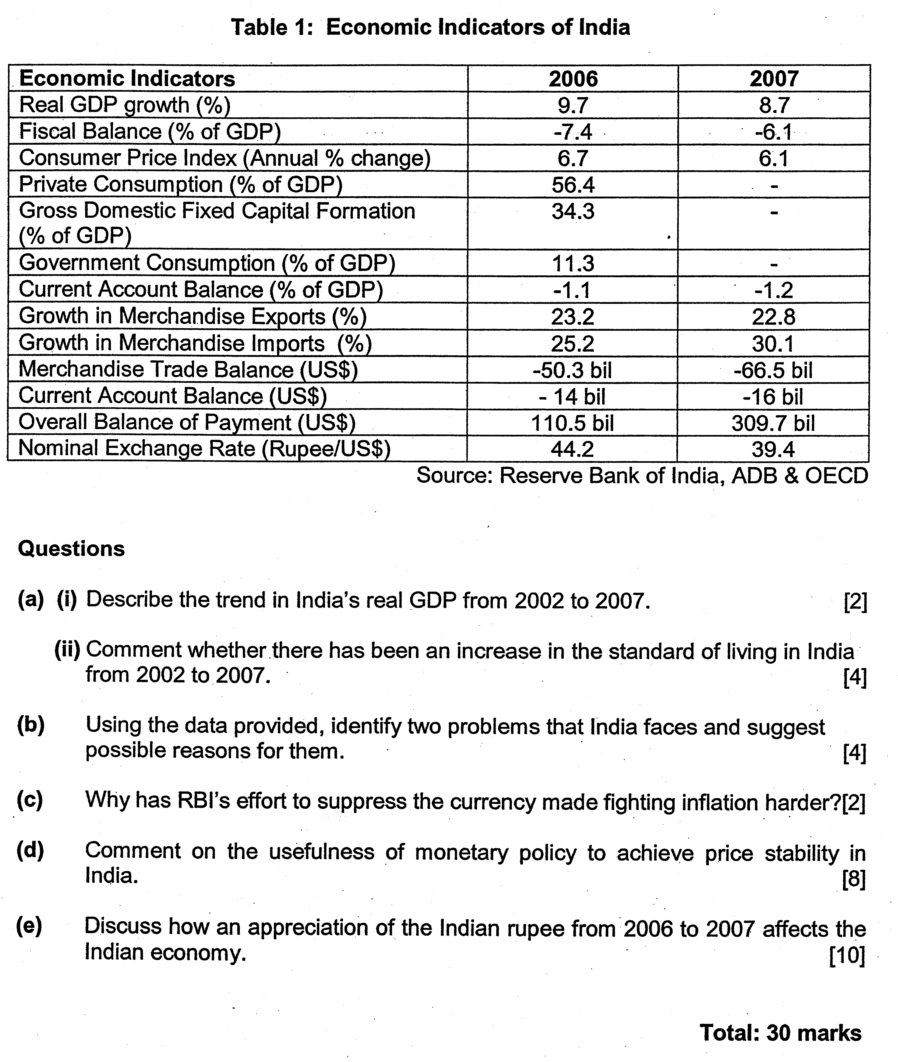

Suggested Answers

ai) Describe the trend in India’s real GDP from 2002 to 2007. (2)

India’s real GDP has increased from the period 2002 to 2007. Between 2002 and 2003 as well as 2004 to 2006, India’s real GDP has increased at an increasing rate while India’s real GDP has increased at decreasing rate for the other time periods.

aii) Comment whether there has been an increase in the standard of living in India from 2002 to 2007. (4)

Standard of living refers to the average quality of living that the citizens of the nation will enjoy in term of quantitative and qualitative measurement. Quantitatively, the rise in real GDP will lead to a rise in the real GDP per capita income which means that the purchasing power of the individuals is higher and thus, there is a higher level of material comforts the citizens in India. Furthermore, the increase in the level actual production capacity will enable the nation to enjoy a higher level of goods and services. Lastly, the higher level of real GDP will mean an increase in the tax revenue, enabling the government to provide a more efficient and effective infrastructures and facilities which will raise the convenience and comfort for the population.

However, the rise in real GDP alone is not sufficient to explain that the standard of living in India has improved. Population growth rate must be taken into consideration whereby a higher population growth rate than the real GDP growth rate will imply that the real per capita income may not rise. It is likely that India’s population growth is high as the population control measures are not effective.

The data also does not reflect the extent of distribution of income. Growth in real GDP per capita does not mean the real income of every Indian will rise if there is a high degree of unequal distribution of income when the Gini ratio is high or wage to GDP ratio is low. India is often criticised for having high income disparity despite the high real GDP growth rates in recent years and high level of consumption as percentage of GDP at 56.4% in 2006.

The data also does not reflect the composition of production which will determine the level of goods and services that Indians can enjoy and thus, determining the level of welfare that Indians can have. If the production is in term of capital goods, the current level of consumption will be lower which means that the standard of living is lower. Besides this, the high level of export demand will mean that the level of goods and services for local consumption is low.

The data in the table can only reflect the quantitative value of standard of living. There is no information on the qualitative aspect of SOL which can be identified from indicators such Measurement of Economic Welfare (MEW) and Human Development Index (HDI). (qualitative assessment is needed as it reflects the value of intangible aspect of well-being)

b) Using the data provided, identify two problems that India faces and suggest possible reasons for them. (4)

From the data, it can be noted that India faces inflation as the consumer price index is above 6% for 2006 and 2007 and there is indication that there is ‘soaring cost of fuel and food prices’ in extract 5. The inflationary condition is due both demand and supply factors. Demand-pull inflation occurs in India as there is extensive rise in export demand and foreign direct investment as global economic growth prompts the growth of FDI into India and higher demand of goods and services from growing industries like ‘telecommunications, information technology and other services sectors. Rise in domestic demand could also be contributed to extensive government expenditure on infrastructures and high income level which will raise local consumption level. At the same time, the ‘soaring cost of fuel and food prices’ in extract 5 has also depicted that India is experiencing imported inflation which will lead to rising cost of living and cost of production and thus, the inflationary condition.

Besides this, India also faces the condition of rising budget deficit in 2006 and 2007 and it has reached ‘9.4% of GDP’ in the year of 2008 which is brought about by extensive oil subsidies, cancellation of bad debts from farm loan at about 710 billion rupees. This will lead to the need to raise tax and increase public debt which will undermine the growth of the economy.

c) Why has RBI’s effort to suppress the currency made fighting inflation harder? (2)

RBI needs to lower the exchange rate as it needs to lower the exchange rate to lower its price of exports and cost of FDI to increase their competitiveness in the international market. However, the depreciation will mean a rise in the cost of import as it will be more difficult for the government for the Indian government to lower the soaring cost of fuel and food prices since India is highly dependent on the import of these resources.

At the same time, the lowering of the exchange rate will induce higher export demand and rise in the flow of FDI as the price of exports and cost of FDI has been lowered. This will induce rise in aggregate demand which will induce demand-pull inflation.

d) Comment on the usefulness of monetary policy to achieve price stability. (8)

The Indian government will conduct a contractionary monetary policy which increases the money supply through the use of quantitative and qualitative monetary tools and thus, contributing to a rise in the interest rates which will lead to fall in aggregate demand as a rise in interest rate will raise the cost of borrowing which will discourage credit consumption and investment and thus, this will lower price level the excess demand condition will be curbed.

As seen from the diagram, the rise in the interest rate due to the contractionary monetary policy will reduce aggregate demand from AD0 to AD1 and thus, lower the price level from P0 to P1.

However, such contractionary monetary policy will not be able to solve inflation in India as there is an inelastic marginal efficiency of investment as the profitability of investment projects and business confidence is still strong and thus, high interest rate discourage in the rise in investment. Furthermore, the rise in investment is mainly from the FDI which is not greatly influenced by the local interest rate which can be explained from the extensive rise in BOP surplus from 2006 at 110.5 bn to 309.7 bn in 2007.

As the main causes of inflation for India are likely to be due to wage-push and imported inflation, monetary policy is unable to reduce the wage level or lower the price of foreign resources and goods and services. In fact, the rise in the interest rate will increase in the fixed cost of production and thus, contributing to cost-push inflation. It is more appropriate for the Indian government to introduce supply-side management policies to solve the cost-push inflation as it can lower cost of production by raising the efficiency of production, rendering the monetary policy ineffective. Furthermore, the use of supply side policy will enable India to achieve ‘the growth of ten percent’ without sustaining excessive rise in price as projected by OECD.

The use of monetary policy is also likely to slow down economic growth in the short run as the high cost of borrowing will reduce aggregate demand, leading to lower production and nation income. For Indian, this will be significant to India as the massive population needs large scale of production to sustain employment and maintain a reasonable level of standard of living.

The rise in interest rate will also raise the exchange rate as it will induce inflow of hot money and this may help India to curb imported inflation. However, the effect is only temporary as the speculator will conduct profit-taking and this will subsequently lead to outflow of hot money which will lower the exchange rate and thus, negate the effect of curbing imported inflation. Furthermore, the rise in exchange rate will mean that the price of exported goods will rise and this will lower the export competitiveness of India.

(e) Discuss how an appreciation of the Indian rupee from 2006 to 2007 affects the Indian economy. [10]

As seen from table 1, the Indian rupee has appreciated from 44.2 Rupee per US$ in 2006 to 39.4 rupee per US$ in 2007. This will lead to a rise in the price of India’s imported goods and services in local value and a rise in the price of India exported goods and services in foreign value and in the cost of Foreign Direct Investment (FDI) in India.

As a result of this appreciation of the rupee, the export demand of India’s good may fall but there is still a growth in merchandise export as a percentage over the previous year. This cannot be due to the effect of the rise in price of India’s export good as a result of the appreciation. The growth in export merchandise is due to the expansion of global market. As for the impact on import expenditure, the rise in price of India’s imported goods in local value still contributes to a large percentage increase in import expenditure from 25.2% in 2006 to 30.1% in 2007 is due to the price-inelastic demand for import and high degree of India’s import dependency seen from the high value of marginal propensity to import (MPM).

Consequently, the deficit merchandise trade balance for India worsened from US$50.3bn to US$66.5bn as the growth of local expenditure of import goods is at a large percentage than the growth total receipt of export from 2006 to 2007

The appreciation may not discourage the inflow of foreign direct investment (FDI) into India as indicated by the Balance of Payment, there is an improvement which can be due to the rise in FDI as there is growth in the global export market demand which will induce more MNCs to invest in India to meet global market demand. But, most of all, the appreciation will encourage more short inflow of hot money as there is capital gain to be made from the speculation in the foreign exchange market since the speculator can further raise the exchange rate with a greater level of inflow of hot money to make more capital gain. This will mean that there will be an increase in the money supply in the local market which will lower the interest rate and make it more difficult for India to curb inflation rate since it cannot reduce money supply to raise interest rate.

With this inflow of hot money due to the impact of appreciation, it may be difficult for the government to curb domestic inflation but the short term appreciation of rupee may make it easy for India to curb imported inflation. However, as India is a price-taker in the global resource market, the effect of imported inflation is quite difficult to curb. Furthermore, the appreciation of Rupee may be short-lived, the appreciation is due to the influence of speculative activities in the foreign exchange market contributed by the flow in hot money. Since the cause of inflation is partially due to domestic factors as seen from excessive rise in aggregate demand and domestic cost, appreciation of the rupee may not be the solution to curb imported inflation.

Nonetheless, the appreciation of rupee did not undermine the economic growth too extensively as real GDP growth was positive in 2007 although there was decrease in growth rate as the appreciation may contribute to slower growth in export demand and inflow of foreign direct investment. This can be quite damaging for India as she relies greatly on external demand for her growth in the production, employment and national income.

In conclusion, the appreciation of rupee will create an extensive impact on India as seen in term of the balance of trade, flow of FDI and flow of fund. This will in turn create external instability for India’s market in the areas of price stability, employment and growth of national income.

