J2 June Intensive Revision 2015
L8 – CSQ – Aims of Government/Macroeconomic Policies – Q2

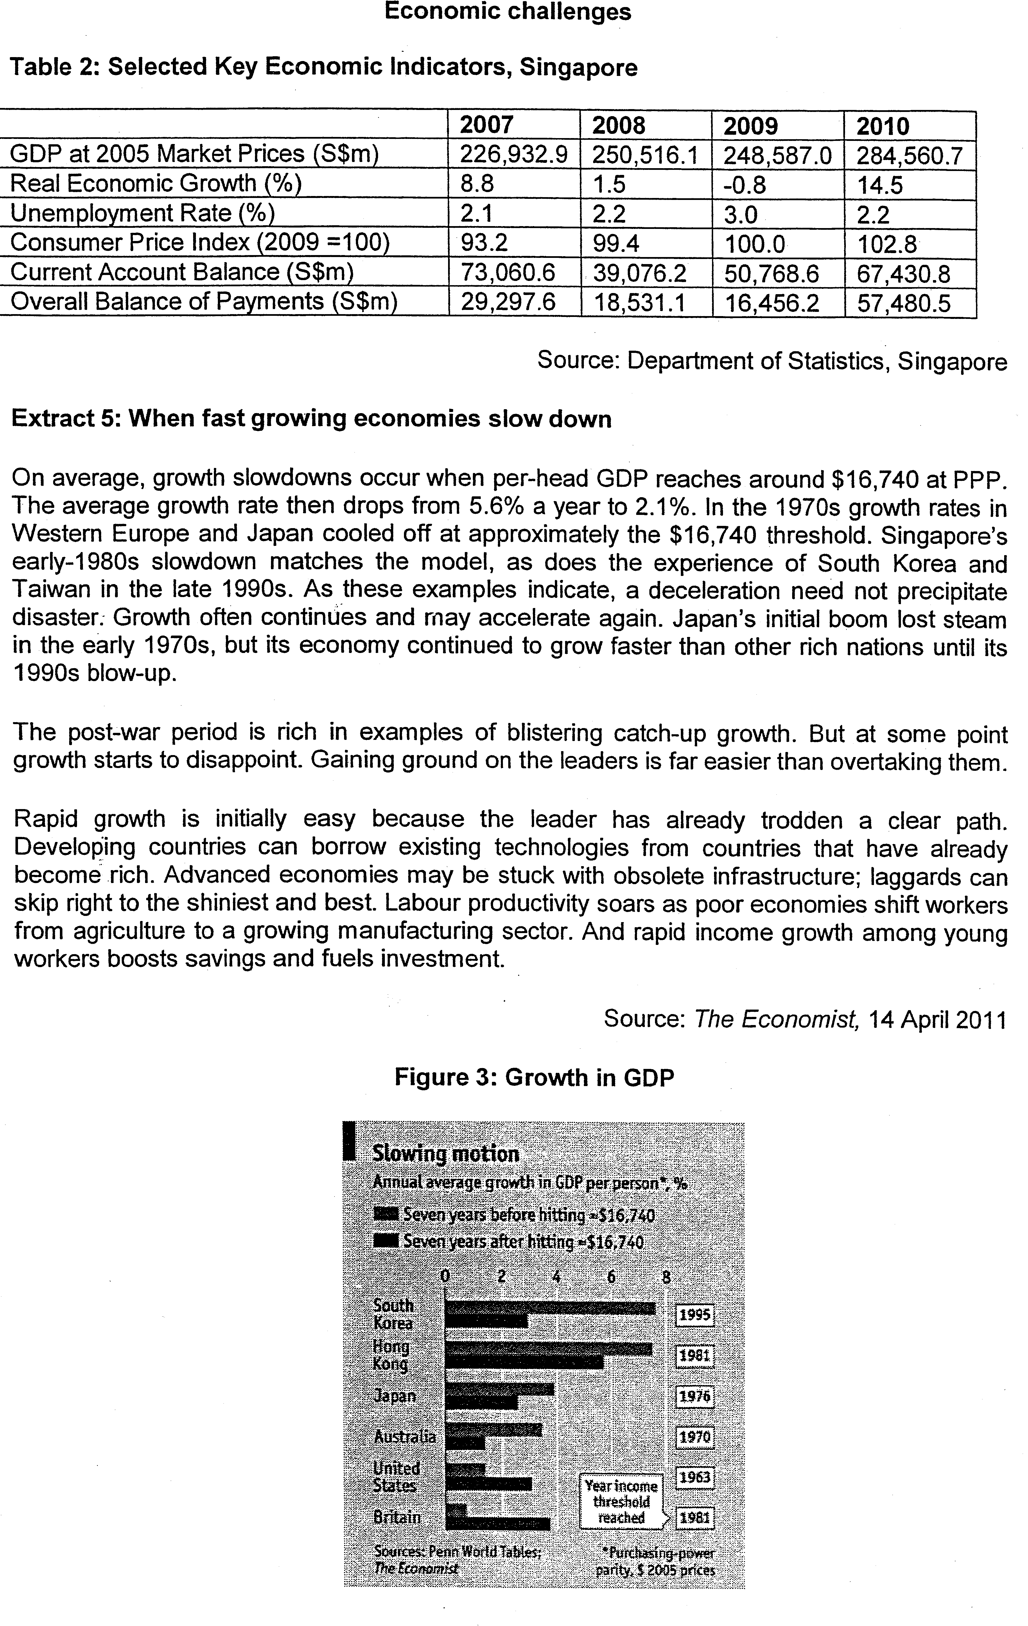
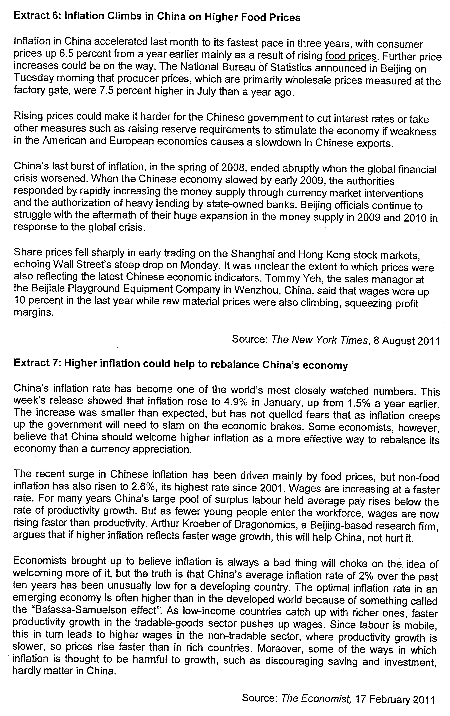
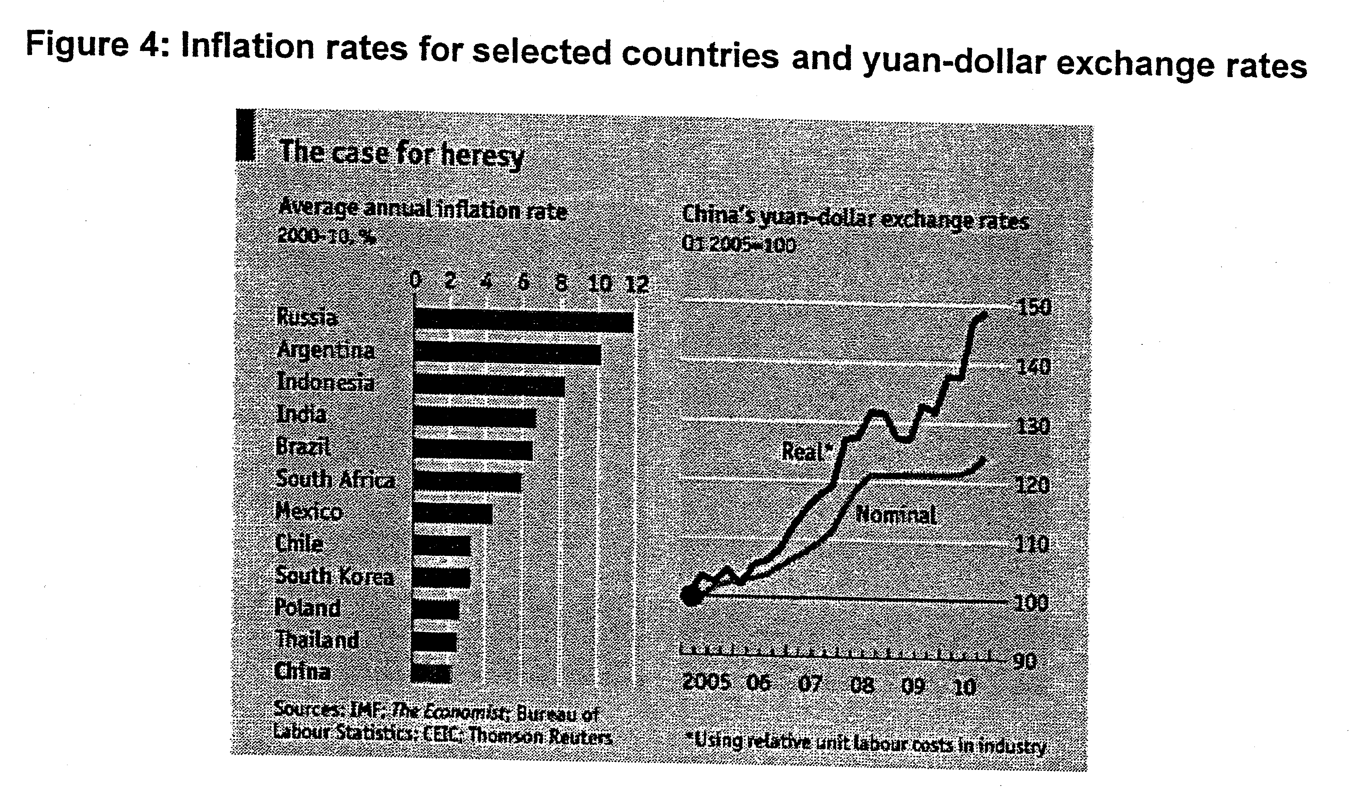
Questions
(a) Using Table 2, explain the changes in Singapore's real economic growth from 2007 to 2010. [2]

(b) To what extent does Table 2 suggest that the material standard of living for Singapore residents have improved between 2007 and 2010? [4]

(c) Comment on the reasons why a developing country's economic growth tends to slow down when GDP per head reaches a certain threshold. [4]

(d) Explain the likely impact of rising prices in China on the US economy. [2]

(e) Discuss the policy options available to the Chinese government to deal with rising prices in the country. [8]

(f) Assess whether China with its huge current account balance surpluses 'should welcome higher inflation as a more effective way to rebalance its economy than a (nominal) currency appreciation'. [10]
[Total: 30]

Suggested Answers

(a) Using Table 2, explain the changes in Singapore's real economic growth from 2007 to 2010. [2]

Singapore's real economic growth fell and turned negative before rebounding strongly. The recession was due to the world economic crisis that started in 2008 with the US sub-prime crisis.

(b) To what extent does Table 1 suggest that the material standard of living for Singapore residents have improved between 2007 and 2010? [4]

The rise in real GDP would roughly mean, other things being constant, a rise in the material standard of living. The change in real income per head depends on whether there has been a rise in the material living standard of the residents.

However, with about the same unemployment rate at the beginning and end of the period but a big increase in the real GDP, and assuming that the population does not increase by very much at all, then it could be concluded rather safely that the material standard of living did indeed improve over the period.

Nevertheless, it is to be noted that the increase in the standard of living might be tempered by the improvement in the current account balance. This is because a proportion of the net output produced in Singapore would have been exported and thus consumed by foreigners.

Also, we could not tell from the information available about whether or not there has been a widening income gap. If that is so, then the increase in real GDP might not translate to a higher material living standard for most the residents in the economy.

(c) Comment on the reasons why a developing country's economic growth tends to slow down when GDP per head reaches a certain threshold. [4]

Many developing countries experience fast economic growth in the initial years of playing catch up with the advanced countries. The average threshold income per head seems to be US$16,740. After a country reaches that level of income, however, growth tends to slow down. Rapid growth for a developing economy at the initial stage is relatively easy because it can borrow existing technologies from those countries that have already become rich.

Advanced economies may be stuck with obsolete infrastructure. The developing country could skip right to the best available technologies and equipment from the developed countries.

Labour productivity rises quickly as the developing economy shifts workers from agriculture to a growing manufacturing sector. And rapid income growth among young workers boosts savings and fuels investment.

However, as the emerging economy rises in her GDP per head and begins to resemble the advanced countries, it would become harder to sustain the pace of growth.

As the stock of borrowable ideas runs low, the developing economy must begin innovating for itself. The supply of cheap agricultural labour dries up and a rising number of workers take jobs in the service sector, where productivity improvements are more difficult to achieve.

At this point economic growth for this developing country slows down, and catching up with the leaders becomes more difficult.

The post-war period is rich in examples of blistering catch-up growth. But at some point growth starts to disappoint. Gaining ground on the leaders is far easier than overtaking them.

(d) Explain the likely impact of rising prices in China on the US economy. [2]

In China the overheated economy has triggered an inflationary cycle as the price of practically everything goes up, including food, wages and raw material prices.

There is also the slow appreciation of the Chinese Yuan against the US dollar, making prices of goods from China higher on another count.

The higher costs and prices will be passed down to consumers in the US in the form of higher prices.

This will further exacerbate the already large trade deficit that the US economy has run up against China, assuming that US demand for Chinese goods are price inelastic as they may well be if Chinese goods are still comparatively cheaper than substitutes elsewhere despite the appreciation of the Yuan. This could be that Chinese products have low cross elasticity of demand vis-à-vis those from other countries

(e) Discuss the policy options available to the Chinese government to deal with rising prices in the country. [8]

Tighter macroeconomic policies e.g. monetary policy - raising interest rates; raising reserve requirements

Raising interest rates reduces aggregate demand (AD) in 3 main ways:
- Discouraging borrowing by both households and firms
- Increasing the rate of saving as the opportunity cost of saving has increased
- Rise in mortgage interest payments will reduce homeowners real effective disposable income and hence their ability to spend; increased mortgage interest rates will also reduce market demand for housing

Private business investment will also fall as the cost of borrowing funds will increase. Some planned investment projects will now become unprofitable and as a result AD falls

Higher interest rates could also limit monetary inflation - a rise in real interest rates would reduce the demand for loans and hence reduce the growth in the money supply which will result in an increase in spending

Evaluation of contractionary monetary policy such as raising interest rates
However, raising interest rates might attract short term capital flows (i.e. hot money) into the economy. This short term capital inflows add to the already ample liquidity and hence exacerbate price pressures.

It also causes the domestic currency to appreciate.

Assuming both exports and imports are price elastic, this appreciation of the Yuan currency will lead to a fall in net exports as prices of imports (in terms of domestic currency) fall and price of exports (if terms of foreign currency) rises.

Raising reserve requirements makes it more expensive for banks to meet their reserve requirements. They must replenish their reserves by reducing their lending. They induce potential borrowers not to borrow so much by raising interest rates they charge on the loans they offer. Thus some borrowers who would have borrowed to purchase goods and services will no longer do so. The AD curve shifts down causing in the SR both the general price level and real GDP to fall.

However, monetary policy is not appropriate to use in the case of cost-push inflation.

Hence, supply-side fiscal policies should be used.

Fiscal policy
Higher direct taxes - causing disposable income to fall

Lower government spending

These contractionary fiscal policies increase leakages and reduce injections into the circular flow of income and will thus reduce demand pull inflation.

Evaluation of contractionary fiscal policy:

However, this solves demand pull inflation at the cost of slower growth and rising unemployment.

Cutting public spending on key social services like healthcare and education will meet with public resistance.

Public spending on long-term infrastructure projects such as roads, schools and hospitals cannot simply be called off when they have already started.

Raising taxes during such a time when the people are suffering from rising prices will be politically unpopular

Furthermore, this will have unfavourable effects on the incentive to work and invest.

Longer term supply-side policies to control inflation

Supply side policies such as education and training, privatisation, R&D, infrastructural developments, tax reforms seek to increase the productive capacity of the economy in the LR and raise the trend of growth of labour and capital productivity.

Besides curbing AD, supply-side policies aim to shift the AS curve downwards

Such policies are used when the inflation is cost-push in nature, or when a wage-price spiral has set in.

Evaluation of supply-side policies

However, supply-side policies tend to take a long time to be effective and uncertain in their outcomes as they require structural changes to be made to increase AS.

Other approaches
Raise unemployment benefits, pensions and minimum wage in line with inflation in order to shield the vulnerable.
Regulations to:
o Cut prices of electricity, gas and rail transport and essential food items e.g. sugar
o Cap prices of staples like rice, noodles, pork, cooking oil, etc.

Evaluation includes the problems that arise from the ensuing shortages, queues forming, the need to use public funds that could be used for other essential projects, possible adulterated quality of the goods affected by the regulations passed, undermining capitalism, etc.

(f) Assess whether China with its huge current account balance surpluses 'should welcome higher inflation as a more effective way to rebalance its economy than a (nominal) currency appreciation'. [10]

The main cause of China's big imbalance in its current accounts is too little consumption. This is because wages (as a share of national income) have been low.

When wages rise more slowly than productivity increases, the economy produces more goods and services than it can consume. This thus results in a current-account surplus in the balance of payments.

On the other hand, if wages rise faster than productivity, workers' incomes rise. This brings about higher consumption demand in the Chinese economy and could result in a reduction of her huge external current account surplus. This is because with the rise in incomes, the Chinese increase their demand for more imports from other countries.

The resulting demand pull inflation would also help to narrow China's trade surplus by pushing up the price of its exports. Imports into China would also become relatively cheaper in terms of the Yuan.

Consequently, demand for her exports fall and her demand for imports rise, and assuming the Marshall-Lerner condition holds, thereby bringing about a reduction of her current account surplus and a rebalancing of her economy.

Having said that it is to be noted that a stronger Yuan from a currency appreciation could also help to reduce China's trade surplus. Prices of Chinese goods will rise in terms of foreign currencies and prices of her imports from other countries fall in terms of her own currency, i.e. the Yuan, Assuming that the Marshall-Lerner condition holds, this will bring about a fall in exports and an increase in imports, bringing about a correction in the balance of payments.

However, the effect of the currency appreciation on reducing the trade surplus would not be as much as would the inflation. This is because in the case of currency appreciation, what really matters is the appreciation of the real exchange rate.

Real exchange rate changes take account of relative inflation rates at home and abroad. Movements in nominal exchange rates do not quite achieve the desired adjustment as real exchange rates do.

This is because changes in nominal exchange rates may by offset and undone by changing domestic prices. Thus, if China's inflation is less than her trading partners, this could render the Chinese goods and services just as competitive as before and thus her current account surplus remains.

Thus a relatively higher inflation (than her trading partners) from higher wages should help the Chinese economy to rebalance more than a nominal currency appreciation.

Furthermore, an inflation rate of say 4-6% would be preferable to either a sharp appreciation of the Yuan. This is because the large appreciation could cause big job losses in export firms, or attract large speculative capital inflows; both of which are undesirable.

However, the inflation should be a mild one and not develop into one that is runaway and out of control.

An out of control runaway inflation is usually the result of fiscal excesses which are financed by printing more money, or rigid labour markets producing a wage-price spirals that the central bank fails to stop. It is, however, to be noted that China has a record of fiscal prudence and is therefore not likely to develop into an uncontrolled runaway inflation, at least in the medium term.

