Suggested approach
4. After years of surging foreign manpower growth, the Singapore government moved to tighten the labour market in 2009 as part of its efforts to reduce reliance on low-skilled labour to encourage innovation and automation, especially among small and medium enterprises.
In 2017, the Singapore economy grew 3.5%, more than double the initial forecast.
Source: The Business Times, 5 February 2018

(a) Explain the factors that are likely to contribute to Singapore’s actual and potential economic growth. [10]
- Use the conceptual framework of AD/AS analysis to explain what contributed to Singapore’s actual and potential economic growth.
- Using real-world examples that is contextualized to Singapore, examine the internal and external factors that causes changes in aggregate demand and aggregate supply.
Introduction: Framing – unpacking actual and potential growth
- Actual economic growth: refers to an increase in a country’s real national income or GDP, and could be caused by an increase in either AD or/and AS as real national output is determined by the interaction of aggregate demand and aggregate supply forces.
- Potential economic growth: refers to an increase in a country’s productive capacity, and can be illustrated by an increase in a country’s LRAS, that is usually due to an increase in quality and quantity of factors of production, to ensure growth is sustained in the long-run.
Body:
A: Internal factors
- One possible factor is an increase in consumer sentiments due to better job prospects and sound government policies e.g In recent years, Singapore sees largest rise in consumer confidence across S-E Asia in 2017. This leads to greater willingness to spend and hence leads to higher consumer spending C.
- This will lead to an increase in aggregate demand as AD = C+ I + G + (X-M). This is illustrated by the shift in AD rightwards from AD₀ to AD₁.
- Diagram:
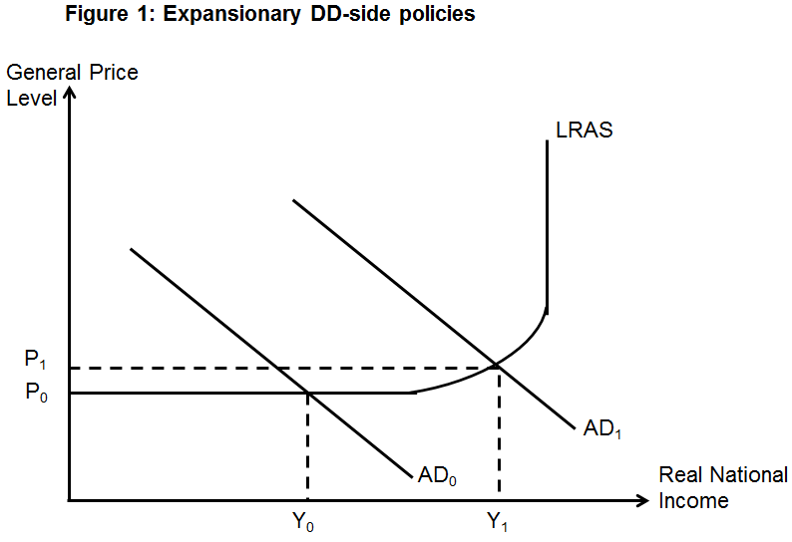
- Explain multiplier effect: Hence firms have to draw on inventories of goods that are produced in the past to meet the increase in aggregate demand. Firms will increase output in the next production cycle in attempt to restore their inventories to their optimal level. Firms enter the factor market to demand for more factors of production, including labour, paying out more factor income. As national income (output) rises, income-induced consumption increases, causing another round of increase in AD, adding to the circular flow of income, setting off the multiplier effect where additional spending creates additional income which induces more spending. Eventually the multiplier process will end when the initial injection = withdrawals.
- Assuming that the economy is operating in the intermediate range where there is spare capacity, an increase in AD will lead to a multiplied increase in real GDP from Y₀ to Y₁ actual growth.

- Another possible factor is government policies. Supply-side policies can help to raise economic growth through an increase of AD/SRAS or productive capacity.
- The Singapore government has encouraged firms to expand innovation and R&D efforts to increase efficiency level since Singapore is also very open to global competition. For example, the Singapore government has poured in $19billions into the Research Innovation Enterprise 2020 Plan (RIE2020) which seeks to support and translate research into solutions that address national challenges, build up innovation and technology adoption in companies, and drive economic growth through value creation.
- Increase in quality of labour: Policies to improve skills and productivity of the workforce (e.g. Skills Future, Adapt and Grow Initiative, TechSkills Accelerator etc.)
- Increase in quantity and quality of capital: Attract FDI, encourage R&D and innovation through funding and tax incentives etc.
- An increase in the quantity and/or quality of factors of production will lead to an increase in productive capacity causing a rise in LRAS from LRAS₀ to LRAS₁.
- Diagram:
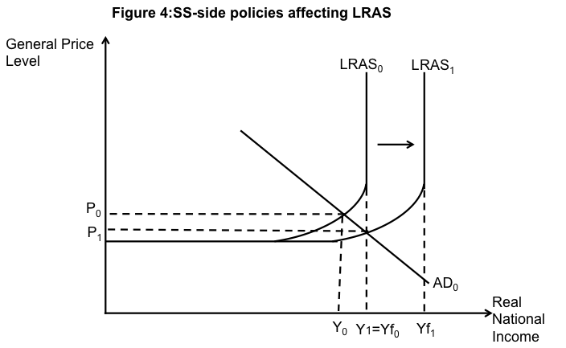
- This causes an increase in the full employment capacity of the economy from Yf₀ to Yf₁ potential growth.
- While an increase in LRAS leads to potential growth, it COULD also lead to actual growth from Y₀ to Y₁ if the economy is operating close to full employment.
B: External factors
- Another possible factor is growth in external demand markets such as China and Eurozone.
- As countries like China and Eurozone are experiencing economic growth, this means that they have higher national income and thus greater purchasing power to increase demand for Singapore’s exports such as semiconductors and semiconductor equipment, and externally oriented service sectors such as finance and insurance, transportation and storage, and wholesale trade.
- This leads to an increase in net exports due to Singapore’s trading partners experiencing higher economic growth and this has a large impact, especially for small and open economies like Singapore which has one of the highest trade to GDP ratio in the world in excess of 300% (X-M).
- Also, there could be an inflow of foreign direct investment, such as Dyson and Neste, as they are attracted by the sound economic fundamentals, good network and infrastructure, strong legal framework and attractive tax system in Singapore (e.g. US$58 billion of foreign direct investment entered Singapore in 2017, Singapore stand out as attractive BRI (Belt and Road Initiative) destination for Chinese investors) I.
- Hence the (X-M) & I AD multiplied NY due to the multiplier effect, leading to actual growth.

Conclusion
- While Singapore is an export-driven economy, internal factors such as domestic consumption and domestic cost are important in contributing to Singapore’s economic growth rate.
- These factors are usually interrelated and there would be simultaneous shifts in both AD and AS curves, affecting the growth rate of the economy.
(b) Discuss the impact of tightening foreign labour supply on living standards in Singapore. [15]

Suggested approach
- Students need to consider the impact of tightening foreign labour supply on both material and non-material standard of living in Singapore.
Introduction:
- Tightening foreign labour supply: Its aim is to reduce reliance on low-skilled labour and encourage innovation and automation. This is done by implementing foreign worker levies, minimum salary levels for foreign worker passes and issuing less work permits for low skilled, untrained workers, especially in construction & shipbuilding sectors.
- Living standards refer to the quality of life; the welfare of the population and this consists of both material and non- material aspect of living standards.
- Material – amount of goods and services that individuals in the country have available for consumption
- Non-material– amount of leisure time, life expectancy, standard of education, amount of pollution
- Context of Singapore: Small and open economy and a great reliance on foreign manpower due to our small and ageing population.

Body:
Argument: Explain how tightening of foreign labour supply can raise living standards in Singapore.
- Due to the tightening of foreign worker supply, businesses, especially SMEs, have been forced to innovate and automate their processes to increase productivity, to cope with the manpower shortage.
- This is because by restricting foreign labour, this will decrease the supply of labour and increase the wage cost. Hence, firms will be incentivise to substitute labour for automation and switch away from labour-intensive methods of production towards more capital-intensive method of production to increase labour productivity and decrease unit cost of production at the same time.
  - The Singapore government has also committed $2.5 billion over the period of 2010 to 2015 to schemes like Continuing Education and Training (CET) and production innovation credits to help firms drive productivity growth.
  - These schemes will lead to lower cost of production and lead to an increase in SRAS and thus national income will increase, while reducing inflationary pressure.
- Also, when producers pass on the fall in cost of production to consumers, this will lead to lower prices of domestic goods and exports. Assuming demand for exports is price elastic, the more price competitive exports will bring about greater export revenue and hence AD rises NY increases.
- The increase in AD and SRAS will result in an increase in real national income and thus greater purchasing power leading to an increase in material standard of living.
- In the long run, the adoption of automation and technology will increase the productive capacity of the Singapore economy, thereby helping to achieve potential growth and dampens DD-pull inflation, maintaining a healthy rate of inflation. In the past, Singapore has a problem of low productivity due to the reliance on low skilled workers. Thus, targeting higher productivity can lead to higher actual & potential economic growth for Singapore leading to an increase in material living standards.

- In addition, as there are stricter rules on immigration, this will result in less overcrowding in public spaces such as public transport, this will result in less stress on the public amenities, thus this could appease the locals’ unhappiness non-material standard of living could rise.

Transition
- While businesses in certain industries have been able to automate their processes, it is not as easy and sometimes not possible, in the service and construction industries, which is very labour intensive. Hence tightening of foreign labour supply may be detrimental to those industries.

Counter-Argument: Explain how tightening of foreign labour supply can cause a fall in living standards in Singapore.
- Due to the restructuring towards productivity-driven growth, firms may adopt more labour-saving technology, where jobs are replaced by machines. This will lead to a falling demand for lower skilled workers and a higher demand for higher-skilled workers. The lower skilled workers may be less educated and thus lack the knowledge and skills to take up jobs take require knowledge of information technology. Furthermore, retraining to equip workers with new skills takes a long period of time and older and less educated workers may also be less receptive towards the use of technology. Hence, this may result in rising structural unemployment fall in material standard of living.
- This may also worsen income inequity as there is a higher demand for higher-skilled workers, resulting in higher wages, and lower demand for lower-skilled workers, resulting in lower wages. This could result in greater tensions among groups in society fall in non-material standard of living.
- In the short run, it is likely that the restriction in foreign labour will cause wages to rise faster than labour productivity. This is because productivity takes a long time to increase. Efforts to improve the work flow and finding and implementing appropriate technology to speed up the work flow takes time. Hence, in the short run, while the wage cost has increased, labour productivity may have increased less than proportionately, hence, unit labour cost will rise.
- Yet, not every industry is able to automate and substitute labour, especially in service oriented industries. Due to the lower supply of foreign workers and the lack of Singaporeans willing to do more manual work, this will result in higher wages for blue-collar workers. Business owners have to pay higher wages to hire foreign workers due to the foreign worker levies, or turn to hiring Singaporeans who demand for higher wages, but less productive, resulting in higher cost of production SRAS decreases This causes the general price level to increase from P₀ to P₁, causing inflation. This will raise cost of living, resulting in purchasing power of locals to decrease, resulting in a fall in material standard of living.
- While there is an increase in domestic cost due to government policies, it could be offset by productivity growth. An increase in productivity through automation can help to reduce average cost. However, as it takes time for business to change their mindset and business processes, living standards will only improve in the long run. For those who embrace automation and technology will benefit more and be able to adapt better when the economy restructures.

Synthesis:
- Instead of tightening all foreign labour supply, perhaps the government should loosen policies targeting lower-skilled foreign workers who do jobs that locals do not wish to, especially as the resident workforce becomes higher-skilled over time. To ensure that there is a substantial labour force, the Singapore government has also increased the retirement age from 62 to 63 by 2022, and 65 by 2030 to slow down the shrinking labour force due to the falling birth rate and ageing population. This will help to increase labour supply and mitigate the negative impact of higher cost of labour on firms and hence cost of living may not increase drastically.
- To reduce no. of lower-skilled foreign workers in labour intensive jobs as an attempt to improve labour productivity is not easy to achieve. This is because; it requires education and retraining which may not be effective if workers are not receptive. Though CET was implemented from 2010, its success has largely been limited with productivity falling in certain years and coupled with ageing population, where older workers mindset could be hard to change. To counter this, the Singapore government advocated for ‘lifelong learning’ and made systemic changes to the educational landscape and introduced the Skillsfuture package to encourage lifelong learning for all Singapore Citizens. Thus in the future, we would expect to see a change in the receptiveness of workers and this limitation will be less pertinent. Nevertheless, this policy on tightening foreign manpower on low skilled workers to improve labour productivity may only be more beneficial in raising living standards in the long run, but it’s likely to have a negative impact on living standards in the short run.

