Economics Term 3 2017
CSQ – Lesson 6 – Aims of Government & Policies – Q2

The Pains and Gains of Economic Restructuring

Extract 5: China – The need to restructure

The National Bureau of Statistics (NBS) announced that the world's second largest economy, China grew 7.4 percent in 2014. Although the pace was the slowest in 24 years, it was in line with mainstream market expectations against the general backdrop of China's painstaking efforts in economic restructuring, which was prompted by both external and internal vulnerabilities.
Hard landing or soft landing – impact on the economy – China’s GDP must grow more than price and population growth – increase in real output to raise employment and wage (7.4 > 3% (P), 2% (pop))
Externally, the prolonged weakness and instability of the United States (US) and Eurozone economies have exposed China’s vulnerability to external shocks. China had to resort to a 4 trillion yuan (US$586 billion) stimulus package in 2008 to fend off the contagion effect of the global financial crisis.

Internally, the Chinese are concerned over the formation of real estate bubbles that are fuelled by excessive borrowing. The fear is that if the real estate bubbles were to burst, housing prices will come tumbling down. This would cause some households to cut down on expenditure of other goods and services in an attempt to pay their debts, sending internal shocks reverberating throughout the economy.

A source close to the central government said, "There are downward risks, but China has enough policy room and there is no need to be pessimistic."

Source: Xinhua, 20 Jan 2015

Extract 6: China - Restructuring to boost consumption

China’s level of consumption, at 36 percent of GDP, is much lower than the world average, which measures at 60 percent of GDP. This is partly because Chinese consumers hold larger precautionary savings to guard against illness and loss of income during old age. High savings may be changeable over time; improvements in health and pension coverage are expected to continue to lower the necessary savings ratio and boost consumption. Planned expansion of urbanization should also improve consumption as China’s cities expand and its middle class grows.

Consumption, however, is dependent not only on the presence of health care and urban residence, but on jobs. Households earning US$16,000 to US$24,000 per annum accounted for only 15 percent of urban households in 2012. GDP per capita averages at only US$6,807 per annum, and the population is aging. China’s challenge now lies in creating the types of jobs that will cater to a growing mass of educated workers and provide higher incomes. As local officials have learned, simply building up urban areas does not draw in high value businesses, nor does it create middle class residents in the absence of jobs.

Moves were announced by the State Council to encourage the hiring of the longer-term unemployed and new graduates to stave off an unemployment crisis. Preference in bids for large-scale projects is to be given to firms that commit to hiring more people. This is on the right track, but while these policies may improve the employment outlook, they could still go further in ensuring that most firms have better access to finance, lower taxes, and strong supporting institutions. In addition, it is the restructuring toward a service-based, skills-intensive economy that is essential.

Source: The Diplomat, 3 May 2015

Extract 7: Singapore - Restructuring into a “manpower lean” and creative economy

Singapore has embarked on a restructuring process towards being a "manpower lean" economy by cutting growth rates of foreign labour. This is done by imposing more stringent stipulations and also increasing the levy fees imposed for hiring foreign staff manpower. Small-Medium enterprises (SMEs) have been hit especially hard by the new rules. There are ample subsidies to push SMEs towards being manpower lean through using more productive capital goods but there is uncertainty about the return on investment. Addressing these concerns, Acting Minister of manpower, Mr Tan Chuan Jin said in parliament, "Given Singapore's small physical size, we will need to grow within the constraints that we have. Restructuring for higher productivity will be a risky and painful process for companies but we cannot proceed with business as usual".
Why we need foreign workers? – fill in the low wage and manual work, lower wage cost, need of foreign talent – alternative strategy – use of machinery
At the same time, Singapore is also trying to restructure into a creative economy and reduce the nation’s dependency on manufactured goods. An emphasis on design has been key to this planned shift into a creative economy. The Singapore government recognizes that, with growing access to better technology, industries are increasingly competing via price and functionality. The new competitive advantage thus lies in the ability to carve out new markets and create new markets through the fusion of business, technology and arts. Design, which serves to bring about such a fusion has emerged as the key differentiation strategy for businesses.

Singapore-based firms seem to be adapting well and are increasingly engaged in the design phase of manufacturing rather than the physical production of goods. The phenomenon is known as the “servicization” of manufacturing. Monetary Authority of Singapore (MAS) managing director Ravi Menon also has referred to this trend, saying that in some cases production of goods is being shifted offshore but control centers remain in Singapore, such as in the semiconductor industry. Singaporean companies are increasingly turning to southern Malaysia for production, where wages are cheaper and government incentives provide tax breaks for new industry.
Source: Various

Extract 8: Youth unemployment in the Eurozone

Why youth unemployment is detrimental to the economy?
Wastage of resources – under-utilization of resources
Rise of unemployment benefit / loss of tax revenue
Rise in crime and social instability

While the Eurozone (a bloc of 28 countries, including Germany and Greece) seems to have stabilized from the debt crisis, the risk that Europe may stagger back into the economic abyss is far from over. In many countries of the Eurozone, serious reforms to improve regional competitiveness had not been undertaken. This has sparked fears of a possible renewed recession in the Eurozone.

Unemployment in the Eurozone is already endemic and a renewed recession would worsen matters. Youth unemployment in particular is a worry because jobless youth often feel rejected by society, and react either by withdrawing or by lashing out violently, as we have already seen in some southern Eurozone nations. The impact on future productivity is also a significant worry. A growing academic literature on the ‘scarring’ effects of launching a career without a full-time stable job suggests that young people who endure early spells of unemployment are likely to have lower wages and greater odds of future unemployment than those who don’t. These scarring effects last throughout the remainder of their 20-30 years of working life.

Currently, Greek’s youth unemployment (for labour force above legal working age and under 25) is at 51.5%, second to Spain, which comes in at 53.7%. But the bloc is hugely divided. Germany and Austria have youth unemployment rates of just 7.6% and 8.2%, respectively.

Source: Duestche Welle, 17 Oct 2014

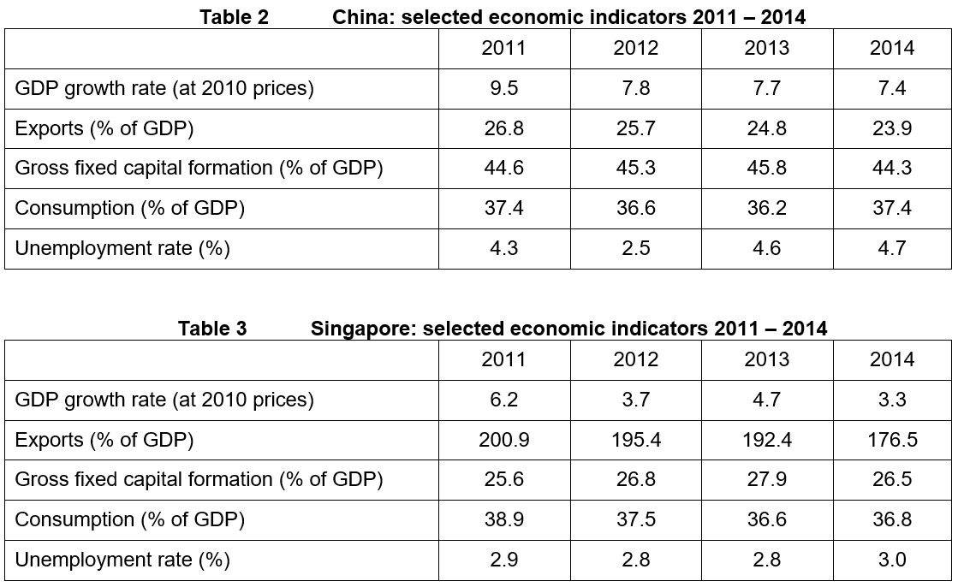

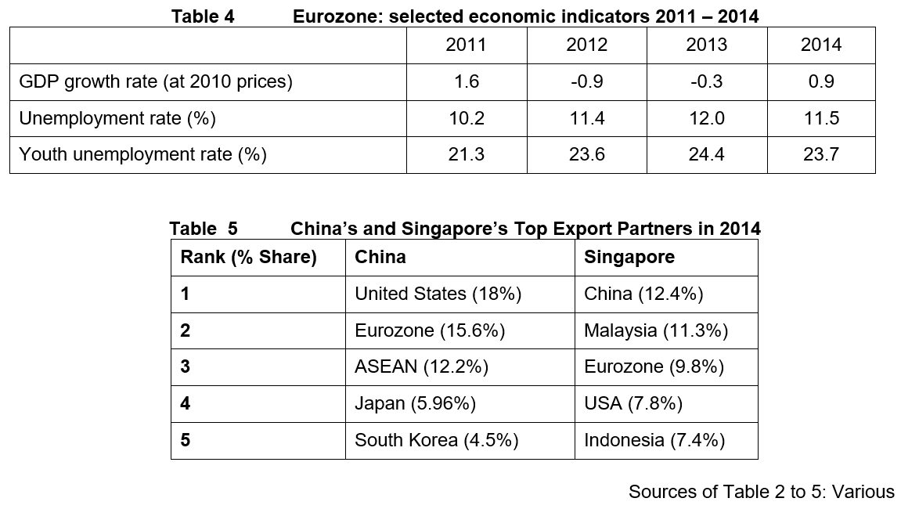

Questions
(a) With reference to Table 2, describe the trend of China’s real GDP from 2011 to 2014. [2]

(b) Extract 5 suggests that the Chinese are concerned over the formation of real estate bubbles.
(i) Use the concept of circular flow of income to explain how a “burst of real estate bubbles” (Extract 5) will affect China’s equilibrium national income. [5]
(ii) Explain and comment on a policy that China can implement to mitigate the ‘downward risk’ on its economy (Extract 5). [5]

(c)(i) Explain what is meant by the term ‘youth unemployment’ of country such as Greece. [2]
(ii) Compare the trend of unemployment rate and youth unemployment rate in Eurozone from 2011 to 2014. [2]
(iii) Using AD/AS analysis, discuss the extent to which youth unemployment in the Eurozone will adversely affect its current and future economic growth. [6]

(d) A Eurozone recession would have a significant contagion impact on other economies such as Singapore and China through direct and indirect trade relationships. Extracts 6 and 7 show how Singapore and China attempt to restructure their economies.

Using the data, discuss the effectiveness of China’s and Singapore’s restructuring efforts in mitigating this possible contagion impact on their economies. [8]

[Total: 30]

Suggested Answers
(a) With reference to Table 2, describe the trend of China’s real GDP from 2011 to 2014. [2]

China’s real GDP generally rising at decreasing rate.

(b) Extract 5 suggests that the Chinese are concerned over the formation of real estate bubbles.
(i) Use the concept of circular flow of income to explain how a “burst of real estate bubbles” (Extract 5) will affect China’s equilibrium national income. [5]

1. If the real estate bubbles were to burst, prices of housing would fall.

2. Consumers would feel less wealthy OR consumers would have to cut down on expenditure to pay their debts, thus cutting autonomous consumption

3. Explain how fall in autonomous consumption (a form of injections) result in J<W (disequilibrium) + Adjustment from disequilibrium to equilibrium

(ii) Explain and comment on a policy that China can implement to mitigate the ‘downward risk’ on its economy (Extract 5). [5]

Explain one expansionary demand management policy or housing cooling measure – must link to how it mitigate fall in NY

FP – lower tax and increase government expenditure – raise the AD – via k – rise in real GDP
Draw diagram – increase in AD – rise in real GDP
Comment on the policy (relevant evaluation)

Rise in public debt – increase in borrowing to finance government expenditure
Crowding out effect – crowd out fund available for private investment
Depends on efficiency of the government
Size of k

(c)(i) Explain what is meant by the term ‘youth unemployment’ of country such as Greece. [2]

Youth employment refers to a situation where youth (those above legal working age and under 25) in the labour force who are willing and able to work but are unable to find employment.

(ii) Compare the trend of unemployment rate and youth unemployment rate in Eurozone from 2011 to 2014. [2]

Similarity – Both unemployment rate and youth unemployment rate generally increase from 2011 to 2014.

Difference – youth unemployment rate is consistently higher than that of unemployment rate over the period.

(iii) Using AD/AS analysis, discuss the extent to which youth unemployment in the Eurozone will adversely affect its current and future economic growth. [6]

1. Explain how youth unemployment in Eurozone may affect its actual economic growth
Loss in production and Income:
Loss of jobs brings about reduction in production and income. Scarring effect (where young people may not have a full time stable job and earn lower wages and at greater possibility of unemployment) reduces purchasing power low consumer confidence among the youths (expectations) fall in (autonomous) consumption fall in AD

Excess labour means the economy is not producing on the boundary of PPC and thus actual growth is affected. The longer youths remain unemployed, the more it will hamper the Eurozone’s recovery.

Loss in tax revenue which may affect future govt spending:
Lack of income of greater proportion of labour force who are unemployed leads to less tax revenue, compounded over a longer period of working life. Leading to less resources for the government to allocate to expenditure. If the government, especially in Eurozone is already running a budget deficit, the loss in tax revenue could possibly lead to a cut in budget spending which in turn exert a further contractionary effect on the economy’s actual growth

Loss of social stability
Unemployment appears to be linked to greater incidence of crime and violence as seen in some Southern Eurozone nations where jobless youth ‘lash out violently’. This in turn lowers investors’ confidence in the economy and may reduce FDI in eurozone.

2. Explain how youth unemployment in Eurozone may affect its Potential Economic Growth

Loss in human capital
With a long productive worklife ahead of youths, the lack of opportunities when young will hamper future work life and lead to loss of skills and even dropping out of the labour force – quality and quantity of labour will be adversely affected thus - lower potential growth

Lack of tax revenues can also affect the ability of governments to invest in infrastructure etc
Since FDI and domestic investment may decline→ lower potential growth

3. Evaluate the extent of adverse effects of youth unemployment on Eurozone
The impact on economic growth is also not evenly spread out as it seems that Germany and Austria’s youth unemployment rate is significantly lower compared to eurozone’s youth unemployment.

(d) A Eurozone recession would have a significant contagion impact on other economies such as Singapore and China through direct and indirect trade relationships. Extracts 6 and 7 show how Singapore and China attempt to restructure their economies.

Using the data, discuss the effectiveness of China’s and Singapore’s restructuring efforts in mitigating this possible contagion impact on their economies. [8]

1. Explain contagion impact
Can impact Sg and China directly through direct trade relationships (Slow growth in Eurozone (see Table 3)) poor consumer confidence possible fall in dd for goods and services fall in DDx from other countries including China and Sg). The extent of the contagion impact depends on the trade relationship between which can be seen in Table 5. It states that the Eurozone is the 2nd most important trading partner of China and the 3rd most important trading partner of Singapore. Ceteris paribus, this implies that China will be more adversely affected.

There is also indirect impact on DDx from China and Sg by other countries as the contagion spreads to other parts of the world.

2. Identify and explain how Singapore and China restructure their economy
Singapore – Increase Productivity and to move towards Creative economy, from high skilled to even higher skilled industries. Manpower lean – leveraging capital goods for higher productivity and reducing reliance on foreign manpower.

The new competitive advantage thus lies in the ability to carve out new markets and create new markets through the fusion of business, technology and arts. Design, which serves to bring about such a fusion has emerged as the key differentiation strategy for businesses.

China – structuring to boost growth driven by consumption instead of trade ➔ less affected by contagion effects of Eurozone recession

3. Discussion on the effectiveness of China’s and Singapore’s restructuring efforts in mitigating contagion effect on their economies
China:
Restructuring efforts are incomplete and still on-going. Despite the measures to improve health and pension coverage, and urbanisation, there are still significant obstacles e.g. finding its graduates suitable jobs. Exports (as % of GDP) has declined only gradually as seen in Table 2 and consumption (as % of GDP) only increased marginally from 2011 to 2014. However, C as %GDP in China is back to 36%.

Singapore:
Still very reliant on exports (176.5% of GDP in 2014). Eurozone recession can have global impact and impact Singapore directly and indirectly. Increased productivity from restructuring efforts can mitigate some of the impact.

Conclusion
Based on the overall direction of the restructuring efforts and nature of each economy, China may be better able to weather the storm as they leverage the might of their large national market should their measures mentioned above shows success overtime.

‘Rank’ whether Sg or China is more effective in mitigating the contagion impact of eurozone recession

