Essay Question 6
Examine the relative impact of a deep recession and a government subsidy on total consumer expenditure in different markets such as food and the Arts and Cultural events. [25] (SRJC Prelim 2012 Q2)

Introduction
To examine the impact of a deep recession and a government subsidy on the total consumer expenditure, we need to analyse its influence on the demand and supply of these markets as a result of the change. In doing so, we need to understand how the two goods are classified which will affect the elasticity of demand for these goods and thus affect the prices and output level which will affect the consumer expenditure, given that consumer expenditure is the product of price and quantity.

Main Body
- Explain how a deep recession would affect the demand for the demand for inferior and normal good

Deep recession fall in income decrease demand for normal good which are goods that occupy a large proportion of income spend increase in demand for inferior goods which are goods that occupy a small proportion of income spent

- Explain how the consumer expenditure for goods like food will change as a result of the deep recession

a. Economic Causation
↓Y↓dd for food which are classified as normal good – dining out at restaurant / ↓ dd for art and cultural events ↓dd for food at hawker centre (inferior)

b. Diagram and Description of Diagram (2 diagrams)
P
P
Q₁
P₀
P₁
D₀
D₁
S_{o}
Q₀
↓Y
S_{o}
P_{o}
D_{o}
P₁

D₁
Q_{ty}
Q_{ty}
Q₁
Q_{o}
Inferior Good (Hawker food)
Normal Good

As seen from the diagram, the decrease in demand for normal good from D₀ to D₁ will lead a supply demand condition, contributing to fall in price and quantity from P₀ to P₁ and Q₀ to Q₁. The total consumer expenditure will also decrease as total expenditure falls from P₀ X Q₀ to P₁ X Q_{1.}
c. Evaluation

- Explain how the consumer expenditure on Arts and Cultural events will change as a result of the government subsidy

a. Economic Causation
↑govt subsidy ↓COP↑SS for food / Art and cultural events

b. Diagram and Description of Diagram
S_{o}
D_{o}
P
Q_{ty}
S₁
Q₁
Q₀
P₀
P₁
S_{o}
D_{o}
P
Q_{ty}
S₁
Q₁
Q₀
P_{o}
P₁

Price falls slightly for the normal good such as art and cultural events ↑(gain>loss)
Why? – large proportion of income spent on these goods availability of substitutes – many
Price falls sharply but increase in quantity is less than proportional total consumer expenditure ↓ (loss >gain)
Why? Staple consumption

S_{o}
D_{o}
P
Q_{ty}
S₁
Q₁
Q₀
P₀
P₁
S_{o}
D_{o}
P
Q_{ty}
S₁
Q₁
Q₀
P_{o}
P₁

Subsidy per unit

Producer benefit more for Arts and cultural events when dd is price-elastic help producers to cover huge cost of events
Consumer benefit more for food items as it is essential to them when dd is price-inelastic

c. Evaluation
i. Extent of change in demand and supply
Subsidy↑SS or recession (↓dd for normal good / ↑ dd for inferior good)
in dd >↑SS
-↑dd>↑SS(Inferior good) ↑P, ↑Qty
-↓dd>↑SS (normal good)↓P,↓Qty
Conclusion

Essay Question 6 Full Essay
Examine the relative impact of a deep recession and a government subsidy on total consumer expenditure in different markets such as food and the Arts and Cultural events. [25]

Introduction
- State that the market is determined by demand for and supply of the product.
- State that total consumer expenditure is derived by multiplying price per unit and total quantity bought by the consumer.

Main Body
1. Explain the impact of a deep recession on the market for food as a broad category

A deep recession will affect the market and cause a fall in the total consumer expenditure for food items.
Q₀
Q₁
P₀
P₁
Price per unit ($)
SS
Quantity of food

D₀

D₁

As seen in the diagram, the downward sloping demand (D) and upward sloping supply (S) curve for a normal good such as food items, for example rice. Ceteris paribus, the lower the price, the higher the quantity demanded by the consumer. Conversely, the higher the price, the greater the incentive for the profit maximising producer to increase quantity supplied. The original market equilibrium is determined where demand equals to supply at point E. The equilibrium price and quantity exchanged is at OP and OQ respectively. The total consumer expenditure is represented by area 0PEQ.

A deep recession would mean that there will be a great fall in the income earned by the citizens of the country. This reduces the disposable income and spending power of the citizens. Ceteris paribus, for example, price of the good remaining unchanged, there will be a fall in the willingness and ability of households to demand for a normal good.

As food as a broad classification are necessities needed for basic survival Hence, other factors remaining unchanged, when there is a fall in income, households will reduce the quantity consumed only by a small extent. Hence, the demand curve will shift to the left by a smaller extent to D₁.

As a result, a surplus arises which exerts a downward pressure on equilibrium price. As price falls, the quantity demanded increases causing a movement along D₁. At the same time, producers seeing the drop in price will reduce quantity supplied until a new equilibrium is re-established at E₁. With a lower equilibrium price at OP₁ and lower quantity bought at OQ₁, total expenditure of consumers falls to 0P₁E₁Q₁.

However, as at the same time, the government grants a subsidy e.g. on the production of rice and other basic food items. Hence, there will be a further influence on food consumption during the recession.

A subsidy on rice production, for example, reduces cost of production and enables rice farmers to produce more rice. The change in total expenditure will depend on the degree of responsiveness of quantity demanded given this price fall. The demand for a necessity like food items is not very sensitive to price changes, so a cheaper price will only bring about a smaller percentage rise in quantity demanded. Hence total expenditure by consumers on food shrinks.

Services like Arts and Cultural events are normal goods which are likely to be luxury items. These are leisure activities and could include pop concerts, museum and other theatre performances either by local or foreign acts.

Hence, like food which is a normal item, during recession where income falls, there will also be a fall in the demand for Arts and Cultural events. However, as these are luxury goods which households can forgo during hard times and will spend on after basic needs are met, there will a greater percentage drop in demand compared to the fall in income. Hence, the demand curve for Arts and Cultural events shifts to the left by a greater extent. Assume supply remaining unchanged, the surplus causes the same automatic market adjustment process through a downward pressure on price as explained earlier in the food market. Ceteris paribus, the bigger surplus will cause a greater fall in equilibrium price and quantity exchanged for such events. Hence with a smaller price and quantity bought, the impact is a greater fall in total expenditure to area 0P_{A}E_{A}Q_{A} compared to food expenditure of area OP_{F}E_{F}Q_{F} as seen in the figure below.
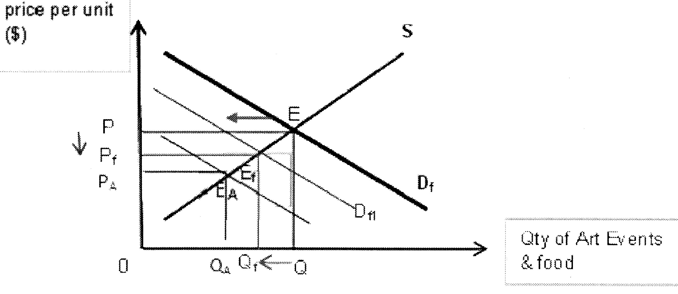

Comparison of the impact on food and arts and cultural events
Hence we can see that the impact on the expenditure on both goods work through a shift in demand and a movement along the demand curve. There are 3 possible final impact of the 2 triggers: Both will see a fall in total expenditure. Both work to reduce consumption expenditure where a deep recession is concerned. Assuming PED<1 for both, then both fall. If PED=1 for Arts, there will be a net fall in total expenditure.

In view of the fact that food items are necessity with low income and price elasticity of demand, the final impact of both a deep recession and a subsidy may cause a bigger fall in total expenditure in food items than for the arts and cultural events. This is because both the recession and subsidy bring about a fall in total expenditure for food.

However, there are the limitations this examination as it hinges on the ceteris paribus assumption. Other factors like changes in lifestyle and taste and preference could have changed at the same time. These can affect the degree of change in the willingness and ability of households to consume a good when income and price changes.

Conclusion
Hence, a closer examination suggests that the relative impact depends on the nature of the good. A strong consideration is the fact that the recession is deep and is likely to cause a fall in total expenditure for both goods. Hence if government wishes to increase total expenditure to boost an economy, it may have to find other ways of doing so, for example by reducing taxes and increase their disposable income.

