Types of graphs for microeconomics

1. Market Adjustment Process

Example 1
How far does the data in Figure 1 show that the change in US oil production was the key reason for the change in oil price between January 2013 and January 2016? [4]

Trend
Oil Price fell in the time period as US oil production rose. (1)

Explanation
Rise in production of US oil, fall in demand for imported oil, thus, the demand for oil market fall. Fall in US demand for oil, surplus, prices also fell. (1)

But it may not be the key reason because the extent of rise in US oil production is rather small as compared to the extent of the fall in world oil prices as seen in figure 1, especially in Jan 2015. Thus, it could be due to other factors such as slowing world economic growth as mentioned in extract 1. (1)

Diagram and description (1)

Example 2

(b) With the help of a supply and demand diagram, explain the likely impact of increasing population and lower energy costs on the market for public transport. [6]
-the resulting change in price and output – cs, ps, total revenue
An increasing population means more users for public transport, which leads to a rise in the demand for public transport trips from Do to D1. A shortage of EoA at Po results in the equilibrium price and quantity of public transport increasing from Po to P1 and Qo to Q1 respectively.

With lower energy costs, the unit cost of producing public transport trips falls, which results in a rise in the supply of public transport trips from So to S1. Equilibrium price falls from P1 to P2, while equilibrium quantity increases from Q1 to Q2.

Prediction – why increase in demand is greater than increase in supply

Draw and describe diagram

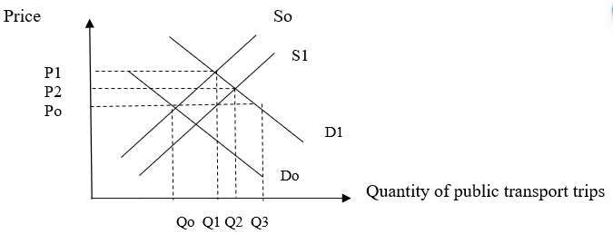

2. How the firm can increase revenue by decreasing price when the demand is price-elastic

(d) In Extract 2, the chief executive of Next considers the effect of an 8% rise in the price of Next’s clothes. With reference to the concept of price elasticity of demand, explain the expected impact of this price rise on the firm's total revenue. [3]

As considered by Next’s chief executive, the effect of an 8% rise in the price of Next’s clothes will lead to a reduction in quantity demanded of Next’s clothes. If as projected, the fall in quantity demanded is about 10%, which has more than proportionate decrease in quantity demand in response to increase in price and this will contribute to a fall in total revenue.

Price of Next’s Clothes

P₁
Gain
Fig. 1 – Price-elastic demand for Next’s Clothes
P₀

SS
Loss

Qty of Next’s Clothes
Q₀
Q₁

As seen from the diagram, there will be a fall in the total revenue for Next’s clothes as the gain in revenue due to the rise in price of Next’s clothes is lesser than the loss in revenue due to the fall in quantity demanded of Next’s clothes, given that the demand is price-elastic, given that the price elastic demand for clothing is price-elastic.

It is likely that the demand is price-elastic since there are extensive substitutes like Primark and Asda and other stores, given its high degree of competition. As clothes are durables, which means there is low degree of necessity of demand for the good, shaping it to be price-elastic in demand.

3. How subsidy affect the market equilibrium

As seen from the diagram, the provision of subsidy contributes to the lowering of cost of production, and this leads to an increase in supply from So to S. Consequently, the price of the good falls from Po to P1 and the quantity increases from Qo to Q1. The producers and consumers both gain benefits as represented by the shaded region while the society gains welfare as seen in the shaded portion (ABC).

4. How removal of subsidy affects the market equilibrium

As seen from the diagram. the removal of subsidy causes a rise in cost of production and this causes the supply curve to reduce the supply from So to S1. This causes the price to rise from Po to P1 and a fall in quantity demanded from Qo to Q1. Besides this change, the consumer and producer benefit is reduced and the welfare gain is reduced by the portion marked ABC.

5. How increase in direct tax affect market equilibrium

As seen from the diagram, the imposition of taxation (specific) causes a rise in cost of production and this leads to a fall in supply from So to S1. Consequently, the price of the good rises from Po to P1 and the quantity demanded falls from qo to q1. There will be a rise in welfare loss and the produce and consumer incur producer tax burden and consumer tax burden respectively as represented by the shaded portion.

6. How Sales tax would affect the market equilibrium

As seen from the diagram, the Sales tax which is percentage-based and varied based on the price level. This contributes to the rise cost of production and the supply curve pivots to the left from So to S1. This causes the price to increase from Po to P1 and contributes to a fall in quantity demanded from qo to q1 and there will be a loss of welfare loss as represented by shaded portion ABC while the producer and consumer benefit both are incurred.

7. How price ceiling affects the market equilibrium

A maximum price set artificially by the government to ensure that goods are bought and sold at that price level which is below the market equilibrium price level. There will be a reduction in qty supplied and an increase in qty dd, which will cause an excess dd condition. E.g. HDB Public Housing

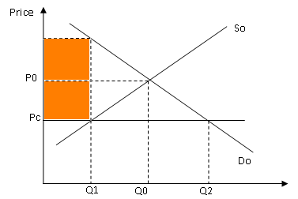

As seen from the diagram, the market equilibrium at Eo where the price and output level is at Po and Qo. When price ceiling is imposed, the prie is lowered rom Po to Pc and this causes an increase in quantity demand from qo to q2 and a decrease in quantity supplied from qo to q2, creating an excess demand condition (shortage) from q1 to q2. If this is not matched by a supply from buffer stock, a black market price occurs Pb where black market is allowed to occur.

8. how floor price affects the market equilibrium

A minimum price set artificially so that goods are bought and sold at that price level which is above the market equilibrium price level.

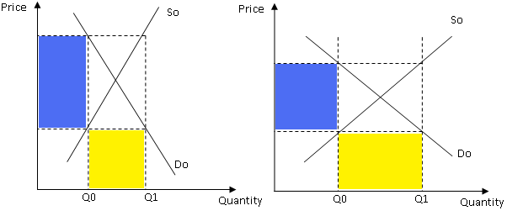

As seen from the diagram, the price and output are originally set at Po and Qo. The imposition of the floor price raises the price from po to p1 and this causes an decrease in quantity demanded from Q* to Q2 and am increase in quantity supplied from Q* to Q1 and an excess supply condition occurs from Q1 to Q2. To clear the excess supply condition, a buffer must be created.

LIST OF QUESTIONS

Question 1

Extract 3: Biofuel and agricultural markets

Food prices in recent years have been marked by considerable volatility. Currently, some agricultural markets are experiencing sharp falls in prices. Lower oil prices have helped bring down the costs of agricultural production and reduced the incentive to use biofuels. As the use of crops for biofuels has been largely policy-driven, a phasing-out of government support for biofuels would contribute to lower and more stable food prices.

Source: OECD-FAO Agricultural Outlook 2017-2026

With the use of a demand and supply diagram, explain the likely consequences of lower oil prices and the phasing-out of government support for biofuels on the market for biofuels. [7]

Lower oil prices increase in quantity demanded for oil fall in demand for substitutes like biofuels fall in price and quantity of biofuels
Extent: depends on PES
Phasing-out of government support on for biofuel less incentive for biofuel producers cut back production of biofuels fall in supply of biofuels increase in price and fall in quantity of biofuels
Extent: depends on PED

While quantity of biofuel falls, price is indeterminate as it depends on the extent of shift in demand versus supply.
Fall in supply > Fall in demand increase in price of biofuels

Mark allocation:
Explanation of impact of change in demand {2}
Explanation of impact of change in supply {2}
Explanation of combined effect and use of elasticities {2}
Diagram {1}

Question 2

Figure 1: World oil price
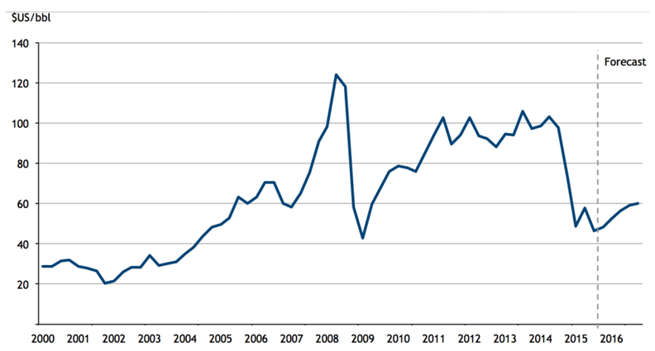
Source: Bloomberg, accessed 11 December 2015

Extract 1: Oil price plunge continues

The price of oil continued its steep fall on Friday, hitting five-and-a-half-year lows after the International Energy Agency (IEA) predicted demand next year would be lower than expected. Crude oil price has dropped 47% since June and fell to just over $61 a barrel. The oil price has plummeted in response to a massive build-up of shale-derived oil in the US through fracking, reduced fears of fighting in Iraq disrupting supplies, and due to the faltering world economy.

The Paris-based IEA singled out Venezuela as a potential flashpoint for trouble and the warning came as Venezuela’s currency, the bolívar, continued to lose close to 80% against the US dollar since the plunge in oil price. This is only part of an even bigger decline since Nicolas Maduro took office two years ago, and the oil price isn’t the only thing to blame. The fall in consumer investor confidence also contributes to the decrease in the economic activities that strongly affect the oil market in Venezuela.

But while the oil-producing countries face lost revenues and budget shortfalls, lower energy prices are expected to have a beneficial impact on the world economy. Many countries, particularly in Asia, are desperately dependent on foreign oil and gas imports, so cheaper prices should cut inflation and give impetus to manufacturing output and consumer spending. Analysts at investment bank ING said: “The recent fall in oil prices may not be sustained but, in the meantime, it provides a very welcome boost to real incomes for most major economies.”

Source: Adapted from The Guardian, 12 December 2014

Extract 2: US$20 Billion subsidy to fossil fuel industry

A joint investigative report by Oil Change International and the Overseas Development Institute reveals that, in the United States alone, the fossil fuel industry has benefitted from over $20 billion per year in government subsidies between 2008 and 2015.These subsidies occur throughout the fossil fuel exploration, production and transportation along the supply chain. This also means subsidizing oil spills, in which oil companies can write off the cost of clean-up as a business expense, including the 2010 BP oil disaster in the Gulf of Mexico. Subsidies are also used extensively in the research of new drilling technologies.

“Since the initial G20 commitment in Pittsburgh six years ago, US subsidies have increased dramatically in [the Obama] Administration, in line with the increase in US oil and gas production,” said Steve Kretzmann, executive director of Oil Change International. “The President can and must do more to eliminate subsidies at home amidst the growing government budget deficit and concerns on climate change.”

Source: Adapted from Overseas Development Institute, 12 November 2015

Extract 3: The true cost of oil production

Every link in the chain of oil production, from exploration through consumption, generates profound damage to the local environment and communities. As the industry moves towards increasingly risky forms of fossil fuel production, the impacts become more pronounced.

A notable Harvard Medical School study identifies impacts from many aspects of oil production. Exploration for new oil and gas often brings seismic explosions and the clearing of huge swaths of forest; drilling produces toxic drilling muds and waste waters; oil transport creates additional hazards, as oil spills from pipelines, tankers and tank farms are still routine, despite industry claims of safety measures. Oil refining creates further chemical, thermal and noise pollution and affects the health and safety of refinery workers and nearby communities and ecosystems. Gasoline and many of its additives are toxic and are associated with some types of cancer, with oil industry employees and those living near refineries, transfer and storage facilities at greater risk.

A 2011 United Nations Environment Programme study estimates that in Ogoniland, Nigeria, “countering and cleaning up the pollution and catalysing a sustainable recovery could take 25 to 30 years.”

Communities in Ogoniland have fought back against this oil pollution, through protest, which at times has met brutal repression, and through lawsuits. Several lawsuits specifically on gas flaring – the burning of natural gas during oil extraction - succeeded in obtaining a court order against flaring, however, Shell and other oil producers continue the practice despite the legislation enacted.

Source: Adapted from Oil Change International, 10 April 2014

Extract 4: Renewable energy can’t replace fossil fuels entirely

While technological advancements have made it possible for renewable energy to be used in many of the same applications as fossil fuels, there are still some limitations. For example, the energy efficiency of electric vehicles is much lower than traditional cars. Additionally, renewable energy can never and will not replace oil, coal and gas entirely. As the world's higher-quality fossil fuel reserves rapidly deplete, no combination of alternative energy sources is likely to be enough to sustain industries at their current scale. Nonetheless, large government funds have been poured into the renewable energy industry as countries seek to increase their energy self-reliance, which may bolster their economic resilience and reduce their ecological footprint.

Alternative energy sources have their own issues, such as energy transfer or destruction of the natural habitat. Hydro energy involves building dams and this, in turn, will destroy the habitat of the river or lake they are placed in. The past and the foreseeable future still belong to hydrocarbons, and we can expect natural gas, the cleanest of the hydrocarbons, to garner a bigger share of the global energy pie in the near and long term.

Source: Adapted from The Straits Times Forum, 17 December 2015

Questions:
(a) Using Figure 1, compare the overall change in world oil price between 2000 and 2008 with that between 2009 and 2014. [3]

(b) With reference to Extract 1,

- Identify and explain two reasons for the fall in world oil price after 2014. [4]

- Is the price floor an effective solution to help the oil industry? [4]

(c) Extract 2 mentions subsidies implemented by the US government in the fossil fuel industry. Comment on the possible consequences of the imposition of such subsidies for the producers and consumers of fossil fuel, as well as the US government. [8]

(d) (i) Briefly explain the relationship between fossil fuels and renewable energy. [2]

(ii) Identify one possible opportunity cost of pouring large government funds into the renewable energy industry. [1]

(e) Do you think the use of government legislation would be the best measure in tackling the circumstances as those described in Extract 3? [8]
[Total: 30]

Suggested Answers
(a) Using Figure 1, compare the overall change in world oil price between 2000 and 2008 with that between 2009 and 2014. [3]

Similarity: Both periods indicate increasing trend in oil price.
Difference: Rate of increase is larger in 2000 – 2008 as compared to 2009 – 2014.
Difference: 2009 – 2014 showed greater fluctuations in oil price.

(b) (i) With reference to Extract 1, identify and explain two reasons for the fall in world oil price after 2014. [4]

Increase in world SS of oil as production levels from producers rise due to “fracking in the US” OR “reduced fears of instability in Iraq”. With the rise in SS, ceteris paribus, equilibrium price of oil will fall.

Decrease in world DD of oil due to falling demand for oil due to lower economic growth / fall in real output in the “faltering world economy”. OR due to consumer expectations of falling future prices as there is “reduced fears of instability in Iraq”. With the fall in DD, ceteris paribus, equilibrium price of oil will fall.

(b). Is the price floor an effective solution to help the oil industry? [4]

(c) Extract 2 mentions subsidies implemented by the US government in the fossil fuel industry. Comment on the possible consequences of the imposition of such subsidies for the producers and consumers of fossil fuel, as well as the US government. [8]

As mentioned in Extract 2, the US government has implemented the use of a subsidy in the fossil fuel industry. This essay will aim to consider the various consequences on the consumers, producers and the US government.

Thesis: Subsidies benefit consumers and producers
The fossil fuel subsidy will benefit the consumers by making the fossil fuel more affordable (lower price) for the consumers, with more quantity available (higher q). With subsidy, the cost of production for the producers of fossil fuel drops. This will lead a rise in supply of fossil fuel as seen in the diagram by a movement from S1 to S2 (diagram is expected). With the demand for fossil fuel remaining the same, there is a surplus created at the initial price P1 as quantity supplied is greater than quantity demanded. This will create a downward pressure on the price until the new equilibrium is reached as a lower price P2 from P1. The new equilibrium also has a higher quantity of fossil fuel, rising from Q1 to Q2 in Figure 2. This results also in a higher consumer surplus, as shown in Figure 1, where consumer surplus increases with the lower price.

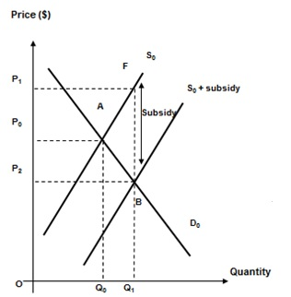

Figure 1: Subsidy in Fossil Fuel Production

Though the fall in price of fossil fuel may result in lower total revenue for producers given that demand for fossil fuel is relatively price inelastic, the per-unit subsidy given by the government on the increased quantity sold will more than cover the fall in TR due to the lowered price. This is reflected in the Figure 1, where there is an increase in total income of producers after subsidy P1FBP2 + P2BQ10. Thus, this will increase the profitability of the producers.

The subsidies are also given to lower the cost of R&D for producers, which will likely create higher incentive for producers to invest in the development of new methods of production which will lower cost of production further. Producers will also research into new innovations that will create better quality products that will have positive benefits to consumers. “These subsidies occur throughout the fossil fuel exploration, production and transportation along the supply chain” and/or “Subsidies are also used extensively in the research of new drilling technologies.” Thus, subsidies have benefits for the consumers and producers. However, there are also disadvantages with the use of government subsidies.

Anti-Thesis: Fossil fuel subsidies disadvantage 3rd parties & government
As shown from Figure 1, the use of subsidies has also increased the quantity of fossil fuel consumed from Q0 to Q1. As the production of fossil fuels leads to negative externalities as evidenced in Extract 3, “creates further chemical, thermal and noise pollution and affects the health and safety of refinery workers and nearby communities and ecosystem”. This will negatively impact consumers and producers who are 3rd parties in the oil transaction. (negative externality)

Provision of subsidies in the fossil fuel industry in the long term will not only add significant financial strain on the government’s budget, there will also be less funds available for other uses which will post considerable opportunity cost.

Due to limited government budget, there is a trade-off when the US government provides fossil fuel subsidy. There is an opportunity cost involved in this policy decision. For example, the government will have to allocate a larger budget for the purpose of providing fossil fuel subsidy and have fewer funds to budget for other key areas of expense such as military defence, education and healthcare.

Also, even those with financial ability may exploit the opportunity and that might add on the burden on US government, which is currently running on a large government budget deficit. This will lead to the unintended consequence of financing the budget deficit with higher tax rates in future. The higher tax rates will create the disincentive to work and investment, which will negatively hurt the consumers and producers in the long run.
Conclusion
The subsidies do indeed benefit the consumers and producers especially in the short run with the lower price and higher profits; the imposition of a long term fossil fuel subsidy is not feasible as it will create a financial burden on the government and weakens its fiscal position. As seen in Extract 2, “President can and must do more to eliminate subsidies at home amidst the growing government budget deficit and concerns on climate change”, the use of the subsidy will likely leads to more negative consequences in the long run for all economic agents.

[Recommendation]
The use of a subsidy is merely a short-term intervention, which will create inefficiency in the market, especially when inefficient producers develop dependency on government for the subsidies. The government should instead encourage the use of cleaner renewable alternatives to fossil fuels which will seek to minimize the environmental impact as well.
(d) (i) Briefly explain the relationship between fossil fuels and renewable energy. [2]

Fossil fuels and renewable energy are substitutes in consumption.

As seen in Extract 4, “While technological advancements have made it possible for renewable energy to be used in many of the same applications as fossil fuels… the energy efficiency of electric vehicles is much lower than traditional cars”, though both could be used in satisfying the same wants / needs (for eg energy input for driving vehicles).

OR

When the price of fossil fuel increases, there will be a fall in quantity demanded of fossil fuel. Consumers will turn to renewable energy to meet their needs for energy input, thus the demand for renewable energy increase.

Question 3

Suggested Answers
(a) (i) Explain the likely magnitude of the price elasticity of demand for smartphones. [2]

Price inelastic demand, magnitude less than 1 in absolute terms. A device for user to stay connected on the go with no close substitutes available. The need to stay connect wherever and whenever makes smartphone a necessity to the user. Price of smartphone takes up insignificant portion of income as it becomes more affordable.

(a) (ii) Explain the likely magnitude of the price elasticity of supply for smartphones. [2]

Price elastic supply, magnitude more than 1 in absolute terms. Manufactured products with short production time. Existence of spare capacity of smartphone producers.

(b) Identify and explain 2 demand factors why the growth in smartphone market is faster in China as compared to the world. [4]

Low smartphone penetration rate relative to other countries, hence has greater potential to grow faster. Hence demand likely to increase faster and thus growth in smartphone market is faster in China.

High economic growth rates over past few years, relative to other countries, leads to faster increase in demand for smartphones and thus growth in smartphone market is faster in China.

As Chinese consumers tend to replace cheap phones much more quickly given its low price relative to high-end smartphones, the increase in quantity demanded can be greater and thus growth in smartphone market is faster in China.
Question 4

Public Transport in Singapore

Extract 1: Bus and train ridership hits new high

Bus and rail ridership rose by 4.1 per cent last year. According to the Land Transport Authority (LTA), LRT patronage led the growth, followed by MRT trips. Together, rail ridership grew 4.6 per cent to cross the three million mark for the first time - more than double the ridership a decade ago.

Table 1: Public Transport Ridership

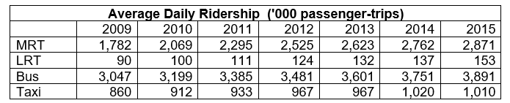

Source: Land Transport Authority, Singapore 2016

The public transport ridership growth has come on the back of a growing population and more prohibitive car prices. It has also been driven by more buses, trains and to a smaller extent, the opening of Downtown Line 2 in late December. As at the end of last year, more than three quarters of a planned tax-funded fleet of 1,000 public buses have been put on the road, while more new trains were added for the various MRT lines. Furthermore, bus and rail fares fell by 1.9% from 2014 to 2015. Meanwhile, taxis suffered a dip in ridership last year.
Source: The Straits Times, 10 March 2016

Extract 2: Government spends on transport infrastructure and subsidies

To ensure that public transport costs in Singapore stay affordable to the commuter, the government has been subsidising public transport by funding the infrastructure and start-up costs of the rail and bus networks, such as rail tracks, signalling and power systems, buying buses under the Bus Service Enhancement Programme and providing direct fare subsidies. While fares should be kept affordable, the government also needs to ensure that the burden on taxpayers does not become excessive.

Both SBS Transit and SMRT have seen higher operating expenses last year, however, public transport operators are seeing lower energy costs today.

Source: The Straits Times, 23 Feb 2015

Extract 3: The bumpy road to a 'car-lite' Singapore
A “car-lite” Singapore by 2030 has been a major theme for the Transport Ministry this year. In January, it launched the “Walk, Cycle, Ride” campaign which encourages commuters to choose public transport over driving. In addition, the construction of infrastructure to facilitate walking, cycling and the use of personal mobility devices (PMDs) has already started to take shape. With legislation that will officially legalise the use of PMDs expected by year’s end, Singapore looks to be on track to achieving its “car-lite” status.

Some bumps, however, still remain. Strong demand for cars is evident from prohibitive car prices. Stocks of cars are running low. Convincing people to give up owning a car in exchange for the alternatives is increasingly difficult. Indeed, changing the belief that car ownership is a mark of success needs to take place before Singapore can realise its goal.
Source: Channel NewsAsia, 18 Jun 2016

Suggested Answers
(a) Using Table 1, compare the relative changes in the public transport ridership of bus, MRT and taxi for the period shown. [2]

Bus ridership, taxi ridership and MRT ridership all rose. MRT ridership increased most significantly while taxi ridership rose by the least.

(b) With the help of a supply and demand diagram, explain the likely impact of increasing population and lower energy costs on the market for public transport. [6]

An increasing population means more users for public transport, which leads to a rise in the demand for public transport trips from Do to D1. A shortage of EoA at Po results in the equilibrium price and quantity of public transport increasing from Po to P1 and Qo to Q1 respectively.

With lower energy costs, the unit cost of producing public transport trips falls, which results in a rise in the supply of public transport trips from So to S1. Equilibrium price falls from P1 to P2, while equilibrium quantity increases from Q1 to Q2.

Diagram description:

With increases in both demand and supply for public transport trips, the quantity of public transport trips rises but the impact on its price is uncertain.

(c) (i) Using Extract 1, calculate the price elasticity of demand for bus travel from 2014 to 2015. [2]

PED = % change in quantity demanded of bus travel / % change in Price of bus travel

PED for bus travel is (-) 1.96.

(c) (ii) Explain the likely impact of a fall in bus fares on bus operators’ total revenue. [3]

The fall in bus fares could be due to a rise in the supply of bus trips due to a subsidy [extract 2] which lowers the unit cost of producing bus trips. (decrease in price and then increase in qty dd)

Total revenue = P X Q
As the demand for bus trips is price elastic as shown in c(i), bus operators’ total revenue is likely to increase as the loss in total revenue due to the fall in bus fares is smaller than the gain in total revenue due to the more than proportionate rise in bus trips.

(d) With reference to Extract 3, explain why car prices may remain prohibitive. [3]

Extract 3 suggests that there continues to be a strong consumer preference towards use of cars which is a status symbol so the high demand for cars results in extremely high car prices or prohibitive prices.

If people increasingly feel that car is a status symbol, demand will increase. The low availability of car stocks means that PES<1. Hence, any increase in demand brings about a sharp increase in price explaining why car prices remaining prohibitive.

- Explain one revenue factor and one cost factor that are necessary for price fixing to be possible. [4]

